Basic\_Statistics\_Level\_1

Q1) Identify the Data type for the following:

|  |  |
| --- | --- |
| Activity | Data Type |
| Number of beatings from Wife | Discrete |
| Results of rolling a dice | Discrete |
| Weight of a person | Continuous |
| Weight of Gold | Continuous |
| Distance between two places | Continuous |
| Length of a leaf | Continuous |
| Dog's weight | Continuous |
| Blue Color | Discrete |
| Number of kids | Discrete |
| Number of tickets in Indian railways | Discrete |
| Number of times married | Discrete |
| Gender (Male or Female) | Discrete |

Q2) Identify the Data types, which were among the following

Nominal, Ordinal, Interval, Ratio.

|  |  |
| --- | --- |
| Data | Data Type |
| Gender | Nominal |
| High School Class Ranking | Ordinal |
| Celsius Temperature | Interval |
| Weight | Ratio |
| Hair Color | Nominal |
| Socioeconomic Status | Ordinal |
| Fahrenheit Temperature | Interval |
| Height | Ratio |
| Type of living accommodation | Nominal |
| Level of Agreement | Nominal |
| IQ(Intelligence Scale) | Interval |
| Sales Figures | Ratio |
| Blood Group | Nominal |
| Time Of Day | Ordinal |
| Time on a Clock with Hands | Interval |
| Number of Children | Ratio |
| Religious Preference | Nominal |
| Barometer Pressure | Interval |
| SAT Scores | Interval |
| Years of Education | Ratio |

Q3) Three Coins are tossed, find the probability that two heads and one tail are obtained?

Answer-:

H = Head

T = tail

S{HHH, HHT, HTH, THH, TTH, THT, HTT, TTT}

N(S) = 8

P(A) = n(A)/n(S)

P(A) = 3/8 = 0.375

Q4) Two Dice are rolled, find the probability that sum is

1. Equal to 1
2. Less than or equal to 4
3. Sum is divisible by 2 and 3

Answer-:

S{(1,1),(1,2),(1,3),(1,4),(1,5),(1,6),

(2,1),(2,2),(2,3),(2,4),(2,5),(2,6),

(3,1),(3,2),(3,3),(3,4),(3,5),(3,6),

(4,1),(4,2),(4,3),(4,4),(4,5),(4,6),

(5,1),(5,2),(5,3),(5,4),(5,5),(5,6),

(6,1),(6,2),(6,3),(6,4),(6,5),(6,6)}

n(S) = 36

1. Equal to 1

Answer-:

Event sum of equal to 1 = 0

1. Less than or equal to 4

Answer-:

B{(1,1),(1,2),(1,3),(2,1),(2,2),(3,1)}

n(B) = 6

P(B) = n(B)/ n(S)

P(B) = 6/36 = 0.1666666666666667

1. Sum is divisible by 2 and 3

Answer-:

C{(1,6),(2,4),(3,3),(4,2),(5,1),(6,6)}

P(C) = n(C) /n(S)

P(C) = 6/36 = 0.1666666666666667

Q5) A bag contains 2 red, 3 green and 2 blue balls. Two balls are drawn at random. What is the probability that none of the balls drawn is blue?

Answer-:

Total number of balls  
= (2 + 3 + 2)  
= 7  
Let S be the sample space  
Then, n(S) = Number of ways of drawing 2 balls out of 7

n(S)=7C2

n(S)=(7×6)/(2×1)

n(S)=21

Let E = Event of 2 balls, none of which is blue  
therefore n(E) = Number of ways of drawing 2 balls out of (2 + 3) balls

n(E)=5C2

n(E)=(5×4)/(2×1)

n(E)=10

P(E)=n(E)/n(S) = 10/21

Q6) Calculate the Expected number of candies for a randomly selected child

Below are the probabilities of count of candies for children (ignoring the nature of the child-Generalized view)

|  |  |  |
| --- | --- | --- |
| CHILD | Candies count | Probability |
| A | 1 | 0.015 |
| B | 4 | 0.20 |
| C | 3 | 0.65 |
| D | 5 | 0.005 |
| E | 6 | 0.01 |
| F | 2 | 0.120 |

Child A – probability of having 1 candy = 0.015.

Child B – probability of having 4 candies = 0.20

Answer-:

The Expected number of candies for a randomly selected child

= 1\*0.015+4\*0.20+3\*0.65+5\*0.005+6\*0.01+2\*0.120

= 0.015+0.8+1.95+0.025+0.06+0.24

= 3.09

Q7) Calculate Mean, Median, Mode, Variance, Standard Deviation, Range & comment about the values / draw inferences, for the given dataset

-For Points,Score,Weigh>

Find Mean, Median, Mode, Variance, Standard Deviation, and Range and also Comment about the values/ Draw some inferences.

Answer:-

|  |  |  |  |
| --- | --- | --- | --- |
|  | Points | Score | Weigh |
| Mazda RX4 | 3.9 | 2.62 | 16.46 |
| Mazda RX4 Wag | 3.9 | 2.875 | 17.02 |
| Datsun 710 | 3.85 | 2.32 | 18.61 |
| Hornet 4 Drive | 3.08 | 3.215 | 19.44 |
| Hornet Sportabout | 3.15 | 3.44 | 17.02 |
| Valiant | 2.76 | 3.46 | 20.22 |
| Duster 360 | 3.21 | 3.57 | 15.84 |
| Merc 240D | 3.69 | 3.19 | 20 |
| Merc 230 | 3.92 | 3.15 | 22.9 |
| Merc 280 | 3.92 | 3.44 | 18.3 |
| Merc 280C | 3.92 | 3.44 | 18.9 |
| Merc 450SE | 3.07 | 4.07 | 17.4 |
| Merc 450SL | 3.07 | 3.73 | 17.6 |
| Merc 450SLC | 3.07 | 3.78 | 18 |
| Cadillac Fleetwood | 2.93 | 5.25 | 17.98 |
| Lincoln Continental | 3 | 5.424 | 17.82 |
| Chrysler Imperial | 3.23 | 5.345 | 17.42 |
| Fiat 128 | 4.08 | 2.2 | 19.47 |
| Honda Civic | 4.93 | 1.615 | 18.52 |
| Toyota Corolla | 4.22 | 1.835 | 19.9 |
| Toyota Corona | 3.7 | 2.465 | 20.01 |
| Dodge Challenger | 2.76 | 3.52 | 16.87 |
| AMC Javelin | 3.15 | 3.435 | 17.3 |
| Camaro Z28 | 3.73 | 3.84 | 15.41 |
| Pontiac Firebird | 3.08 | 3.845 | 17.05 |
| Fiat X1-9 | 4.08 | 1.935 | 18.9 |
| Porsche 914-2 | 4.43 | 2.14 | 16.7 |
| Lotus Europa | 3.77 | 1.513 | 16.9 |
| Ford Pantera L | 4.22 | 3.17 | 14.5 |
| Ferrari Dino | 3.62 | 2.77 | 15.5 |
| Maserati Bora | 3.54 | 3.57 | 14.6 |
| Volvo 142E | 4.11 | 2.78 | 18.6 |

|  |  |  |  |
| --- | --- | --- | --- |
|  | Points | Score | Weigh |
| Mean | 3.597 | 3.217 | 17.85 |
| Median | 3.695 | 3.325 | 17.71 |
| Mode | numeric | numeric | numeric |
| Range | 2.76 4.93 | 1.513 5.424 | 14.5 22.9 |
| Variance | 0.285881350806452 | 0.957378967741936 | 3.19316612903226 |
| Standard deviation | 0.534678736070971 | 0.978457442989697 | 1.78694323609684 |

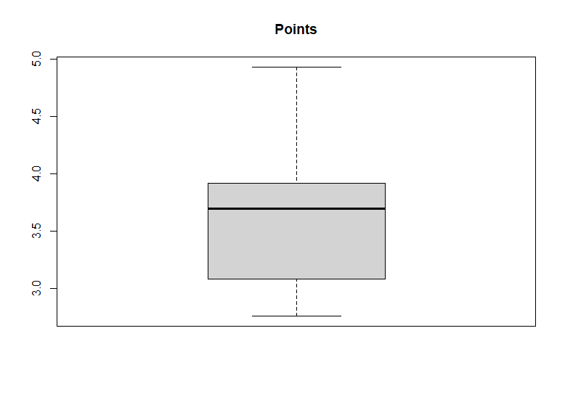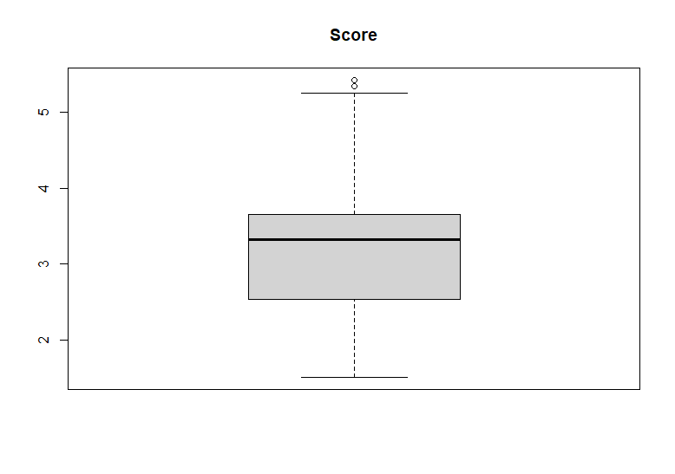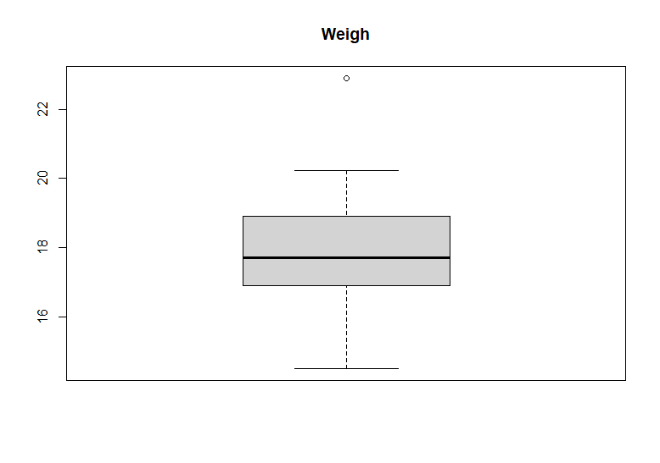

**Code:-**

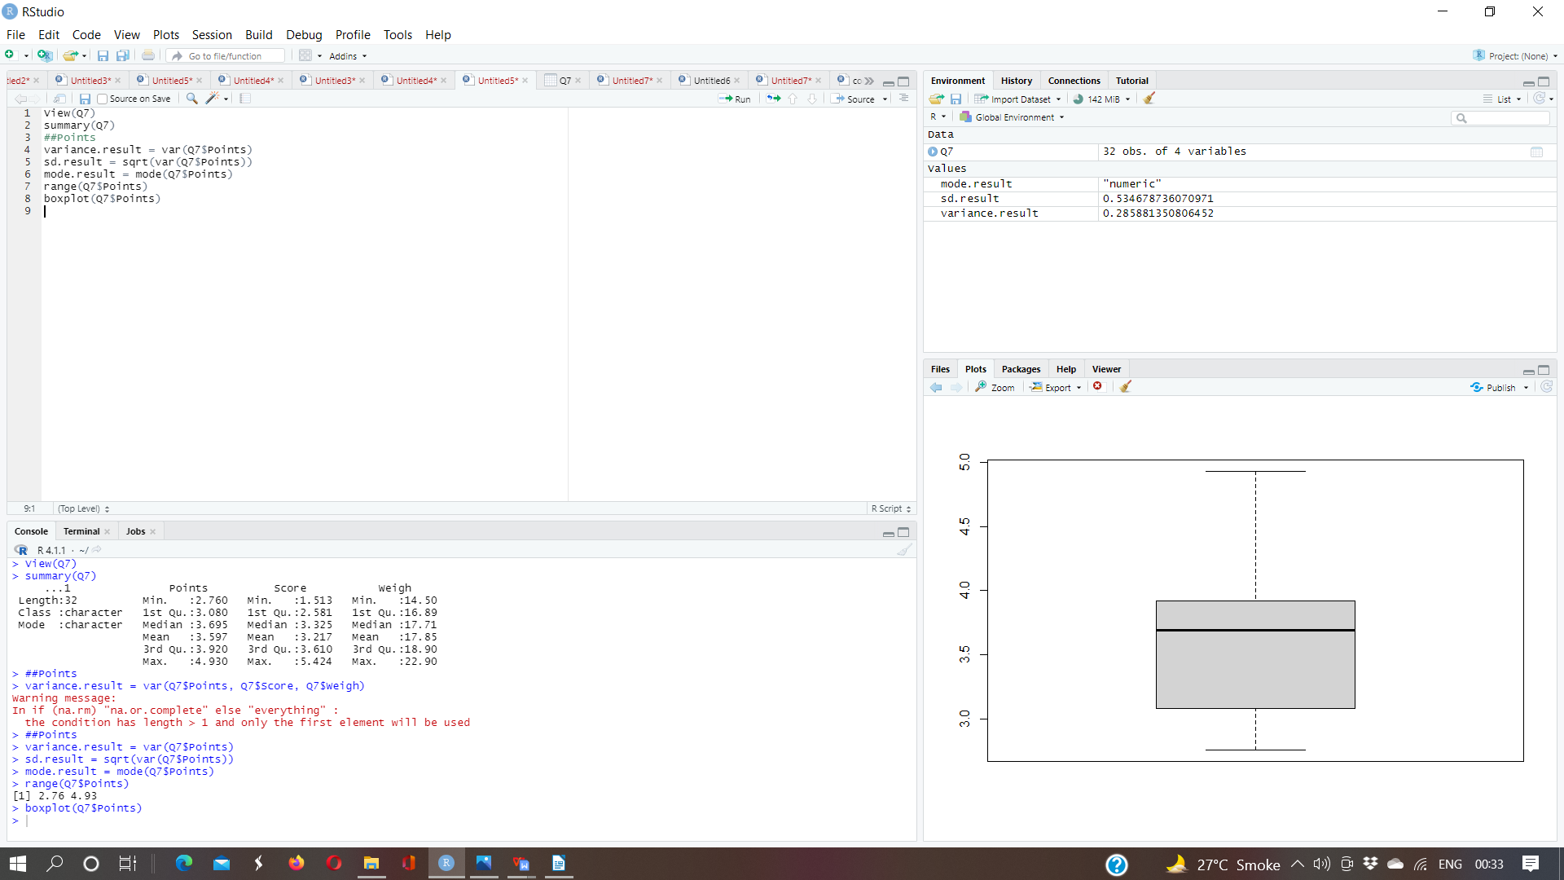

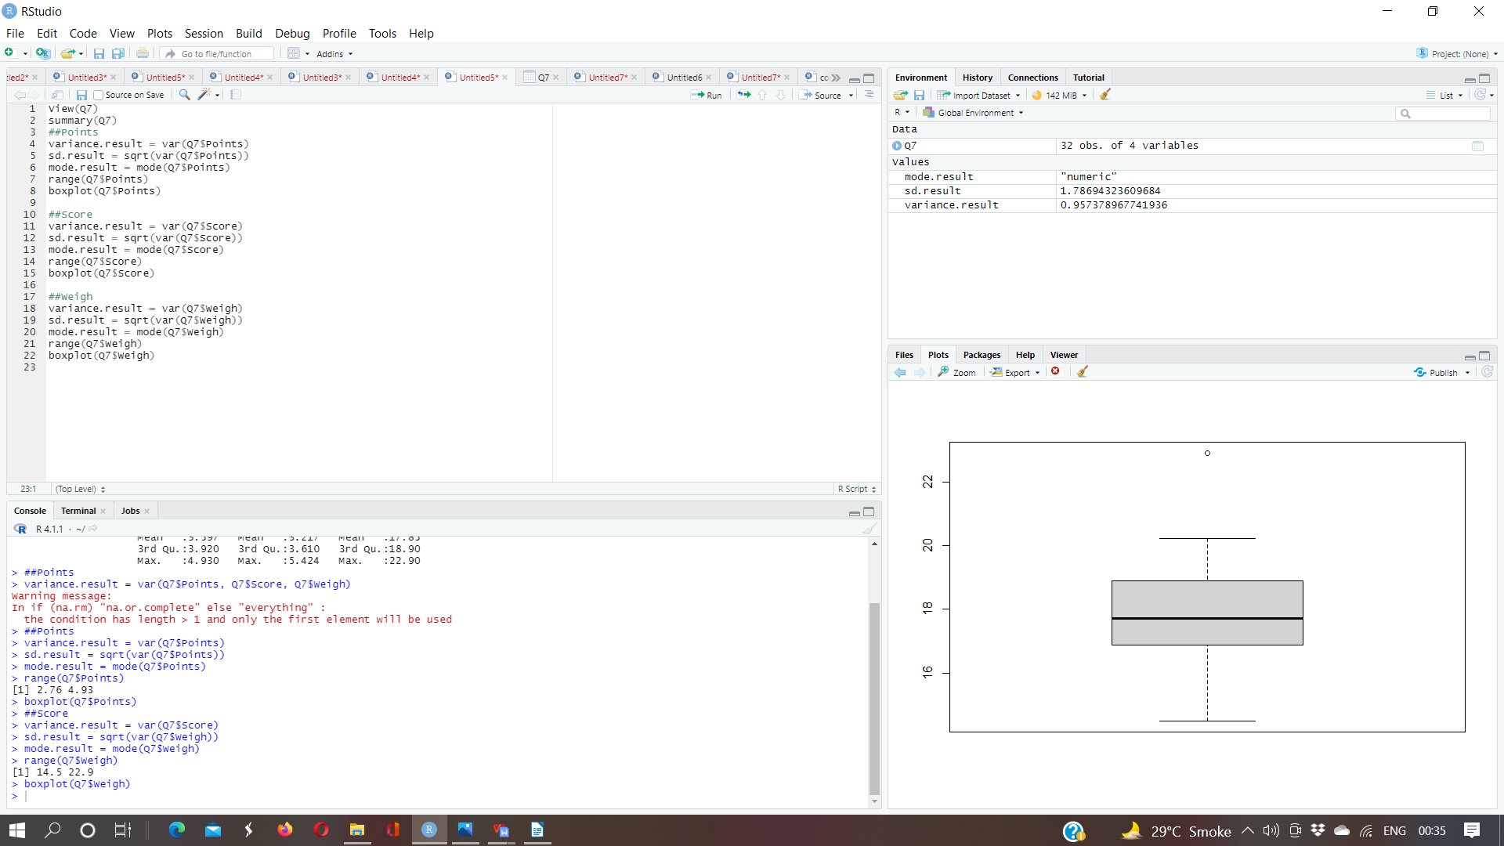

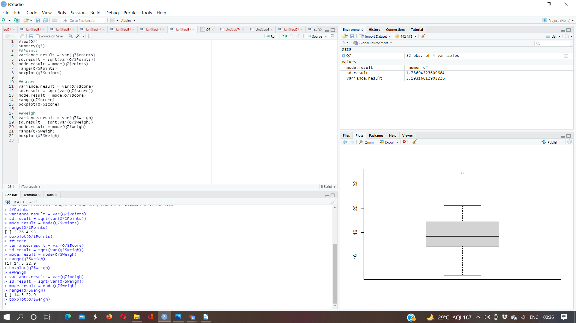

Q8) Calculate Expected Value for the problem below

1. The weights (X) of patients at a clinic (in pounds), are

108, 110, 123, 134, 135, 145, 167, 187, 199

Assume one of the patients is chosen at random. What is the Expected Value of the Weight of that patient?

Answer:- Expected Value of X

S(108, 110, 123, 134, 135, 145, 167, 187, 199)

n(S) = 9

P(X) = n(X)/n(S)

P(X) = 1308/9

P(X) = 145.333333

**Q9) Calculate Skewness, Kurtosis & draw inferences on the following data**

**Cars speed and distance**

**Use Q9\_a.csv**

**SP and Weight(WT)**

**Use Q9\_b.csv**

**Answer:-**

1. **Car Speed and Distance**

|  |  |  |
| --- | --- | --- |
| Index | speed | dist |
| 1 | 4 | 2 |
| 2 | 4 | 10 |
| 3 | 7 | 4 |
| 4 | 7 | 22 |
| 5 | 8 | 16 |
| 6 | 9 | 10 |
| 7 | 10 | 18 |
| 8 | 10 | 26 |
| 9 | 10 | 34 |
| 10 | 11 | 17 |
| 11 | 11 | 28 |
| 12 | 12 | 14 |
| 13 | 12 | 20 |
| 14 | 12 | 24 |
| 15 | 12 | 28 |
| 16 | 13 | 26 |
| 17 | 13 | 34 |
| 18 | 13 | 34 |
| 19 | 13 | 46 |
| 20 | 14 | 26 |
| 21 | 14 | 36 |
| 22 | 14 | 60 |
| 23 | 14 | 80 |
| 24 | 15 | 20 |
| 25 | 15 | 26 |
| 26 | 15 | 54 |
| 27 | 16 | 32 |
| 28 | 16 | 40 |
| 29 | 17 | 32 |
| 30 | 17 | 40 |
| 31 | 17 | 50 |
| 32 | 18 | 42 |
| 33 | 18 | 56 |
| 34 | 18 | 76 |
| 35 | 18 | 84 |
| 36 | 19 | 36 |
| 37 | 19 | 46 |
| 38 | 19 | 68 |
| 39 | 20 | 32 |
| 40 | 20 | 48 |
| 41 | 20 | 52 |
| 42 | 20 | 56 |
| 43 | 20 | 64 |
| 44 | 22 | 66 |
| 45 | 23 | 54 |
| 46 | 24 | 70 |
| 47 | 24 | 92 |
| 48 | 24 | 93 |
| 49 | 24 | 120 |
| 50 | 25 | 85 |

|  |  |  |
| --- | --- | --- |
|  | **skewness** | **kurtosis** |
| **Speed** | **-0.1139548** | **2.422853** |
| **Distance** | **0.7824835** | **3.248019** |

**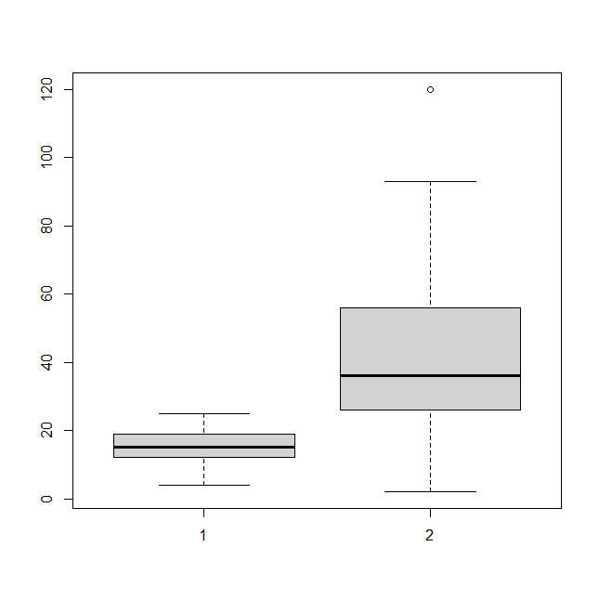**

**Code:-**

**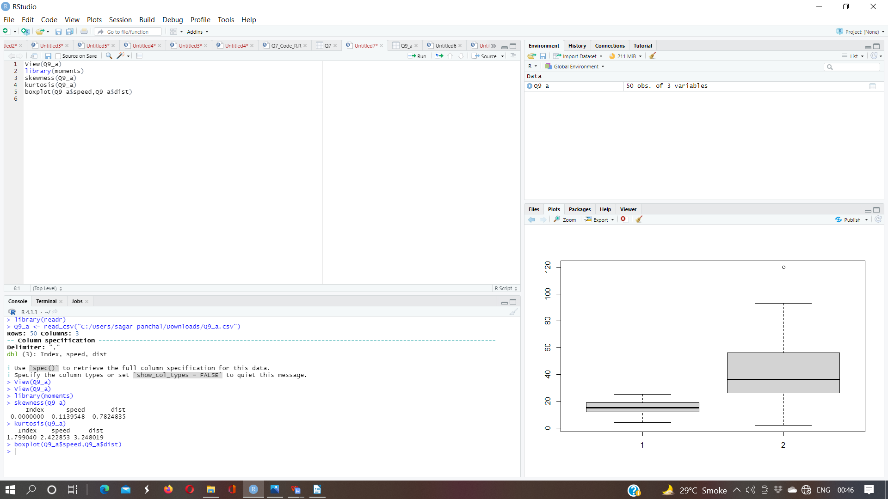**

1. **SP and Weight**

|  |  |  |
| --- | --- | --- |
|  | SP | WT |
| 1 | 104.1853528 | 28.7620589 |
| 2 | 105.4612635 | 30.46683298 |
| 3 | 105.4612635 | 30.19359657 |
| 4 | 113.4612635 | 30.63211391 |
| 5 | 104.4612635 | 29.88914864 |
| 6 | 113.1853528 | 29.59176832 |
| 7 | 105.4612635 | 30.30847957 |
| 8 | 102.5985128 | 15.84775807 |
| 9 | 102.5985128 | 16.35948352 |
| 10 | 115.6452041 | 30.92015417 |
| 11 | 111.1853528 | 29.36334142 |
| 12 | 117.5985128 | 15.75353468 |
| 13 | 122.1050553 | 32.81359241 |
| 14 | 111.1853528 | 29.3784363 |
| 15 | 108.1853528 | 29.34727902 |
| 16 | 111.1853528 | 29.60452658 |
| 17 | 114.3692933 | 29.5357836 |
| 18 | 117.5985128 | 16.19412154 |
| 19 | 114.3692933 | 29.92939368 |
| 20 | 118.4729364 | 33.51697417 |
| 21 | 119.1050553 | 32.32464971 |
| 22 | 110.8408174 | 34.90821127 |
| 23 | 120.2889958 | 32.6758277 |
| 24 | 113.8291446 | 31.83712236 |
| 25 | 119.1853528 | 28.78172789 |
| 26 | 114.5985128 | 16.04317492 |
| 27 | 120.7605199 | 38.06282335 |
| 28 | 119.1050553 | 32.83506939 |
| 29 | 99.56490661 | 34.4832075 |
| 30 | 121.8408174 | 35.54935984 |
| 31 | 113.4846092 | 37.04235003 |
| 32 | 112.2889958 | 33.23436141 |
| 33 | 119.9211148 | 31.38004084 |
| 34 | 121.3926389 | 37.57328965 |
| 35 | 111.2889958 | 32.701644 |
| 36 | 115.0130851 | 31.9112234 |
| 37 | 114.0933825 | 28.75400008 |
| 38 | 116.909442 | 27.87991549 |
| 39 | 116.909442 | 28.63050247 |
| 40 | 128.4612635 | 30.11543403 |
| 41 | 116.3926389 | 37.39252442 |
| 42 | 115.7488471 | 35.02717556 |
| 43 | 117.4612635 | 30.52742698 |
| 44 | 114.0933825 | 28.34397592 |
| 45 | 114.3809661 | 33.07863163 |
| 46 | 117.1050553 | 32.62191589 |
| 47 | 118.2086984 | 36.49861738 |
| 48 | 116.4729364 | 33.91005598 |
| 49 | 127.909442 | 28.07059654 |
| 50 | 118.2889958 | 33.45847152 |
| 51 | 118.2889958 | 33.21395395 |
| 52 | 118.2889958 | 33.43671117 |
| 53 | 120.4043117 | 40.39816357 |
| 54 | 143.3926389 | 37.62069475 |
| 55 | 135.3926389 | 37.25439197 |
| 56 | 126.4043117 | 40.58906845 |
| 57 | 110.4612635 | 30.14754329 |
| 58 | 118.2889958 | 32.73451818 |
| 59 | 112.6452041 | 30.61528334 |
| 60 | 115.5765794 | 37.66287367 |
| 61 | 130.2086984 | 36.88815313 |
| 62 | 117.6685497 | 37.86041143 |
| 63 | 126.0481035 | 43.3909885 |
| 64 | 125.3123415 | 40.72283115 |
| 65 | 128.128401 | 40.15948186 |
| 66 | 126.5985128 | 15.71285853 |
| 67 | 132.4846092 | 37.97995604 |
| 68 | 133.6802225 | 41.57397476 |
| 69 | 133.3123415 | 40.47204238 |
| 70 | 158.3006687 | 37.14173328 |
| 71 | 164.5985128 | 15.82306042 |
| 72 | 133.4159845 | 44.01313857 |
| 73 | 133.1400738 | 43.35312292 |
| 74 | 124.7152409 | 52.99775236 |
| 75 | 121.864163 | 42.61869847 |
| 76 | 132.864163 | 42.77821864 |
| 77 | 169.5985128 | 16.13294744 |
| 78 | 150.5765794 | 37.92311321 |
| 79 | 151.5985128 | 15.76962542 |
| 80 | 167.9444604 | 39.42309899 |
| 81 | 139.8408174 | 34.94861469 |

|  |  |  |
| --- | --- | --- |
|  | **skewness** | **kurtosis** |
| **SP** | **1.581454** | **5.723521** |
| **Weight** | **-0.6033099** | **3.819466** |

**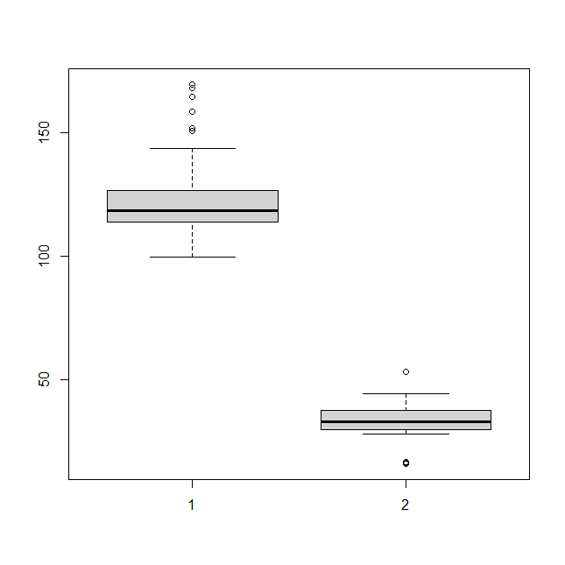**

**Code:-**

**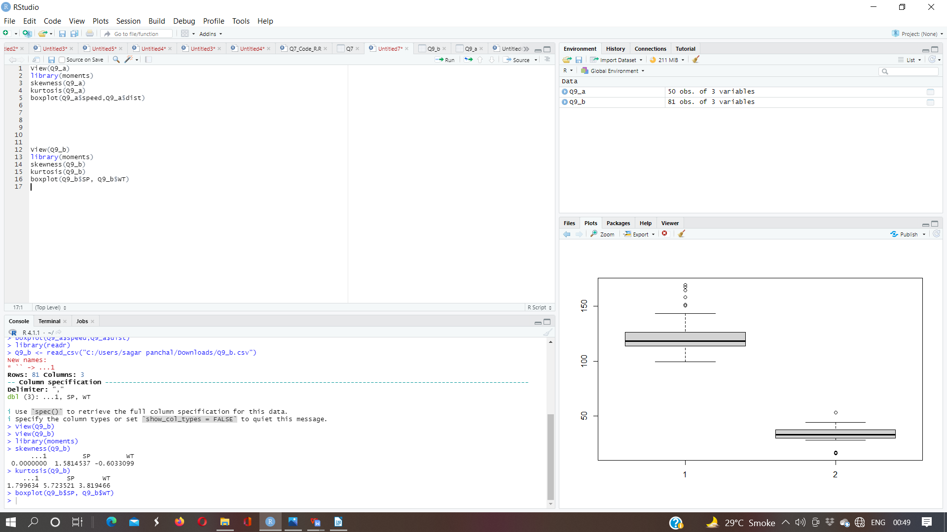**

**Q10) Draw inferences about the following boxplot & histogram**





Answer:-

10.a

(1) The distribution of data is right skewed or positive skewed and most of the data lie on the right side

(2) Majority of chick are having weight less than 200

(3) The most of the data points are connected in the range 50-100 and lest range in 0-10 are in 400

(4) The man in the case of distribution will be greater than the median

10.b

1. The above boxplot we can see that are outliers beyond the upper extreme.
2. The boxplot is skewed right and most of the data is concentrade in the lower quartike

**Q11)** Suppose we want to estimate the average weight of an adult male in Mexico. We draw a random sample of 2,000 men from a population of 3,000,000 men and weigh them. We find that the average person in our sample weighs 200 pounds, and the standard deviation of the sample is 30 pounds. Calculate 94%,98%,96% confidence interval?

Answer:-

X+/-(Z1- α. σ/sqrt(n)

Degrees of freedom= 2000-1= 1999

Confidence interval= 94%

(1- σ/2)= 1-0.03) =0.97

for confidene interval for 94% is 1.882

Confidence interval for 98%= 2.33

Confidence interval for 96% = 2.05

**Q12)** Below are the scores obtained by a student in tests

**34,36,36,38,38,39,39,40,40,41,41,41,41,42,42,45,49,56**

1. Find mean, median, variance, standard deviation.
2. What can we say about the student marks?

Answer:-

(1)

|  |  |
| --- | --- |
| mean | 41.00 |
| median | 40.50 |
| variance | 25.5294117647059 |
| Standard deviation | 5.05266382858645 |

1. The average marks obtained by student in test is 41 and we can say that student is maintaining his/her marks around 41 as deviation is very less

Q13) What is the nature of skewness when mean, median of data are equal?

Answer:- symmetrical distribution

Q14) What is the nature of skewness when mean > median ?

Answer:- Right skewed distribution

Q15) What is the nature of skewness when median > mean?

Answer:- Left Skewed

Q16) What does positive kurtosis value indicates for a data ?

Answer:- A distribution with a positive kurtosis value indicates that the distribution has heavier tails than the normal distribution.

Q17) What does negative kurtosis value indicates for a data?

Answer:- A distribution with a negative kurtosis value indicates that the distribution has lighter tails than the normal distribution.

Q18) Answer the below questions using the below boxplot visualization.



1. What can we say about the distribution of the data?
2. What is nature of skewness of the data?
3. What will be the IQR of the data (approximately)?

Answer:-  
(a) We can say that the distribution of data is not symmetrical. In other words, most of the data lies on the right side or in the upper quartile.

(b) Nature: Data is left skewed or negative skewed.

(c) Approximately= IQR = Q3-Q1

=18-10

=8  
  
Q19) Comment on the below Boxplot visualizations?



Draw an Inference from the distribution of data for Boxplot 1 with respect Boxplot 2.

Answer:-

1. Both the boxplot have uniform distribution and same median.
2. The IQR for boxplot 1 is lower than the IQR for boxplot 2. Hence, the data points in boxplot 1 are consistenly hovered around the central value than in boxplot 2.
3. The range of data of boxplot 1 smaller than the range of data of boxplot 2. Hence, the overall data is widely distributed in boxplot 2 as compared to boxplot 1.
4. There are no outliers present in both the boxplot.

Q 20) Calculate probability from the given dataset for the below cases

Data \_set: Cars.csv

Calculate the probability of MPG of Cars for the below cases.

MPG <- Cars$MPG

* 1. P(MPG>38)
  2. P(MPG<40)
  3. P (20<MPG<50)

Answer:-

1. There are 33 observations in MPG which are greater then 38.
2. There are 61 observations in MPG which are lesser then 40.
3. There are 69 observations in MPG which are lgreater then 20 & there are 81 observations in MPG which lesser then 50. (69/81)

**Code:-**

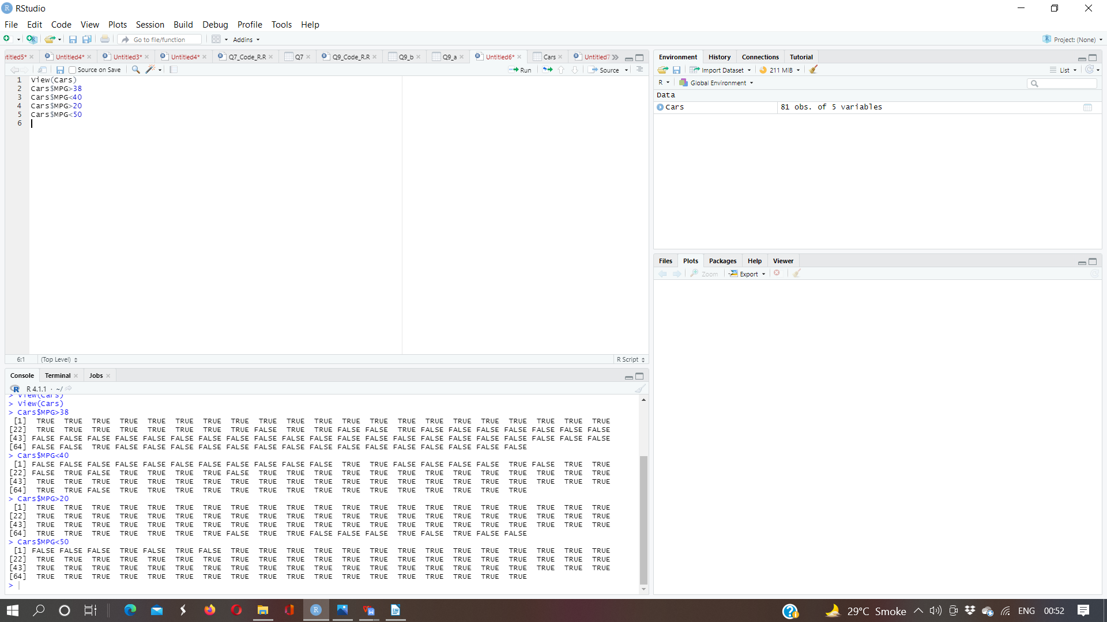

Q 21) Check whether the data follows normal distribution

1. Check whether the MPG of Cars follows Normal Distribution

Dataset: Cars.csv

1. Check Whether the Adipose Tissue (AT) and Waist Circumference(Waist) from wc-at data set follows Normal Distribution

Dataset: wc-at.csv

Answer:-

1. We can interpret that the data of weight of MPG of cars follows the normal distribution by:
2. Conducting shapiro test(W = 0.98846, p-value = 0.6872)
3. Evaluating kurtosis value which is 2.352262 & skewness value ehich is -0.1746343
4. Finding of mean value (34.42) which is not so far difference from meadian value (35.15 )

1. .(A) We can interpret that the data of waist of WC\_AT of cars follows the normal distribution by:

(1 ) Conducting shapiro test(W = 0.99119, p-value = 0.7087)

(2) Evaluating kurtosis value which is 1.892724 & skewness value ehich 0.1322042

(3) Finding of mean value (91.9) which is not so far difference from meadian value ( 90.8)

b) .(B) We can interpret that the data of AT of WC\_AT of cars follows the normal distribution by:

(1) Conducting shapiro test(W = 0.99352, p-value = 0.891)

(2) Evaluating kurtosis value which is 2.672812 & skewness value ehich is 0.5767897

(3) Finding of mean value (101.89) which is not so far difference from meadian value (96.54)

**Code:-**

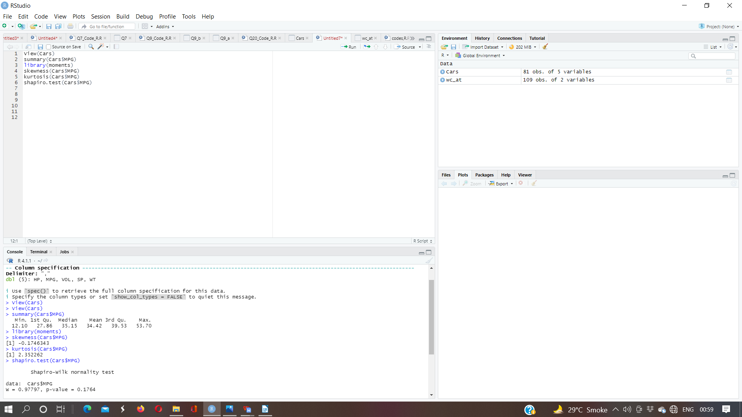

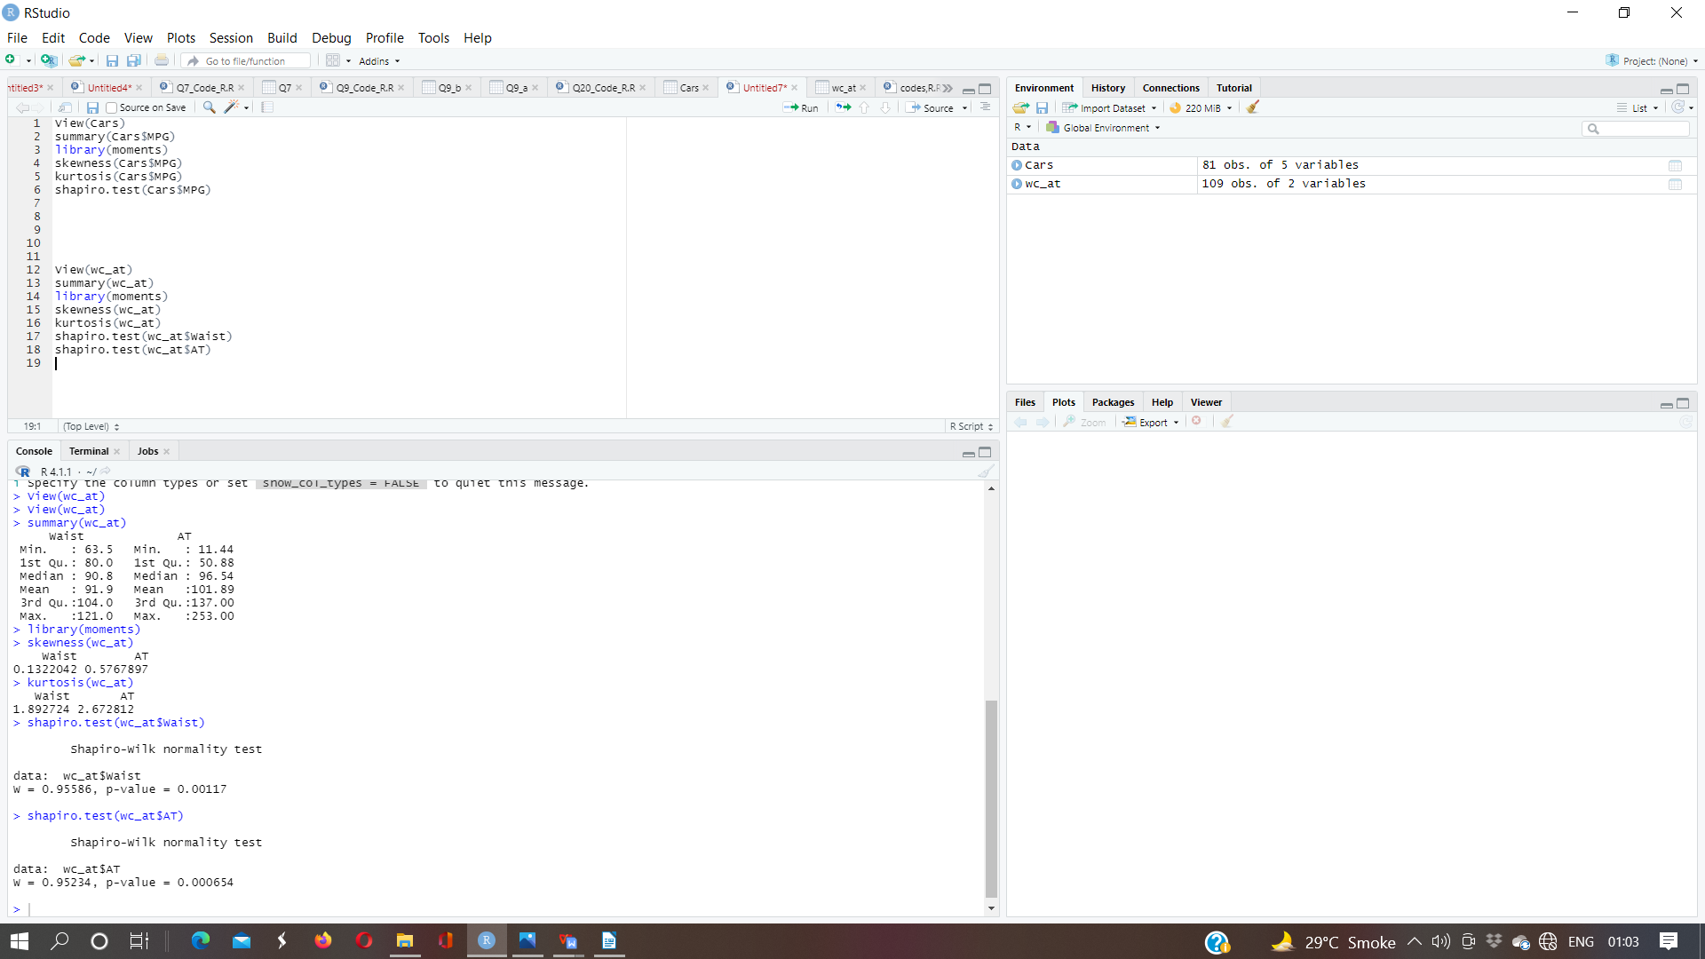

Q 22) Calculate the Z scores of 90% confidence interval,94% confidence interval, 60% confidence interval

Answer:-

Z score of 90% confidence interval is 1.644854

Z score of 94% confidence interval is 1.880794

Z score of 60% confidence interval is 0.8416212

Q 23) Calculate the t scores of 95% confidence interval, 96% confidence interval, 99% confidence interval for sample size of 25

Answer:-

t scores of 95% confidence interval is 1.959964

t scores of 96% confidence interval is 2.053749

t scores of 25% confidence interval is 0.3186394

Q 24**)** A Government company claims that an average light bulb lasts 270 days. A researcher randomly selects 18 bulbs for testing. The sampled bulbs last an average of 260 days, with a standard deviation of 90 days. If the CEO's claim were true, what is the probability that 18 randomly selected bulbs would have an average life of no more than 260 days

Hint:

rcode → pt(tscore,df)

df → degrees of freedom

Answer:-

Mean = 270 days = u

Sample size = 18 = n

Smaple mean = 260 = x

Deviation sample = 90 days =s

Sol:-

IMG_256

t = 260-270/90/sqrt18

t = -10/90/3^2

t = -10/30/2^

t = -1\*2^/3

t = 0.417