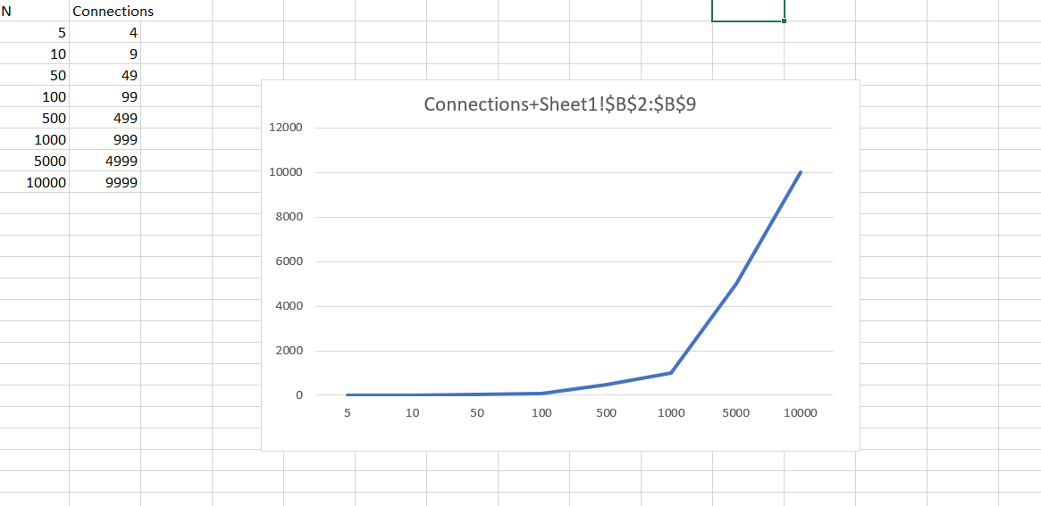

So to conclude, for n inputs, n-1 connections are made.

My theory: for each new value that is introduced by the union find client a pair is formed there are n distinct values to n-1 connections are made.