**FaceApp**

* Faceapp is neural-network face manipulation application for smartphones.
* This gem provides command-line utility and Ruby library to utilize Faceapp API without using smartphone application.
* Faceapp Application is available on Google Play and Apple App Store

**Usage**

* FaceApp is an AI-powered mobile app which allows users to apply a number of transformative filters to uploaded pictures. Want to know what you’d look like as a member of the opposite sex
* Launch **FaceApp**.
* You'll see a live view of your camera with a head-shaped overlay. The overlay disappears when the app detects a face. **Position your face within the overlay**.
* When you've got the framing just right, **tap the shutter button**. FaceApp will immediately begin to process the photo.
* When processing is complete, swipe through the filters and **choose one**. FaceApp will immediately begin to apply the filter.
* Tap the **save button** (looks like an arrow pointing downward toward a line) or tap any of the **share icons** to share your new creation.
* figured you might want to know what some of these filters look like, so I went ahead and asked the iMore team to submit their photos for FaceApp'ing

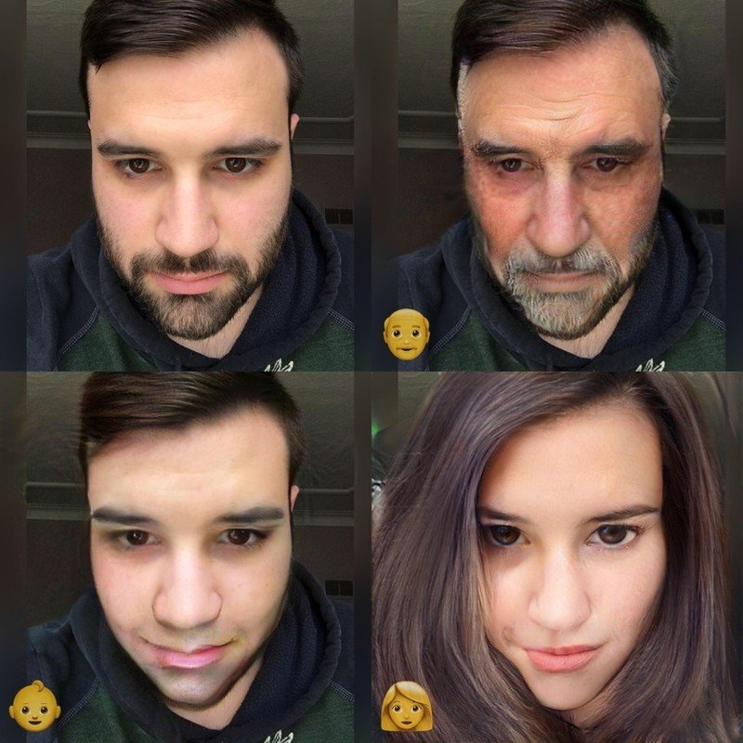

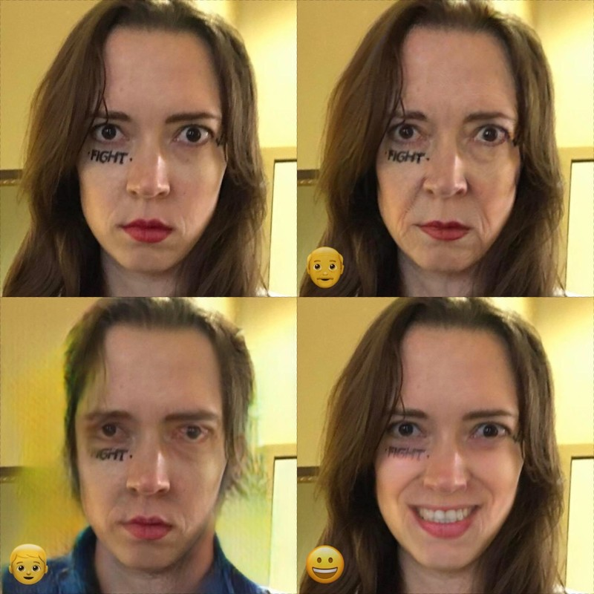

**Installation**

* install it yourself as:

$ gem install faceapp

**Function**

result = client.apply_filter(code, filter,output)

# => StringIO

Parameters:code,filter,output

Returns :a filtered image of a face.

**License**:abc(eg)

**Contact**:ahhdh@gmail.com(eg)