NAME | SHASTRI PANCHAM
COURSE | DIMPLOMA IN CYBERSECURITY
SUBJECT | HARDWARE

Assignment: Desktop PC Hardware and Storage Devices
1. Labelled Diagram of a Desktop PC
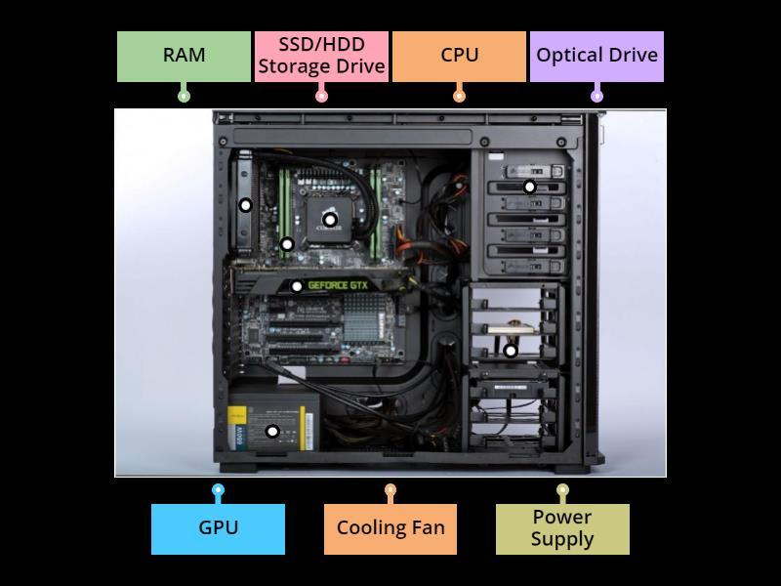
wordwall.net
Main components and their functions:
- Motherboard: The main circuit board that connects all computer components.
- CPU (Central Processing Unit): Executes instructions and performs calculations.
- RAM (Random Access Memory): Temporarily stores data and programs currently in use.
- GPU (Graphics Processing Unit): Processes graphics and renders images for games and applications.
- HDD (Hard Disk Drive): Stores files and applications using rotating magnetic disks.
- SSD (Solid State Drive): Stores the operating system, games, and files using flash memory.
2. Comparison Between HDD and SSD
Feature | HDD | SSD
Speed | Slower read and write speeds | Much faster read and write speeds
Durability | Contains moving mechanical parts and is more vulnerable to physical shocks | Has no moving parts and is generally more shock-resistant
Noise | Produces some mechanical noise | Operates silently
Cost | Usually cheaper per GB | Usually more expensive per GB
Typical use | Large file storage, backups, and budget computers | Operating systems, gaming PCs, laptops, and applications requiring fast loading
Conclusion: An SSD is better for speed and durability, while an HDD is useful for storing large amounts of data at a lower cost.
3. Role of CPU, RAM, and GPU in Gaming
A. CPU (Central Processing Unit)
The CPU processes game instructions, player movements, game logic, and other calculations. In games such as PUBG, it also helps manage physics, artificial intelligence, and communication with other players.
B. RAM (Random Access Memory)
RAM temporarily stores the game data and other information that the computer needs while the game is running. Having sufficient RAM helps reduce slowdowns and stuttering when switching between applications or loading game assets.
C. GPU (Graphics Processing Unit)
The GPU renders graphics, textures, lighting, and visual effects displayed on the monitor. A powerful GPU helps games run at higher resolutions and frame rates, providing smoother gameplay.
4. Hardware Upgrades to Run the Latest FIFA Smoothly
To improve gaming performance, I would consider the following upgrades:
Component | Recommended upgrade | Reason
GPU | Upgrade to a suitable modern graphics card | Improves graphics quality, frame rates, and rendering performance.
CPU | Upgrade to a compatible, faster processor if needed | Improves game logic processing and helps maintain stable frame rates.
RAM | Upgrade to at least 16 GB if the current system has less | Provides enough memory for modern games and background applications.
SSD | Install the game on an SSD | Reduces loading times and speeds up game startup.
Power supply (PSU) | Upgrade if required by the new GPU | Provides sufficient and reliable power to the upgraded components.
Cooling system | Improve CPU or case cooling if temperatures are high | Helps prevent thermal throttling during long gaming sessions.
Conclusion: I would first check the game's system requirements and my current PC specifications. I would prioritize the GPU, CPU, and sufficient RAM for gaming performance, while using an SSD to improve loading times. All upgrades must be compatible with the motherboard and power supply.

