NAME | SHASTRI PANCHAM
COURSE | DIMPLOMA IN CYBERSECURITY
SUBJECT | HARDWARE

important.
Assignment: Desktop PC Components, Disassembly, Reassembly, and Safety
1. Main Components Inside a Desktop PC
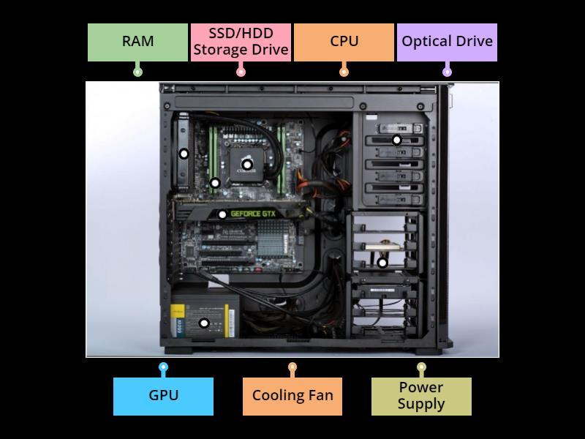
wordwall.net
No. | Component | Description
1 | Motherboard | The main circuit board that connects the CPU, RAM, storage, GPU, and other components.
2 | CPU (Processor) | Executes instructions and performs calculations required to run programs.
3 | RAM | Temporarily stores data and instructions currently being used by the computer.
4 | HDD | Stores the operating system, software, and files on magnetic disks.
5 | SSD | Stores data using flash memory and usually provides faster access than an HDD.
6 | GPU (Graphics Card) | Processes graphics for gaming, video editing, and display output.
7 | Power Supply Unit (PSU) | Converts AC power from the wall outlet into DC power required by computer components.
8 | CPU Cooler | Uses a heatsink and fan, or a liquid-cooling system, to prevent the processor from overheating.
9 | Case Fans | Circulate air through the cabinet to remove hot air and improve cooling.
10 | Network Interface | Provides a wired Ethernet or wireless network connection, depending on the hardware installed.
11 | Sound Hardware | Processes audio input and output; it is usually integrated into the motherboard.
12 | CMOS Battery | Supplies power to maintain the motherboard's real-time clock and certain firmware settings.
13 | SATA Data Cables | Connect compatible HDDs and SSDs to motherboard SATA ports.
14 | Expansion Cards | Add extra functions, such as Wi-Fi, additional USB ports, or professional audio.
15 | Cabinet/Chassis | Holds and protects the components and provides mounting points and airflow paths.
2. Desktop PC Disassembly Procedure
Use the following steps to organize your practical document. Add your own photographs at each stage if you have access to a desktop PC.
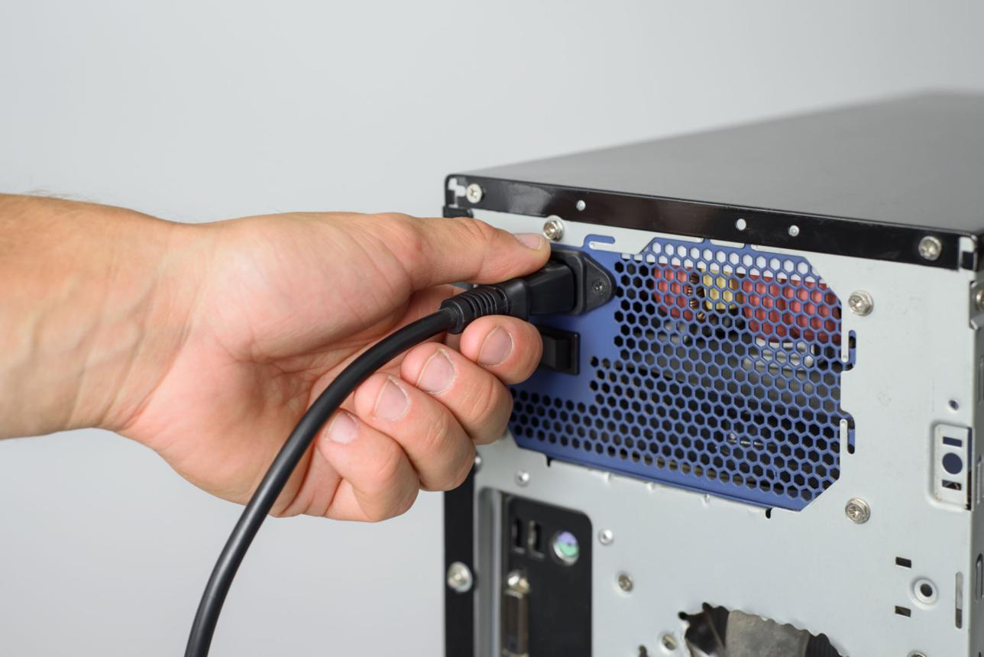
Step 1: Disconnect the power
Shut down the computer, unplug the power cable, and disconnect all external devices. This reduces the risk of electric shock and hardware damage.
Caption: The PC is disconnected from its power source before opening.
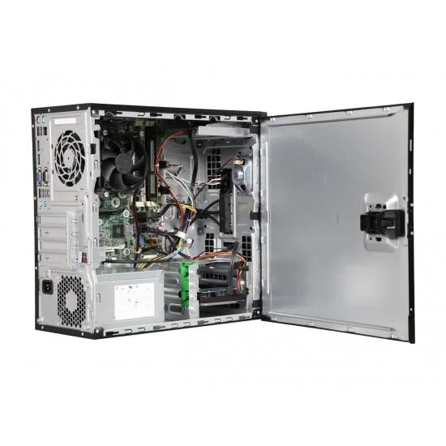
Step 2: Remove the side panel
Unscrew the cabinet's side panel and carefully slide or lift it away to access the internal components.
Caption: The side panel is removed to expose the motherboard and components.
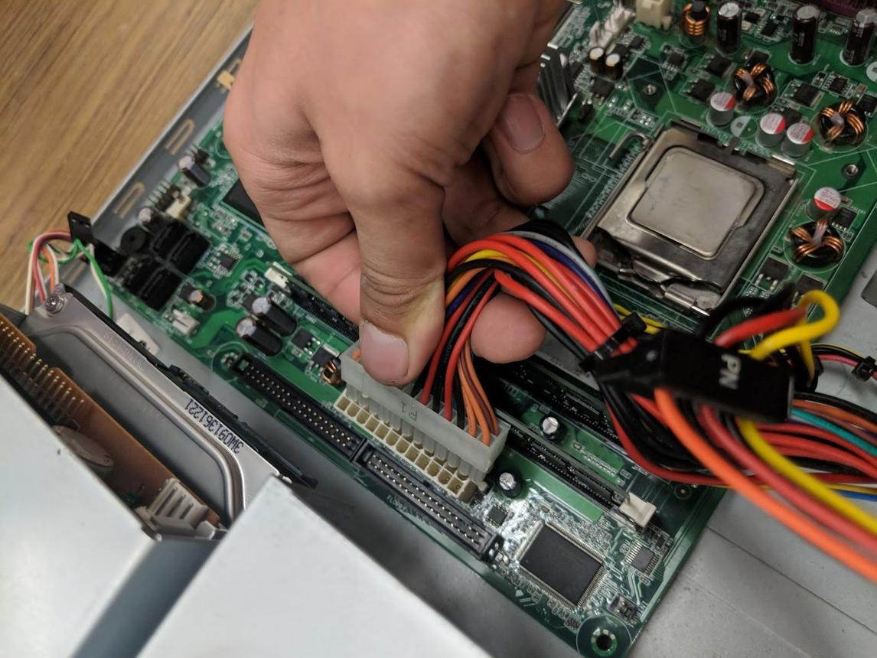
Step 3: Disconnect internal cables
Photograph cable connections first. Disconnect the motherboard power connectors, storage cables, and other necessary connectors by their plugs, not by pulling the wires.
Caption: Internal cables are carefully disconnected before component removal.
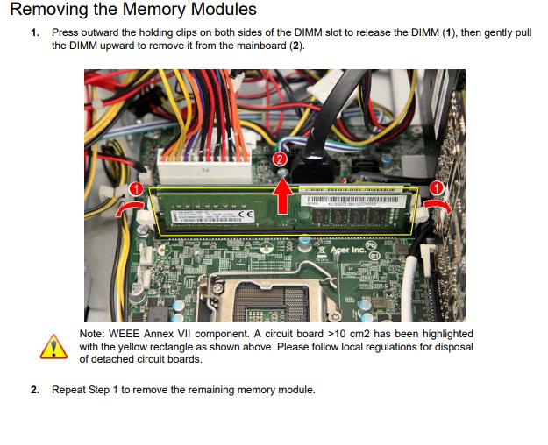
Step 4: Remove the RAM
Release the retaining clips and remove each RAM module by its edges. Store the modules in an antistatic bag.
Caption: RAM modules are removed carefully from their motherboard slots.
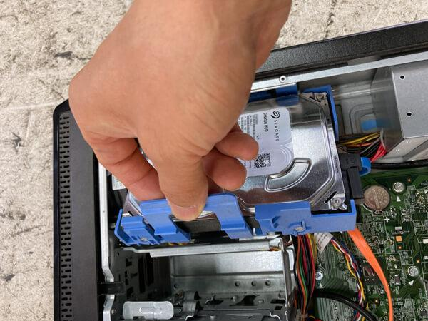
Step 5: Remove the storage drive
Disconnect its data and power cables, remove the mounting screws or release the drive tray, and take out the HDD or SATA SSD. An M.2 SSD must be removed according to its slot's instructions.
Caption: The storage device is disconnected and removed from its mounting position.
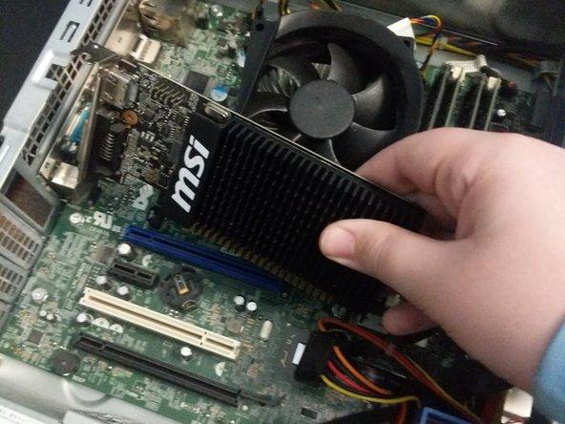
Step 6: Remove the graphics card and other expansion cards
Disconnect any power cables, remove the bracket screws, release the PCIe slot latch, and carefully lift the card out.
Caption: The expansion card is removed after its power and mounting connections are released.
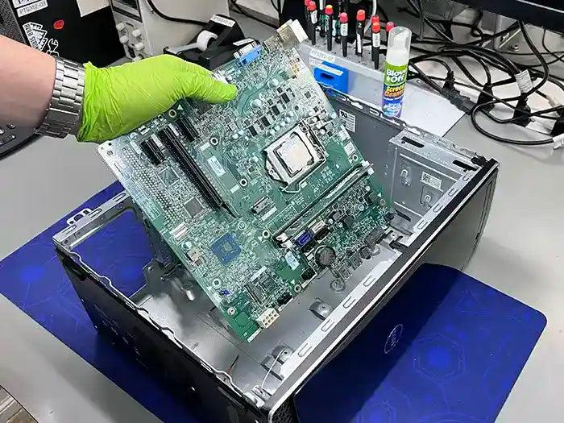
Step 7: Remove the motherboard
Disconnect any remaining attached cables and remove the motherboard mounting screws. Lift the board out carefully, ensuring it does not catch on the case.
Caption: The motherboard is removed and placed on a suitable antistatic surface.
Important: These are reference images, not photographs of your own disassembly. If you are completing this as a practical assignment, take your own photos at each stage where possible. Do not remove the CPU cooler or processor unless the task specifically requires it.
3. Desktop PC Reassembly Procedure
Reassembly generally follows the reverse order of disassembly, but the motherboard and power supply connections should be checked carefully before starting the computer.
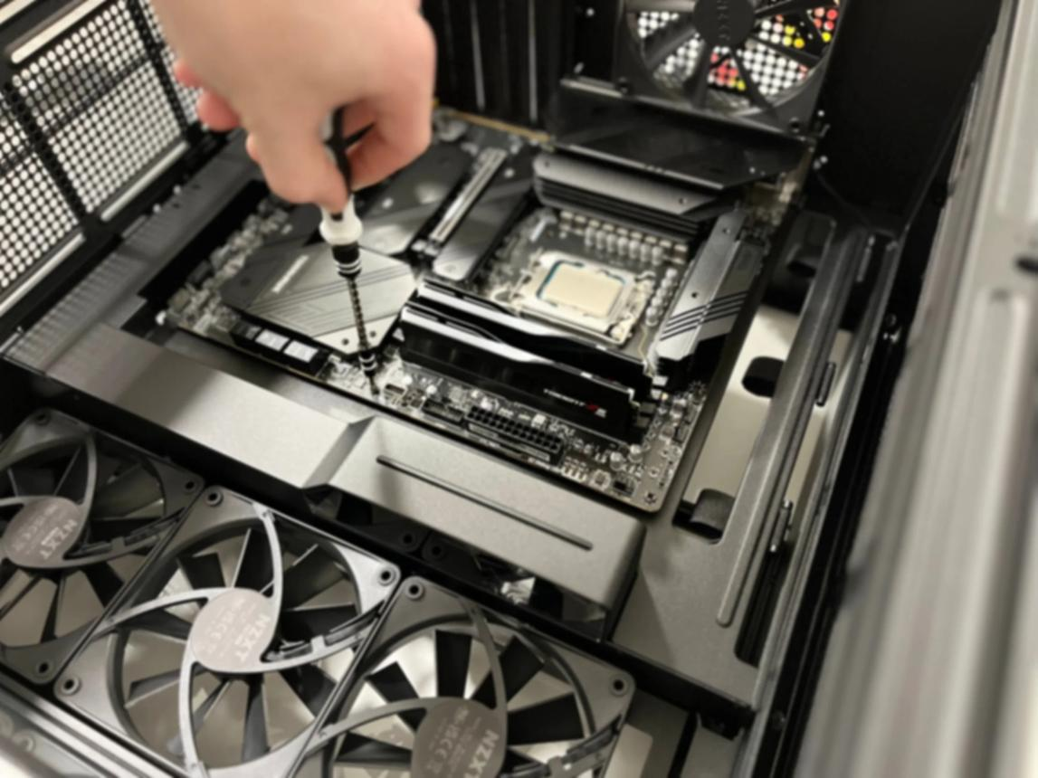
Step 1: Install the motherboard
Position the motherboard correctly on its standoffs and tighten the screws gently. This provides a secure base for the other components.
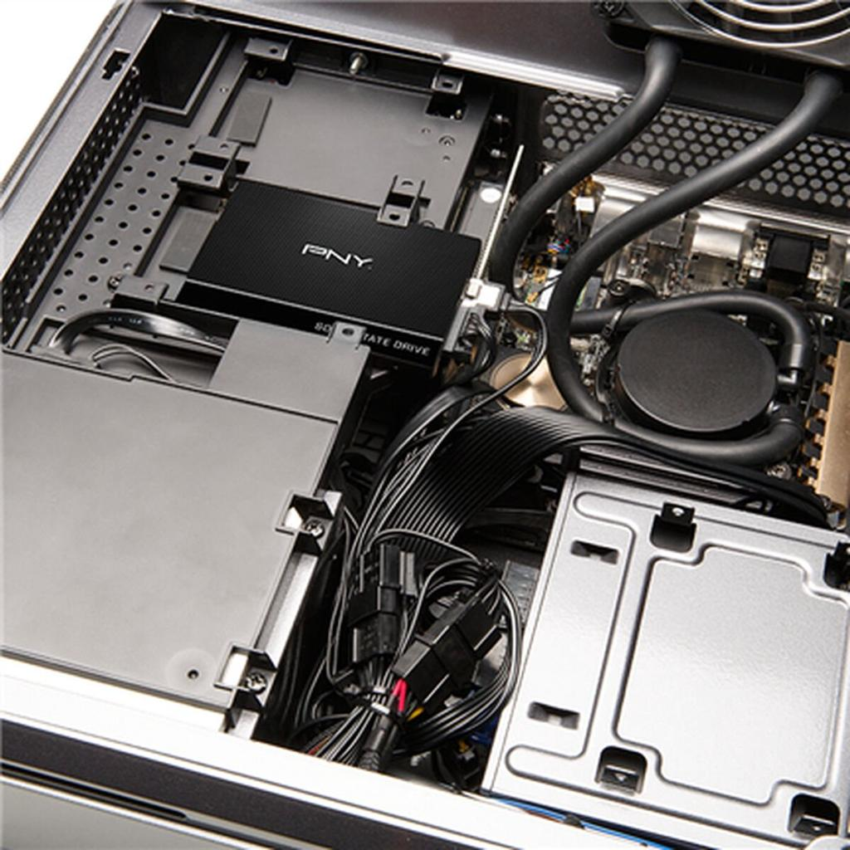
Step 2: Install the storage drive
Secure the HDD or SSD in its bay or slot and reconnect the required data and power connections. The computer needs storage to access its operating system and files.
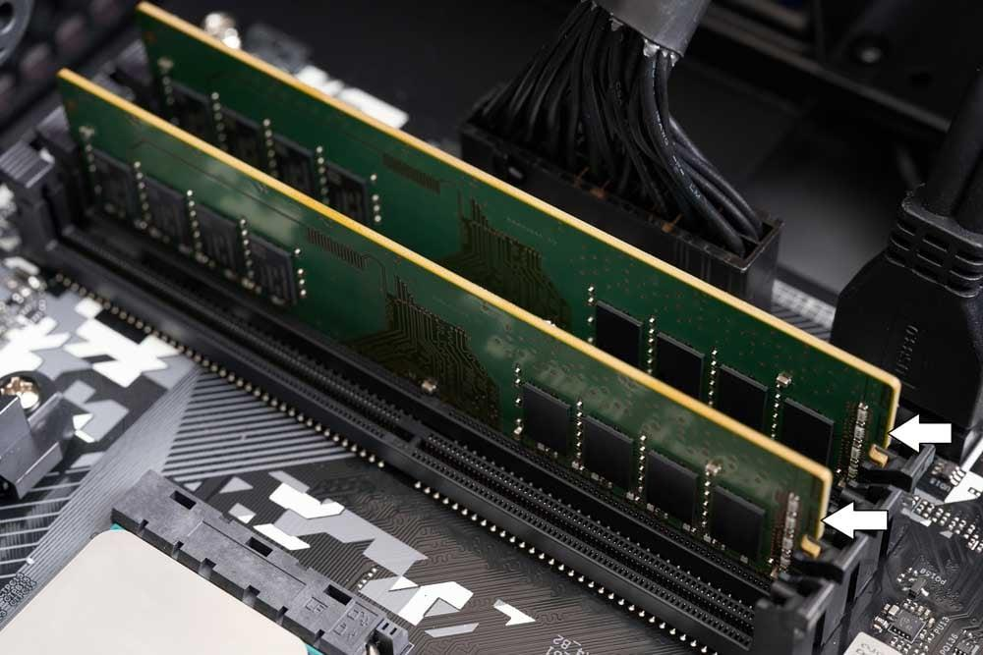
Step 3: Install RAM
Align each module's notch with the slot and press it into place until the retaining clips engage. Correct installation allows the computer to detect and use its memory.
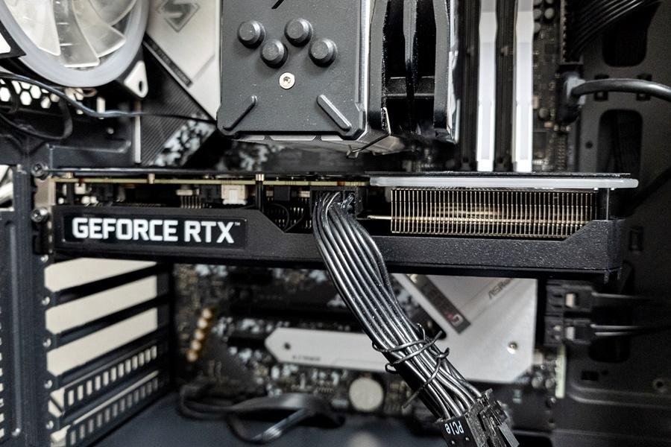
Step 4: Reinstall expansion cards
Insert the graphics card or other expansion cards into the correct slots and secure their brackets. Reconnect any required GPU power cables.
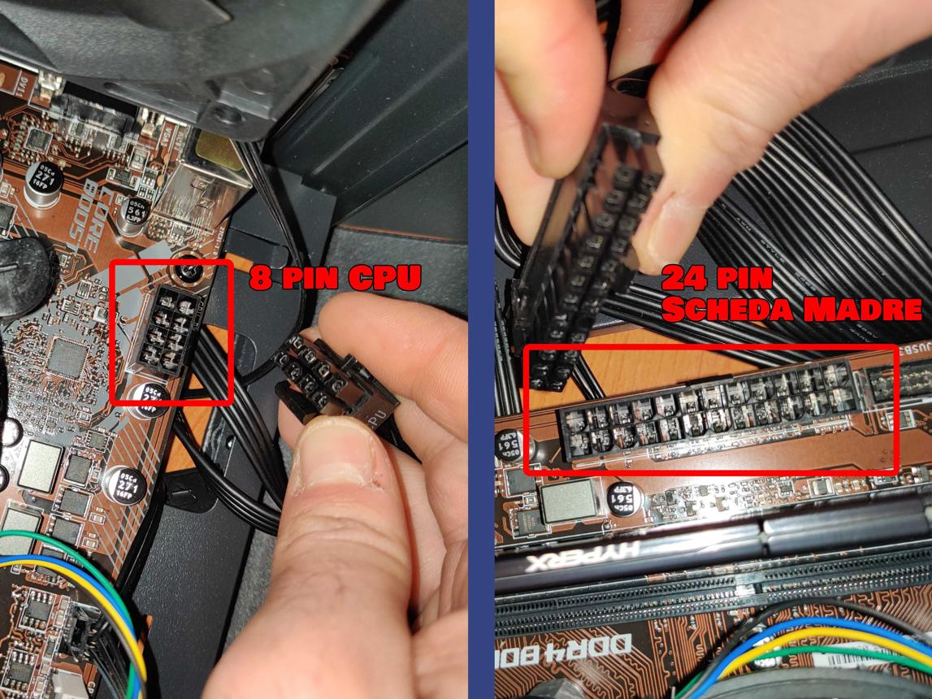
Step 5: Reconnect all cables
Reconnect the motherboard's main power connector, CPU power connector, storage cables, case connectors, and fans. These connections are necessary for the components to function correctly.
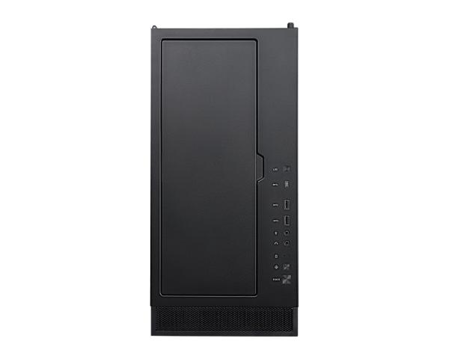
Step 6: Close the cabinet and test
Check that no tools or loose screws remain inside. Refit the side panel, reconnect external devices and power, then start the PC and verify that it boots successfully.
Why does the order matter? Installing and securing the motherboard first provides a stable base. Storage, RAM, and expansion cards can then be installed without obstructing access, followed by cable connections and final checks. This reduces the risk of damaging components or leaving connections loose.
4. Safety Precautions and Required Tools
Tools required
Tool or item | Purpose
Phillips-head screwdriver | Removes and tightens most cabinet and motherboard screws.
Antistatic wrist strap | Helps protect components from static electricity.
Small screw container | Keeps screws organized and prevents them from getting lost.
Flashlight | Helps locate connectors and screws inside the cabinet.
Phone or camera | Records each disassembly and reassembly step.
Antistatic work surface | Provides a safer surface for handling sensitive electronic components.
Conclusion
Desktop PC disassembly and reassembly require care, correct tools, and an understanding of each component's function. Following a systematic procedure, recording photographs, and observing antistatic precautions helps prevent hardware damage. After reassembly, the final step is to verify that the PC powers on, detects its RAM and storage, and boots normally.

