NAME | SHASTRI PANCHAM
COURSE | DIMPLOMA IN CYBERSECURITY
SUBJECT | HARDWARE

Assignment: RAM and Storage Devices
1. Comparison of DDR3, DDR4, and DDR5 RAM
Feature | DDR3 RAM | DDR4 RAM | DDR5 RAM
Data transfer speed | Typically 800–2133 MT/s | Typically 1600–3200 MT/s | Typically 4800–8400+ MT/s
Operating voltage | 1.5 V (typically) | 1.2 V | 1.1 V
Performance | Lower speed and bandwidth | Better speed and efficiency than DDR3 | Higher bandwidth and improved efficiency
Capacity | Commonly 2–8 GB per module | Commonly 4–32 GB per module | Commonly 8–48 GB or more per module
Typical use cases | Older desktops and laptops | Many mainstream desktops and laptops | Newer desktops, laptops, and high-performance systems
Compatibility | Requires a DDR3-compatible motherboard | Requires a DDR4-compatible motherboard | Requires a DDR5-compatible motherboard
Conclusion: DDR5 offers higher bandwidth and improved efficiency compared with DDR4 and DDR3. However, RAM generations are physically and electrically different, so the motherboard must support the selected RAM type.
2. Locating and Installing a RAM Module
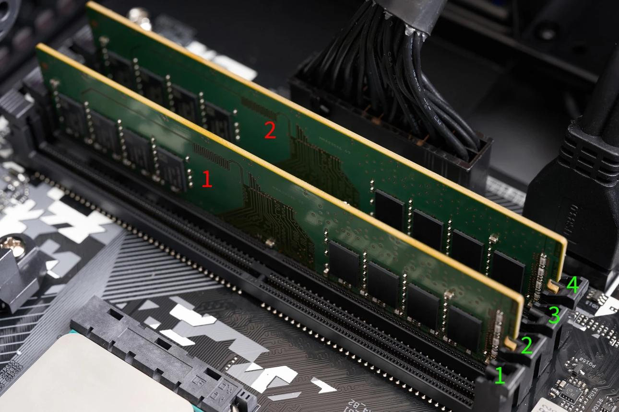
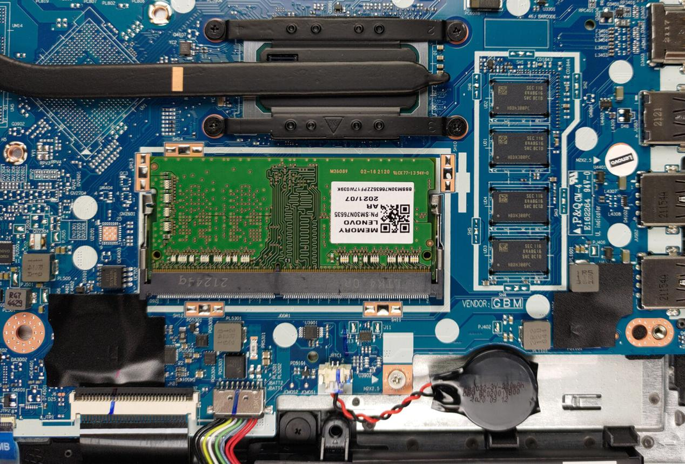
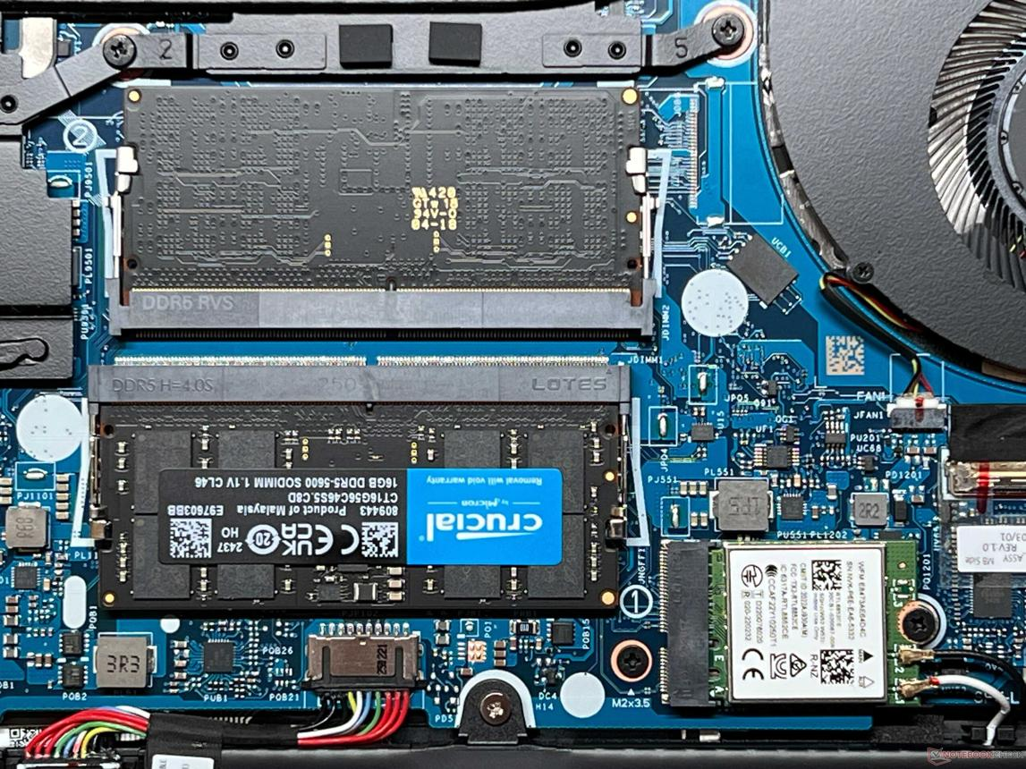
7
Procedure:
- Shut down the computer and disconnect its power cable. For a laptop, follow the manufacturer's instructions for disconnecting the battery if possible.
- Open the computer case or the service panel, following the device manual.
- Locate the RAM slots on the motherboard.
- Take a clear photograph of the installed RAM module and its slot.
- If removal is required, release the retaining clips (for a desktop DIMM) or carefully follow the laptop's SODIMM removal instructions.
- Align the notch on the RAM module with the slot and reinstall it correctly. Do not force it.
- Close the case, reconnect power, and start the computer.
- Verify that the computer boots successfully and that the installed memory is detected in BIOS/UEFI or the operating system.
Observation: Attach your own photograph of the installed RAM module here and record whether the computer booted successfully.
Safety note: If you are unfamiliar with opening your device, do not remove the RAM. Use the manufacturer's service manual or ask a qualified technician for assistance.
3. Comparison of HDD, SSD, and NVMe Storage
Feature | HDD | SATA SSD | NVMe SSD
Full form | Hard Disk Drive | Solid-State Drive | Non-Volatile Memory Express SSD
Technology | Rotating magnetic disks | Flash memory | Flash memory using the PCIe interface
Typical speed | Around 80–160 MB/s | Around 450–550 MB/s | Commonly 1,500–7,000+ MB/s, depending on the drive
Moving parts | Yes | No | No
Cost per GB | Usually lowest | Higher than HDD | Often higher than HDD; varies by model
Best use case | Large files, backups, photos, and videos | Everyday applications and general computing | Fast booting, gaming, software development, and large file transfers
Note: Speeds are approximate and depend on the specific drive, interface, and system.
Daily apps and their suitable storage
- HDD — Photos and video archives: Suitable for storing large collections of photos, videos, and backups at a relatively low cost.
- SATA SSD — Google Chrome: Helps the operating system and browser launch faster than on a typical HDD.
- NVMe SSD — Video games or Android Studio: Provides high data-transfer speeds that can reduce game loading times and speed up large project builds or file operations.
Conclusion: HDDs are economical for bulk storage, SATA SSDs offer a noticeable everyday speed improvement, and NVMe SSDs provide higher performance for demanding workloads.
4. Identifying and Reinstalling a Storage Drive
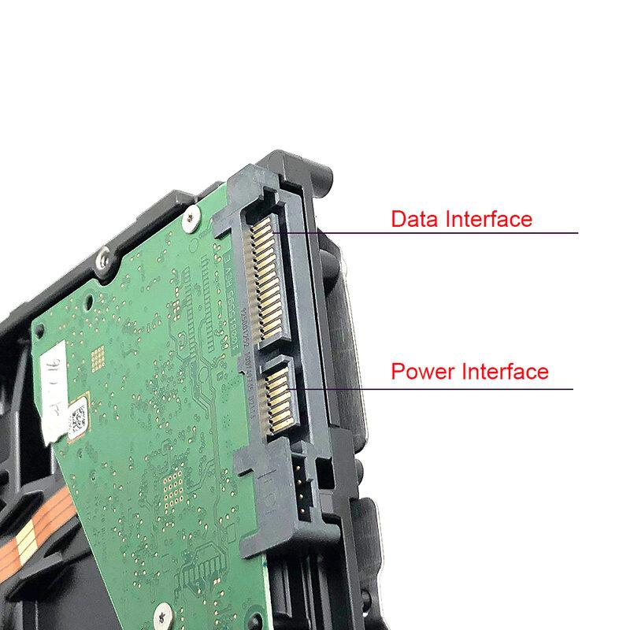
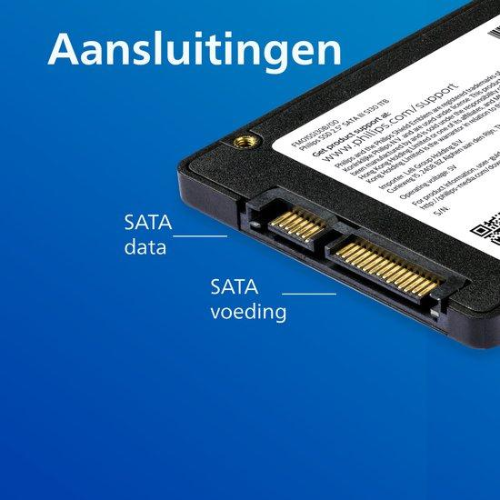
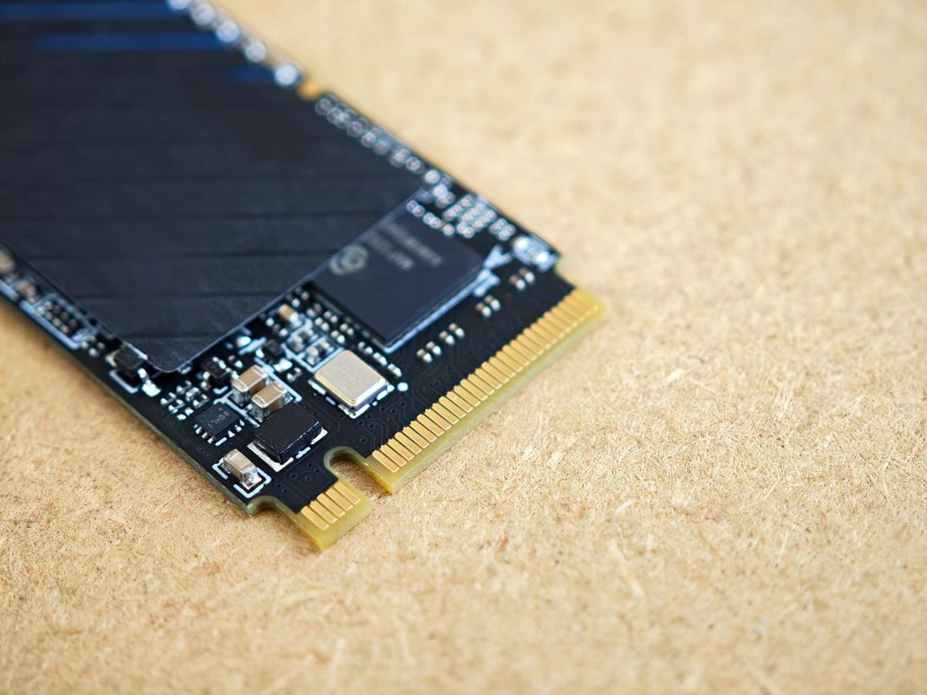
Common storage connector types
Connector | How to identify it
SATA | A 2.5-inch SSD or 3.5-inch HDD usually has two separate L-shaped connectors for data and power.
M.2 SATA | A small, flat circuit-board drive installed directly into an M.2 slot; it uses the SATA protocol.
M.2 NVMe | A small, flat circuit-board drive installed directly into an M.2 slot; it uses the PCIe/NVMe protocol.
Procedure:
- Shut down the computer and disconnect the power supply.
- Consult the manufacturer's service manual before opening the device.
- Locate the storage drive and identify its connector type.
- Take a clear photograph of the drive and connector.
- If you are qualified to do so, remove and reinstall the drive carefully, securing any screws and reconnecting cables as appropriate.
- Reassemble the device and start it.
- Verify that the drive is detected in BIOS/UEFI or the operating system. In Windows, you can check Settings → System → Storage or Disk Management.
Observation: Attach your own photograph of the storage connector and record the drive type and whether the computer recognized it after reassembly.

Final conclusion: RAM temporarily stores data used by running programs, while HDDs and SSDs store files and applications permanently. Choosing compatible RAM and suitable storage improves system performance and reliability.

