NAME | SHASTRI PANCHAM
COURSE | DIMPLOMA IN CYBERSECURITY
SUBJECT | HARDWARE

Assignment: GPU and Cooling Systems
1. Identify the GPU Model
A Graphics Processing Unit (GPU) processes graphics, images, videos, and visual effects. It can be integrated into the processor or installed as a separate graphics card.
Detail | Information
GPU brand | NVIDIA / AMD / Intel
GPU model number | Write the model shown on your computer
GPU type | Integrated or Dedicated
Main function | Rendering graphics, video playback, and gaming
How to check your GPU in Windows:
- Press Ctrl + Shift + Esc to open Task Manager.
- Select the Performance tab.
- Click GPU 0 or GPU 1.
- Write down the GPU name displayed in the top-right corner.
Alternatively, press Win + R, type dxdiag, press Enter, and open the Display tab.
Example only: NVIDIA GeForce RTX 5060 — dedicated GPU. Use the actual model displayed on your computer for your submission.
2. Cooling System: Components and Functions
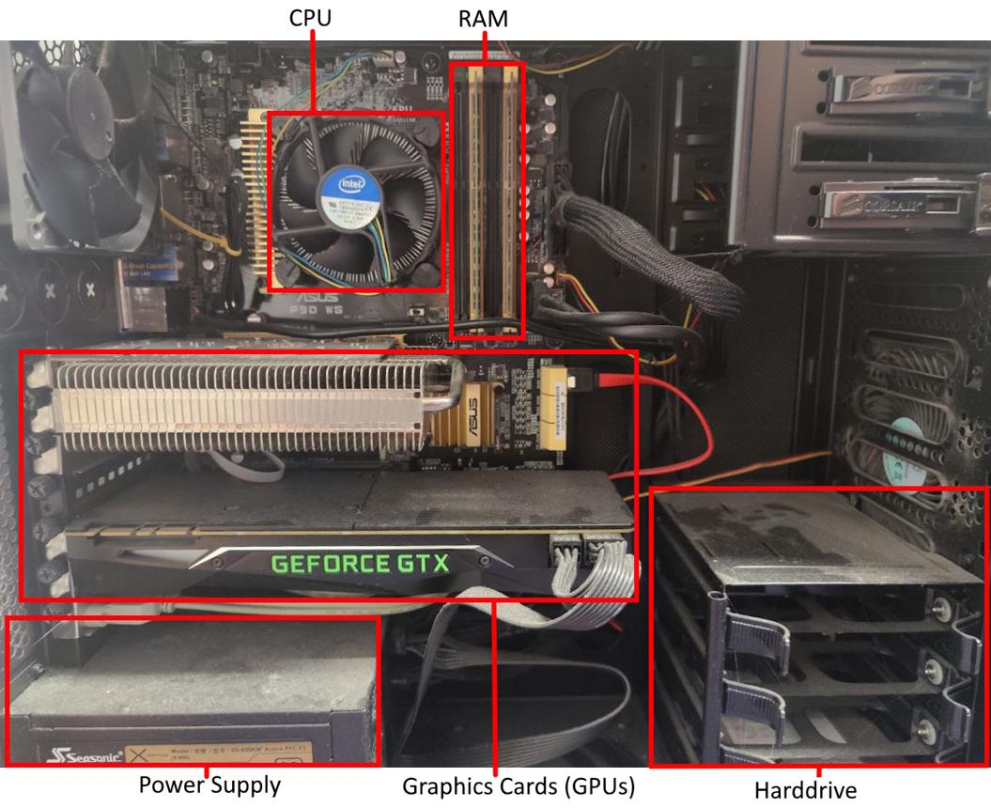

The cooling system removes heat from computer components and helps prevent overheating during gaming and other demanding tasks.
Component | Function
Fan | Moves air over the heatsink to remove heat.
Heatsink | Transfers heat away from the GPU or CPU into metal fins.
Heat pipes | Carry heat from the GPU base to the heatsink fins.
Thermal paste | Improves heat transfer between the GPU chip and cooler.
Case fan | Brings cool air into the case or pushes hot air out.
Photo task: Use a clear photo of your own PC's cooling system or a screenshot from a hardware simulator. Label the fan, heatsink, heat pipes (if visible), and case fan. The image above is a reference, not a photograph of your own computer.
3. Air Cooling vs. Liquid Cooling for GPUs
Factor | Air Cooling | Liquid Cooling
Cost | Usually cheaper | Usually more expensive
Cooling efficiency | Effective for most gaming GPUs | Can provide better heat removal in demanding setups
Maintenance | Mainly cleaning dust from fans and heatsinks | May require pump monitoring and additional maintenance, depending on the system
Noise | Fans may become loud under heavy load | Can be quieter in some setups, though radiator fans and pumps still make noise
Installation | Generally simpler | More complex, especially with custom loops
Risk | No coolant leakage risk | Liquid leaks are possible, though uncommon with properly installed systems
Air cooling is generally simpler and more affordable, while liquid cooling can offer advantages for high-power systems. The result depends on the specific GPU and cooler.

Intel
+2
4. Cooling Choice for a Gaming and IPL Streaming PC
I would choose air cooling for the GPU because a good factory-installed GPU cooler is sufficient for most gaming and video-streaming setups. It is generally less expensive, easier to maintain, and does not have the risk of coolant leakage. I would also install suitable case fans to maintain good airflow. Liquid cooling would be worth considering if I used a very high-power GPU and needed lower temperatures or reduced noise under sustained heavy workloads.

