NAME | SHASTRI PANCHAM
COURSE | DIMPLOMA IN CYBERSECURITY
SUBJECT | HARDWARE

Assignment: ATX Motherboard and CPU Socket Types
1. Labelled Diagram of an ATX Motherboard
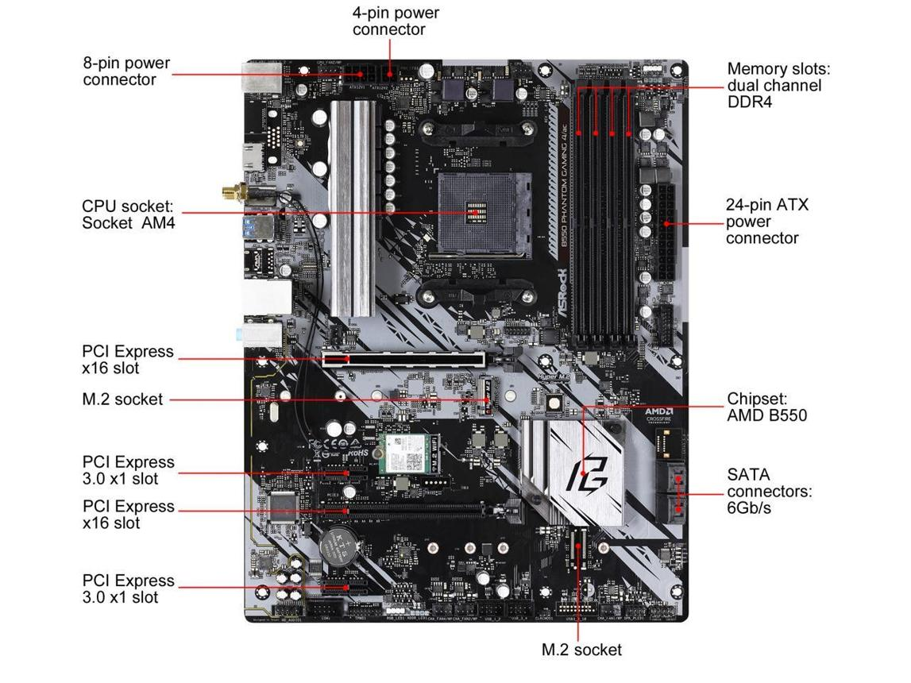
beachaudio.com
An ATX motherboard is the main circuit board of a desktop computer. It connects the CPU, RAM, storage devices, graphics card, power supply, and external peripherals.

Sockets, Slots and Ports
+1
Important parts and their functions:
- CPU socket: Holds the processor.
- RAM slots (DIMM): Hold memory modules used by running programs.
- PCIe x16 slot: Connects a graphics card (GPU).
- PCIe x1 slot: Supports expansion cards such as network or sound cards.
- SATA ports: Connect SATA hard drives and SSDs.
- M.2 slot: Supports compatible M.2 SSDs.
- 24-pin ATX power connector: Supplies main power to the motherboard.
- CPU power connector (4/8-pin): Supplies power to the CPU's voltage regulation circuitry.
- USB header: Connects front-panel USB ports on the computer case.
- Rear I/O ports: Provide external USB, Ethernet, audio, and other connections.
- CMOS battery: Helps maintain the real-time clock and firmware settings when power is off.
- Chipset: Manages communication with various devices and interfaces.
Note: The exact arrangement of components varies between motherboard models.
2. Three Popular CPU Socket Types and Compatible Processors
A CPU socket is the physical connector on a motherboard where the processor is installed. Different socket types support different CPU families.
CPU socket type | Compatible CPU model | Manufacturer
LGA1151 | Intel Core i7-9700 | Intel
AM4 | AMD Ryzen 5 5600 | AMD
LGA1200 | Intel Core i7-10700 | Intel
Sources: Intel's socket compatibility documentation and AMD's Ryzen 5 5600 specifications.

Intel
+2
Note: Socket compatibility alone is not enough. The motherboard chipset and BIOS version must also support the selected processor.
3. Functions of the CPU and Chipset
CPU (Central Processing Unit)
The CPU is the main processor of a computer. It executes program instructions, performs calculations, and manages the operations needed to run applications.
Chipset
The chipset manages communication between the CPU and various motherboard components and interfaces. Depending on the motherboard, it provides connectivity for USB ports, SATA devices, expansion interfaces, and other peripherals.
How they work together when opening Spotify
When I open Spotify, the CPU executes the operating system and Spotify instructions and processes the application's data. The chipset helps provide access to connected storage and peripheral interfaces, while the CPU, memory, network hardware, and audio hardware work together to load the application, stream music, and play sound.
4. Real Motherboard Photo and Identification of Ports and Slots
Use this reference to find a clear motherboard image with labelled components:
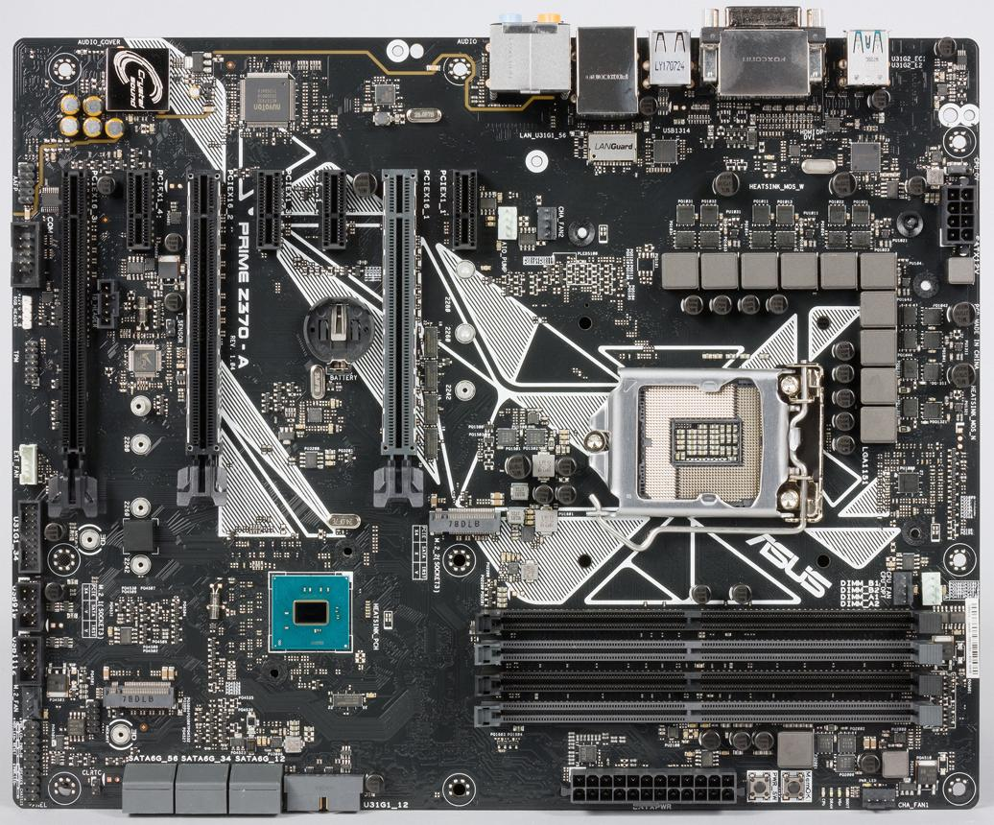
Real motherboard photo references
- Tom's Hardware — Motherboard diagram and components
- Label the Diagram — Motherboard parts
For your assignment, identify and label these five components on the motherboard photo:
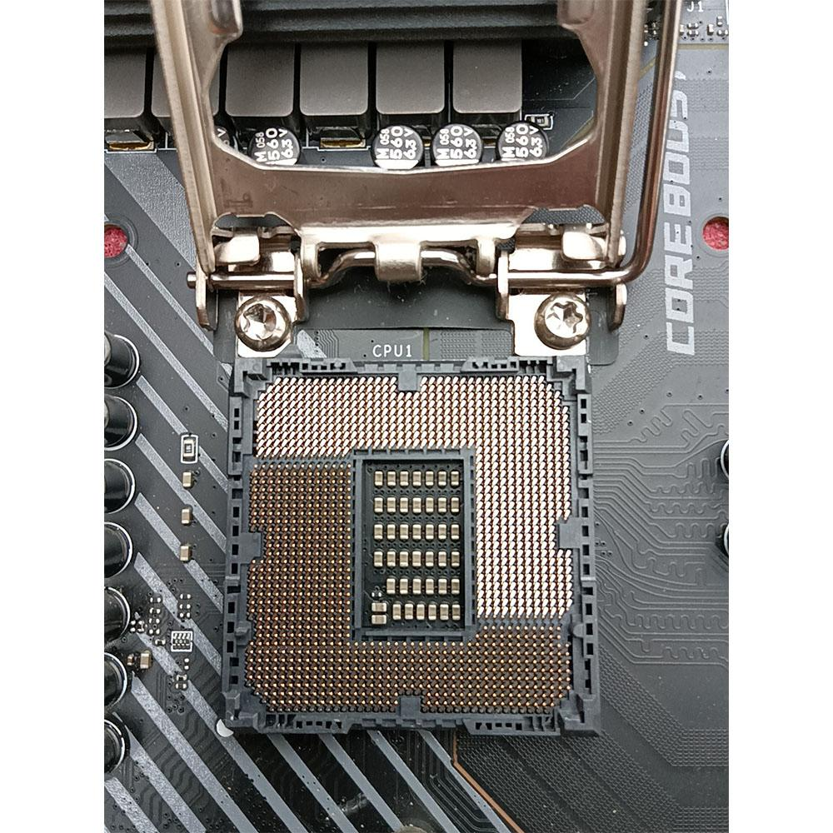
1. CPU socket
The large square socket, usually near the top-centre of the board. It holds the processor.
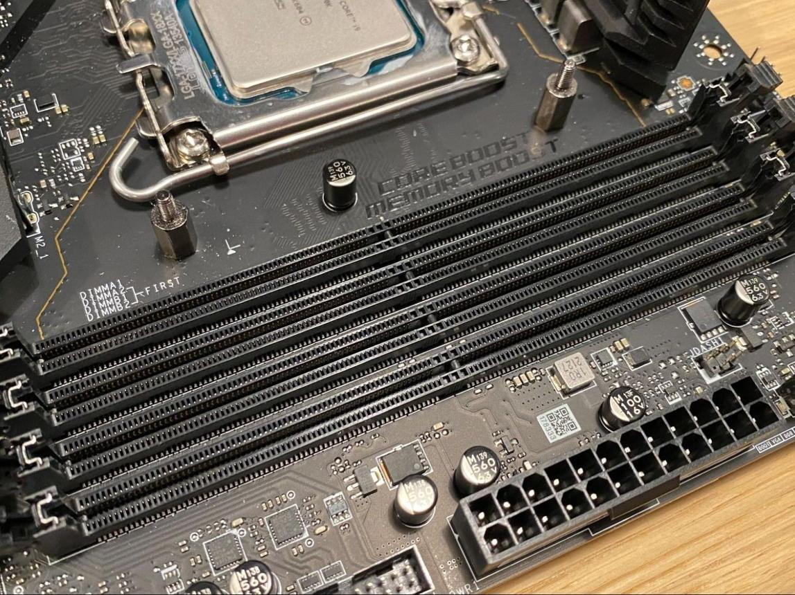
2. RAM slots
Long slots beside the CPU socket where memory modules are installed.
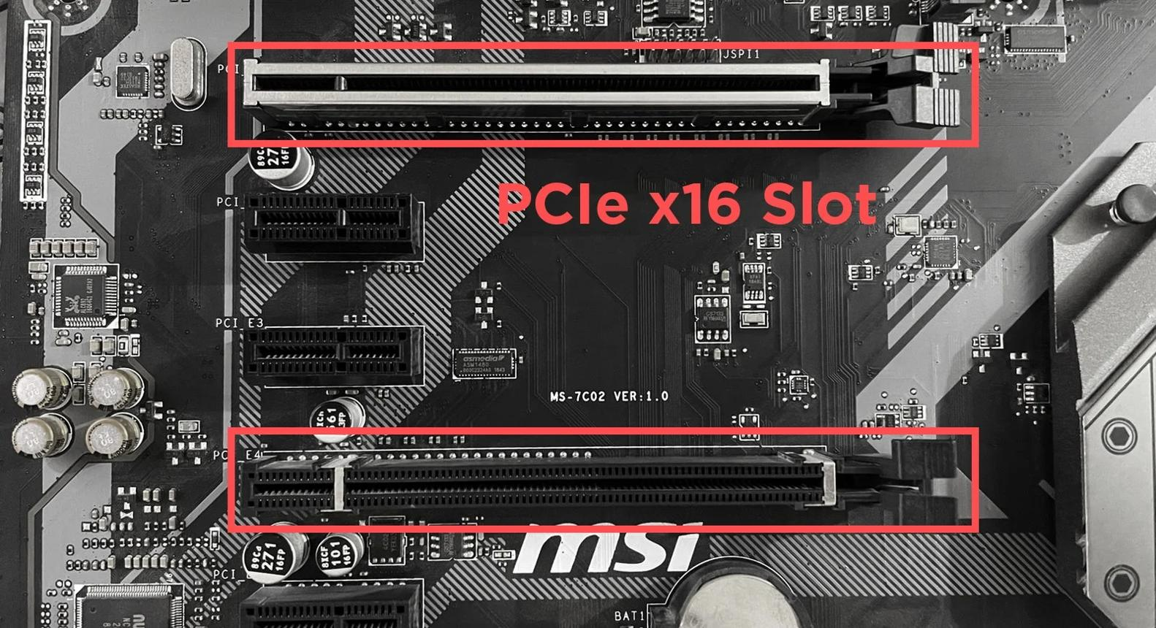
3. PCIe x16 slot
The long expansion slot used for a graphics card.
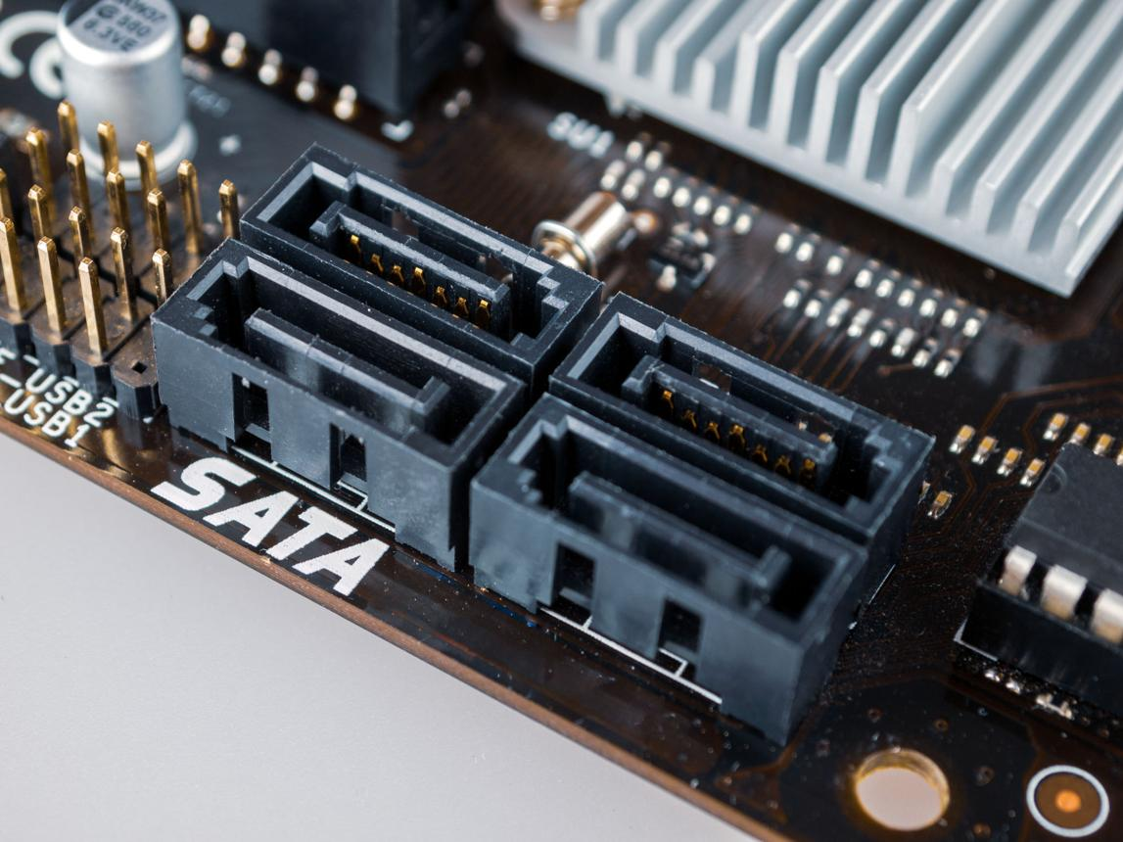
4. SATA ports
Small L-shaped connectors used for SATA HDDs and SSDs.
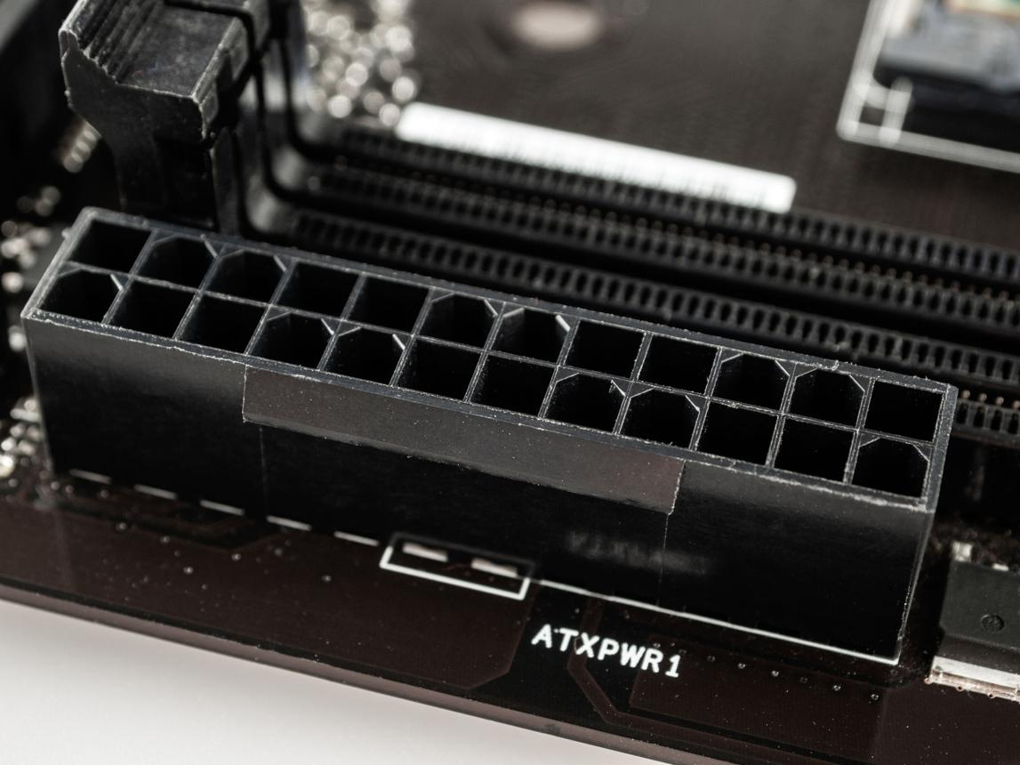
5. 24-pin ATX power connector
A large connector along the motherboard's right edge that supplies main power.
Conclusion: The motherboard connects the processor, memory, storage, graphics card, and peripheral devices. CPU socket compatibility and the correct motherboard chipset are important when selecting or upgrading a processor.

