NAME | SHASTRI PANCHAM
COURSE | DIMPLOMA IN CYBERSECURITY
SUBJECT | HARDWARE

1. Labelled Diagrams of a Wi-Fi Router and a Network Switch
A. Home Wi-Fi Router
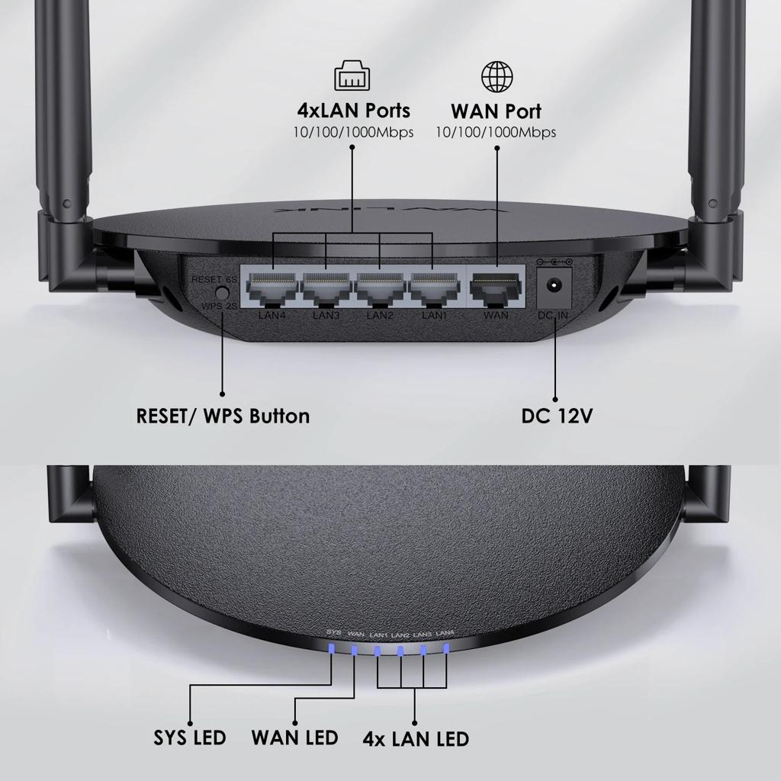

Labelled diagram:
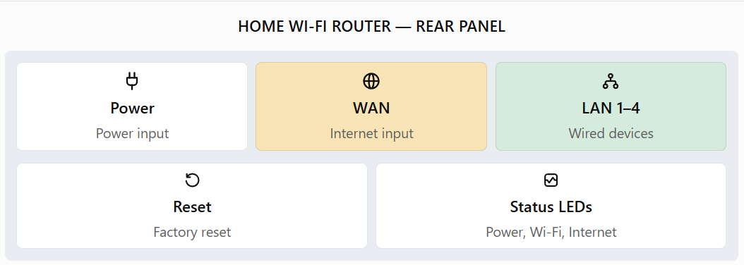

Functions of the main parts:
- Power port: Connects the router to its power adapter.
- WAN port: Connects the router to the ISP modem or ONT.
- LAN ports: Connect computers, printers, and other wired devices.
- Status LEDs: Indicate power, internet connection, Wi-Fi activity, and Ethernet link status.
- Reset button: Restores the router to its factory settings.
- Antennas: Transmit and receive wireless signals.
B. Network Switch
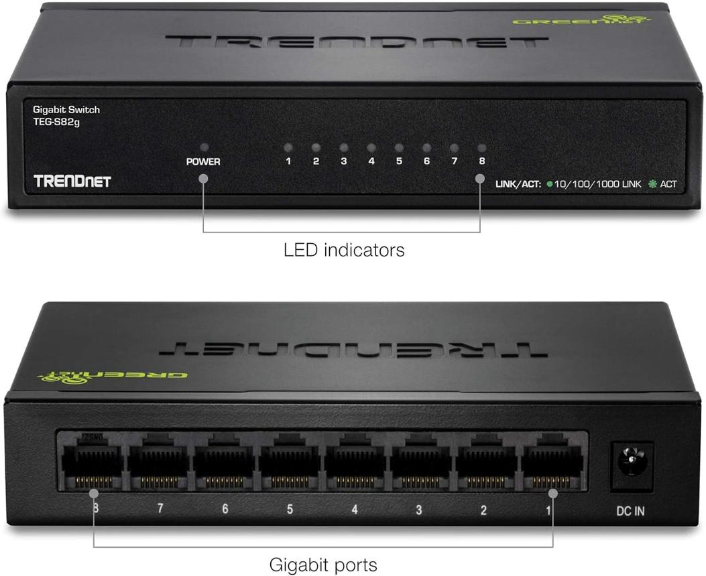

Labelled diagram:
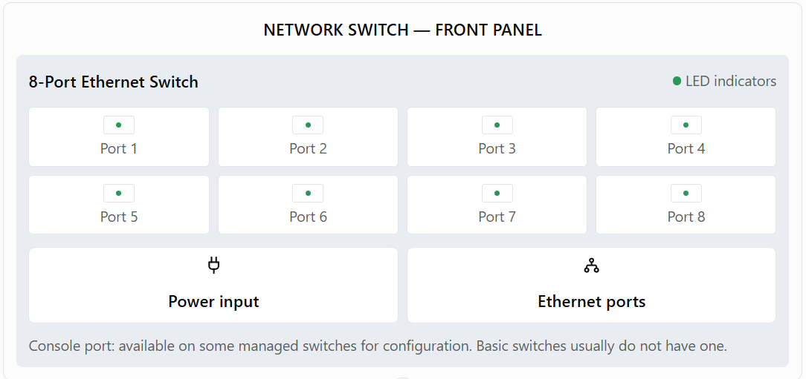

Functions of the main parts:
- Power port: Supplies electrical power to the switch.
- Ethernet ports: Connect computers, routers, printers, and other network devices.
- Status LEDs: Indicate connection status, data activity, and sometimes link speed.
- Console port: Allows administrators to configure certain managed switches.
2. Three Key Differences Between Routers and Switches
Feature | Router | Switch
Main function | Connects different networks, such as a local network and the internet. | Connects devices within the same local area network (LAN).
Addresses used | Uses IP addresses to determine where packets should be forwarded. | Typically uses MAC addresses to forward Ethernet frames to the correct port.
Traffic handling | Routes packets between networks and selects the appropriate next hop. | Forwards frames within a LAN using its MAC address table.
Conclusion: A router connects different networks, while a switch connects devices within a network. Both are essential for building computer networks.
3. Identification of Router and Switch Components
The images above serve as visual references. The following tables identify the required components and explain their purposes.
A. Router identification
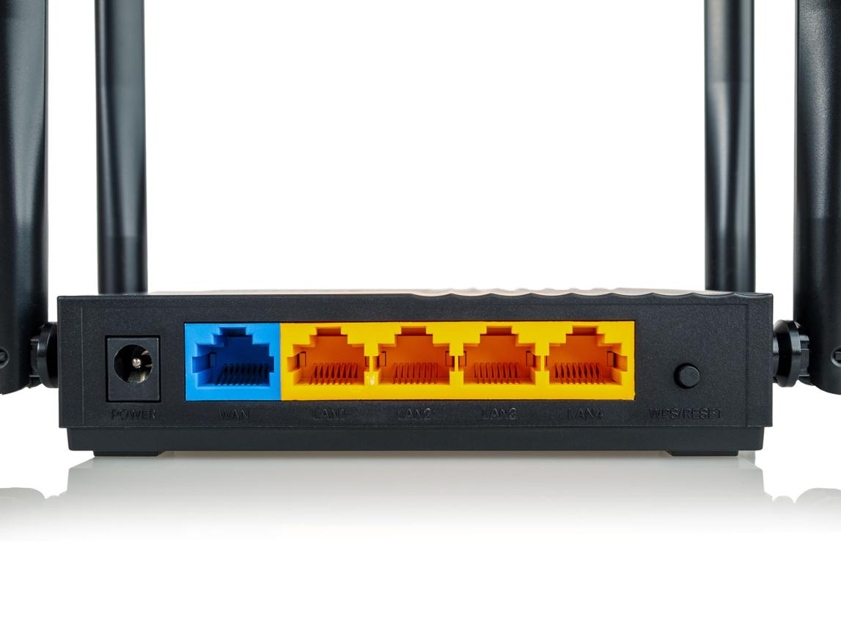
Component | Position | Purpose
Power port | Usually on the rear | Connects the power adapter.
WAN Ethernet port | Usually on the rear | Connects the router to the ISP modem or ONT.
LAN Ethernet ports | Usually grouped near the WAN port | Connect wired computers and other devices.
LED indicators | Usually on the front or top | Show power, Wi-Fi, internet, and connection activity.
B. Switch identification
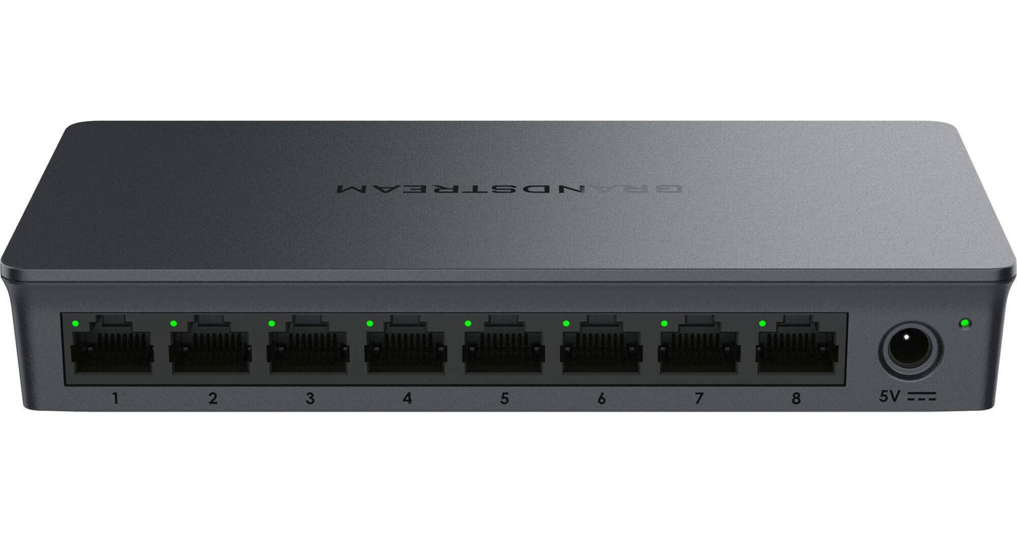

Component | Position | Purpose
Power port | Usually on the rear or side | Connects the power adapter.
Ethernet port 1 | On the front panel | Connects a computer or another network device.
Ethernet port 2 | Beside the first Ethernet port | Connects an additional device.
LED indicators | Beside or above Ethernet ports | Show link status and data activity.
Console port | Only on some managed switches | Used for configuration and troubleshooting.
Observation: Routers generally have a dedicated WAN port and LAN ports. Basic switches usually have multiple Ethernet ports, and managed switches may include a console port.
4. Gaming Café Network Scenario
Imagine I am setting up a small gaming café with eight gaming PCs. The café requires reliable internet for IPL streaming, online multiplayer games, and web browsing.
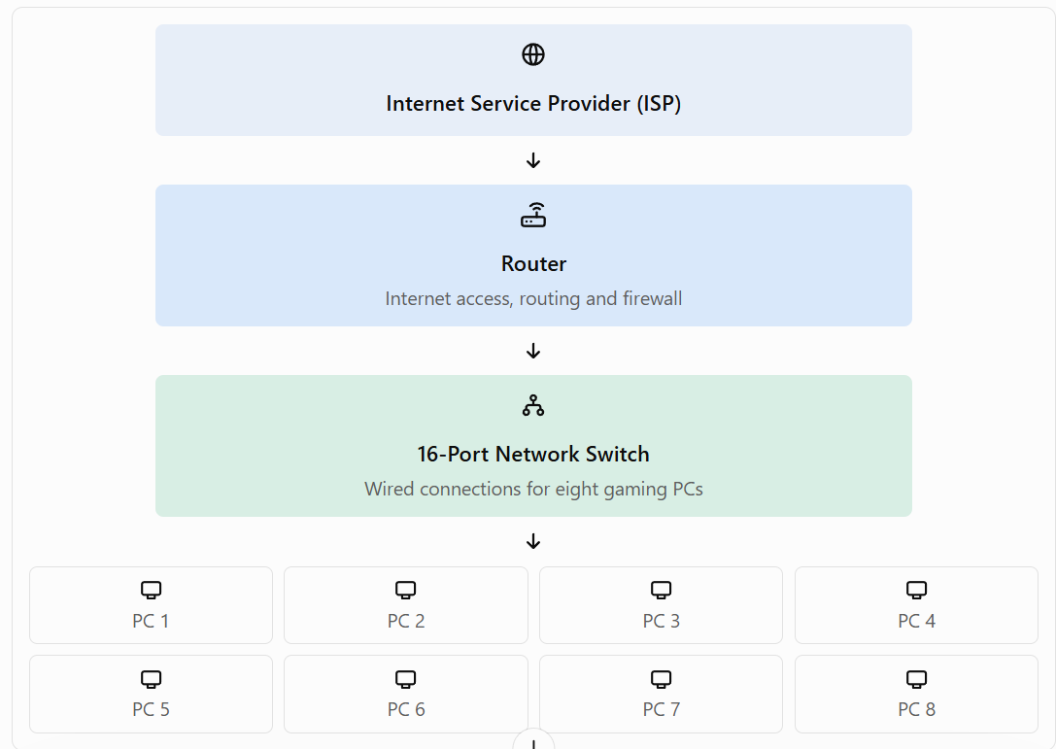
Steps to set up the network:
- Connect the ISP internet line to the modem or ONT, if required, and then connect it to the router's WAN port.
- Connect one LAN port on the router to an Ethernet port on the 16-port network switch.
- Connect all eight gaming PCs to separate switch ports using Ethernet cables.
- Configure the router to provide IP addresses through DHCP and enable its firewall for network protection.
- Test the internet connection and verify that all gaming PCs can access online games and stream IPL matches.
Justification: The router is connected to the ISP because it manages communication between the café's local network and the internet. The switch provides enough Ethernet ports for all eight PCs, with additional ports available for future devices. Wired Ethernet connections generally provide more stable connectivity and lower latency than Wi-Fi, making them suitable for gaming and streaming.
Final Conclusion
Routers and switches perform different but complementary functions. A router uses IP addresses to direct packets between networks, whereas a switch typically uses MAC addresses to forward frames within a LAN. Using both devices together provides a reliable and efficient network for homes, offices, and gaming cafés.

