NAME | SHASTRI PANCHAM
COURSE | DIMPLOMA IN CYBERSECURITY
SUBJECT | HARDWARE

1. Labelled Diagrams of a Wi-Fi Router and a Network Switch
A. Typical Home Wi-Fi Router
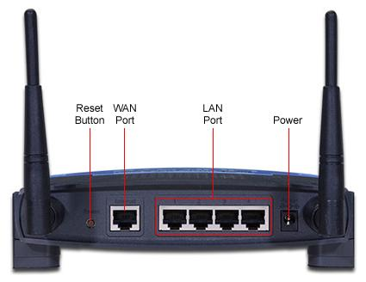

Labelled diagram:
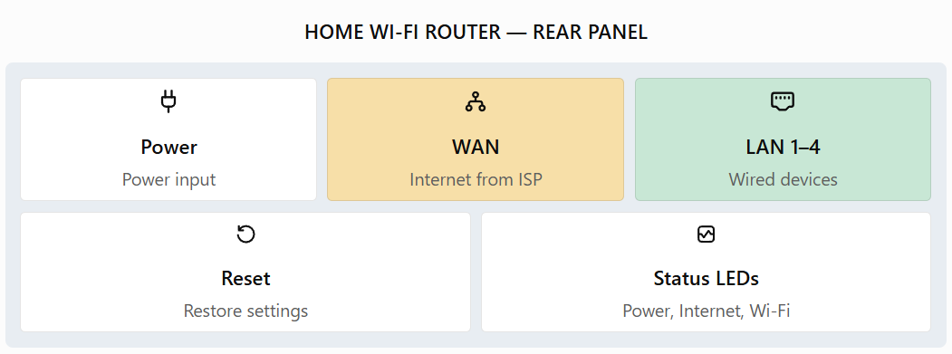

Main parts and their functions:
- Power port: Connects the router to its power adapter.
- WAN port: Connects to the ISP modem or ONT to receive internet access.
- LAN ports: Connect computers, printers, and other wired devices.
- Status LEDs: Indicate power, internet connectivity, Wi-Fi activity, and Ethernet connections.
- Reset button: Restores factory settings when required.
- Antennas: Transmit and receive wireless signals.
B. Typical Network Switch
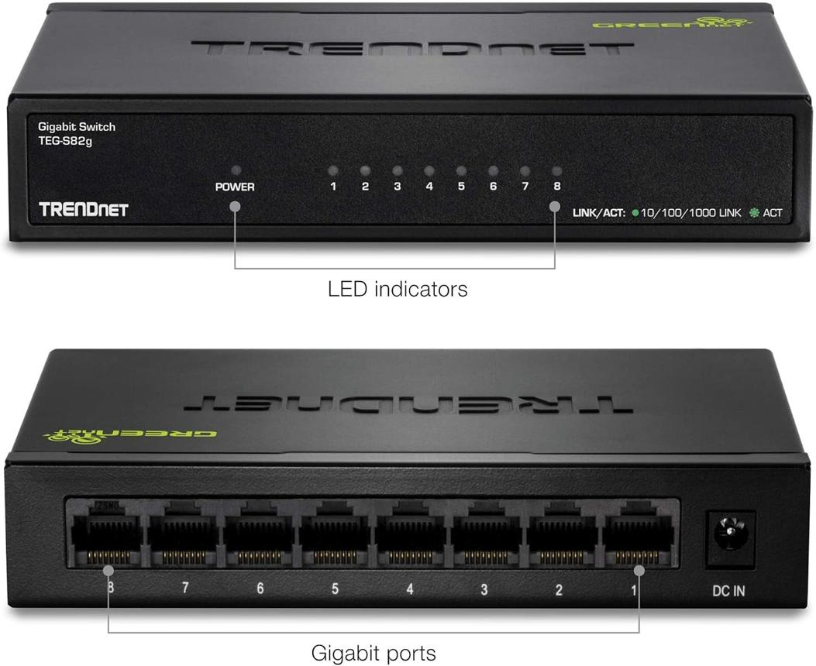
manuals.plus
Labelled diagram:
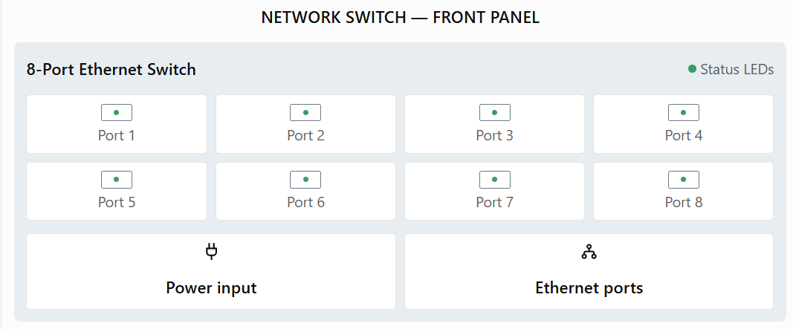

Main parts and their functions:
- Power port: Supplies electrical power to the switch.
- Ethernet ports: Connect computers, routers, printers, and other network devices.
- Status LEDs: Show link status, data activity, and sometimes connection speed.
- Console port (managed switches only): Allows an administrator to configure and troubleshoot the switch.
2. Three Key Differences Between Routers and Switches
Feature | Router | Switch
Main function | Connects different networks, such as a home network and the internet. | Connects devices within the same local area network (LAN).
Addresses used | Uses IP addresses to route packets between networks. | Typically uses MAC addresses to forward Ethernet frames within a LAN.
Network traffic | Selects a route for packets to reach another network. | Forwards frames to the appropriate port based on its MAC address table.
Conclusion: A router connects networks, while a switch connects devices within a network. Both devices are important for building efficient computer networks.
3. Identification of Router and Switch Components
The images in Question 1 can be used as visual references. For your assignment, you can also take photographs of actual devices at home or in a computer lab.
A. Router identification
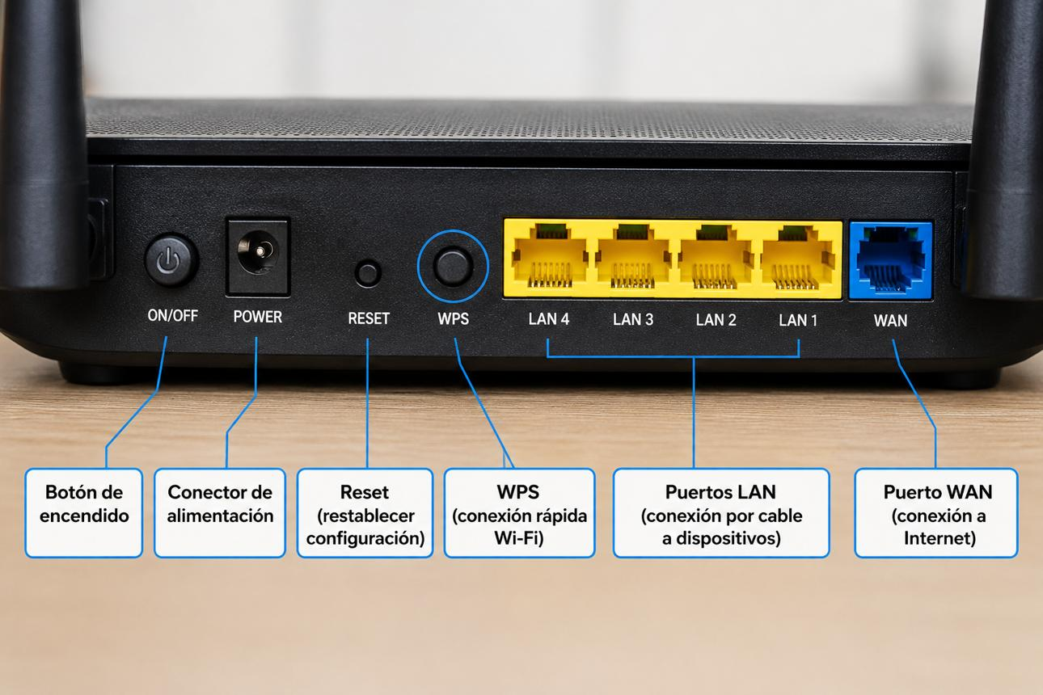
tn.com.ar
Component | Position | Purpose
Power port | Usually at the rear | Connects the power adapter.
WAN port | Usually at the rear | Connects the router to the ISP modem or ONT.
Ethernet LAN ports | Usually grouped beside the WAN port | Connect wired computers and other devices.
LED indicators | Usually on the front or top | Show power, internet, Wi-Fi, and LAN activity.
B. Switch identification
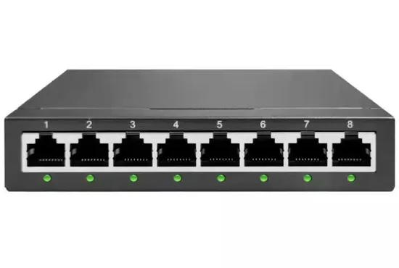
id.made-in-china.com
Component | Position | Purpose
Power port | Usually on the rear or side | Connects the power adapter.
Ethernet ports | Usually arranged in a row on the front | Connect computers and other network devices.
LED indicators | Beside or above each Ethernet port | Show whether a device is connected and whether data is being transmitted.
Console port | Present on some managed switches | Used for configuration and troubleshooting.
Observation: A router often has separate WAN and LAN ports, whereas a basic network switch usually has multiple Ethernet ports for connecting devices. Not all switches include a console port.
4. Gaming Café Network Scenario
Imagine I am setting up a small gaming café with eight gaming PCs. Customers need a reliable internet connection for IPL streaming, online multiplayer games, and web browsing.
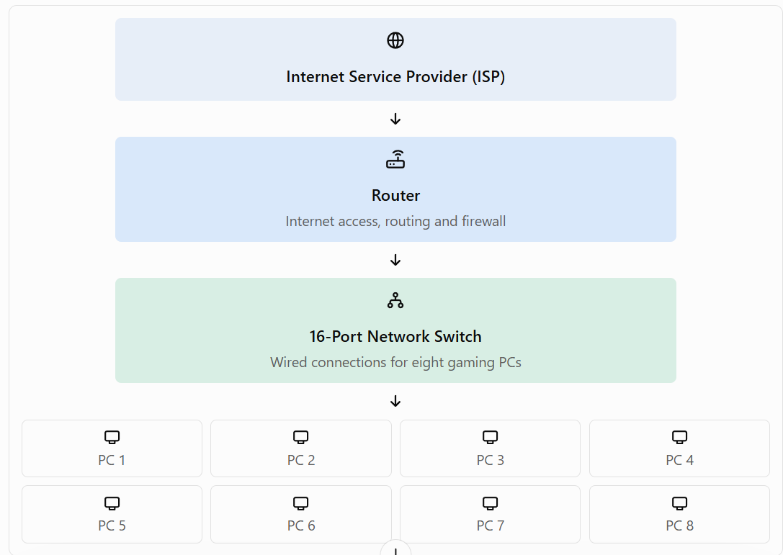

Explanation:
- First, I would connect the ISP internet line to the modem or ONT, if required by the ISP, and connect it to the router's WAN port.
- Next, I would connect one of the router's LAN ports to an Ethernet port on a 16-port network switch.
- I would connect all eight gaming PCs to separate ports on the switch using Ethernet cables.
- The router would provide internet access, assign IP addresses using DHCP, and help protect the network through its firewall.
- The switch would forward data between the gaming PCs and the router, providing stable wired connectivity for multiplayer gaming and IPL streaming.
Justification: The router must be connected first to manage internet traffic between the café's LAN and the ISP network. The switch provides enough Ethernet ports for all eight PCs and leaves additional ports available for future devices. A wired connection is preferable for gaming because it generally provides more stable connectivity and lower latency than Wi-Fi.
Final Conclusion
Routers and switches perform different but complementary roles. A router connects separate networks and directs IP packets, while a switch connects devices within a LAN and forwards Ethernet frames using MAC addresses. Using both devices together creates a reliable and efficient network for homes, offices, and gaming cafés.

