NAME | SHASTRI PANCHAM
COURSE | DIMPLOMA IN CYBERSECURITY
SUBJECT | HARDWARE

Assignment: Ethernet and Fiber Optic Cables
1. Three Key Differences Between Ethernet and Fiber Optic Cables
Feature | Ethernet Cable (Copper) | Fiber Optic Cable
Transmission medium | Uses copper wires to transmit electrical signals. | Uses thin glass or plastic fibers to transmit light signals.
Speed and distance | Commonly supports 1 Gbps or 10 Gbps, depending on cable category and distance. Standard twisted-pair Ethernet channels are generally limited to 100 metres. | Supports very high speeds over longer distances, from hundreds of metres to many kilometres depending on fiber type and equipment.
Cost and installation | Generally cheaper and easier to install for short connections. | Usually costs more to install because it may require optical modules and specialized tools.
Real-world examples:
- Ethernet cable: Connecting a home Wi-Fi router to a desktop computer or connecting gaming PCs in a café.
- Fiber optic cable: Connecting buildings across a college campus or linking servers within a data center.
2. Straight-Through Ethernet Cable Wiring — T568B Standard
A straight-through Ethernet cable has the same wiring standard at both ends. For this assignment, both connectors use the T568B standard.
Pin numbers and wire colours
T568B wiring order — Pin 1 to Pin 8
Pin 1
White/Orange
Pin 2
Orange
Pin 3
White/Green
Pin 4
Blue
Pin 5
White/Blue
Pin 6
Green
Pin 7
White/Brown
Pin 8
Brown
A straight-through cable uses the same pin order at both ends. The eight wires must be arranged correctly to ensure reliable data transmission.
3. Step-by-Step Guide to Attaching an RJ45 Connector to a CAT6 Cable
Watch this tutorial before writing the practical steps:
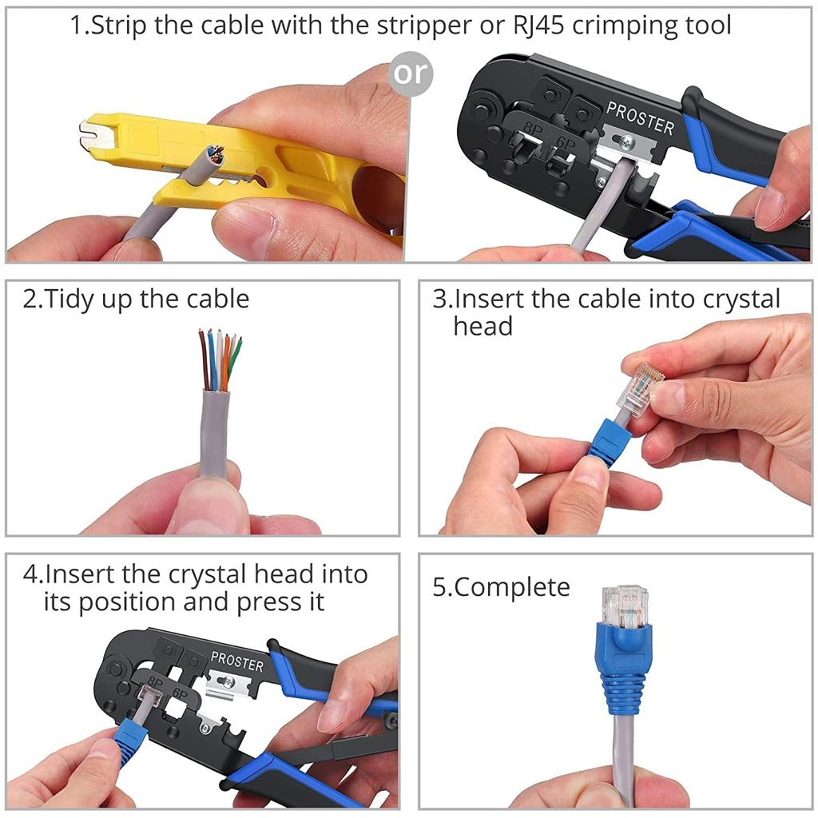
How to Crimp RJ45 Connector
YouTube tutorial · T568B wiring standard
Watch the tutorial
Tools required:
- CAT6 Ethernet cable
- RJ45 connector compatible with the cable
- RJ45 crimping tool
- Cable stripper or cutter
- LAN cable tester
Procedure:
- Cut the cable: Measure the required length and cut the CAT6 cable cleanly.
- Strip the outer jacket: Remove approximately 2–3 cm of the outer insulation without damaging the inner wires.
- Separate the wires: Carefully untwist and straighten the eight wires.
- Arrange the wires: Place them in T568B order: White/Orange, Orange, White/Green, Blue, White/Blue, Green, White/Brown, Brown.
- Trim the wires: Cut all eight wires evenly so that they fit inside the RJ45 connector.
- Insert the wires: Push them into the connector, ensuring each wire reaches the end and the outer cable jacket extends inside the connector for strain relief.
- Crimp the connector: Insert the connector into the crimping tool and squeeze the handles firmly to secure the contacts.
- Repeat at the other end: Use the same T568B standard on the other end to make a straight-through cable.
- Test the cable: Use a LAN cable tester to check that all eight conductors are connected correctly.
Result: A CAT6 Ethernet cable with RJ45 connectors is prepared and tested for network connectivity.

iFixit Repair Guide
+1
4. Gaming Café Setup: 10 PCs
For a gaming café with 10 PCs, I would choose CAT6 Ethernet cables and an RJ45 crimping tool. CAT6 supports 1 Gbps Ethernet over standard channels up to 100 metres, which is suitable for most small cafés and provides stable, low-latency connections. Ethernet cables and RJ45 connectors are generally cheaper and easier to install than fiber optic equipment. A fiber cleaver is unnecessary because I am using copper Ethernet cables rather than fiber optics.
