NAME | SHASTRI PANCHAM
COURSE | DIMPLOMA IN CYBERSECURITY
SUBJECT | HARDWARE

1. Log in to the Home Wi-Fi Router Admin Panel
Objective: To access the router's administration page using its default gateway IP address.
Procedure:
- Connect your laptop to your home Wi-Fi network.
- Open Command Prompt on Windows by pressing Win + R, typing cmd, and pressing Enter.
- Type the following command:
ipconfig
- Find the Default Gateway under your Wi-Fi adapter. It may be 192.168.1.1 or 192.168.0.1.
- Open a web browser and enter the gateway address in the address bar.
- Enter the router's administrat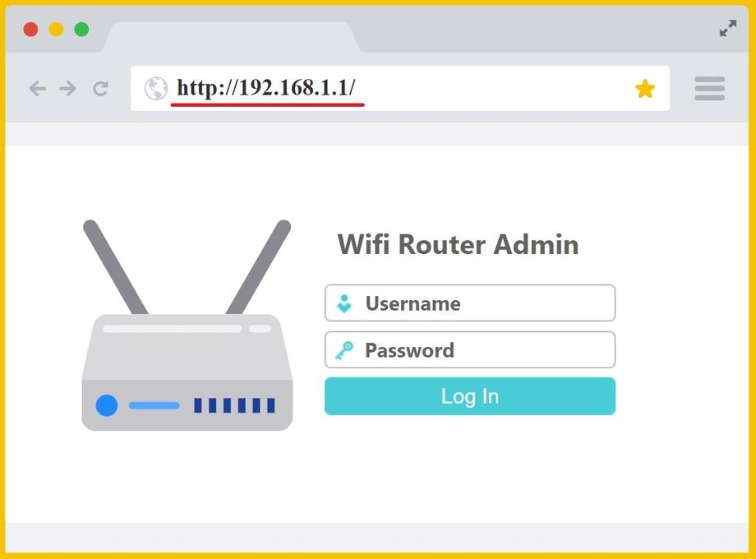or username and password to log in, if prompted.

Screenshot: Take a screenshot of your actual router login page and insert it here.
Result: The router administration login page was accessed using the default gateway IP address.
2. Find the Device's Current IP Address, Subnet Mask, and Default Gateway
Objective: To identify the network configuration assigned to the laptop.
Procedure:
- Connect the laptop to the home Wi-Fi network.
- Open Command Prompt.
- Run ipconfig.
- Find the Wi-Fi adapter section and record the IPv4 address, subnet mask, and default gateway.
Example output:
Wireless LAN adapter Wi-Fi:

IPv4 Address. . . . . . : 192.168.1.105
Subnet Mask . . . . . . : 255.255.255.0
Default Gateway . . . . : 192.168.1.1
Network setting | Example value | Purpose
IPv4 address | 192.168.1.105 | Identifies the laptop on the local network.
Subnet mask | 255.255.255.0 | Defines which IP addresses belong to the local subnet.
Default gateway | 192.168.1.1 | Provides a route from the local network to other networks, including the internet.
Result: The current IP address, subnet mask, and default gateway were identified.
Note: These are example values. Replace them with the actual values displayed by your laptop.
3. Change the IP Address from DHCP to Static
Objective: To configure a static IPv4 address and test internet connectivity.
Procedure on Windows 10/11:
- Open Settings → Network & Internet → Wi-Fi.
- Open your connected Wi-Fi network's properties.
- Find IP assignment and click Edit.
- Change the setting from Automatic (DHCP) to Manual.
- Enable IPv4 and enter the appropriate network details.
Example configuration, assuming your router uses 192.168.1.1:
Setting | Example value
IP address | 192.168.1.50
Subnet mask / prefix length | 255.255.255.0 / 24
Default gateway | 192.168.1.1
Preferred DNS | 192.168.1.1
- Save the settings and open a browser to test internet access. You can also run:
- ping 192.168.1.1
ping 8.8.8.8
- After testing, return to IP assignment → Edit → Automatic (DHCP) and save the settings.
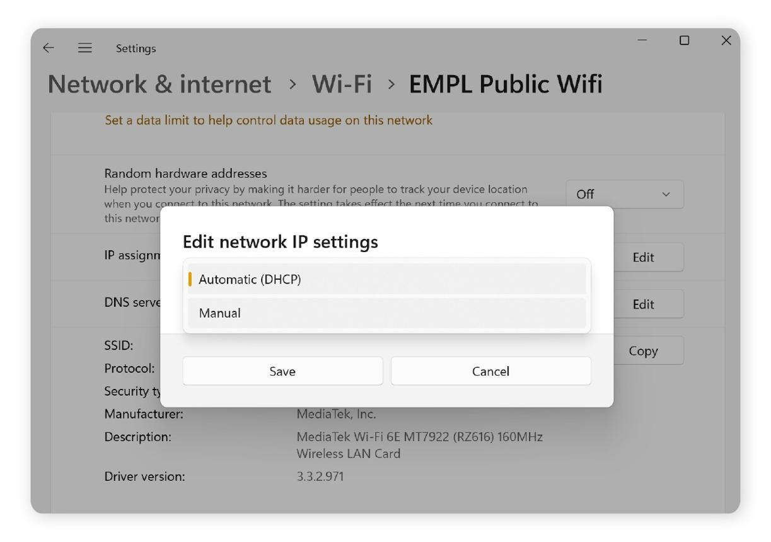
Important: Use an address that matches your router's subnet and is not already assigned to another device. Prefer an address outside the DHCP pool or one reserved for your device in the router. If your router uses a different subnet, adjust the example accordingly.
Result: The laptop was configured with a static IP address and internet connectivity was tested. The original DHCP setting was restored afterward.
4. Find the DHCP Range and Explain Duplicate IP Addresses
Objective: To identify the DHCP address pool and understand IP address conflicts.
Procedure:
- Log in to the router administration panel.
- Find a section named LAN Settings, DHCP Server, or Network Settings.
- Locate the DHCP start and end addresses.
- Record the range displayed by your router.
Example:
DHCP setting | Example value
DHCP start address | 192.168.1.100
DHCP end address | 192.168.1.200
Subnet mask | 255.255.255.0
Default gateway | 192.168.1.1
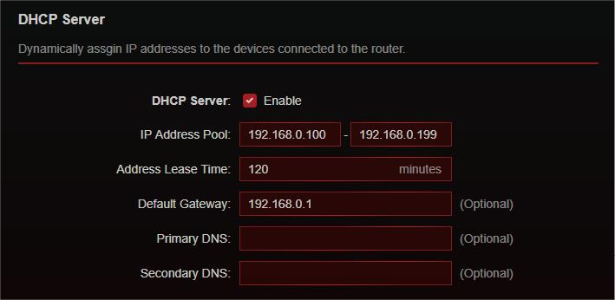
What happens if two devices have the same IP address?
If two devices on the same network use the same IP address, an IP address conflict occurs. They may experience intermittent connectivity, failed communication, or loss of internet access. DHCP normally manages address assignments to avoid conflicts, but manually configured static addresses can overlap with the DHCP pool and cause problems.
Result: The DHCP range was located, and the effect of duplicate IP addresses was understood.

