NAME | SHASTRI PANCHAM
COURSE | DIMPLOMA IN CYBERSECURITY
SUBJECT | HARDWARE

Assignment: SMPS, UPS, and Power Connectors
1. Devices That Use SMPS and UPS
A. Three devices that use SMPS
An SMPS (Switched Mode Power Supply) converts electrical power into the voltage and current required by electronic devices.
No. | Device | Why it uses an SMPS
1 | Desktop computer | Converts AC electricity into regulated DC power for the motherboard, CPU, GPU, and storage drives.
2 | Laptop charger | Converts AC mains power into suitable DC power to operate the laptop and charge its battery.
3 | LED television | Converts incoming AC electricity into the DC voltages needed by its display and electronic circuits.
B. Two devices that use UPS
A UPS (Uninterruptible Power Supply) provides temporary backup power when the main electricity supply fails.
No. | Device | Why it uses a UPS
1 | Desktop computer | Provides temporary backup power to save work and shut down safely during a power cut.
2 | Wi-Fi router | Keeps the internet connection available during short power interruptions, provided the internet service itself remains active.
Note: An SMPS supplies or regulates power during normal operation, whereas a UPS provides backup power when the mains supply is interrupted. A UPS may itself contain an SMPS or other power-conversion circuitry.
2. Labeled Diagram of a Desktop PC SMPS
The diagram below illustrates the main stages of a typical desktop PC SMPS.
SMPS Block Diagram
AC Input (100–240 V)
Electricity from the wall socket
Input Protection and Filter
Helps protect against electrical interference and certain faults
Rectifier
Converts AC into DC
High-Frequency Switching Circuit
Switches the electrical power at high frequency
High-Frequency Transformer
Provides electrical isolation and voltage conversion
Output Rectifier and Filters
Converts and smooths the output into stable DC voltages
DC Outputs: +12 V, +5 V, +3.3 V
Power for the motherboard, drives, and other components

Component functions:
- AC input: Receives electricity from the wall socket.
- Rectifier: Converts incoming AC electricity to DC.
- Transformer: Transfers energy at high frequency and adjusts voltage while providing isolation.
- DC output section: Supplies the regulated voltages required by computer components.

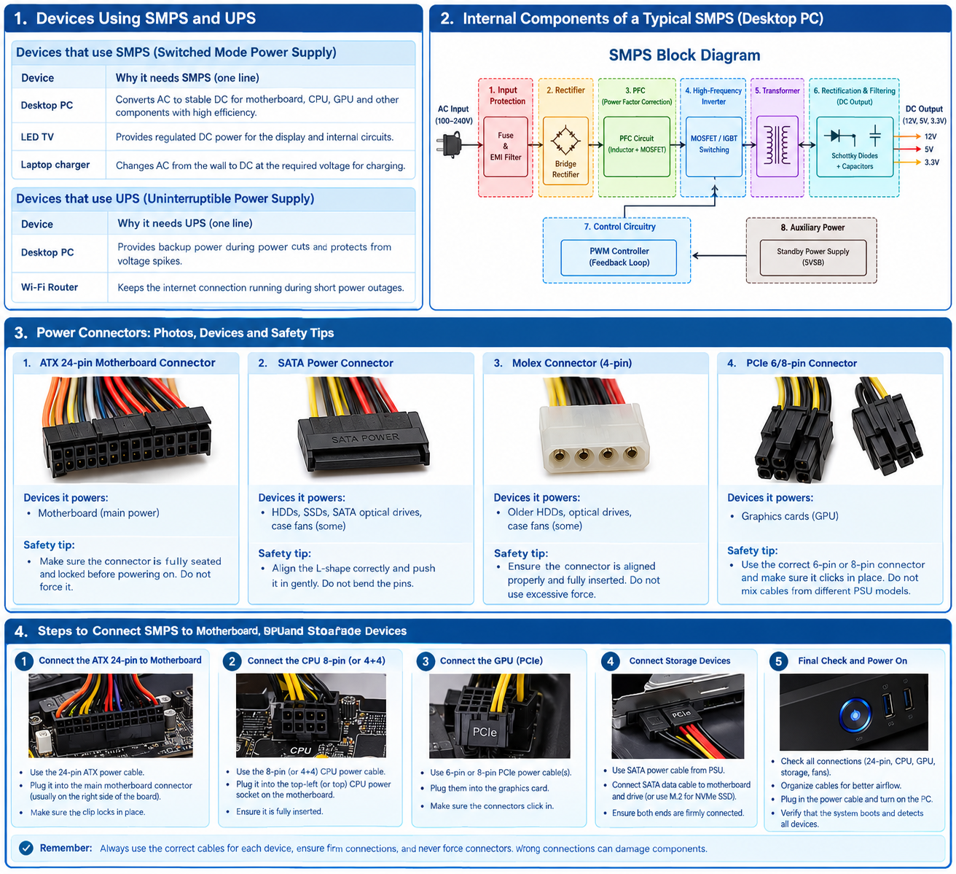

3. Common PC Power Connectors
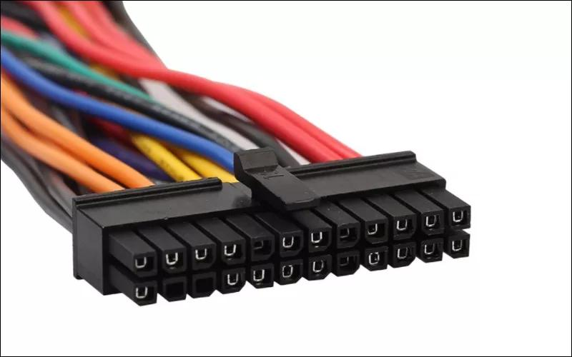
A. ATX 24-pin motherboard connector
- Powers: The motherboard's main power circuits.
- Safety tip: Align the clip with the socket and ensure it locks into place. Never force it.
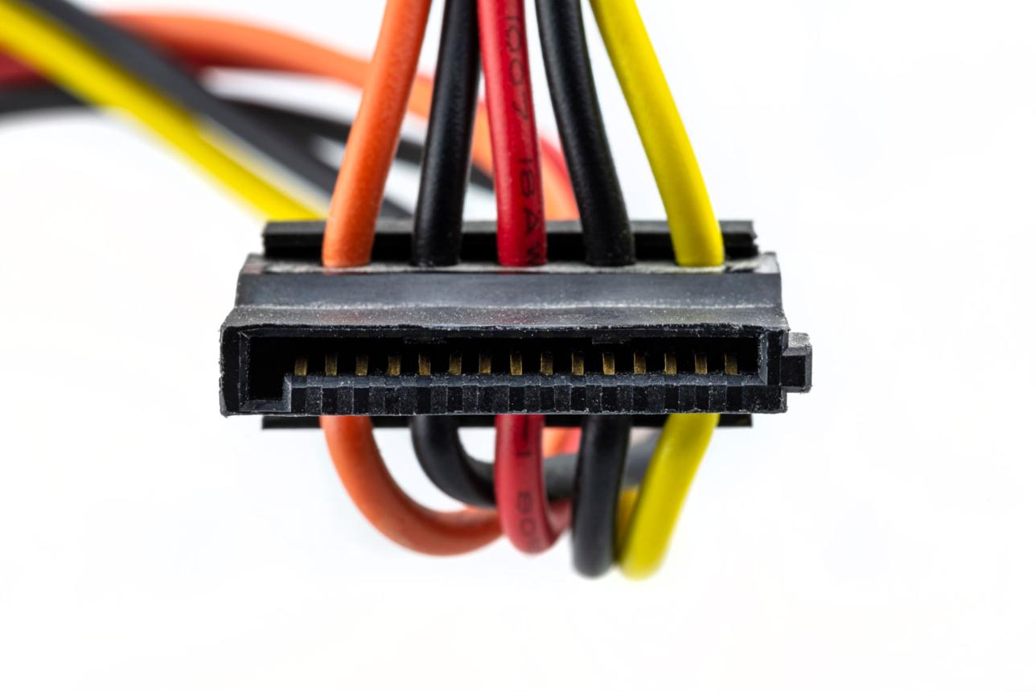
B. SATA power connector
- Powers: SATA HDDs, SATA SSDs, and compatible optical drives.
- Safety tip: Align the L-shaped connector correctly before inserting or removing it.
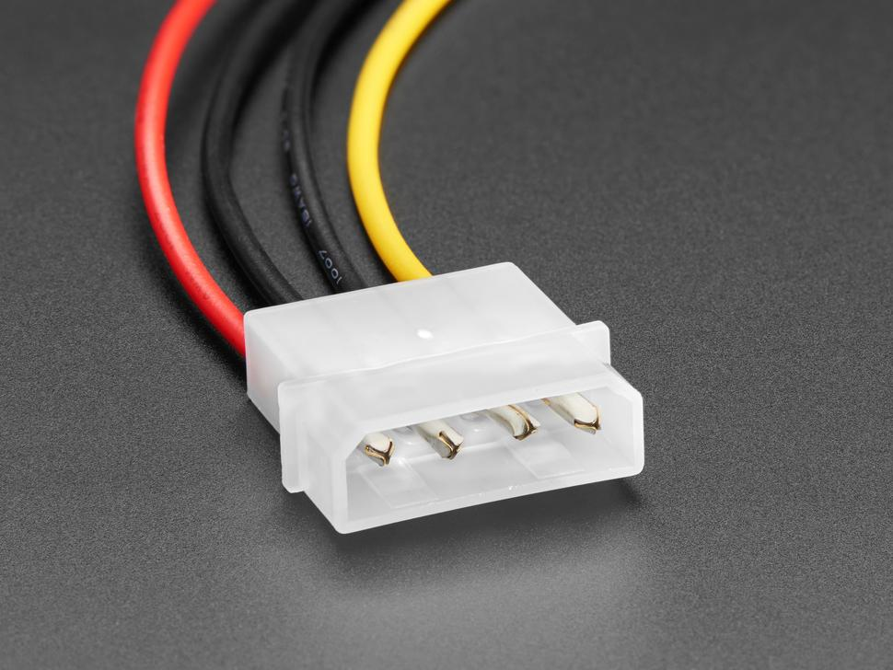
C. Molex 4-pin connector
- Powers: Older HDDs, optical drives, and some fans or accessories.
- Safety tip: Switch off and unplug the PSU before connecting or disconnecting it.
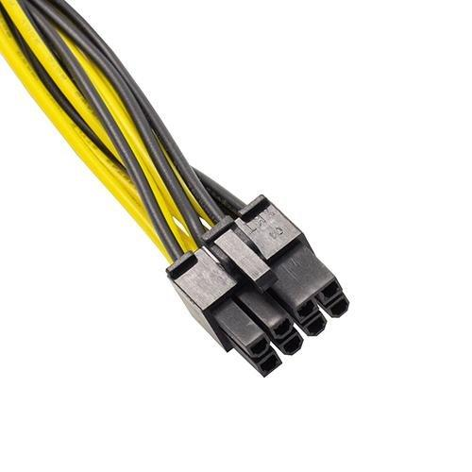
D. PCIe 6/8-pin power connector
- Powers: Compatible dedicated graphics cards.
- Safety tip: Use the correct GPU power cable supplied or approved for the PSU. Never confuse a PCIe cable with a CPU/EPS cable.
4. Connecting an SMPS to a New Gaming PC
Follow these steps with the computer powered off and the PSU unplugged.
- Connect the motherboard: Attach the PSU's 24-pin ATX cable to the motherboard's main power socket.
- Connect CPU power: Attach the 4-pin or 8-pin CPU/EPS cable to the motherboard's CPU power socket, usually near the processor.
- Connect the graphics card: If required, attach the correct PCIe 6-pin, 8-pin, or manufacturer-specified GPU power cable. Some newer graphics cards use a 16-pin connector.
- Connect storage devices: Attach SATA power from the PSU to SATA HDDs or SSDs. Connect the separate SATA data cable between each SATA drive and the motherboard. M.2 NVMe SSDs normally receive power through their motherboard slot and do not need a SATA power cable.
- Check all connections: Confirm that plugs are fully seated, cables do not obstruct fans, and no loose screws remain inside the case.
- Power on and test: Close the case, connect the external power cable, switch on the PSU, and start the PC. Verify that the system boots and detects its storage devices.
Important safety rule: Never open the PSU casing, and never mix modular PSU cables from different PSU models—even if their connectors appear to fit. Incorrect cables can damage computer components.
Conclusion: The SMPS converts mains electricity into regulated DC power for a computer, while the UPS provides backup power during outages. Correctly identifying power connectors and following safety precautions helps ensure reliable operation and prevents hardware damage.

