NAME | SHASTRI PANCHAM
COURSE | DIMPLOMA IN CYBERSECURITY
SUBJECT | HARDWARE

Assignment: Printers, Scanners, Webcams, and Connection Interfaces
1. Types of Printers, Scanners, and Webcams
Device type | Description | Real-life use case
Inkjet printer | Sprays tiny droplets of ink onto paper. | Printing college assignments and colour photographs.
Laser printer | Uses toner powder and a laser-based printing process. | Printing large quantities of office documents quickly.
Dot-matrix printer | Uses pins and an ink ribbon to print characters. | Printing multi-copy bills and invoices.
Flatbed scanner | Scans documents or photos placed on a glass surface. | Scanning college certificates into digital files.
Sheet-fed scanner | Pulls sheets of paper through the scanner automatically. | Scanning multiple office documents quickly.
Built-in laptop webcam | A camera integrated into a laptop. | Attending online classes and video meetings.
External USB webcam | A separate camera connected to a computer. | Recording presentations or making video calls on a desktop PC.
2. Labeled Diagram: Connecting a Printer to a Computer
A typical home printer can connect to a laptop or desktop using a USB cable or wirelessly through Wi-Fi. Some devices also support Bluetooth.
Labeled connection diagram
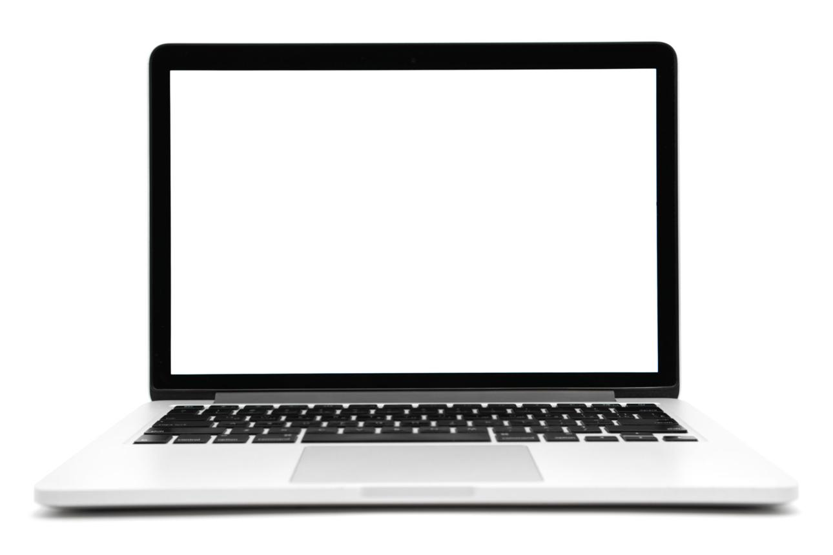
Laptop / PC
USB cable
or Wi-Fi
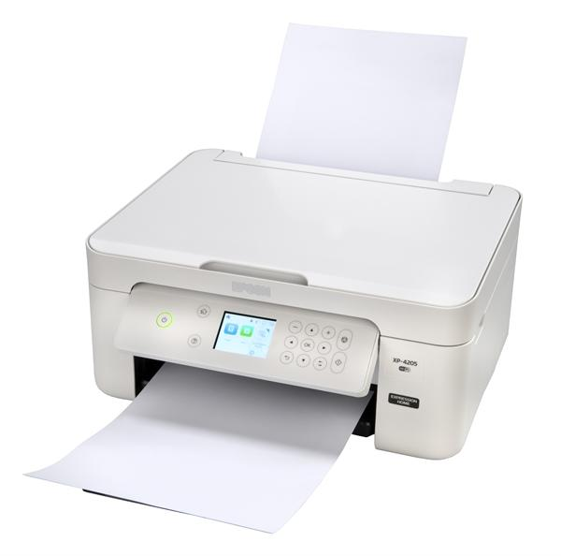
Printer
USB provides a direct wired connection. Wi-Fi allows printing wirelessly over a compatible network.
3. Connection Interfaces: Advantages and Disadvantages
Interface | Advantage | Disadvantage
USB | Fast, stable connection and simple setup. | Requires a cable and limits mobility.
Wi-Fi | Connects compatible devices wirelessly and allows multiple computers to share a printer. | Setup may be more complex and performance depends on network quality.
Bluetooth | Convenient short-range wireless connection with low power consumption. | Limited range and often lower data-transfer speeds than USB or Wi-Fi.
4. Steps to Connect a Printer to a Computer
Example: Connecting a home inkjet printer using Wi-Fi.
- Turn on the printer: Connect its power cable and switch it on.
- Connect to Wi-Fi: Use the printer's control panel or setup application to connect it to your home wireless network.
- Prepare the computer: Make sure the laptop or desktop is connected to the same Wi-Fi network.
- Install the printer software: Download the correct driver or official setup application for the printer model.
- Add the printer: In Windows, open Settings → Bluetooth & devices → Printers & scanners → Add device.
- Test the connection: Select the printer, print a test page, and check that the output is correct.
If Wi-Fi is unavailable, connect the printer directly using a compatible USB cable and install its driver if required.
Conclusion: Printers, scanners, and webcams are useful computer peripherals for education, office work, and communication. USB offers a reliable wired connection, while Wi-Fi and Bluetooth provide wireless convenience depending on the device's capabilities.

