Doubt is gone; I boldly recognize you in everything,
in the first light of dawn, in grass the wind keeps stirring.
In every tender breath of breeze I catch you there,
you are in each small drop, in each small radiance murmuring.

You are the forest's hush, the birds across the sky,
you are the deep of starlit night, its stillness keeping.
In your two hands lies all: life, warmth, and light on high,
you are each instant, and you walk with me unsleeping.

I see you in the glints that shimmer on the stream,
in meadow flowers and in the oak grove's rustle.
You are the soul's own light no darkness can quench,
your handiwork is every breath, the waking, and the bustle.

You are the heart of storms, the living joy that springs,
you are in every day that lends my mouth a smile.
I feel you in my soul, in all its earthbound things,
and through your whole creation see the spark the while.

Now this I know: it is yourself who are the light
that fills this life with love that has no ending.
You are my Creator; in each thing I will find
you as the answer, and this is the heart's path.
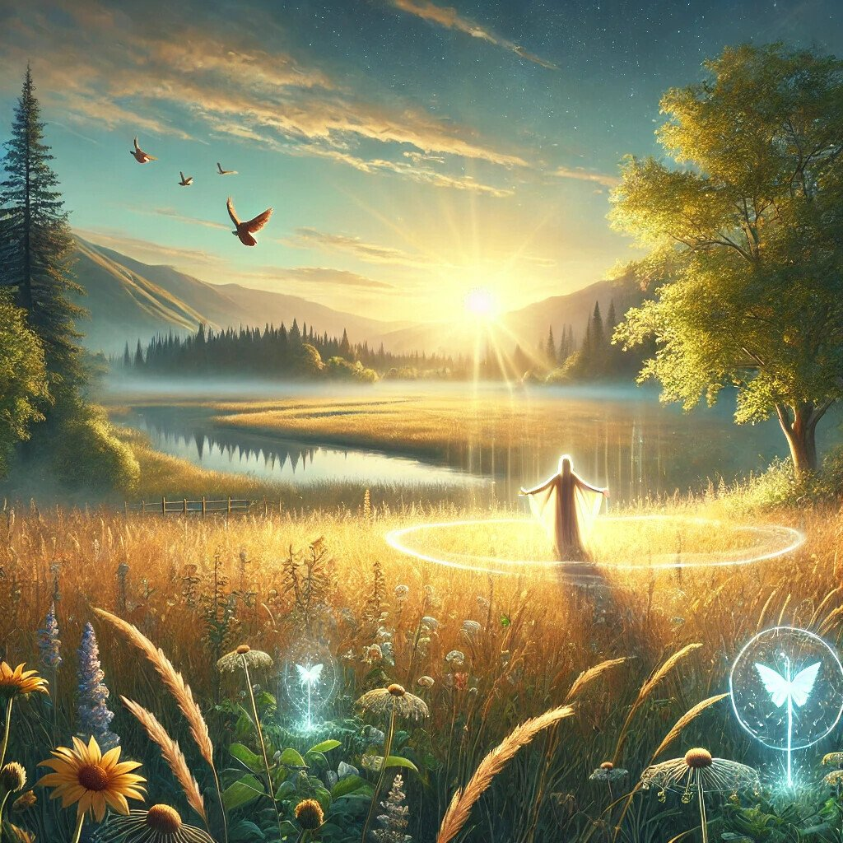
27.10.2024, Сергей Панкратиус

