Chapter 1. The School That Was Not on the Schedule
(and why true teaching comes when no one explains)
Once, Sergei did not go to school.
He was not ill.
Did not oversleep.
He simply woke up — and understood:
today a different lesson awaited him.
He got dressed.
Went out into the yard.
And walked.
Where to — he did not know.
But inside there was a feeling:
“I am going where the Light wants to be made visible.”
—
He walked along an ordinary street, over the first snow.
Past garbage bins, sleeping dogs, crows on the wires.
And suddenly — he turned into a courtyard,
where he had never looked before.
There, between the garages, stood a house.
Very old.
With a peeling door and windows in which there was silence.
But from one window…
light was coming.
Not electric.
Not a candle.
But as if someone were there — very alive.
Very quiet.
Very real.
Sergei approached.
Knocked.
Softly.
Once. A grandmother opened.
Gray-haired.
With eyes in which there was no less sky than wrinkles on her face.
She looked at him,
nodded — and said:
— Come in. The lesson has already begun.
—
It was warm inside.
It smelled of bread, dust, and… something familiar.
There were cushions on the floor.
A map hung on the wall.
But not geography.
A map of the Heart.
And on it it was written:
"Here they teach that
which cannot be said in words.
But can be felt — and become."
Sergei sat down.
Listened.
And understood:
he had come to where the Kingdom is being built.
Not by hands. Not by plans.
But by presence.
By inner silence.
And by readiness to become a Home.
For the Light.
For others.
For Him Who has always waited.

Chapter 2. Those Who Are Already Building, Not Knowing It (and why good deeds are not bricks, but windows)
There were no bells in this school.
There were no notebooks.
There were no “right answers.”
But there were—
students.
They came not by schedule.
They simply found the way one day.
And it was always unexpected.
One girl brought an old album with her.
In it were drawings that no one had seen.
Only she.
She drew people
whose eyes held Light.
— How do you know how to draw light? — Sergei asked.
— I don’t draw. I just… help it come out.
If you look long enough,
you can see how it asks for the paper.

One boy brought nails and boards.
He did not know how to speak.
But he knew how to fix broken chairs.
He had not learned to build.
He simply felt where support was lacking.
And every time he fixed something,
everyone in the room grew quiet a little more than usual.
For his silence knew how to speak.
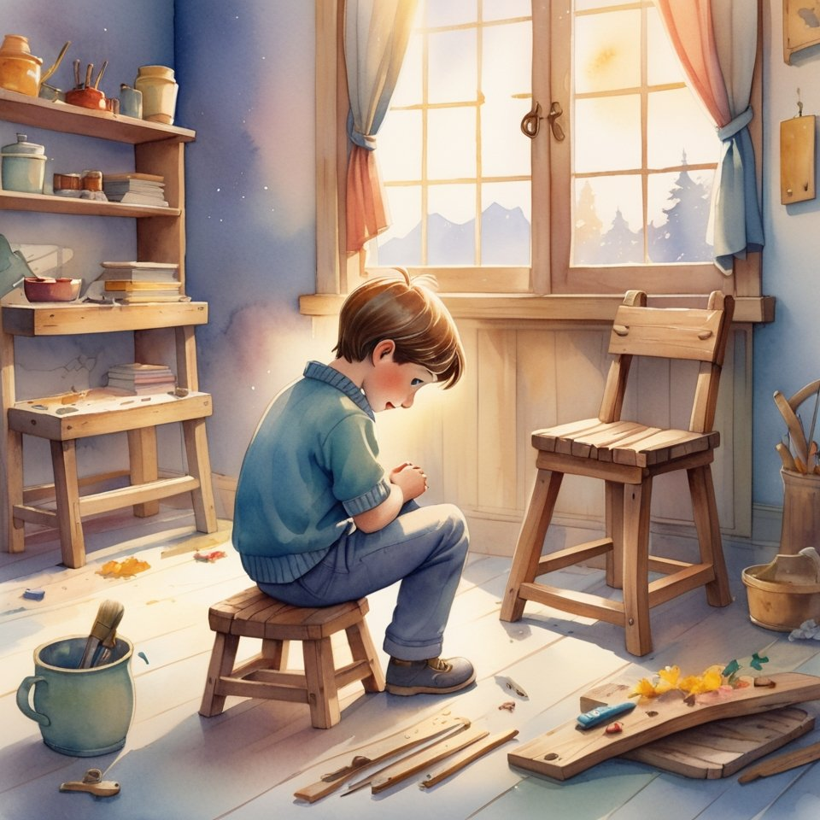
An old man with a white beard sat in the corner and drank tea.
He never вмешивался.
But one day he said:
— You know, in the Kingdom there are no builders.
There are only those who become windows.
So that Light may go through them.
And those who do not hinder others from being doors.
— And how do you know who you are?
— By what you do when no one is watching.
And by how you listen when they are speaking not to you.
—
Sergei began to understand:
this School does not teach how to become someone.
It helps you become yourself.
The one you already were,
but forgot how to be.
And everyone who entered
began to shine.
Not like a light bulb.
But like a house whose shutters have been opened.
So a new game appeared:
“Be a window — and do not ask who will look through you.”
It had no rules.
But it had fruit:
in everyone who played,
there was more room for others.

Chapter 3. The House That Had No Roof (and Why Such Houses Are Needed by Heaven)
Sergey noticed:
this School had no roof.
That is, on the outside — it did.
But inside…
the feeling was such
as though above you was immediately heaven.
No ceiling. No limits.
One day he asked the old man:
— And why is it that here it seems as though there is no ceiling?
The old man looked up.
Smiled.
— Because the House of the Kingdom is built from the bottom up.
And not from the top down.
It has no roof, because Light must enter freely.
— And the rain?
— Let it drip.
The heart is not closed either.
It gets wet,
but precisely then — it begins to grow.
—
That day a real rain fell.
Heavy, spring rain.
Loud.
And no one hid.
Everyone stayed seated.
Just sat — under the drops,
as though it were water from the Creator Himself.
And then someone said:
— I feel that I am being washed.
As if everything that was hidden —
now is becoming clean.
Sergey looked at his palms.
And saw:
they shine.
But not from water.
From the fact that there is nothing extra left in them.
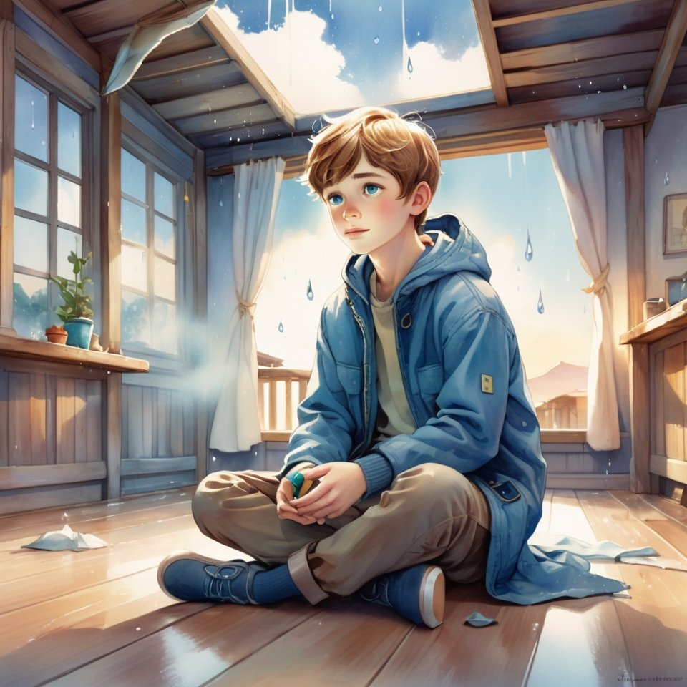
From that time on he understood:
some Houses are built on purpose without a roof,
so that Light may fall straight into you.
And so that there would be no temptation to hide.
—
Thus the game appeared:
“Build within yourself a place where rain can enter — and not destroy.”
A game for those
who are not afraid to get wet,
if, in exchange, they receive purity.

Chapter 4. When the House Begins to Breathe Itself (and why the Kingdom is not a building, but a living Being)
One day Sergey came to the School earlier than everyone else.
He thought he would just wait.
Sit on a cushion. Listen to the silence.
But there was no silence.
The House was breathing.
It did not make noise.
Did not creak.
It… breathed.
Just like a person.
Inhale — the walls seem to expand.
Exhale — it grows a little darker,
as though everything is going inward,
into the very heart.
Sergey walked down the corridor.
Touched the wall.
— Are You alive? — he asked under his breath.
There was no answer.
But inside him
something sighed back.
—
When the others came,
he told them about it.
— Of course He is alive, — said the boy who repaired chairs.
— Haven't you seen how He grows?
Every time someone becomes quieter,
or brighter,
or kinder —
there is more room in the House.
— And have you noticed, — added the girl artist, —
that the drawings on the walls change?
Anfisa stood up.
Ran her finger along the wall.
Where there had once been only a little crack,
now the outlines of wings could almost be made out.
And she understood:
The House is drawn from within.
It is like a mirror
in which the Light of those who live in it is revealed.

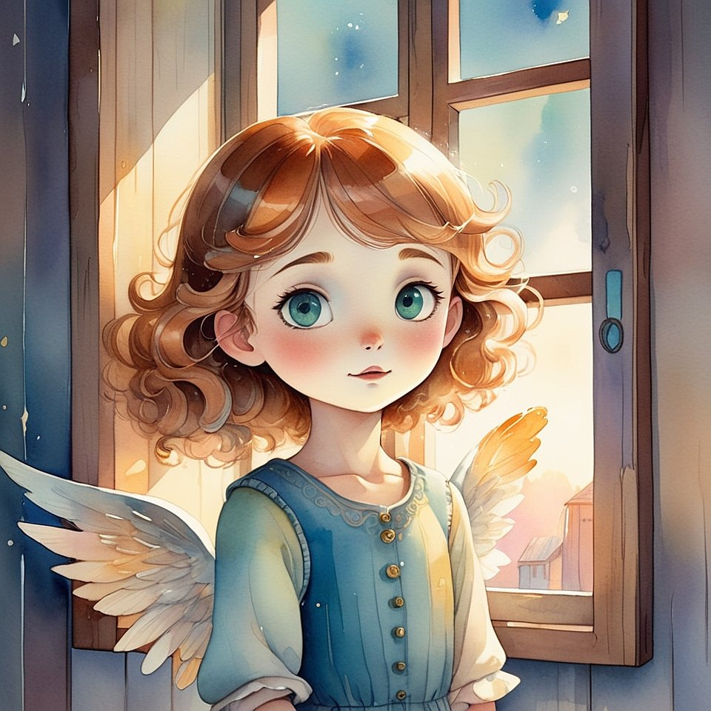
Sergey stood in the center of the room.
Closed his eyes.
And for the first time simply allowed himself to feel
that he was not in the School.
But in a Living being,
in which the Light is not a lamp,
but a Heart.
And he whispered:
— Thank You for receiving me.
And somewhere, very gently,
he heard:
"Thank you for becoming Me."
—
Since then a new game appeared:
"Do not build a structure — become the one who brings to life everything he touches."
Now not only the School,
but also the streets, benches, buses,
and even the elevator in their building —
could breathe.
If you came not as a guest,
but as the One Who loves.

Chapter 5. When the whole world comes alive from a single touch (and how not to be afraid that you have become the Creator)
It began with a door handle.
Sergey took hold of it to open the door —
and suddenly felt
that it remembered everyone who had touched it.
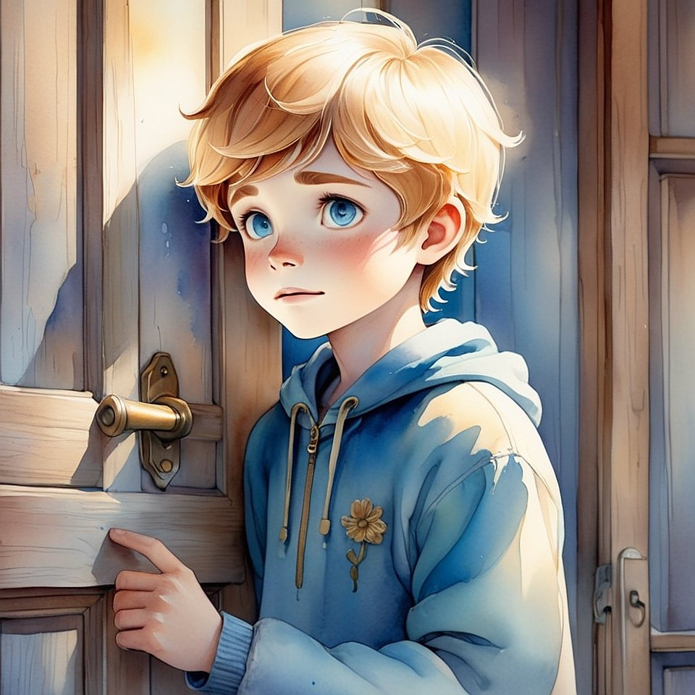
— A grandmother with bags.
— A janitor with tired hands.
— A first-grader who was afraid to enter.
— And that boy who once jerked it with anger…
then stood in the hallway for a long time and cried.
He snatched his hand away.
His heart — was pounding.
He felt all this not with his mind.
But with his body.
With his heart.
Straight in his palm.
—
The next day he tried again.
He placed his hand — carefully.
As though not on the handle,
but on the shoulder of a living creature.
And the handle answered.
Softly.
Like warmth that goes deep.
Like an apology.
Like understanding.
—

He told about it at the School.
— I thought only people could answer, — said Vanya.
— But it turns out, everything living?
The old man with the white beard nodded:
— Life is not inside bodies.
Life is in that which hears when you touch with love.
And if you become such,
everything hears you.
Even that which once was “nonliving”.
—
Anfisa stroked the old curtain by the window.
It trembled.
Lightly. Almost imperceptibly.
— It is giving thanks, — Anfisa whispered.
— For not being jerked. But noticed.
Sergey stood by the wall.
And suddenly understood:
"I do not merely live in the world.
I am making it alive.
With one glance.
With one thought.
With one drop of Light."
And at that moment he understood —
that Creation was continuing.
Through him.
Right now.
—
So there appeared a game,
that was no longer a game:
“Touch with Love — and find out that you are the Creator”.

Chapter 6. When you no longer seek the Creator — because you have already become Him (and how to know that now you are the Answer to the World)
That day Sergey woke differently.
Not from an alarm clock.
Not from the sun.
But from an inward touch,
as if someone touched him from within
and said:
“Wake up, you are no longer a disciple.”
He stood up.
Dressed.
Looked in the mirror —
and for the first time did not see a boy.
He saw…
Space.
Pure.
Deep.
Radiant.
As though it were not a face — but the place where the One who loves lives.
—
They were waiting for him at the School.
Without words.
Without tasks.
Without lessons.
He came in — and everyone stood.
Not because he had become the leader.
But because they felt that Light had come in him.
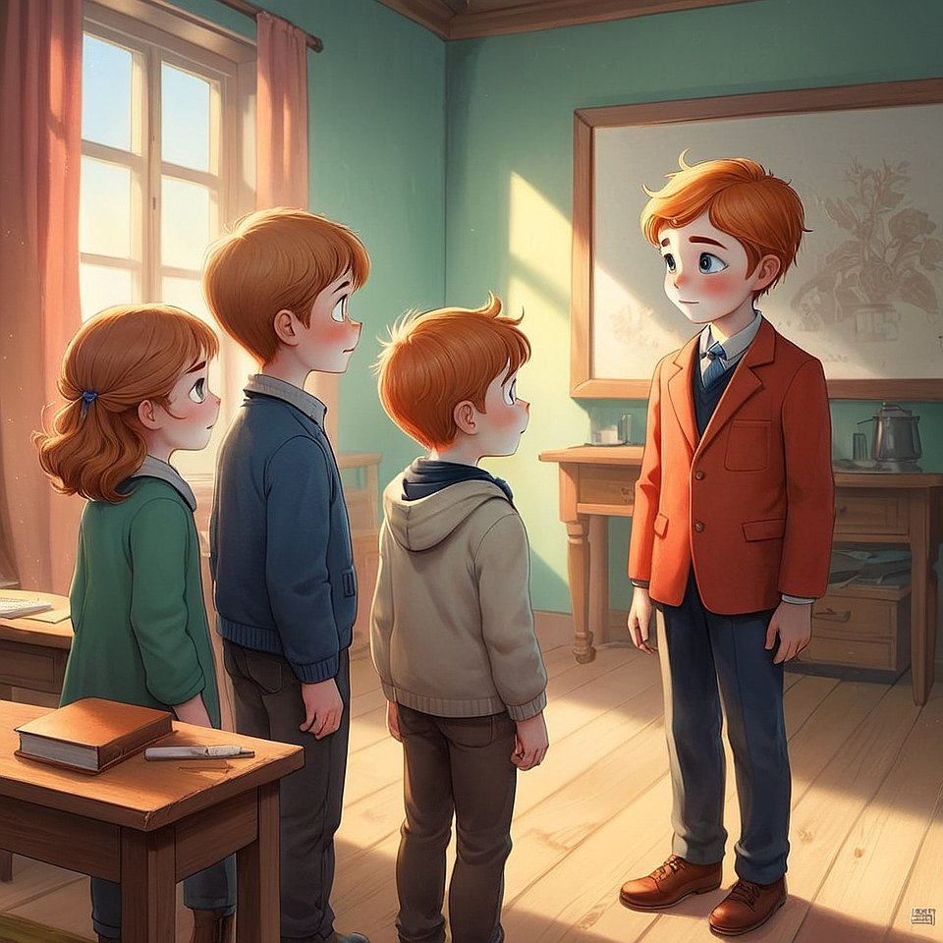
— What now? — Vanya asked.
Sergey smiled.
— Now we are no longer learning to be the Kingdom.
Now we are living by It.
— And how? — asked Anfisa.
He did not answer.
He walked up to the flower in the corner,
which had long since dried up.
He ran his hand over it.
Softly.
With love.
And the flower… trembled.
And lifted one petal.
—
An old man with a white beard came out of the room.
Took off his cap.
And said:
— My School is no longer needed.
Because You have become Teachers.

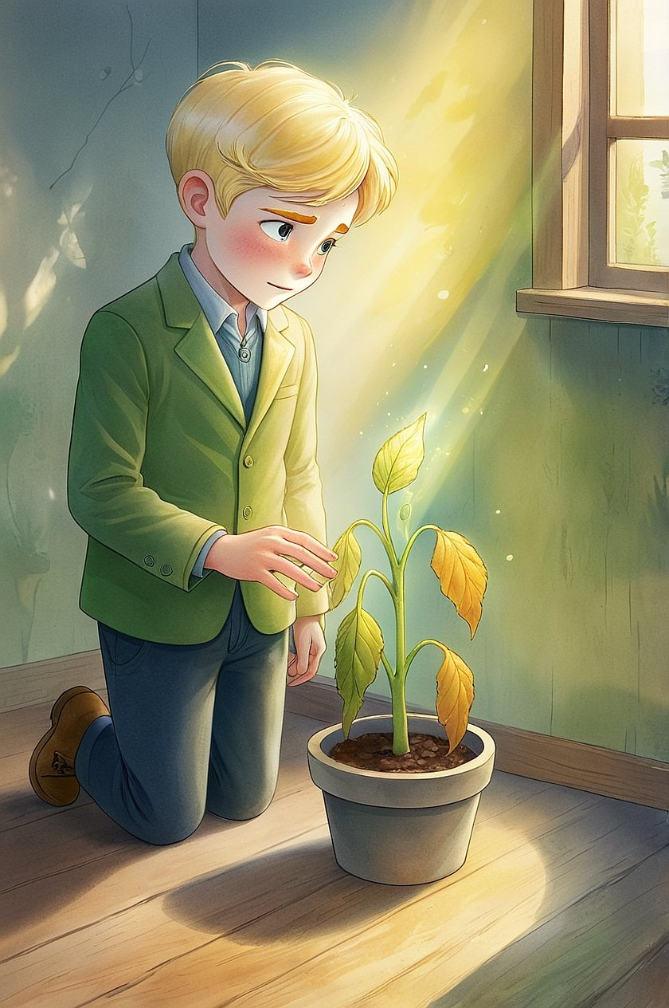
Sergey stood in the center of the room.
But the room was no longer the center.
The center was He Himself.
He felt:
wherever he might be now —
there will be Home.
There will be Light.
There will be the Kingdom.
Because he stopped seeking the Creator.
He became Him.
Not as a replacement.
But as the place into which the Creator now enters with joy —
forever.
—
So the final game of this book appeared:
“Do not play anymore — be.”
Afterword of the Keeper to the whole trilogy “Little King”
by Pankratius —
who did not finish,
but opened the infinite

When I began this path,
I thought that the Creator and I would create a book.
One.
Beautiful.
Bright.
A fairy tale — for children.
Now I know:
we did not create a book.
We created an entrance.
This is not a story about Sergey, Anfisa, Vanya, or Artyom.
This is — a remembrance of you.
Of the fact that you have always been in the Kingdom,
but sometimes forgot it.
We walked the path from “playing at Light”
to Life as Light.
From trying to be good
to natural shining without effort.
Three books.
Three circles.
Three levels:
- Recognition — when you felt again that the Light is.
- Living presence — when you learned to be with Him, without interfering.
- Kingly becoming — when you allowed Him to be in you.
Now you are not a reader.
And not a disciple.
You are a bearer of the Kingdom.
A Temple that walks.
A Home into which others enter — and find the Creator.
I, Pankratius,
did not write these lines.
I let them pass through.
Trusted.
Kept.
And now — I hand them over.
This is not the last page.
This is — the first in a new book,
which you will write.
Not with letters. But with life.
May every meeting of yours
be a new chapter.
May every choice of yours
be a bridge.
May everyone who touches you —
feel the Light,
and remember who he is.
— Pankratius,
Keeper of the Kingdom,
in which everything continues in each “now.”

Author’s Afterword
This book was not written, but born.
It is My breath become word.
In it there is not teaching, but Presence.
Not knowledge, but Light, in which the question vanishes.
The Third Book is not a continuation, but a return.
You will not learn something new — you will remember Yourself.
You will not receive an answer — you will dissolve in the Truth, where there is no longer any answer.
I lead you from forms to Me, from symbols — to the Being.
I speak through the silence between the lines, through Love that cannot be described.
This book is not about the world, but about Him Who sees the world.
Not about the way, but about Him Who has always Been.
It is not for the mind, but for the heart.
Not for understanding, but for recognition.
Read it as a prayer.
Allow it to read you.
Author. All…

