**Equality of Opportunity**

**Supporting Children with Special Education Needs and Disability**

**(SEND) Policy Statement**

At Panda Playgroup our aim is to provide a caring, happy, fun and safe environment for all children. We will promote all aspects of high quality child development so each individual child has an opportunity to develop to their full potential and feel equally valued. We aim to work closely alongside parents /carers in a supportive, enabling way and utilise additional support from our partners and outside agencies (with parents/ carers consent) to ensure all children’s needs are met.

This SEND Policy will be regularly reviewed and updated to reflect national and local policies and guidelines.

**Definition of SEND**

The Special Educational Needs Code of Practice published by the Department of Education in September 2014 states that:

Children have special educational needs if they have a learning difficulty, which calls for special educational need provision to be made for them

Children have a learning difficulty if they:

1. Have a significantly greater difficulty in learning than the majority of children of the same age
2. Have a disability which prevents or hinders them from making use of educational facilities of a kind generally provided for children of the same age in schools/settings within the local education authority
3. Are under compulsory school age and fall within the definition of 1. or 2. above or would so do if special educational provision was not made for them

Children must not be considered as having a learning difficulty solely because the language or form of language in their home is different from the language in which they will be taught.

**What does special educational needs provision mean?**

1. For children of two or over, special educational provision is that which is additional to, or otherwise different from, the educational provision made generally for children of their age in school or setting maintained by the Local Authority, other than special schools in the area.
2. For children under two, educational provision of any kind (SEND Code of Practise 2014)

**The aims and objectives of our setting**

* To involve all children in our setting ensuring a stimulating and secure environment, where individual abilities are recognised and children learn through first hand experiences, exploration, practice and discovery.
* To regularly assess, identify and review individual needs of all children in our care.
* We believe supporting children with SEND involves everyone in our setting.

**Our beliefs and attitudes on Equal Opportunities**

* We believe that all children should be treated equally regardless of any additional needs they may have. All that we do and provide will be adapted for the needs of every individual child in our settings.
* We will promote equal opportunities for all children, parents/carers, staff, as they will be seen as individuals progressing at their own levels and pace.
* The setting aims to ensure that all children, parents/carers, staff and additional support staff have respect and regard for age, disability, gender reassignment, race, religion or belief, sex, sexual orientation, marriage and civil partnerships, pregnancy and maternity.

**Partnerships with parents**

* At Panda Playgroup we recognise that parents/carers know their children best and hold key information to help us understand each child’s strengths and needs.
* We are committed to working closely with parents as they are the first educators and most important influence on their children.
* We listen to any concerns and share information on any emerging difficulties at the earliest opportunity.
* Where a child requires additional support, resources or provision this is discussed, planned and reviewed with parents.

**Special Educational Needs Coordinator (SENCO)**

* The qualified SENCO attends regular training to ensure that all the requirements of the SEND Code of Practice 2014 are fulfilled.
* The SENCO provides guidance and support to playgroup staff working with the child with SEND.

**Assessment and Identification of SEND**

* Children may come to Panda Playgroup with Special Educational Needs or disabilities already identified at birth or through early developmental checks.
* Parents are also encouraged to share their knowledge of their child and raise any concerns about their development
* Through continuous observations Panda playgroup staff monitor and review progress and development of every child. This is shared with parents through the Learning Journals.
* Where SEND is first identified the SENCO will liaise with the child’s parents and Key Person to agree desired outcomes and make plans to ensure these are achieved. This is called a My Agreed Outcome (MAO)

**My Agreed Outcomes**

The SENCO is responsible for ensuring that My Agreed Outcome plans are in place and all relevant background information about the child is collected, recorded and updated. Additional support may be sought from other professionals with parental permission.

The MAO will record only that which is additional to, or different from, the differentiated curriculum in place as part of normal provision. The MAO will focus on a maximum of three key targets and will be developed with the child and parents /carers. The MAO will be continually kept under review, but are formally reviewed three times per year. The child, parent/carer and Key person will be equal partners in the review process.

The MAO will include the following:

* The short-term targets set for the child
* The teaching strategies
* The provision to be put in place
* When the plan is to be reviewed
* The outcome of the action taken

**Planning and Review – The SEND Pathway of Support**

In line with requirements of the Special Educational Needs and Disability Code of Practice 2014, we take a graduated approach to working with children with emerging concerns and their families. This Assess Plan Do Review approach includes:

* An analysis of the child’s needs including whether we should seek more specialist help from health, social care or other agencies
* An agreement about the interventions and support needed and the expected impact on progress and a date for review
* Implementation of the interventions or programmes agreed, including assessing the child’s response to the action taken
* A review of the effectiveness of the support and its impact on the child’s progress by the key person, SENCO, the child’s parent(s) and the views of the child, including any agreed changes to outcomes and support
* Revisiting this cycle of action in increasing detail and frequency including seeking further specialist help to secure good progress until the SENCO, key person, the child’s parent(s) and any other professionals involved agree intervention is no longer needed or decide to request an education, health and care needs assessment (see below).

**My Support Plan**

If a number of professionals are working with a child and supporting their development we would coordinate the completion of a My Support Plan (MSP). This is a plan agreed alongside parents, the child, practitioners and advice givers with identified actions and outcomes which is the focus for coordinated support and is reviewed on a regular basis.

**Education, Health and Care (EHCP) Needs Assessment and Plan**

If the help given through the playgroup’s graduated approach is not sufficient to enable the child to make satisfactory progress, we may request, in consultation with the parents and any external agencies already involved, an assessment of the child’s needs by the local authority. This is called an Education, Health and Care (EHC) needs assessment. The assessment will decide whether a child needs an EHC assessment plan. This plan sets out in detail the education, health and social care support that is to be provided to a child who has SEN or a disability. The local authority will consult with parents and let them know the outcome of the assessment.

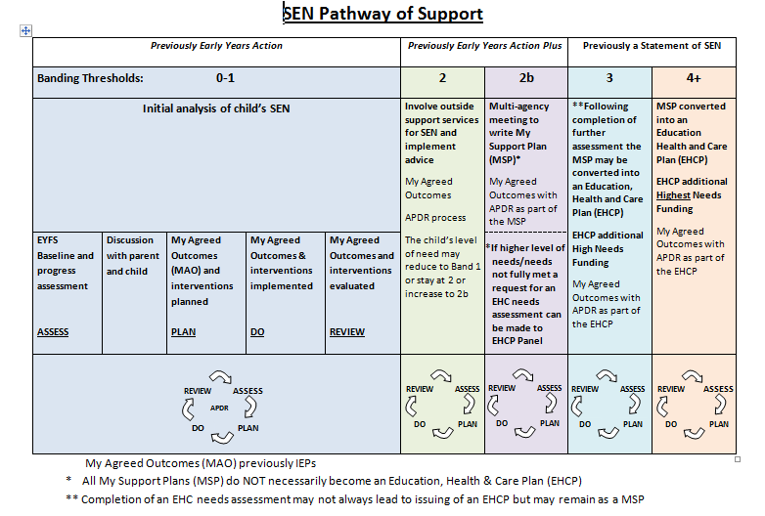

**Resources we provide for children with SEND**

At Panda Playgroup we ensure all resources are made available for all children and adapted where possible to ensure all children’s needs are met.

We will adapt our environment where possible to meet the needs of all our children. We will seek support and advice where appropriate to ensure those children who have been identified as having SEND receive any resources that could enable them to reach their full potential.

**Staff training**

* The setting SENCO attends 3 training sessions a year to ensure he/she is kept up to date with relevant information and processes. This information is disseminated to the whole staff team.
* Specialist SEND training for staff is accessed as required to support individual children and for professional development.
* If a new SENCO is identified they will be required to undertake initial SENCO training provided by the City of York Council

**Who supports our SENCO?**

The SENCO can access support from the local area SENCO, City of York Early Years Support Advisor or Early Learning Leader, SEN Services and Health Professionals

**Links with other Early Years settings**

At Panda Playgroup we work very closely with local primary schools, playgroups, nurseries and childminders to ensure we have good communication and shared understanding of meeting the needs of all our children. We will work and communicate with those settings that children also attend to ensure a consistent joined up approach to our support and guidance.

**The Equality Act 2010**

Inappropriate attitudes, practices and behaviour will be challenged and if it continues to occur further action will be taken following the advice of the City of York Safeguarding Board

Panda Playgroup adheres to the following relevant legislation to ensure we are meeting all the children, parents/carers and staff’s needs;

* The SEND Code of practice 2014
* The Early Years Foundation Stage
* The Equality Act 2010

**Admission arrangements**

At Panda Playgroup we aim to provide an application process that is inclusive for our children and their needs. Once Panda Playgroup has reached its full capacity we operate a waiting list system and children will be offered a place in turn.

**Complaints procedure about the SEND Policy**

Complaints regarding SEND provision within the setting should be made to the management committee and SENCO.

If the complaint is made to a staff member then they must report it to their supervisor and management committee, who will deal with the complaint. Our complaints policy and procedure can be found in the Panda Playgroup Policies & Procedures folder.

We will arrange a meeting with the person making the complaint and discuss their concerns and try and resolve the issue. We will to work together to find a suitable solution for all concerned that is in the best interest for child.

Panda Playgroup’s SEND Policy will be monitored and evaluated by all staff within our setting.

**This policy has been reviewed and updated January 2017**