We could see from visualization which brands are the most sought for in the ecommerce business.

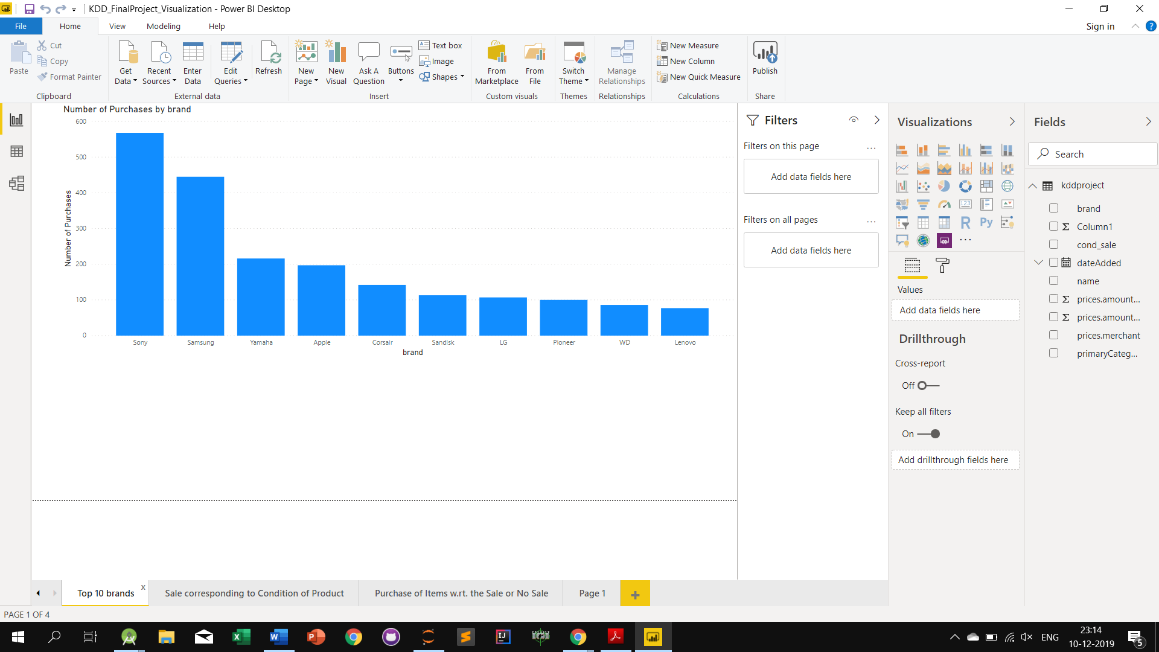

Below graph is to show the proportion of items sold wrt the item being used, new or discounted or both

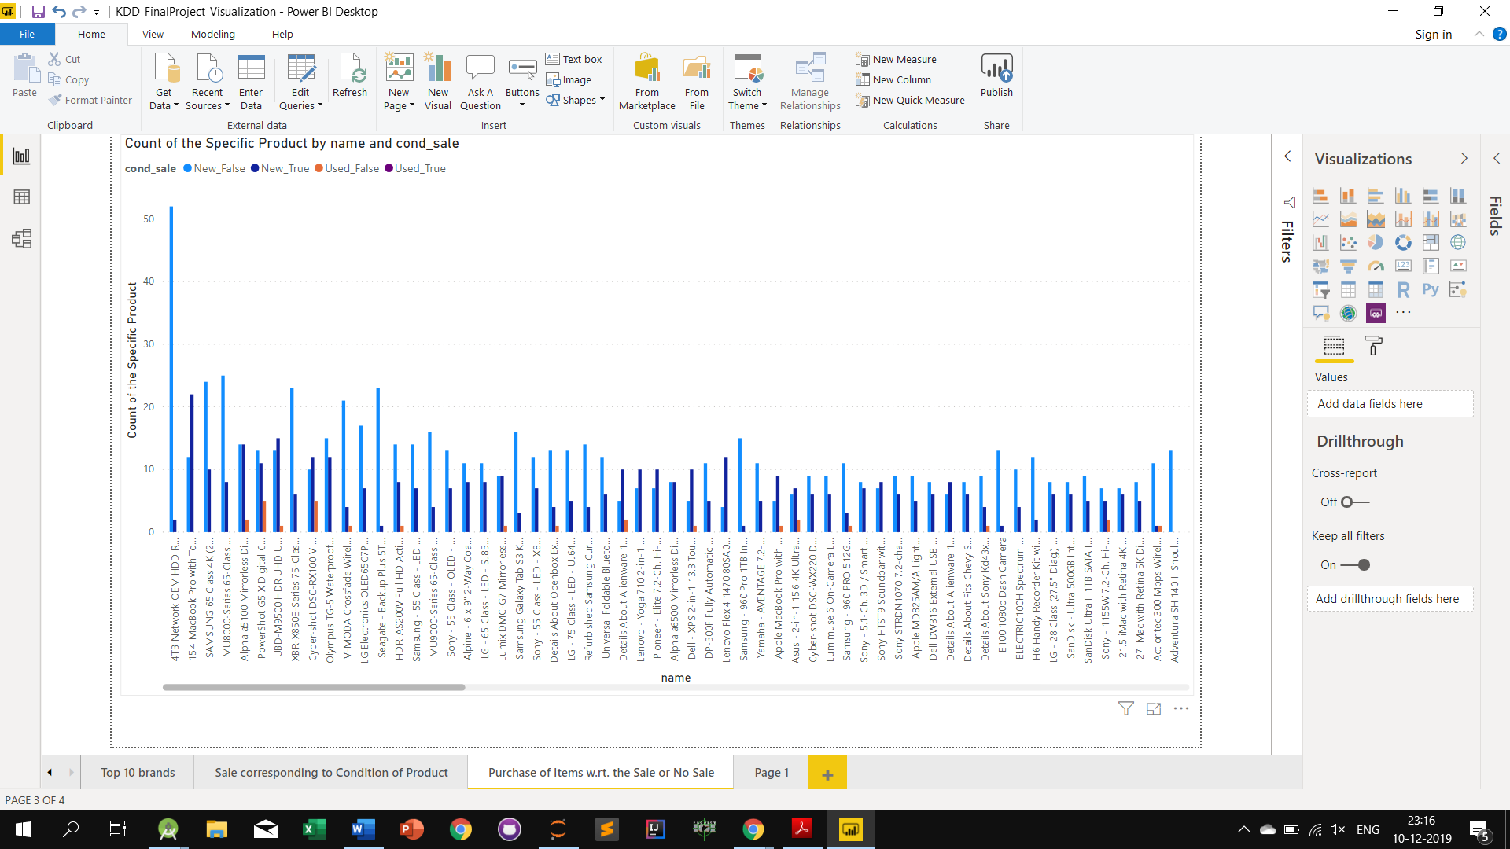

Used_False – The item is not new and also there are no discount on the item

Month November shows the max sale on this item type

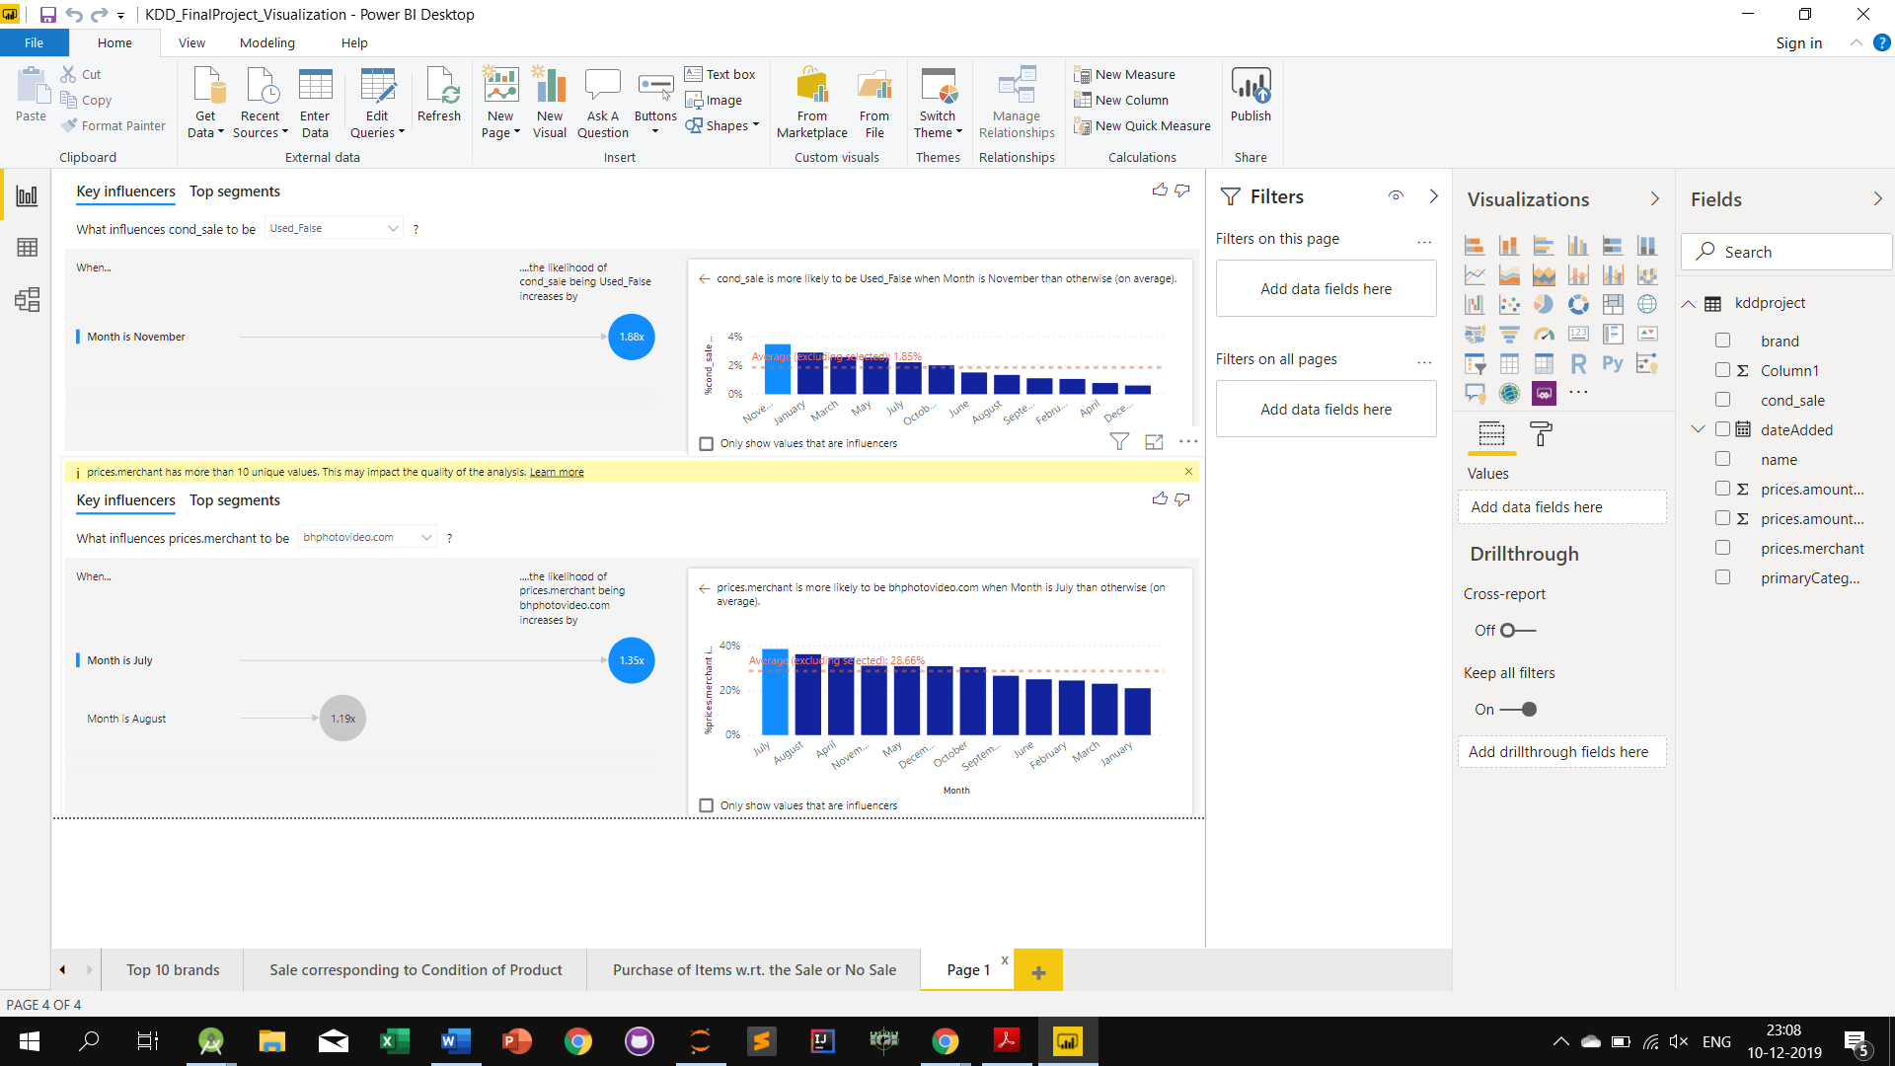

New_True – The item is new and also there are discounts on the item

Month March shows the max sale on this item type

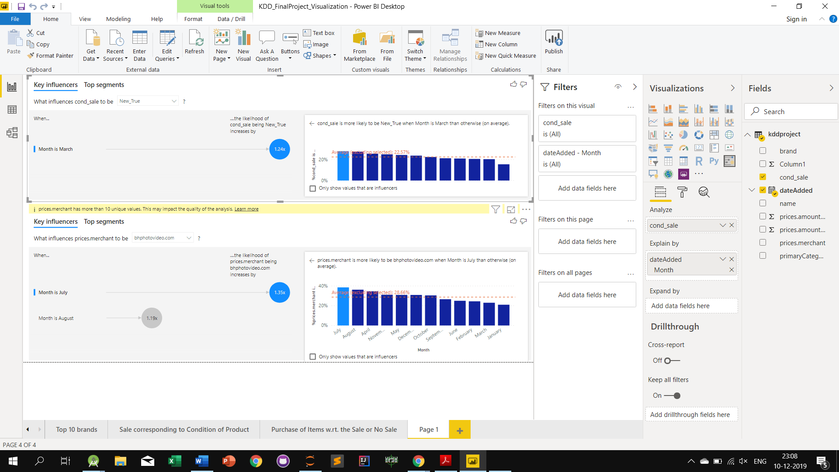

New_False – The item is new and also there are no discounts on the item

Month September shows the max sale on this item type

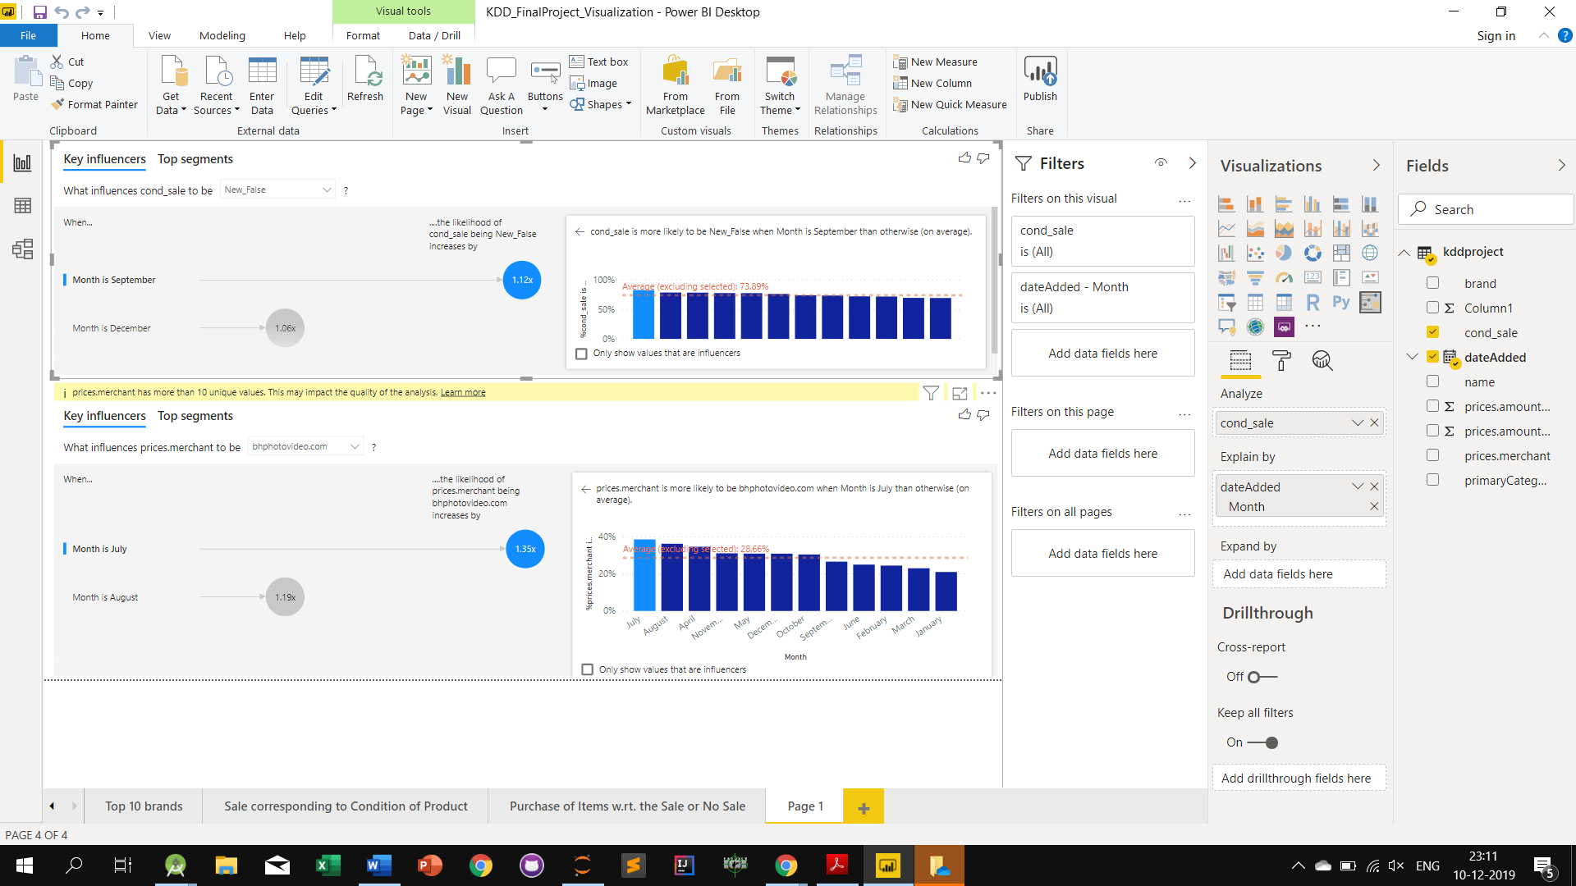

Month January shows max number of purchases from Bestbuy.com

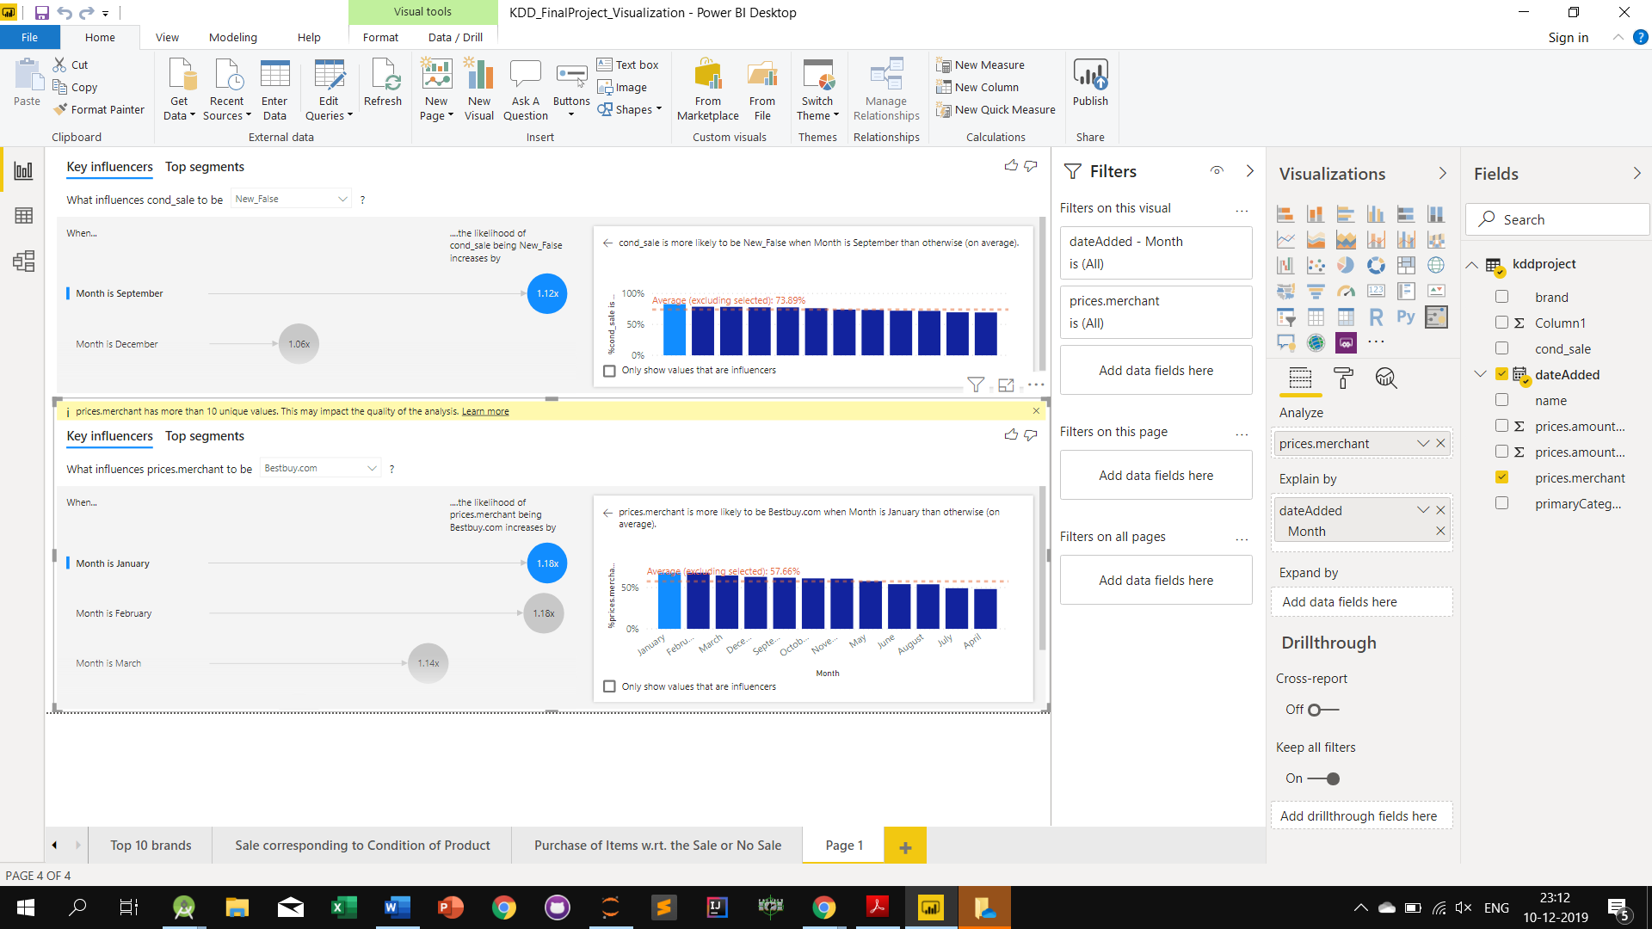

Month July shows max number of purchases from Bhpphotovideo.com

