# **Database Project**

**Student Last Name: Hao First Name: Zhang**

# **Overview**

A database will be created for a medical clinic to manage the appointments of patients, the visits and bills as well as managing the ways of payments.

# **Purpose and Objective**

The database will help the medical clinic manage the appointments from their patients, as well as their bills. For every patient, the information about name, age, gender, address, phone number and insurance information will be stored in the database. And the information of doctor will be stored either. A patient can make many appointments with one or more doctors in the clinic, and a doctor can accept appointments with many patients. However, each appointment is made with only one doctor and one patient. So, for an appointment, the name of patient, the name of doctor and visit time will be stored. If it is an emergency, the appointment time will be “unscheduled”.

If kept, an appointment yields a visit. The visit yields a diagnosis. Each visit will be stored in patients’ medical history. For medical history, information about patient name, diagnosis and date will be stored.

Each patient visit creates a bill. For a bill, information about doctor, patient, amount, payment and the deductible will be stored. And if patient has an insurance company to pay the bill, the deductible will be submitted to the payment.

## Diagram Tool

Oracle SQL Data Modeler will be used to create diagrams such as Data Flow Diagrams and Entity Relationship Diagrams.

## Database

Oracle 11g will be used to create the database. Oracle SQL Developer will be used to access the database.

## Hardware and Software

The database will be hosted on a Linux server at The George Washington University. SQL Developer will be used to access the database. For offsite access, the server will be accessed using https://vpn.gwu.edu.

**The DFD:**

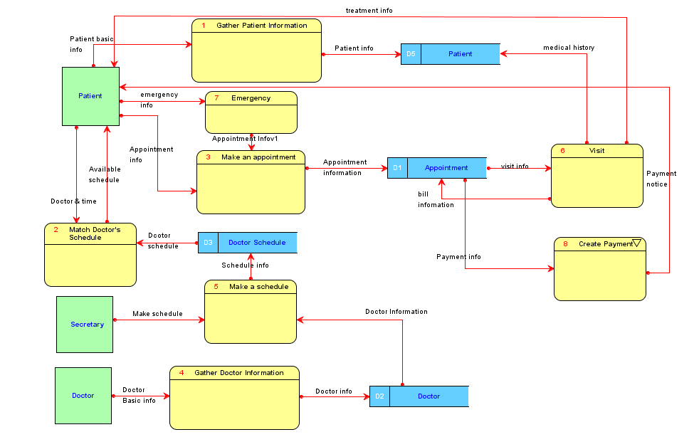

*Figure 1*: Data Flow Diagram of Clinic

**The DFD of Process “Create Payment”:**

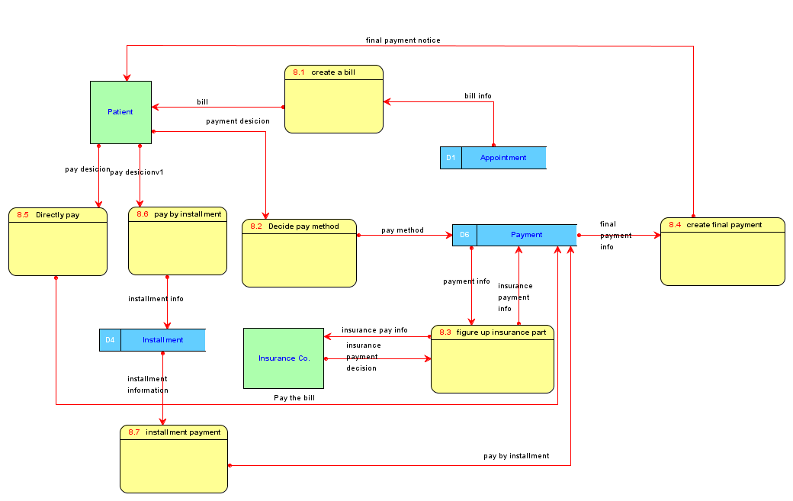

*Figure 2*: Data Flow Diagram of Create Payment

**The ERD:**

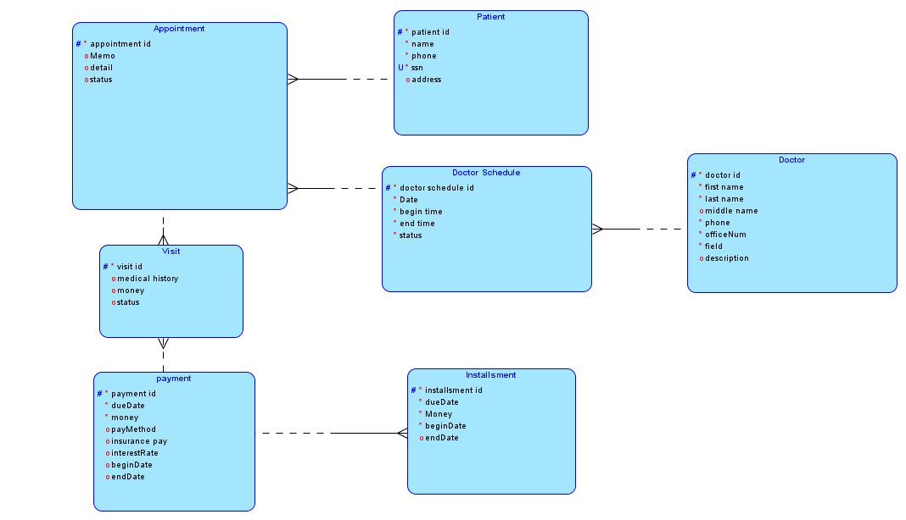

*Figure 3*: Entity-Relation Diagram

**The Dependency Diagram:**

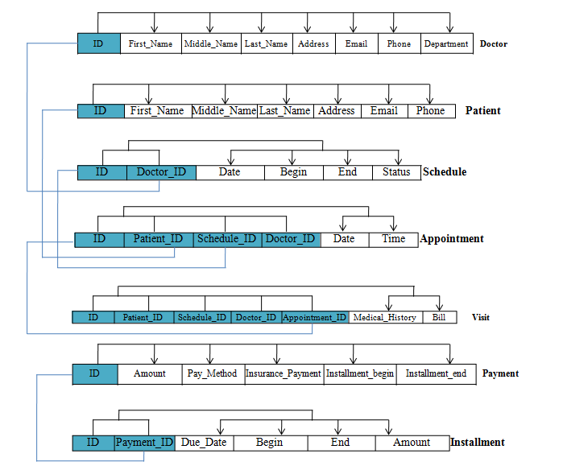

*Figure 4*: Dependency Diagram

The dependency diagram shows how attributes are dependent on the primary keys. The attributes are dependent on the primacy keys, and the transitive dependencies have been removed.

**The Relational Diagram:**

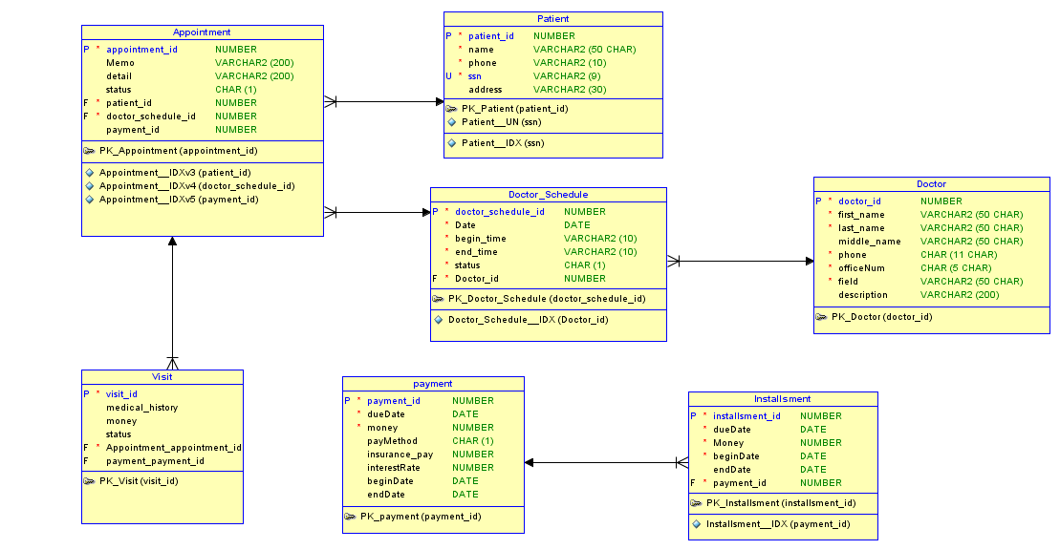

*Figure 5*: Relational Diagram

Oracle Data Modeler generated the relationship diagram after the entities have been created. The relationship diagram transited from the entity relationship diagram. The difference with the relationship diagram is it also displays primary keys, unique attributes, and foreign keys as they are created in the database. The crows-feet notations in the relationship arrow denote that the table with the crows-feet has a foreign key to the table at the other end of the relationship.

**Normalization:**

All tables were designed originally with 3rd Normal Form and BCNF Normal Form in mind. These normalization rules are enforced in all tables. According to *Database Systems: Design, Implementation, and Management,* there rules are:

1. All of key attributes are defined.
2. There are no repeating groups in the table.
3. All attributes are dependent on the primary key.
4. It includes no partial dependencies.
5. It contains no transitive dependencies.

**Physical Design Process**

**Tables**

1. Doctor
2. Patient
3. Doctor Schedule
4. Appointment
5. Visit
6. Payment
7. Installsment

**Constraints**

1. Doctor:
   1. Primary Key(doctor_id)
2. Patient:
   1. Primary Key(patient_id)
   2. UNIQUE(ssn)
3. Doctor_Schedule
   1. Primary Key(doctor_schedule_id)
   2. Foreign Key(doctor_id)
4. Appointment
   1. Primary Key(appointment_id)
   2. Foreign Key(patient_id)
   3. Foreign Key(doctor_schedule_id)
5. Visit
   1. Primary Key(visit_id)
   2. Foreign Key(appointment_id)
   3. Foreign Key(payment_id)
6. Payment
   1. Primary Key(payment_id)
7. Installsment
   1. Primary Key(installsment_id)
   2. Foreign Key(payment_id)

**Indexes**

1. Appointment

Index for doctor_ schedule_id, patient_ID.

1. Patient

Index for ssn

1. Doctor_Schedule

Index for doctor_id

1. Installsment

Index for payment_id

**Data Definition Language (DDL)**

**Create tables, sequences and triggers**

CREATE TABLE Appointment

(

appointment_id NUMBER NOT NULL ,

Memo VARCHAR2 (200) ,

detail VARCHAR2 (200) ,

status CHAR (1) ,

patient_id NUMBER NOT NULL ,

doctor_schedule_id NUMBER NOT NULL

) ;

CREATE INDEX Appointment__IDXv3 ON Appointment

( patient_id ASC

) ;

CREATE INDEX Appointment__IDXv4 ON Appointment

( doctor_schedule_id ASC

) ;

ALTER TABLE Appointment ADD CONSTRAINT PK_Appointment PRIMARY KEY

(

appointment_id

)

;

CREATE TABLE Doctor

(

doctor_id NUMBER NOT NULL ,

first_name VARCHAR2 (50 CHAR) NOT NULL ,

last_name VARCHAR2 (50 CHAR) NOT NULL ,

middle_name VARCHAR2 (50 CHAR) ,

phone CHAR (11 CHAR) NOT NULL ,

officeNum CHAR (5 CHAR) NOT NULL ,

field VARCHAR2 (50 CHAR) NOT NULL ,

description VARCHAR2 (200)

) ;

ALTER TABLE Doctor ADD CONSTRAINT PK_Doctor PRIMARY KEY

(

doctor_id

)

;

CREATE TABLE Doctor_Schedule

(

doctor_schedule_id NUMBER NOT NULL ,

"Date" DATE NOT NULL ,

begin_time VARCHAR2 (10) NOT NULL ,

end_time VARCHAR2 (10) NOT NULL ,

status CHAR (1) NOT NULL ,

Doctor_id NUMBER NOT NULL

) ;

CREATE INDEX Doctor_Schedule__IDX ON Doctor_Schedule

( Doctor_id ASC

) ;

ALTER TABLE Doctor_Schedule ADD CONSTRAINT PK_Doctor_Schedule PRIMARY KEY

(

doctor_schedule_id

)

;

CREATE TABLE Installsment

(

installsment_id NUMBER NOT NULL ,

dueDate DATE NOT NULL ,

Money NUMBER NOT NULL ,

beginDate DATE NOT NULL ,

endDate DATE ,

payment_id NUMBER NOT NULL

) ;

CREATE INDEX Installsment__IDX ON Installsment

( payment_id ASC

) ;

ALTER TABLE Installsment ADD CONSTRAINT PK_Installsment PRIMARY KEY

(

installsment_id

)

;

CREATE TABLE Patient

(

patient_id NUMBER NOT NULL ,

name VARCHAR2 (50 CHAR) NOT NULL ,

phone VARCHAR2 (10) NOT NULL ,

ssn VARCHAR2 (9) NOT NULL ,

address VARCHAR2 (30)

) ;

ALTER TABLE Patient ADD CONSTRAINT CK_Patientv1 CHECK

(

LENGTH(PHONE) = 10 AND regexp_like(PHONE, '^[[:digit:]]{10}$')

)

;

ALTER TABLE Patient ADD CONSTRAINT CK_Patient CHECK

(

LENGTH(SSN) = 9 AND regexp_like(SSN, '^[[:digit:]]{9}$')

)

;

CREATE UNIQUE INDEX Patient__IDX ON Patient

(

ssn ASC

)

;

ALTER TABLE Patient ADD CONSTRAINT PK_Patient PRIMARY KEY

(

patient_id

)

;

ALTER TABLE Patient ADD CONSTRAINT Patient__UN UNIQUE

(

ssn

)

;

CREATE TABLE Visit

(

visit_id NUMBER NOT NULL ,

medical_history VARCHAR2 (200) ,

money NUMBER ,

status NUMBER ,

Appointment_appointment_id NUMBER NOT NULL ,

payment_payment_id NUMBER

) ;

ALTER TABLE Visit ADD CONSTRAINT PK_Visit PRIMARY KEY

(

visit_id

)

;

CREATE TABLE payment

(

payment_id NUMBER NOT NULL ,

dueDate DATE NOT NULL ,

money NUMBER NOT NULL ,

payMethod CHAR (1) ,

insurance_pay NUMBER ,

interestRate NUMBER ,

beginDate DATE ,

endDate DATE

) ;

ALTER TABLE payment ADD CONSTRAINT PK_payment PRIMARY KEY

(

payment_id

)

;

ALTER TABLE Appointment ADD CONSTRAINT FK_Appointment_Doctor_Schedule FOREIGN KEY ( doctor_schedule_id ) REFERENCES Doctor_Schedule ( doctor_schedule_id ) ;

ALTER TABLE Appointment ADD CONSTRAINT FK_Appointment_Patient FOREIGN KEY ( patient_id ) REFERENCES Patient ( patient_id ) ;

ALTER TABLE Doctor_Schedule ADD CONSTRAINT FK_Doctor_Schedule_Doctor FOREIGN KEY ( Doctor_id ) REFERENCES Doctor ( doctor_id ) ;

ALTER TABLE Installsment ADD CONSTRAINT FK_Installsment_payment FOREIGN KEY ( payment_id ) REFERENCES payment ( payment_id ) ;

ALTER TABLE Visit ADD CONSTRAINT FK_Visit_Appointment FOREIGN KEY ( Appointment_appointment_id ) REFERENCES Appointment ( appointment_id ) ;

ALTER TABLE Visit ADD CONSTRAINT FK_Visit_payment FOREIGN KEY ( payment_payment_id ) REFERENCES payment ( payment_id ) ;

CREATE SEQUENCE APPOINTMENT_ID_SEQ START WITH 1 NOCACHE ORDER ;

CREATE OR REPLACE TRIGGER APPOINTMENT_ID_TRG BEFORE

INSERT ON Appointment FOR EACH ROW WHEN (NEW.appointment_id IS NULL) BEGIN

SELECT APPOINTMENT_ID_SEQ.NEXTVAL

INTO :NEW.appointment_id

FROM DUAL;

END;

/

CREATE SEQUENCE DOCTOR_ID_SEQ START WITH 1 NOCACHE ORDER ;

CREATE OR REPLACE TRIGGER DOCTOR_ID_TRG BEFORE

INSERT ON Doctor FOR EACH ROW WHEN (NEW.doctor_id IS NULL) BEGIN

SELECT DOCTOR_ID_SEQ.NEXTVAL INTO :NEW.doctor_id FROM DUAL;

END;

/

CREATE SEQUENCE DOCTOR_SCHEDULE_ID_SEQ START WITH 1 NOCACHE ORDER ;

CREATE OR REPLACE TRIGGER DOCTOR_SCHEDULE_ID_TRG BEFORE

INSERT ON Doctor_Schedule FOR EACH ROW WHEN (NEW.doctor_schedule_id IS NULL) BEGIN

SELECT DOCTOR_SCHEDULE_ID_SEQ.NEXTVAL

INTO :NEW.doctor_schedule_id

FROM DUAL;

END;

/

CREATE SEQUENCE INSTALLSMENT_ID_SEQ START WITH 1 NOCACHE ORDER ;

CREATE OR REPLACE TRIGGER INSTALLSMENT_ID_TRG BEFORE

INSERT ON Installsment FOR EACH ROW WHEN (NEW.installsment_id IS NULL) BEGIN

SELECT INSTALLSMENT_ID_SEQ.NEXTVAL

INTO :NEW.installsment_id

FROM DUAL;

END;

/

CREATE SEQUENCE PATIENT_ID_SEQ START WITH 1 NOCACHE ORDER ;

CREATE OR REPLACE TRIGGER PATIENT_ID_TRG BEFORE

INSERT ON Patient FOR EACH ROW WHEN (NEW.patient_id IS NULL) BEGIN

SELECT PATIENT_ID_SEQ.NEXTVAL INTO :NEW.patient_id FROM DUAL;

END;

/

CREATE SEQUENCE VISIT_ID_SEQ START WITH 1 NOCACHE ORDER ;

CREATE OR REPLACE TRIGGER VISIT _ID_TRG BEFORE

INSERT ON Visit FOR EACH ROW WHEN (NEW.visit _id IS NULL) BEGIN

SELECT APPOINTMENT_ID_SEQ.NEXTVAL

INTO :NEW. visit _id

FROM DUAL;

END;

/

CREATE SEQUENCE PAYMENT_ID_SEQ START WITH 1 NOCACHE ORDER ;

CREATE OR REPLACE TRIGGER PAYMENT_ID_TRG BEFORE

INSERT ON payment FOR EACH ROW WHEN (NEW.payment_id IS NULL) BEGIN

SELECT PAYMENT_ID_SEQ.NEXTVAL INTO :NEW.payment_id FROM DUAL;

END;

**Insert Data**

INSERT INTO DOCTOR (DOCTOR_ID,FIRST_NAME, LAST_NAME, PHONE, OFFICENUM, FIELD, DESCRIPTION) VALUES (DOCTOR_ID_SEQ.NEXTVAL,'Hao', 'Zhang', '5712163655', '2', 'physical', 'nice');

INSERT INTO DOCTOR (DOCTOR_ID,FIRST_NAME, LAST_NAME, PHONE, OFFICENUM, FIELD, DESCRIPTION) VALUES (DOCTOR_ID_SEQ.NEXTVAL,'Hao', 'Zhang', '5712163655', '3', 'heart', 'nice');

INSERT INTO DOCTOR (DOCTOR_ID,FIRST_NAME, LAST_NAME, PHONE, OFFICENUM, FIELD, DESCRIPTION) VALUES (DOCTOR_ID_SEQ.NEXTVAL,'Hao1', 'Zhang', '5712163655', '4', 'brain', 'nice');

INSERT INTO DOCTOR (DOCTOR_ID,FIRST_NAME, LAST_NAME, PHONE, OFFICENUM, FIELD, DESCRIPTION) VALUES (DOCTOR_ID_SEQ.NEXTVAL,'Hao2', 'Zhang', '5712163655', '5', 'nose', 'nice');

INSERT INTO DOCTOR (DOCTOR_ID,FIRST_NAME, LAST_NAME, PHONE, OFFICENUM, FIELD, DESCRIPTION) VALUES (DOCTOR_ID_SEQ.NEXTVAL,'Hao3', 'Zhang', '5712163655', '6', 'eye', 'nice');

INSERT INTO DOCTOR (DOCTOR_ID,FIRST_NAME, LAST_NAME, PHONE, OFFICENUM, FIELD, DESCRIPTION) VALUES (DOCTOR_ID_SEQ.NEXTVAL,'Hao4', 'Zhang', '5712163655', '7', 'ear', 'nice');

INSERT INTO DOCTOR (DOCTOR_ID,FIRST_NAME, LAST_NAME, PHONE, OFFICENUM, FIELD, DESCRIPTION) VALUES (DOCTOR_ID_SEQ.NEXTVAL,'Hao5', 'Zhang', '5712163655', '8', 'mouse', 'nice');

INSERT INTO DOCTOR (DOCTOR_ID,FIRST_NAME, LAST_NAME, PHONE, OFFICENUM, FIELD, DESCRIPTION) VALUES (DOCTOR_ID_SEQ.NEXTVAL,'Hao6', 'Zhang', '5712163655', '9', 'face', 'nice');

INSERT INTO DOCTOR_SCHEDULE (DOCTOR_SCHEDULE_ID,"Date", BEGIN_TIME, END_TIME, STATUS, DOCTOR_ID) VALUES (DOCTOR_SCHEDULE_ID_SEQ.NEXTVAL,TO_DATE('14-NOV-13', 'DD-MON-RR'), '8am', '9am', '0', '1');

INSERT INTO DOCTOR_SCHEDULE (DOCTOR_SCHEDULE_ID,"Date", BEGIN_TIME, END_TIME, STATUS, DOCTOR_ID) VALUES (DOCTOR_SCHEDULE_ID_SEQ.NEXTVAL,TO_DATE('14-NOV-13', 'DD-MON-RR'), '9am', '10am', '0', '1');

INSERT INTO DOCTOR_SCHEDULE (DOCTOR_SCHEDULE_ID,"Date", BEGIN_TIME, END_TIME, STATUS, DOCTOR_ID) VALUES (DOCTOR_SCHEDULE_ID_SEQ.NEXTVAL,TO_DATE('14-NOV-13', 'DD-MON-RR'), '10am', '11am', '0', '1');

INSERT INTO DOCTOR_SCHEDULE (DOCTOR_SCHEDULE_ID,"Date", BEGIN_TIME, END_TIME, STATUS, DOCTOR_ID) VALUES (DOCTOR_SCHEDULE_ID_SEQ.NEXTVAL,TO_DATE('14-NOV-13', 'DD-MON-RR'), '1pm', '2pm', '0', '1');

INSERT INTO DOCTOR_SCHEDULE (DOCTOR_SCHEDULE_ID,"Date", BEGIN_TIME, END_TIME, STATUS, DOCTOR_ID) VALUES (DOCTOR_SCHEDULE_ID_SEQ.NEXTVAL,TO_DATE('15-NOV-13', 'DD-MON-RR'), '8am', '9am', '0', '2');

INSERT INTO DOCTOR_SCHEDULE (DOCTOR_SCHEDULE_ID,"Date", BEGIN_TIME, END_TIME, STATUS, DOCTOR_ID) VALUES (DOCTOR_SCHEDULE_ID_SEQ.NEXTVAL,TO_DATE('15-NOV-13', 'DD-MON-RR'), '9am', '10am', '0', '2');

INSERT INTO DOCTOR_SCHEDULE (DOCTOR_SCHEDULE_ID,"Date", BEGIN_TIME, END_TIME, STATUS, DOCTOR_ID) VALUES (DOCTOR_SCHEDULE_ID_SEQ.NEXTVAL,TO_DATE('15-NOV-13', 'DD-MON-RR'), '10am', '11am', '0', '2');

INSERT INTO DOCTOR_SCHEDULE (DOCTOR_SCHEDULE_ID,"Date", BEGIN_TIME, END_TIME, STATUS, DOCTOR_ID) VALUES (DOCTOR_SCHEDULE_ID_SEQ.NEXTVAL,TO_DATE('15-NOV-13', 'DD-MON-RR'), '1pm', '2pm', '0', '2');

INSERT INTO DOCTOR_SCHEDULE (DOCTOR_SCHEDULE_ID,"Date", BEGIN_TIME, END_TIME, STATUS, DOCTOR_ID) VALUES (DOCTOR_SCHEDULE_ID_SEQ.NEXTVAL,TO_DATE('14-NOV-13', 'DD-MON-RR'), '8am', '9am', '0', '3');

INSERT INTO DOCTOR_SCHEDULE (DOCTOR_SCHEDULE_ID,"Date", BEGIN_TIME, END_TIME, STATUS, DOCTOR_ID) VALUES (DOCTOR_SCHEDULE_ID_SEQ.NEXTVAL,TO_DATE('14-NOV-13', 'DD-MON-RR'), '9am', '10am', '0', '3');

INSERT INTO DOCTOR_SCHEDULE (DOCTOR_SCHEDULE_ID,"Date", BEGIN_TIME, END_TIME, STATUS, DOCTOR_ID) VALUES (DOCTOR_SCHEDULE_ID_SEQ.NEXTVAL,TO_DATE('14-NOV-13', 'DD-MON-RR'), '10am', '11am', '0', '3');

INSERT INTO DOCTOR_SCHEDULE (DOCTOR_SCHEDULE_ID,"Date", BEGIN_TIME, END_TIME, STATUS, DOCTOR_ID) VALUES (DOCTOR_SCHEDULE_ID_SEQ.NEXTVAL,TO_DATE('14-NOV-13', 'DD-MON-RR'), '1pm', '2pm', '0', '3');

INSERT INTO DOCTOR_SCHEDULE (DOCTOR_SCHEDULE_ID,"Date", BEGIN_TIME, END_TIME, STATUS, DOCTOR_ID) VALUES (DOCTOR_SCHEDULE_ID_SEQ.NEXTVAL,TO_DATE('15-NOV-13', 'DD-MON-RR'), '8am', '9am', '0', '4');

INSERT INTO DOCTOR_SCHEDULE (DOCTOR_SCHEDULE_ID,"Date", BEGIN_TIME, END_TIME, STATUS, DOCTOR_ID) VALUES (DOCTOR_SCHEDULE_ID_SEQ.NEXTVAL,TO_DATE('15-NOV-13', 'DD-MON-RR'), '9am', '10am', '0', '4');

INSERT INTO DOCTOR_SCHEDULE (DOCTOR_SCHEDULE_ID,"Date", BEGIN_TIME, END_TIME, STATUS, DOCTOR_ID) VALUES (DOCTOR_SCHEDULE_ID_SEQ.NEXTVAL,TO_DATE('15-NOV-13', 'DD-MON-RR'), '10am', '11am', '0', '4');

INSERT INTO DOCTOR_SCHEDULE (DOCTOR_SCHEDULE_ID,"Date", BEGIN_TIME, END_TIME, STATUS, DOCTOR_ID) VALUES (DOCTOR_SCHEDULE_ID_SEQ.NEXTVAL,TO_DATE('15-NOV-13', 'DD-MON-RR'), '1pm', '2pm', '0', '4');

INSERT INTO PATIENT (PATIENT_ID,NAME, PHONE, SSN, ADDRESS) VALUES (PATIENT_ID_SEQ.NEXTVAL,'A', '5712163655', '111222333', '1900');

INSERT INTO PATIENT (PATIENT_ID,NAME, PHONE, SSN, ADDRESS) VALUES (PATIENT_ID_SEQ.NEXTVAL,'B', '5712163655', '111222334', '1900');

INSERT INTO PATIENT (PATIENT_ID,NAME, PHONE, SSN, ADDRESS) VALUES (PATIENT_ID_SEQ.NEXTVAL,'C', '5712163655', '111222335', '1900');

INSERT INTO PATIENT (PATIENT_ID,NAME, PHONE, SSN, ADDRESS) VALUES (PATIENT_ID_SEQ.NEXTVAL,'D', '5712163655', '111222336', '1900');

INSERT INTO PATIENT (PATIENT_ID,NAME, PHONE, SSN, ADDRESS) VALUES (PATIENT_ID_SEQ.NEXTVAL,'E', '5712163655', '111222337', '1900');

INSERT INTO PATIENT (PATIENT_ID,NAME, PHONE, SSN, ADDRESS) VALUES (PATIENT_ID_SEQ.NEXTVAL,'F', '5712163655', '111222338', '1900');

INSERT INTO PATIENT (PATIENT_ID,NAME, PHONE, SSN, ADDRESS) VALUES (PATIENT_ID_SEQ.NEXTVAL,'G', '5712163655', '111222339', '1900');

INSERT INTO PAYMENT (PAYMENT_ID,DUEDATE, MONEY, PAYMETHOD, INSURANCE_PAY, INTERESTRATE, BEGINDATE, ENDDATE) VALUES (PAYMENT_ID_SEQ.NEXTVAL,TO_DATE('30-NOV-13', 'DD-MON-RR'), '60000', '0', '30000', '5', TO_DATE('14-NOV-13', 'DD-MON-RR'), TO_DATE('20-NOV-13', 'DD-MON-RR'));

INSERT INTO PAYMENT (PAYMENT_ID,DUEDATE, MONEY, PAYMETHOD, INSURANCE_PAY, INTERESTRATE, BEGINDATE, ENDDATE) VALUES (PAYMENT_ID_SEQ.NEXTVAL,TO_DATE('30-NOV-13', 'DD-MON-RR'), '50000', '0', '20000', '4', TO_DATE('14-NOV-13', 'DD-MON-RR'), TO_DATE('20-NOV-13', 'DD-MON-RR'));

INSERT INTO PAYMENT (PAYMENT_ID,DUEDATE, MONEY, PAYMETHOD, INSURANCE_PAY, INTERESTRATE, BEGINDATE, ENDDATE) VALUES (PAYMENT_ID_SEQ.NEXTVAL,TO_DATE('30-NOV-13', 'DD-MON-RR'), '40000', '0', '10000', '3', TO_DATE('14-NOV-13', 'DD-MON-RR'), TO_DATE('20-NOV-13', 'DD-MON-RR'));

INSERT INTO PAYMENT (PAYMENT_ID,DUEDATE, MONEY, PAYMETHOD, INSURANCE_PAY, INTERESTRATE, BEGINDATE, ENDDATE) VALUES (PAYMENT_ID_SEQ.NEXTVAL,TO_DATE('30-NOV-13', 'DD-MON-RR'), '30000', '0', '15000', '2', TO_DATE('14-NOV-13', 'DD-MON-RR'), TO_DATE('20-NOV-13', 'DD-MON-RR'));

INSERT INTO APPOINTMENT (APPOINTMENT_ID,MEMO, DETAIL, STATUS, PATIENT_ID, DOCTOR_SCHEDULE_ID, PAYMENT_ID) VALUES (APPOINTMENT_ID_SEQ.NEXTVAL,'hurry', '20', 'a,b,c', '0', '1', '1', '1');

INSERT INTO APPOINTMENT (APPOINTMENT_ID,MEMO, DETAIL, STATUS, PATIENT_ID, DOCTOR_SCHEDULE_ID, PAYMENT_ID) VALUES (APPOINTMENT_ID_SEQ.NEXTVAL,'hurry', 'a,b,c', '0', '1', '2', '1');

INSERT INTO APPOINTMENT (APPOINTMENT_ID,MEMO, DETAIL, STATUS, PATIENT_ID, DOCTOR_SCHEDULE_ID, PAYMENT_ID) VALUES (APPOINTMENT_ID_SEQ.NEXTVAL,'hurry', 'a,b,c', '0', '1', '3', '1');

INSERT INTO APPOINTMENT (APPOINTMENT_ID,MEMO, DETAIL, STATUS, PATIENT_ID, DOCTOR_SCHEDULE_ID, PAYMENT_ID) VALUES (APPOINTMENT_ID_SEQ.NEXTVAL,'hurry', 'a,b,c', '0', '1', '4', '1');

INSERT INTO APPOINTMENT (APPOINTMENT_ID,MEMO, DETAIL, STATUS, PATIENT_ID, DOCTOR_SCHEDULE_ID, PAYMENT_ID) VALUES (APPOINTMENT_ID_SEQ.NEXTVAL,'hurry', 'a,b,c', '0', '2', '5', '2');

INSERT INTO APPOINTMENT (APPOINTMENT_ID,MEMO, DETAIL, STATUS, PATIENT_ID, DOCTOR_SCHEDULE_ID, PAYMENT_ID) VALUES (APPOINTMENT_ID_SEQ.NEXTVAL,'hurry', 'a,b,c', '0', '2', '6', '2');

INSERT INTO APPOINTMENT (APPOINTMENT_ID,MEMO, DETAIL, STATUS, PATIENT_ID, DOCTOR_SCHEDULE_ID, PAYMENT_ID) VALUES (APPOINTMENT_ID_SEQ.NEXTVAL,'hurry', 'a,b,c', '0', '2', '7', '2');

INSERT INTO APPOINTMENT (APPOINTMENT_ID,MEMO, DETAIL, STATUS, PATIENT_ID, DOCTOR_SCHEDULE_ID, PAYMENT_ID) VALUES (APPOINTMENT_ID_SEQ.NEXTVAL,'hurry', 'a,b,c', '0', '2', '8', '2');

INSERT INTO APPOINTMENT (APPOINTMENT_ID,MEMO, DETAIL, STATUS, PATIENT_ID, DOCTOR_SCHEDULE_ID, PAYMENT_ID) VALUES (APPOINTMENT_ID_SEQ.NEXTVAL,'hurry', 'a,b,c', '0', '3', '9', '3');

INSERT INTO APPOINTMENT (APPOINTMENT_ID,MEMO, DETAIL, STATUS, PATIENT_ID, DOCTOR_SCHEDULE_ID, PAYMENT_ID) VALUES (APPOINTMENT_ID_SEQ.NEXTVAL,'hurry', 'a,b,c', '0', '3', '10', '3');

INSERT INTO APPOINTMENT (APPOINTMENT_ID,MEMO, DETAIL, STATUS, PATIENT_ID, DOCTOR_SCHEDULE_ID, PAYMENT_ID) VALUES (APPOINTMENT_ID_SEQ.NEXTVAL,'hurry', 'a,b,c', '0', '3', '11', '3');

INSERT INTO APPOINTMENT (APPOINTMENT_ID,MEMO, DETAIL, STATUS, PATIENT_ID, DOCTOR_SCHEDULE_ID, PAYMENT_ID) VALUES (APPOINTMENT_ID_SEQ.NEXTVAL,'hurry', 'a,b,c', '0', '3', '12', '3');

INSERT INTO APPOINTMENT (APPOINTMENT_ID,MEMO, DETAIL, STATUS, PATIENT_ID, DOCTOR_SCHEDULE_ID, PAYMENT_ID) VALUES (APPOINTMENT_ID_SEQ.NEXTVAL,'hurry', 'a,b,c', '0', '4', '13', '4');

INSERT INTO APPOINTMENT (APPOINTMENT_ID,MEMO, DETAIL, STATUS, PATIENT_ID, DOCTOR_SCHEDULE_ID, PAYMENT_ID) VALUES (APPOINTMENT_ID_SEQ.NEXTVAL,'hurry', 'a,b,c', '0', '4', '14', '4');

INSERT INTO APPOINTMENT (APPOINTMENT_ID,MEMO, DETAIL, STATUS, PATIENT_ID, DOCTOR_SCHEDULE_ID, PAYMENT_ID) VALUES (APPOINTMENT_ID_SEQ.NEXTVAL,'hurry', 'a,b,c', '0', '4', '15', '4');

INSERT INTO APPOINTMENT (APPOINTMENT_ID,MEMO, DETAIL, STATUS, PATIENT_ID, DOCTOR_SCHEDULE_ID, PAYMENT_ID) VALUES (APPOINTMENT_ID_SEQ.NEXTVAL,'hurry', 'a,b,c', '0', '4', '16', '4');

INSERT INTO INSTALLSMENT (INSTALLSMENT_ID, DUEDATE, MONEY, BEGINDATE, PAYMENT_ID) VALUES (INSTALLSMENT_ID_SEQ.NEXTVAL,TO_DATE('14-DEC-13', 'DD-MON-RR'), '2500', TO_DATE('14-NOV-13', 'DD-MON-RR'), '2');

INSERT INTO INSTALLSMENT (INSTALLSMENT_ID,DUEDATE, MONEY, BEGINDATE, PAYMENT_ID) VALUES (INSTALLSMENT_ID_SEQ.NEXTVAL,TO_DATE('14-JAN-13', 'DD-MON-RR'), '2500', TO_DATE('14-NOV-13', 'DD-MON-RR'), '2');

INSERT INTO INSTALLSMENT (INSTALLSMENT_ID,DUEDATE, MONEY, BEGINDATE, PAYMENT_ID) VALUES (INSTALLSMENT_ID_SEQ.NEXTVAL,TO_DATE('14-FEB-13', 'DD-MON-RR'), '2500', TO_DATE('14-NOV-13', 'DD-MON-RR'), '2');

INSERT INTO INSTALLSMENT (INSTALLSMENT_ID,DUEDATE, MONEY, BEGINDATE, PAYMENT_ID) VALUES (INSTALLSMENT_ID_SEQ.NEXTVAL,TO_DATE('14-MAR-13', 'DD-MON-RR'), '2500', TO_DATE('14-NOV-13', 'DD-MON-RR'), '2');

INSERT INTO INSTALLSMENT (INSTALLSMENT_ID,DUEDATE, MONEY, BEGINDATE, PAYMENT_ID) VALUES (INSTALLSMENT_ID_SEQ.NEXTVAL,TO_DATE('14-DEC-13', 'DD-MON-RR'), '2500', TO_DATE('14-NOV-13', 'DD-MON-RR'), '3');

INSERT INTO INSTALLSMENT (INSTALLSMENT_ID,DUEDATE, MONEY, BEGINDATE, PAYMENT_ID) VALUES (INSTALLSMENT_ID_SEQ.NEXTVAL,TO_DATE('14-JAN-13', 'DD-MON-RR'), '2500', TO_DATE('14-NOV-13', 'DD-MON-RR'), '3');

INSERT INTO INSTALLSMENT (INSTALLSMENT_ID,DUEDATE, MONEY, BEGINDATE, PAYMENT_ID) VALUES (INSTALLSMENT_ID_SEQ.NEXTVAL,TO_DATE('14-FEB-13', 'DD-MON-RR'), '2500', TO_DATE('14-NOV-13', 'DD-MON-RR'), '3');

INSERT INTO INSTALLSMENT (INSTALLSMENT_ID,DUEDATE, MONEY, BEGINDATE, PAYMENT_ID) VALUES (INSTALLSMENT_ID_SEQ.NEXTVAL,TO_DATE('14-MAR-13', 'DD-MON-RR'), '2500', TO_DATE('14-NOV-13', 'DD-MON-RR'), '3');

INSERT INTO VISIT (VISIT_ID, MEDICAL_HISTORY, MONEY, STATUS, APPOINTMENT_ID, PAYMENT_ID) VALUES (VISIT_ID_SEQ.NEXTVAL, '1 PILL A', '30', '1', '1', '1');

INSERT INTO VISIT (VISIT_ID, MEDICAL_HISTORY, MONEY, STATUS, APPOINTMENT_ID, PAYMENT_ID) VALUES (VISIT_ID_SEQ.NEXTVAL, '1 PILL A', '30', '1', '2', '2');

INSERT INTO VISIT (VISIT_ID, MEDICAL_HISTORY, MONEY, STATUS, APPOINTMENT_ID, PAYMENT_ID) VALUES (VISIT_ID_SEQ.NEXTVAL, '1 PILL A', '30', '1', '3', '3');

INSERT INTO VISIT (VISIT_ID, MEDICAL_HISTORY, MONEY, STATUS, APPOINTMENT_ID, PAYMENT_ID) VALUES (VISIT_ID_SEQ.NEXTVAL, '1 PILL A', '30', '1', '4', '4');

INSERT INTO VISIT (VISIT_ID, MEDICAL_HISTORY, MONEY, STATUS, APPOINTMENT_ID, PAYMENT_ID) VALUES (VISIT_ID_SEQ.NEXTVAL, '1 PILL A', '30', '1', '5', '5');

INSERT INTO VISIT (VISIT_ID, MEDICAL_HISTORY, MONEY, STATUS, APPOINTMENT_ID, PAYMENT_ID) VALUES (VISIT_ID_SEQ.NEXTVAL, '1 PILL A', '30', '1', '6', '6');

INSERT INTO VISIT (VISIT_ID, MEDICAL_HISTORY, MONEY, STATUS, APPOINTMENT_ID, PAYMENT_ID) VALUES (VISIT_ID_SEQ.NEXTVAL, '1 PILL A', '30', '1', '7', '7');

**SELECT Statements**

select name as name from patient

union

select first_name||last_name as name from doctor;

select name from patient order by patient_id;

select unique d.first_name || d.last_name as name ,ds."Date" as "Date", ds.begin_time, ds.end_time from DOCTOR d, DOCTOR_SCHEDULE ds

where d.doctor_id = ds.doctor_id;

select ds."Date" || ' ' ||ds. begin_time || '-' || ds.end_time as "Date",

p.name as patientName , d.first_name || ' ' || d.last_name as doctorName

from Appointment a

join patient p on p.patient_id = a.patient_id and p.name = 'A'

join doctor_schedule ds on ds.doctor_schedule_id = a.doctor_schedule_id

join Doctor d on d.doctor_id = ds.doctor_id

select i.money, i.beginDate

from installsment i

join payment p using(payment_id)

where p.money > 40000;

select d.first_name || ' ' || d.last_name as doctorName

from doctor d

where d.doctor_id in (

select doctor_id from doctor_schedule

where begin_time = '8am' and end_time = '9am'

);

select ds.begin_time || '-' || ds.end_time as OpenTime, ds.status as status

from doctor_schedule ds

where ds.doctor_id = (

select doctor_id from doctor d

where first_name = 'Junchao'

);

select money, payMethod, insurance_pay

from payment p

where exists(

select 1 from installsment i

where i.payment_id = p.payment_id

);

select min(sum(a.money)) from appointment a group by a.patient_id;

select count(*), (select name from patient p where p.patient_id = a.patient_id) as "name"

from appointment a group by a.patient_id;