STRATA
Tiered Embodied Intelligence for Autonomous Surface Robotics and Crew Support
A subsumption-based, self-adapting multi-agent architecture - from edge perception to deliberative direction - for lunar and planetary surface systems.
Main author | DotVision SAS (France, ESA Member State) - Guillaume Pelletier, President
Campaign | Embodied Intelligence for Autonomous Space Systems (OSIP / ESA Discovery)
Scenarios | 1 - Autonomous exploration . 3 - Support to long-term human presence
Approach | Physical Intelligence (with an embodied co-design dimension)
Preferred path | Preparation - Pre-Phase A system study (fallback: Discovery early technology development)

Abstract
Today's space autonomy automates isolated functions. STRATA proposes the opposite: an architecture where perception, decision, control and adaptation are tightly coupled across five tiers of embodied agents, each with its own body, time horizon and compute substrate. The organising principle is an inversion of authority - deliberation grows from the edge upward, but authority over survival actions grows downward, so a reactive on-board agent can stop a runaway without waiting for the reasoning tier. On the edge, agents run as int8 neural graphs on microcontrollers and adapt their own topology online to a drifting body. The same quantised runtime executes bit-for-bit in a physics-grade Unreal Engine 5 twin and on flight-representative hardware, closing the sim-to-real gap by construction. We have the building blocks - a portable runtime, a graph-native training stack, rover stereo and LiDAR navigation demonstrators, and a closed-loop life-support twin. What is novel, and what this activity would establish, is their integration into verifiable system-level autonomy.

1. The gap: function-level automation is not system-level autonomy
Autonomy on today's surface assets is a collection of point solutions - one network for terrain classification, another for fault detection, a planner bolted on top. Each is competent in isolation, yet the whole cannot be trusted to run for weeks without a human in the loop, because nothing binds perception, decision, control and adaptation into a single verifiable system. The campaign names this exact shift: from automating isolated functions to system-level autonomy where these are tightly integrated. STRATA is a concrete answer to that shift, not a better component.
Two hard constraints make it non-trivial. First, safety cannot depend on the smartest part of the system: the tier best able to reason is also the slowest and least available, so it must not hold the authority to keep the machine alive. Second, the body drifts - sensors degrade, terrain changes, a catalyst ages - so an agent with a frozen model slowly stops matching the equipment it controls. An architecture that ignores either constraint fails in operation, however good its individual models are.

2. The idea: authority-inverted tiered embodied autonomy
STRATA distributes intelligence over five tiers. Each tier is defined jointly by its embodiment (which body it is bound to), its time horizon, and its execution substrate. These co-vary: the tighter an agent is bound to a narrow body, the shorter its horizon and the more constrained its substrate.
Tier | Embodiment | Horizon | Substrate
0 — Physical substrate | Rover, plant, regolith | (the environment) | Physics
1 — Reactive embodied | A single piece of equipment / sensor | ms to second | Edge MCU (int8 ONNX)
2 — Coordinative | The loop / vehicle topology | minute to hour | Compute node
3 — Deliberative | No fixed body | session to mission | LLM via MCP
4 — Human supervision | A human body | continuous | Crew (VR/AR)

The property that makes this correct - not merely a convenient stratification - is the inversion. The deliberative tier reasons best and has the least authority over survival actions; the reactive edge agent does not deliberate at all and holds absolute authority over its one safety action. A reactor that is running away, or a rover about to roll, does not wait for the reasoning tier to finish. This is Brooks' subsumption principle, applied to a coupled physical system rather than a single mobile robot.
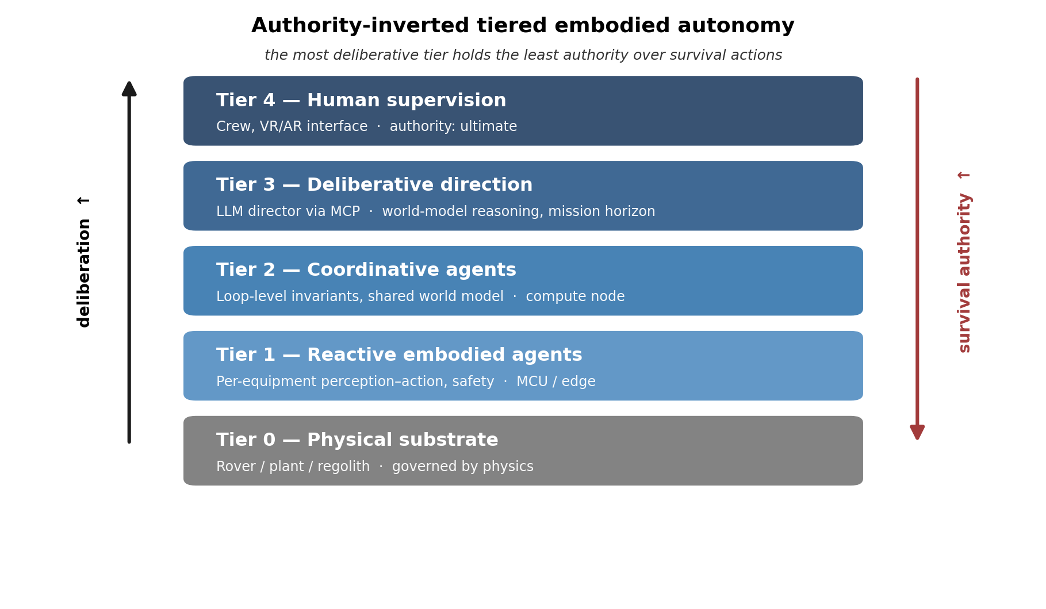
Two further properties follow structurally. Graceful degradation: losing a higher tier removes a capability, not safety - without the LLM there are no adaptive scenarios, but the system still runs and still protects itself. Design traceability: each tier has a bounded scope and horizon, so an edge agent can be verified in isolation, where a monolithic controller mixing five time-scales could not.

3. What is new
The innovation is the integration, plus four component-level contributions that do not exist, to our knowledge, at the proposed level of integration:
- Modal-temporal edge substrate - the reactive tier runs as a spectral-synapse network whose recurrent core is a diagonal complex-pole state-space model (an LRU). Its poles are literally a bank of biquad resonators, so it deploys as second-order sections on a microcontroller - no FFT, no per-step nonlinearity - while reaching published-LSTM accuracy at about half the parameters, and exceeding it with a lightweight nonlinear variant.
- Authority-inverted system-level autonomy - a distributed embodied-agent control scheme in which survival authority is inverted against deliberative capability, giving a certifiable safety story for agentic AI on a physical system.
- Structural plasticity at the edge - edge agents that adjust their own network topology (synaptogenesis, pruning, Hebbian updates) to track a slowly drifting body, on MCU-class compute, rather than fixed-topology networks that require retraining. This is the campaign's online adaptation made concrete.
- Emergent stereo via cross-synapses - binocular depth that emerges from learned inter-branch synapses inside one graph, instead of an external cost volume (DispNet, PSMNet, RAFT-Stereo). Low-power, no LiDAR, aimed at a rover in GNSS-denied terrain.
- Sim-to-real by construction - one quantised ONNX model runs bit-for-bit in a physics-grade UE5 twin and on flight-representative MCU/HPSC hardware, so pre-flight validation transfers to the deployed system without a reality gap.
These are not paper claims. A modal-temporal state-space model - an LRU that reduces to a bank of biquads - already reaches published-LSTM fault-diagnosis accuracy at roughly half the parameters, within an edge budget, which is our evidence - not our pitch - that the tiers can live on the hardware we target.

4. How it addresses the scenarios

Scenario 1 - Autonomous exploration
The rover branch is a direct instance. Stereo cross-synapse depth and LiDAR occupancy-grid encoding feed a navigation policy fused with inertial and odometric inputs, all on the edge, at a power budget compatible with a small platform and with no dependence on GNSS or a comms link. Structural plasticity lets the perception agents re-tune to changing terrain and to sensor degradation without a ground-side retraining loop - exactly the resilient, long-traverse, communication-degraded operation the scenario calls for, including permanently shadowed and cryogenic settings where tightly coupled perception-action must replace classical sense-plan-act.

Scenario 3 - Support to long-term human presence
The HELIOS branch is a closed-loop CO2 to CH4 life-support and ISRU plant with 28 tiered agents. It performs continuous inspection, diagnostics and predictive maintenance of crew assets (reactor, electrolyser, thermal chain), with an on-board safety agent holding absolute authority over emergency shutdown. A deliberative LLM director, acting only through a validated MCP surface, supports mixed-initiative planning, natural-language interaction and explanation of actions, while the crew supervises through a research-grade VR/AR layer. This is the scenario's cooperation between heterogeneous human and robotic agents, its shared task representation, and its safe close-proximity operation - instantiated and testable.

5. Fit to the approach, and what we are not proposing
STRATA sits in the Physical Intelligence approach: multimodal perception and sensor fusion, online adaptation, and multi-agent coordination in which loop-level agents reason over emergent invariants from a shared world model, with the LLM director as a foundation-model backbone coupled to physics-informed lower tiers through MCP. It also carries an embodied co-design dimension: because the neural substrate is an explicit graph, its topology can be co-adapted to the body and task by neuroevolution and plasticity, rather than fixed a priori.
We are deliberately not proposing an isolated model or a single-function automation: the contribution is the tightly coupled perception-decision-control-adaptation loop across tiers, and no individual network is submitted as the idea. The targets are surface and surface-proximal; no orbital application is in scope.

6. Maturity, demonstration and ESA facilities
The components exist at different maturities; the integrated five-tier system does not, and that is what the activity would establish.
Building block | Role in the architecture | Maturity
CyanMycelium | Portable C++14 int8-ONNX runtime; same binary on MCU and in the UE5 twin | Runtime proven (~TRL 5)
SpikyPanda | Graph-native design/training; structural plasticity, neuroevolution, ONNX export | Framework working (~TRL 4)
Spectral-synapse / LRU | Frequency-multiplexed edge substrate; recurrent core is a bank of biquads, deployable as second-order sections on MCU | Validated on real MCSA data
Stereo cross-synapse | Emergent binocular depth for a low-power rover with no LiDAR | Demonstrator
LiDAR SAT navigation | Occupancy-grid encoding for traversability; local attention, 32x fewer ops | Demonstrator
HELIOS twin | Closed-loop ECLSS / ISRU plant, 28 tiered agents, LLM scenario director, VR/AR | Design + partial impl.
Integrated system | The five tiers working end to end on one embodiment | Target (TRL 3->5)

Two ESA facilities would support the work. LUNA (Cologne) offers a lunar-analog regolith environment for the rover navigation and ISRU handling tests; the Automation & Robotics Laboratories (ESTEC, Noordwijk) offer a robotic testbed for the tiered control stack. We would engage both proactively to confirm feasibility and conditions of use.

7. Expected impact
STRATA gives Europe a mission-agnostic autonomy backbone: one architecture and one portable runtime that carry from a small exploration rover to a crewed ISRU habitat, deployable on flight-representative and HPSC-class compute. Because the safety story is structural - the certifiable authority lives in the simplest, most local tier - it offers a credible route to trustworthy agentic AI in space, where centralised architectures cannot pass a safety case. The stack is open source (Apache 2.0) and non-ITAR by construction, which fits ESA's open Discovery element, enables international academic reuse, and lowers the barrier for other European actors to build on it.

8. Implementation and eligibility
We propose a Preparation Pre-Phase A system study (<= 6 months) to define the tiered embodied-autonomy architecture as a reference autonomy backbone and to mature the concept for the two scenarios up to Pre-Phase A, with a bench demonstrator of the edge tiers and the sim-to-real path. A Discovery early-technology-development activity is an equally suitable fallback if a single focused demonstrator (rover stereo navigation with online plasticity, validated across the UE5 twin and hardware) is preferred.
The main author, DotVision SAS, is established in France (ESA Member State) and is the sole ESA interface. Academic collaboration within ESA Member States (e.g. the National and Kapodistrian University of Athens, on distributed-agent and cyber-physical systems) can be brought in; any non-Member-State involvement would remain limited to a supporting role, consistent with the campaign's special conditions.

References
Brooks, R. - A Robust Layered Control System for a Mobile Robot, IEEE J. Robotics & Automation, 1986; Intelligence without representation, Artificial Intelligence, 1991.
Varela, Thompson & Rosch - The Embodied Mind, MIT Press, 1991.
Sutton, Precup & Singh - Between MDPs and semi-MDPs: temporal abstraction in RL, Artificial Intelligence, 1999.
Sabatier & Senderens - Comptes Rendus 134, 1902 (CO2 methanation, reference ISRU/ECLSS reaction).
Supporting material: DotVision internal design documents (HELIOS embodied-AI architecture; SpikyPanda structural plasticity; CyanMycelium runtime and UE5 integration; rover stereo and LiDAR navigation notes), available on request.

DotVision measurements (2026; 5 seeds, model selection on validation only, adversarial script audit). A linear modal-temporal LRU - a pure bank of biquad resonators - reaches 88.0% five-class broken-bar fault accuracy at 2,565 parameters on the public IEEE DataPort (UFU) benchmark, matching the published LSTM (88.0%, 4,773 params) at ~54% of its weights; a lightweight nonlinear variant reaches 90.2 +/- 1.0% at 2,693 params. A static spectral snapshot plateaus at 84.5%, showing the gain comes from keeping the temporal trajectory (the resonators), not the complex representation alone.

