1. Successfully completed test. Do not enter anything in Custom path.

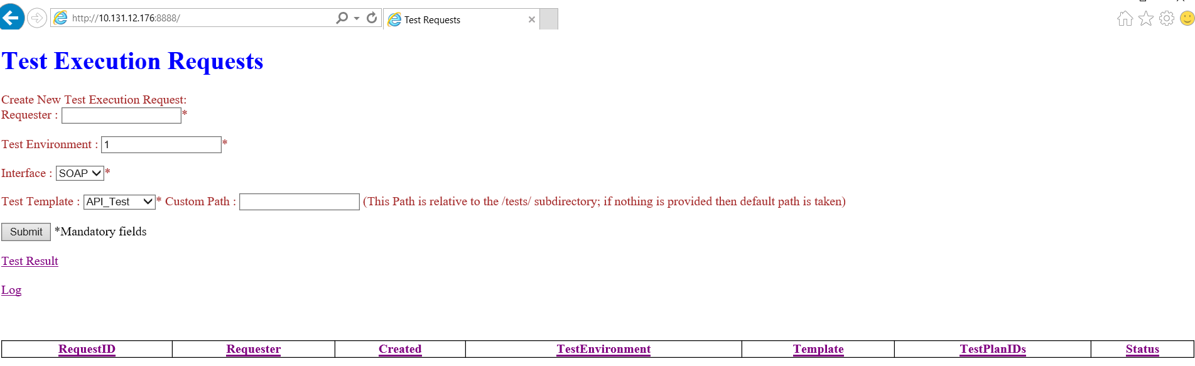

1. Check mandatory field

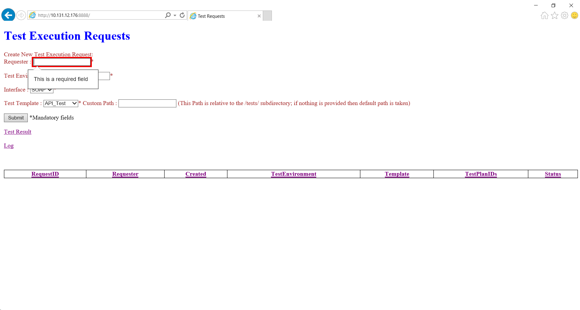

1. Completed, Invalid, Failed cases

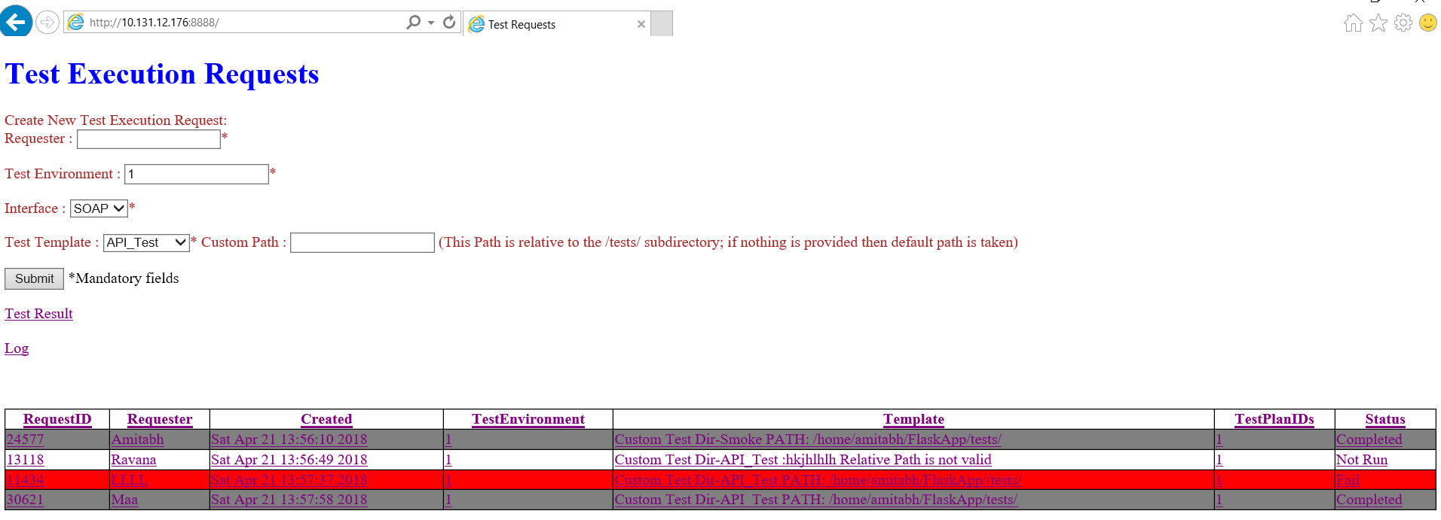

1. Click Log to view the log file.

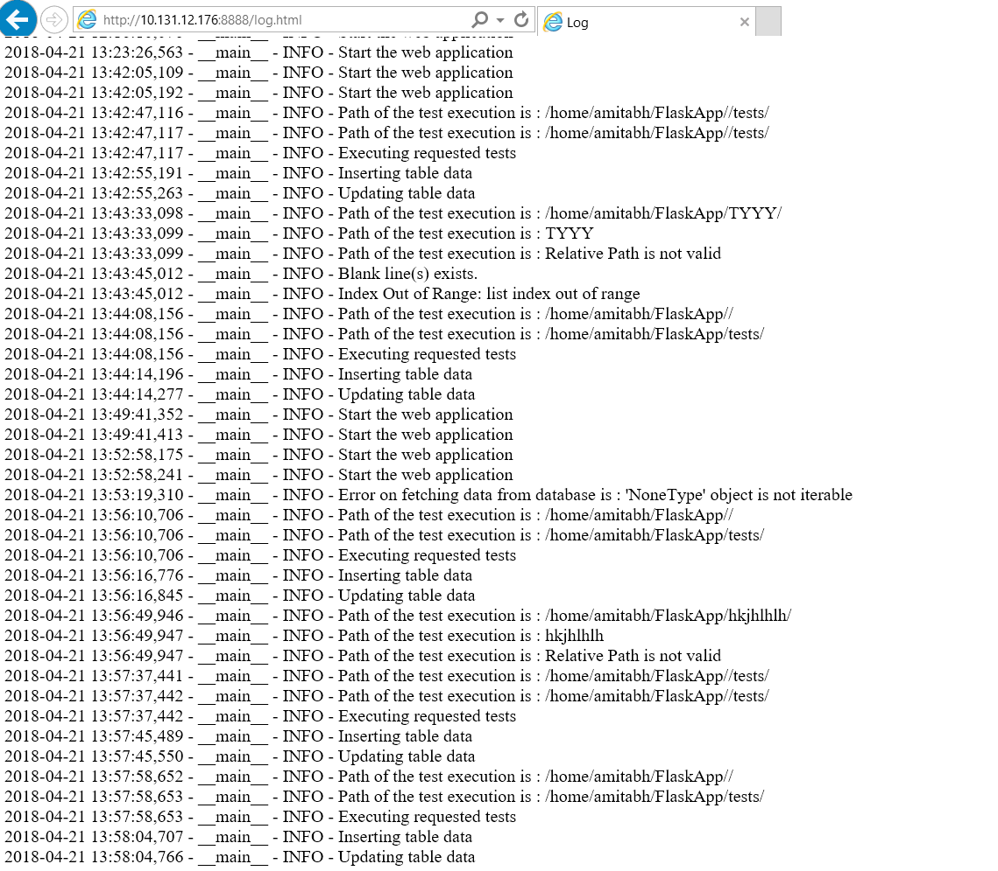

1. Click Test Result to view pass/fail of the test cases.

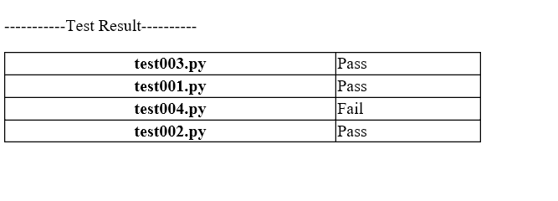

1. Clicking the hyperlink of the table will take the user to logs section.
2. Execute pytests : /<directory>/pytest -v testPy.py

Pytest results as below:

