

Masterfoods Japan
Data Warehouse Forecasting
Technical Documentation

Author: Steve Gregan
Creation Date: 08/09/2005
Last Updated: 21/11/2007 10:17:00 PM
Version: Draft

Notice of Confidentiality
This document and the information contained in it are the property of Information Services International and MFANZ. They may not in any way be disclosed, copied or used by anyone except as expressly authorized by ISI and/or MFANZ. The document should always be kept in a secure place and should be destroyed or returned to ISI when it is no longer needed.

Table of Contents

1 Overview 5
1.1 Background 5
1.2 Objectives 5
1.3 Deliverables and Benefits 5
2 System Functionality 6
2.1 Overview 6
2.1.1 Forecast Modeling 6
2.1.2 Forecast Maintenance – Load Creation 6
2.1.3 Forecast Maintenance – Load Download 9
2.1.4 Forecast Maintenance – Load Upload 10
2.1.5 Forecast Maintenance – Load Deletion 10
2.1.6 Forecast Loading 11
2.1.7 Forecast Aggregation 11
2.1.8 Forecast Load Purging 11
2.1.9 Forecast Plan Purging 11
2.2 Concepts 13
2.2.1 Forecast Split 13
2.2.2 Forecast Replacement 13
2.2.3 Forecast Casting 14
2.3 Technical Implementation 15
2.3.1 Database Server 15
2.3.2 Databases 15
2.3.3 CLIO Database Tables 15
2.3.4 CLIO Stored Procedures 16
2.3.5 ICS Stored Procedures 16
2.4 Technical Installation 16
3 System Architectures 17
3.1 Forecast System Architecture 17
3.2 Intranet Technical Architecture 18
4 Database Tables 19
4.1 Forecast Load Tables 19
4.1.1 Forecast Load Header Table 19
4.1.2 Forecast Load Period Detail Table 19
4.2 Forecast Data Tables 20
4.2.1 Forecast Period Table 20
4.2.2 Forecast Month Table 20
5 Text File Formats 21
5.1 Forecast Files 21
5.1.1 Forecast Text File – Quantity Only 21
5.1.2 Forecast Text File – Quantity and Value 22
6 User Interface 23
6.1 Data Entry Interface 23
6.1.1 Forecast Maintenance Spreadsheets 23
6.2 Intranet Interface 23
6.2.1 Forecast Maintenance - Selection Screen 24
6.2.2 Forecast Maintenance - Create Load Screen 25
6.2.3 Forecast Maintenance - Download Load Screen 26
6.2.4 Forecast Loading – Selection Screen 27

Overview

Background

The existing MFJ Data Warehouse Forecasting functionality was originally developed as part of the CLIO data warehouse application for the MFJ Atlas implementation and has since been modified to cater for various business requirements. This has resulted in an application that is spread over three databases and two technologies with the following issues:

- Business process spread over multiple applications.
- Business logic spread over multiple applications.
- Data duplicated across multiple databases.
- Application support issues.
- Database support issues.
- Lack of purging facility for historical data.
- Lack of test environment for single user Access database.

Objectives

The objective of this project is to integrate the Planning Database and Planning Desktop applications functionality into the CLIO data warehouse application and in doing so:

- Remove the complexity from the current application architecture.
- Consolidate the business logic onto a single platform.
- Provide a purging facility for historical data.
- Improve the level of application supportability.
- Improve the level of database supportability.

Deliverables and Benefits

The project will deliver an integrated data warehouse forecasting application to the MFJ business with the following benefits:

- Integrated application.
- Simpler application architecture.
- Improved supportability.
- Single point of user access.
- Test and production environments.

System Functionality

Overview

The demand forecasting loading process is divided between two applications – the demand planning system and the CLIO data warehouse system.

    - Forecast Modeling
The forecast modeling functionality is performed in spreadsheets on the user personal computers. The following tasks are performed once the user has completed the forecast modeling:
- The user will create forecast data text files (see Forecast Text File layouts) from the forecast model spreadsheets to be imported into the CLIO Forecast Load tables using the Forecast Load Creation function.
    - Forecast Maintenance – Load Creation
The forecast load creation function allows the user to create new forecast load data in preparation for loading into the CLIO data warehouse. The forecast data is sourced from text files produced from the Forecast Modeling spreadsheets. This function has been integrated into the ICS web environment (see 6.1.1 Forecast Load Creation). The process is as follows:

- The user selects the Forecast Maintenance option on the ICS intranet site.
- The user presses the Create button and the website navigates to the Load Creation page.
- The user makes the required data entries and selections.
- The system executes an Oracle stored procedure that creates the related forecast load data in the CLIO database.
The following options are available for creating forecast loads:

Business Review Previous Period Casting - Forecast Data Source = Text File (Quantity Only)

- The system retrieves 13 forecast quantity values from a text file that has 14 fields (material code and 13 forecast quantities)

- Casting period is set to the CLIO previous period. Therefore, these forecasts will be aggregated in the CLIO data warehouse overnight.

- Price, General Discount and Average Volume Discount are retrieved from LADS for each material forecast quantity by period.

- BPS is calculated as Forecast Quantity * Price

- GSV is calculated as Forecast Quantity * Round((Price + General Discount) - ((Price + General Discount) * Average Volume Discount Percentage), 0)

- Validation rules for each material in the forecast load:

  - Material must exist in CLIO.
  - Material must be active in CLIO.
  - Material must belong to the selected Forecast Split (ie. The material division, brand and sub brand must match).
  - At least one non-zero forecast quantity must exist.
  - All non-zero forecast quantities must have a non-zero price.

Business Review Previous Period Casting - Forecast Data Source = Text File (Quantity and Value)

- The system retrieves 13 forecast quantity values, 13 BPS values and 13 GSV values from a text file that has 40 fields (material code and 13 forecast quantities, 13 BPS values, 13 GSV values)

- Casting period is set to the CLIO previous period. Therefore, these forecasts will be aggregated in the CLIO data warehouse overnight.

- Price, General Discount and Average Volume Discount are set to zero for each forecast quantity by period. These values are not used as the user has supplied the required BPS and GSV values.

- Validation rules for each material in the forecast load:

  - Material must exist in CLIO.
  - Material must be active in CLIO.
  - Material must belong to the selected Forecast Split (ie. The material division, brand and sub brand must match).
  - At least one non-zero forecast quantity must exist.
  - All non-zero forecast quantities must have a non-zero BPS and GSV value.

Business Review Current Period Casting - Forecast Data Source = Text File (Quantity Only)

- The system retrieves 13 forecast quantity values from a text file that has 14 fields (material code and 13 forecast quantities)

- Casting period is set to the CLIO current period. Therefore, these forecasts will not be aggregated in the CLIO data warehouse until the following period.

- Price, General Discount and Average Volume Discount are retrieved from LADS for each material forecast quantity by period.

- BPS is calculated as Forecast Quantity * Price

- GSV is calculated as Forecast Quantity * Round((Price + General Discount) - ((Price + General Discount) * Average Volume Discount Percentage), 0)

- Validation rules for each material in the forecast load:

  - Material must exist in CLIO.
  - Material must be active in CLIO.
  - Material must belong to the selected Forecast Split (ie. The material division, brand and sub brand must match).
  - At least one non-zero forecast quantity must exist.
  - All non-zero forecast quantities must have a non-zero price.

Business Review Current Period Casting - Forecast Data Source = Text File (Quantity and Value)

- The system retrieves 13 forecast quantity values, 13 BPS values and 13 GSV values from a text file that has 40 fields (material code and 13 forecast quantities, 13 BPS values, 13 GSV values)

- Casting period is set to the CLIO current period. Therefore, these forecasts will not be aggregated in the CLIO data warehouse until the following period.

- Price, General Discount and Average Volume Discount are set to zero for each forecast quantity by period. These values are not used as the user has supplied the required BPS and GSV values.

- Validation rules for each material in the forecast load:

  - Material must exist in CLIO.
  - Material must be active in CLIO.
  - Material must belong to the selected Forecast Split (ie. The material division, brand and sub brand must match).
  - At least one non-zero forecast quantity must exist.
  - All non-zero forecast quantities must have a non-zero BPS and GSV value.

Operating Plan This Year - Forecast Data Source = Text File (Quantity Only)

- The system retrieves 13 forecast quantity values from a text file that has 14 fields (material code and 13 forecast quantities)

- Casting period is set to the CLIO current year period 00.

- Price, General Discount and Average Volume Discount are retrieved from LADS for each material forecast quantity by period.

- BPS is calculated as Forecast Quantity * Price

- GSV is calculated as Forecast Quantity * Round((Price + General Discount) - ((Price + General Discount) * Average Volume Discount Percentage), 0)

- Validation rules for each material in the forecast load:

  - Material must exist in CLIO.
  - Material must be active in CLIO.
  - Material must belong to the selected Forecast Split (ie. The material division, brand and sub brand must match).
  - At least one non-zero forecast quantity must exist.
  - All non-zero forecast quantities must have a non-zero price.

Operating Plan This Year - Forecast Data Source = Text File (Quantity and Value)

- The system retrieves 13 forecast quantity values, 13 BPS values and 13 GSV values from a text file that has 40 fields (material code and 13 forecast quantities, 13 BPS values, 13 GSV values)

- Casting period is set to the CLIO current year period 00.

- Price, General Discount and Average Volume Discount are set to zero for each forecast quantity by period. These values are not used as the user has supplied the required BPS and GSV values.

- Validation rules for each material in the forecast load:

  - Material must exist in CLIO.
  - Material must be active in CLIO.
  - Material must belong to the selected Forecast Split (ie. The material division, brand and sub brand must match).
  - At least one non-zero forecast quantity must exist.
  - All non-zero forecast quantities must have a non-zero BPS and GSV value.

Operating Plan Next Year - Forecast Data Source = Text File (Quantity Only)

- The system retrieves 13 forecast quantity values from a text file that has 14 fields (material code and 13 forecast quantities)

- Casting period is set to the CLIO next year period 00.

- Price, General Discount and Average Volume Discount are retrieved from LADS for each material forecast quantity by period.

- BPS is calculated as Forecast Quantity * Price

- GSV is calculated as Forecast Quantity * Round((Price + General Discount) - ((Price + General Discount) * Average Volume Discount Percentage), 0)

- Validation rules for each material in the forecast load:

  - Material must exist in CLIO.
  - Material must be active in CLIO.
  - Material must belong to the selected Forecast Split (ie. The material division, brand and sub brand must match).
  - At least one non-zero forecast quantity must exist.
  - All non-zero forecast quantities must have a non-zero price.

Operating Plan Next Year - Forecast Data Source = Text File (Quantity and Value)

- The system retrieves 13 forecast quantity values, 13 BPS values and 13 GSV values from a text file that has 40 fields (material code and 13 forecast quantities, 13 BPS values, 13 GSV values)

- Casting period is set to the CLIO next year period 00.

- Price, General Discount and Average Volume Discount are set to zero for each forecast quantity by period. These values are not used as the user has supplied the required BPS and GSV values.

- Validation rules for each material in the forecast load:

  - Material must exist in CLIO.
  - Material must be active in CLIO.
  - Material must belong to the selected Forecast Split (ie. The material division, brand and sub brand must match).
  - At least one non-zero forecast quantity must exist.
  - All non-zero forecast quantities must have a non-zero BPS and GSV value.

    - Forecast Maintenance – Load Download
The forecast maintenance download function allows the user to select forecast load data from the CLIO Forecast Load tables for maintenance purposes. This function has been integrated into the ICS web environment (see 6.1.2 Forecast Load Maintenance Download). The process is as follows:

- The user selects the Forecast Maintenance option on the ICS intranet site.
- The user selects the required forecast load to download from the available list.
- The system generates the forecast load maintenance spreadsheet from the selected forecast load data and related CLIO information (e.g. material list prices and volume discounts) where applicable. For quantity only forecast loads the spreadsheet will contain pricing and discount information and the BPS and GSV values will always be calculated by the system. For quantity and value forecast loads the spreadsheet will contain only quantity, BPS, and GSV values which must be maintained by the user.
- The system downloads the spreadsheet to the users’ web browser.
- The user saves the generated spreadsheet to the computer local hard drive and makes any required changes.

    - Forecast Maintenance – Load Upload
The forecast maintenance upload function allows the user to upload a forecast load spreadsheet from their hard drive and update the related forecast load on the database. The selected spreadsheet must have been previously downloaded and saved using the forecast maintenance download function. Rows and columns should never be inserted or deleted on the spreadsheet and only the quantity, price, general discount, and average volume discount cells should be changed. This function has been integrated into the ICS web environment (see 6.1.3 Forecast Load Maintenance Update). The process is as follows:

- The user has modified a forecast load maintenance spreadsheet on their computer local hard drive.
- The user selects the Forecast Maintenance option on the ICS intranet site.
- The user enters the forecast load maintenance spreadsheet location and name in the web browser and then presses the Upload button.
- The system uploads the forecast data from the spreadsheet to an Oracle stored procedure that updates the related forecast load data in the CLIO database.

The following validation in applied when the spreadsheet is uploaded:

- The spreadsheet must conform to the required layout.

- The forecast load must exist and must not have a status *LOADED.

- The spreadsheet material code must exist in the forecast load.

- No check is made that all materials in the forecast load exist in the spreadsheet, therefore, any materials deleted from the spreadsheet will remain unchanged in the forecast load. If deletion of a material from a forecast load is required the user must set all forecast quantities for the material to zero in the spreadsheet (see next point).

- Any spreadsheet material with all zero quantities is deleted from the forecast load (allows deletion of materials from load).

- Validation rules for each material remaining in the forecast load:

  - Material must exist in CLIO.
  - Material must be active in CLIO.
  - Material must belong to the selected Forecast Split (ie. The material division, brand and sub brand must match).
  - At least one non-zero forecast quantity must exist.
  - All non-zero forecast quantities must have a non-zero price for quantity only forecast loads.
  - All non-zero forecast quantities must have a non-zero BPS and GSV value for quantity an value forecast loads.

    - Forecast Maintenance – Load Deletion
The forecast maintenance delete function allows the user to delete unwanted forecast load data from the CLIO Forecast Load tables. This function has been integrated into the ICS web environment (see 6.1.2 Forecast Load Maintenance Delete). The process is as follows:

- The user selects the Forecast Maintenance option on the ICS intranet site.
- The user selects the required forecast load to delete from the available list.
- The system executes an Oracle stored procedure that deletes the selected forecast load data from the CLIO database.
    - Forecast Loading
The forecast loading function allows the user to load selected forecast load data from the Forecast Load tables to the Forecast Data table (FCST_PERIOD) within CLIO. Only forecast loads with a *VALID status are available for loading into the CLIO data warehouse. This is where the forecast replacement setting is used to determine which existing CLIO forecast data is removed before loading the forecast data from the selected forecast load. This function has been integrated into the ICS web environment (see 6.1.4 Forecast Loading). The process is as follows:

- The user selects the Forecast Loading option on the ICS intranet site.
- The user selects the required forecast load to load into CLIO from the available list.
- The system executes an Oracle stored procedure that updates the current forecast data in the CLIO database from the selected forecast load data.
- The selected forecast load must satisfy the following rules:

  - Forecast load must have a *VALID status.
  - Forecast load casting period must be equal to the CLIO current period for business review.
  - Forecast load casting period must be equal to the CLIO current year period 00 for operating plan this year.
  - Forecast load casting period must be equal to the CLIO next period 00 for operating plan next year.

    - Forecast Aggregation
The forecast aggregation function aggregates forecast data from the Forecast Data table (FCST_PERIOD) into the Forecast Fact tables. This function has been integrated into the ICS web and scheduling environments.

After the forecast data has been loaded into the CLIO data warehouse, the forecast aggregation program (scheduled daily at 00:15AM) aggregates the forecast data from the FSCT _PERIOD table into the FCST_PERIOD_01_FACT and FCST_PERIOD_02_FACT tables for the current casting period, that is, the previous CLIO period (current period minus 1). The scheduled forecast aggregation executes at 00:15AM so that forecast data loaded during the current period (will have a casting period equal to the current CLIO period) will be aggregated at 00:15AM on day one of the next period and therefore be available for period-end reporting that is scheduled for 03:00AM on the same day.

    - Forecast Load Purging
The forecast load purging function purges historical forecast load data from the CLIO database. The forecast load data will be purged automatically for casting periods that are less than the current casting period. The current casting period is always considered to be the current period minus one (i.e. the previous period). This function has been integrated into the ICS scheduling environment and is scheduled to execute daily at 07:00AM.

    - Forecast Plan Purging
The forecast plan purging function purges historical forecast plan data from the CLIO database. The forecast plan data will be purged automatically for casting periods that are older than a history retention value. The history retention period value can be maintained as updatable settings on the ICS web site. This function has been integrated into the ICS scheduling environment and is scheduled to execute daily at 07:00AM.

Concepts

The CLIO data warehouse forecasting system incorporates the following concepts into the demand forecast loading process.

    - Forecast Split
The forecast split is used to assign materials to forecast key data based on the material division, brand and sub brand codes. Therefore, the source of the forecast data does not need to supply this information. Each material is assigned to the related forecast split keys based on their division, brand an sub brand. The following splits have been supplied by the business:

Division | Brand | Sub Brand | Description | Forecast Split Keys
01 | *ALL | *ALL | Snackfood | 131 – 10 – 51 – 70001105 – 131 – 10 – 51
02 | *ALL | *ALL | Food | 131 – 10 – 57 – null – null – null
03 | *ALL | *ALL | Drinks | 132 – 10 – 51 – 70001305 – 132 – 10 – 51
05 | *ALL | *ALL | Petcare Grocery | 131 – 11 – 51 – 70001176 – 131 – 11 – 51
05 | 063 | 459 | Pedigree Club | 131 – 20 – 51 – 70001334 – 131 – 20 – 51
05 | 328 | *ALL | Greenies | 131 – 20 – 51 – 70003988 – 131 – 20 – 51

The forecast split key columns are (in the sequence listed in the table):

- sap_sales_org_code
- sap_distbn_chnl_code
- sap_division_code
- sap_sales_div_cust_code
- sap_sales_div_sales_org_code
- sap_sales_div_distbn_chnl_code
- sap_sales_div_division_code

    - Forecast Replacement
The forecast replacement setting for a forecast load is used to instruct the system how to replace any existing forecasts in the CLIO data warehouse. Care should be exercised when selecting this setting for a forecast load as it has a direct impact on what forecast data will remain in CLIO after the forecast load has been loaded. The available settings are:

Replace all materials in forecast split will result in all existing CLIO forecast data, that has the same forecast split key information and casting period as the forecast load, to be removed before the load forecast data is inserted into CLIO. This option should be used when a full replacement of the forecast data for a forecast split is required. This is the only option that will allow material forecasts to be deleted from CLIO. For example...

- Material A has existing forecast data in CLIO for casting period 200607.
- A new forecast load is created for the forecast split (to which material A belongs) and casting period 200607.
- Material A is excluded because all forecast quantities are zero.
- All existing forecast data for the forecast split and casting period 200607 are removed from CLIO when before the forecast load is loaded (ie. Material A existing forecast data is removed).
- Material A no longer has forecast data in CLIO.

Replace selected materials only will result in only those existing CLIO forecasts, that have the same forecast split key information, material code and casting period as the forecast load, to be removed before the load forecast data is inserted. This option should be used when a partial replacement of the forecast data for a forecast split is required, that is, only forecast data for materials in the forecast load will be replaced in CLIO. This option does allow material forecasts to be deleted from CLIO.

    - Forecast Casting
The forecast casting period defines the period from which the next 13 periods of forecast data are to be applied, for example, casting period 200606 defines forecast data for periods 200607 to 200806. The CLIO current casting period is the CLIO previous period (ie. the current period minus one).

- Only forecast data with a casting period greater than or equal to the CLIO previous period can be loaded into the CLIO data warehouse.

- Only forecast data with a casting period equal to the CLIO current casting period is aggregated in the CLIO data warehouse.

The casting period is assigned to forecast load data as follows:

- For business review forecast data supplied in a test file, the casting period is set to the CLIO previous or current period. Forecasts will not be aggregated in the CLIO data warehouse until the following period for current period casting.

- For this year operating plan forecast data, the casting period is set to the CLIO current year period 00.

- For next year operating plan forecast data, the casting period is set to the CLIO next year period 00.

Technical Implementation

The technical implementation is a combination of the following:

- Oracle stored procedures and tables.
- Intranet components.
- Microsoft Excel spreadsheets.

New standard functionality has been added to the ICS system to allow for the downloading and uploading of Excel spreadsheet data.

    - Database Server
Both the production and test environments exist on the following server:

- TOKU006 – MFJ Unix Server.
    - Databases
The following databases are required for this application:

- AP0093P – Production CLIO data warehouse.
- AP0080T – Test CLIO data warehouse.
    - CLIO Database Tables
The following CLIO database tables are used by this application:

- FCST_TYPE – this table stores the CLIO forecast type information. There is no maintenance function for this table.
- FCST_PRICE_TYPE – this table stores the CLIO forecast price type information. There is no maintenance function for this table.
- FCST_SPLIT – this table stores the CLIO forecast split information. There is no maintenance function for this table.
- FCST_LOAD_HEADER – this table stores the CLIO forecast load header information. This table is maintained by the forecast maintenance function.
- FCST_LOAD_DETAIL – this table stores the CLIO forecast load detail information. This table is maintained by the forecast maintenance function.
- FCST_PERIOD – this table stores the CLIO forecast period information. This table is maintained by the forecast loading function.
- FCST_PERIOD_01_FACT– this table stores the CLIO forecast period customer fact information. This table is maintained by the forecast aggregation function.
- FCST_PERIOD_02_FACT – this table stores the CLIO forecast period material fact information. This table is maintained by the forecast aggregation function.
- FCST_PLAN_PERIOD – this table stores the CLIO forecast plan period information. This table is maintained by the forecast plan import function.

    - CLIO Stored Procedures
The following CLIO stored procedures are used by this application:

- DW_FORECAST_LOADING – this stored procedure provides the Oracle procedures for both the forecast mainteanance and forecast loading functonality.
- DW_FORECAST_AGGREGATION – this stored procedure provides the Oracle procedures for the forecast aggregation functionality.
- DW_FORECAST_PLANNING – this stored procedure provides the Oracle procedures for the forecast plan import functionality.
- DW_FORECAST_PURGING – this stored procedure provides the Oracle procedures for the forecast loading and plan purging functionality.
    - ICS Stored Procedures
The following ICS stored procedure is used by this application:

- LICS_SPREADSHEET – this stored procedure provides the standard functionality that allows other Oracle stored procedures to either generate Excel spreadsheets or read existing spreadsheets.

Technical Installation

The new CLIO forecast maintenance function requires the ICS_XLCLIENT.DLL to be installed and registered on the users PC. The installation procedure is as follows:

- Copy the ICS_XLCLIENT.DLL file into a directory on the users PC (any directory is ok as long as it is permanent).

- Register the DLL with this command → regsvr32 "the directory where the file was copied"\ics_xlclient.dll

System Architectures

Forecast System Architecture

Forecast System Architecture
Forecast Maintenance
CLIO Database
Planning Database
Forecast
Load
Tables
Forecast
Data Tables
Forecast
Fact Tables
Forecast Tables
Business Objects
Forecast Reporting
Forecast Plan Import
Business Objects
Sales Reporting
Intranet
Interface
Forecast
Maintenance Spreadsheet
Forecast
Plan
Tables
Forecast Load Download
Forecast Load Upload
Forecasting Model
Spreadsheet
User Desktop
Forecast Text File – QTY and QTY/VAL
Forecast Text File
Sales
Fact Tables
Dimension
Tables
Forecast Loading
Forecast Aggregation
Forecast Load Creation
Forecast Load Delete
ICS
Scheduler

Intranet Technical Architecture

COMPONENTS
ORACLE DATABASE SERVER
Output
PL/SQL Stored Procedure
Data Warehouse
PL/SQL - CLOB (XML)
ics_spreadsheet (PL/SQL)
Windows
Developer

System
Input
PL/SQL Stored Procedure
ics_spreadsheet (PL/SQL)
WINDOWS WEB SERVER (IIS)
WINDOWS CLIENT
Excel
Spreadsheet
ICS_XLCLIENT (VB6 COM Object)
Object References
Microsoft XML Version 2.0
Microsoft Excel Version 97 +
Implements IobjectSafety
Intranet Technical Architecture
ICS_XLSERVER (VB6 COM Object)
Object References
Microsoft XML Version 2.0

I
nvoke

I
nvoke
(public)
GetSpreadsheet
Input: Procedure Name

(public)
SetSpreadsheet
Input: Procedure Name

ICS_SPREADSHEET.ASP
Execute and stream CLOB (XML) to client browser
Web Browser
(public)
SetXMLStream
Input: XML stream

ICS_SPREADSHEET.ASP
Stream CLOB (XML) to database and execute
(private)
GetXMLStream
Input: Excel Spreadsheet

Database Tables

Forecast Load Tables

The forecast load tables represent the forecast data from the planning system. This data is imported into the CLIO database on an as required basis from the planning system or text files created from the user forecasting spreadsheets. The forecast load tables are a staging area where forecasts are priced before loading into the forecast data tables.

    - Forecast Load Header Table

FCST_LOAD_HEADER – Forecast Load Period Header Table
Column | Description | Attribute | Mandatory
LOAD_IDENTIFIER | Load identifier | VARCHAR2(64 CHAR) | Y
LOAD_DESCRIPTION | Load description | VARCHAR2(128 CHAR) | Y
LOAD_STATUS | Load status *CREATE,*ERROR,*VALID,*LOADED | VARCHAR2(10 CHAR) | Y
LOAD_REPLACE | Load replace *SPLIT or *MATERIAL | VARCHAR2(10 CHAR) | Y
FCST_SPLIT_DIVISION | Forecast split SAP material division | VARCHAR2(5 CHAR) | Y
FCST_SPLIT_BRAND | Forecast split SAP brand flag or *ALL | VARCHAR2(5 CHAR) | Y
FCST_SPLIT_SUB_BRAND | Forecast split SAP brand sub flag or *ALL | VARCHAR2(5 CHAR) | Y
FCST_MATERIAL_LIST | Forecast material list or *ALL | VARCHAR2(4000 CHAR) | Y
FCST_TIME | Forecast time dimension (*PRD or *MTH) | VARCHAR2(4 CHAR) | Y
FCST_TYPE | Forecast type (*BR, *OP1 or *OP2) | VARCHAR2(4 CHAR) | Y
FCST_SOURCE | Forecast source (*PLN, *TXQ or *TXV) | VARCHAR2(4 CHAR) | Y
FCST_CAST_YYYYNN | Forecast casting period/month | NUMBER(6,0) | Y
SAP_SALES_ORG_CODE | Sales organisation code | VARCHAR2(4 CHAR) | Y
SAP_DISTBN_CHNL_CODE | Distribution channel code | VARCHAR2(2 CHAR) | Y
SAP_DIVISION_CODE | Division code | VARCHAR2(2 CHAR) | Y
SAP_SALES_DIV_CUST_CODE | Sales division customer code | VARCHAR2(10 CHAR) | N
SAP_SALES_DIV_SALES_ORG_CODE | Sales division sales organisation code | VARCHAR2(4 CHAR) | N
SAP_SALES_DIV_DISTBN_CHNL_CODE | Sales division distribution channel code | VARCHAR2(2 CHAR) | N
SAP_SALES_DIV_DIVISION_CODE | Sales division division code | VARCHAR2(2 CHAR) | N
CRT_USER | Creation user identifier | VARCHAR2(30 CHAR) | Y
CRT_DATE | Creation timestamp | DATE | Y
UPD_USER | Update user identifier | VARCHAR2(30 CHAR) | Y
UPD_DATE | Update timestamp | DATE | Y
Primary Key: | LOAD_IDENTIFIER

    - Forecast Load Period Detail Table

FCST_LOAD_DETAIL – Forecast Load Detail Table
Column | Description | Attribute | Mandatory
LOAD_IDENTIFIER | Load identifier | VARCHAR2(64 CHAR) | Y
SAP_MATERIAL_CODE | SAP material code | VARCHAR2(18 CHAR) | Y
FCST_QTY_01 - FCST_QTY_13 | Forecast quantities 1 to 13 | NUMBER | Y
FCST_PRC_01 - FCST_PRC_13 | Forecast prices 1 to 13 | NUMBER | Y
FCST_DIS_01 - FCST_DIS_13 | Forecast general discounts 1 to 13 | NUMBER | Y
FCST_VOL_01 - FCST_VOL_13 | Forecast average volume discount percentages 1 to 13 | NUMBER | Y
FCST_BPS_01 - FCST_BPS_13 | Forecast base price values 1 to 13 | NUMBER | Y
FCST_GSV_01 - FCST_GSV_13 | Forecast gross sales values 1 to 13 | NUMBER | Y
Primary Key: | LOAD_IDENTIFIER, SAP_MATERIAL_CODE

Forecast Data Tables

The forecast data tables represent the current forecast data for the CLIO data warehouse. The data is aggregated to the forecast fact tables on a daily basis for reporting purposes.

    - Forecast Period Table

FCST_PERIOD – Forecast Period Table
Column | Description | Attribute | Mandatory
FCST_TYPE_CODE | Forecast type code | NUMBER(8,0) | Y
FCST_PRICE_TYPE_CODE | Forecast price type code (e.g. BPS, GSV) | NUMBER(8,0) | Y
CASTING_YYYYPP | Period defining the forecast e.g. P2 = BR3 (P3-P2) | NUMBER(6,0) | Y
FCST_YYYYPP | Forecast period | NUMBER(6,0) | Y
SAP_SALES_DTL_SALES_ORG_CODE | Sales organisation code | VARCHAR2(4 CHAR) | Y
SAP_SALES_DTL_DISTBN_CHNL_CODE | Distribution channel code | VARCHAR2(2 CHAR) | Y
SAP_SALES_DTL_DIVISION_CODE | Division code | VARCHAR2(2 CHAR) | Y
SAP_SALES_DIV_CUST_CODE | Sales division customer code | VARCHAR2(10 CHAR) | N
SAP_SALES_DIV_SALES_ORG_CODE | Sales division sales organisation code | VARCHAR2(4 CHAR) | N
SAP_SALES_DIV_DISTBN_CHNL_CODE | Sales division distribution channel code | VARCHAR2(2 CHAR) | N
SAP_SALES_DIV_DIVISION_CODE | Sales division division code | VARCHAR2(2 CHAR) | N
SAP_MATERIAL_CODE | Material code | VARCHAR2(18 CHAR) | Y
FCST_VALUE | Forecast value | NUMBER(16,2) | Y
FCST_QTY | Forecast quantity (BUOM) | NUMBER(12,0) | Y
FCST_PERIOD_LUPDP | Last updated person | VARCHAR2(8 CHAR) | Y
FCST_PERIOD_LUPDT | Last updated time | DATE | Y
Primary Key: | None

    - Forecast Month Table

FCST_MONTH – Forecast Month Table
Column | Description | Attribute | Mandatory
FCST_TYPE_CODE | Forecast type code | NUMBER(8,0) | Y
FCST_PRICE_TYPE_CODE | Forecast price type code (e.g. BPS, GSV) | NUMBER(8,0) | Y
CASTING_YYYYMM | Month defining the forecast e.g. M2 = BR3 (M3-M2) | NUMBER(6,0) | Y
FCST_YYYYMM | Forecast month | NUMBER(6,0) | Y
SAP_SALES_DTL_SALES_ORG_CODE | Sales organisation code | VARCHAR2(4 CHAR) | Y
SAP_SALES_DTL_DISTBN_CHNL_CODE | Distribution channel code | VARCHAR2(2 CHAR) | Y
SAP_SALES_DTL_DIVISION_CODE | Division code | VARCHAR2(2 CHAR) | Y
SAP_SALES_DIV_CUST_CODE | Sales division customer code | VARCHAR2(10 CHAR) | N
SAP_SALES_DIV_SALES_ORG_CODE | Sales division sales organisation code | VARCHAR2(4 CHAR) | N
SAP_SALES_DIV_DISTBN_CHNL_CODE | Sales division distribution channel code | VARCHAR2(2 CHAR) | N
SAP_SALES_DIV_DIVISION_CODE | Sales division division code | VARCHAR2(2 CHAR) | N
SAP_MATERIAL_CODE | Material code | VARCHAR2(18 CHAR) | Y
FCST_VALUE | Forecast value | NUMBER(16,2) | Y
FCST_QTY | Forecast quantity (BUOM) | NUMBER(12,0) | Y
FCST_MONTH_LUPDP | Last updated person | VARCHAR2(8 CHAR) | Y
FCST_MONTH_LUPDT | Last updated time | DATE | Y
Primary Key: | None

Text File Formats

Forecast Files

The forecast file layouts are used to load text delimited forecast data into the CLIO database.

    - Forecast Text File – Quantity Only

Forecast Text File
Column | Description | Attribute | Mandatory
SAP_MATERIAL_CODE | Material code | STRING | Y
QTY_01 | Forecast quantity 01 | NUMBER | Y
QTY_02 | Forecast quantity 02 | NUMBER | Y
QTY_03 | Forecast quantity 03 | NUMBER | Y
QTY_04 | Forecast quantity 04 | NUMBER | Y
QTY_05 | Forecast quantity 05 | NUMBER | Y
QTY_06 | Forecast quantity 06 | NUMBER | Y
QTY_07 | Forecast quantity 07 | NUMBER | Y
QTY_08 | Forecast quantity 08 | NUMBER | Y
QTY_09 | Forecast quantity 09 | NUMBER | Y
QTY_10 | Forecast quantity 10 | NUMBER | Y
QTY_11 | Forecast quantity 11 | NUMBER | Y
QTY_12 | Forecast quantity 12 | NUMBER | Y
QTY_13 | Forecast quantity 13 | NUMBER | Y
Delimiter: | Tab Delimited

    - Forecast Text File – Quantity and Value

Forecast Text File
Column | Description | Attribute | Mandatory
SAP_MATERIAL_CODE | Material code | STRING | Y
QTY_01 | Forecast quantity 01 | NUMBER | Y
QTY_02 | Forecast quantity 02 | NUMBER | Y
QTY_03 | Forecast quantity 03 | NUMBER | Y
QTY_04 | Forecast quantity 04 | NUMBER | Y
QTY_05 | Forecast quantity 05 | NUMBER | Y
QTY_06 | Forecast quantity 06 | NUMBER | Y
QTY_07 | Forecast quantity 07 | NUMBER | Y
QTY_08 | Forecast quantity 08 | NUMBER | Y
QTY_09 | Forecast quantity 09 | NUMBER | Y
QTY_10 | Forecast quantity 10 | NUMBER | Y
QTY_11 | Forecast quantity 11 | NUMBER | Y
QTY_12 | Forecast quantity 12 | NUMBER | Y
QTY_13 | Forecast quantity 13 | NUMBER | Y
BPS_01 | Forecast BPS value 01 | NUMBER | Y
BPS_02 | Forecast BPS value 02 | NUMBER | Y
BPS_03 | Forecast BPS value 03 | NUMBER | Y
BPS_04 | Forecast BPS value 04 | NUMBER | Y
BPS_05 | Forecast BPS value 05 | NUMBER | Y
BPS_06 | Forecast BPS value 06 | NUMBER | Y
BPS_07 | Forecast BPS value 07 | NUMBER | Y
BPS_08 | Forecast BPS value 08 | NUMBER | Y
BPS_09 | Forecast BPS value 09 | NUMBER | Y
BPS_10 | Forecast BPS value 10 | NUMBER | Y
BPS_11 | Forecast BPS value 11 | NUMBER | Y
BPS_12 | Forecast BPS value 12 | NUMBER | Y
BPS_13 | Forecast BPS value 13 | NUMBER | Y
GSV_01 | Forecast GSV value 01 | NUMBER | Y
GSV_02 | Forecast GSV value 02 | NUMBER | Y
GSV_03 | Forecast GSV value 03 | NUMBER | Y
GSV_04 | Forecast GSV value 04 | NUMBER | Y
GSV_05 | Forecast GSV value 05 | NUMBER | Y
GSV_06 | Forecast GSV value 06 | NUMBER | Y
GSV_07 | Forecast GSV value 07 | NUMBER | Y
GSV_08 | Forecast GSV value 08 | NUMBER | Y
GSV_09 | Forecast GSV value 09 | NUMBER | Y
GSV_10 | Forecast GSV value 10 | NUMBER | Y
GSV_11 | Forecast GSV value 11 | NUMBER | Y
GSV_12 | Forecast GSV value 12 | NUMBER | Y
GSV_13 | Forecast GSV value 13 | NUMBER | Y
Delimiter: | Tab Delimited

User Interface

The user interface isa combination of intranet interface and Excel spreadsheets. The intranet interface is used for functional invocation purposes and Excel spreadsheets are used for data entry purposes.

Data Entry Interface

    - Forecast Maintenance Spreadsheets
The forecast load maintenance is performed using Excel spreadsheets. These spreadsheets are generated in the users’ web browser using the data from the forecast load tables. The following are samples of the Business Review and Operating Plan data entry spreadsheets:

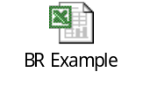 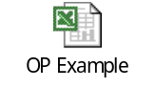 (double click to view)

Intranet Interface

The intranet interface has been attached to the existing ICS website as additional local menu options with specific user access authority. The intranet URL addresses are as follows:

- Test - http://mfj-lads-test.ap.mars/

- Production - http://mfj-lads.ap.mars/

The ICS intranet security is maintained in a security XML file on the web server. Users are authorised to menu files that contain their access to system functionality. An example of the security file is as follows:

<?xml version="1.0"?>
<!-- -->
<!-- Interface Control System MFJ Security -->
<!-- -->
<security connectionString="Provider=MSDAORA;User Id=lics_app;Password=xxx;Data
Source=ap0080t.ap.mars;">
<!-- -->
<!-- Authorised users -->
<!-- -->
<User identifier="miyatkou" menu="d:\data\inetpub\wwwroot\mfj_lad_t\ics_planning.txt"/>
<User identifier="shiromas" menu="d:\data\inetpub\wwwroot\mfj_lad_t\ics_planning.txt"/>
</security>

The ICS intranet menus are maintained in XML files on the web server. These files are used to grant users access to system functionality. An example of a menu file is as follows:

<?xml version="1.0"?>
<!-- -->
<!-- Interface Control System MFJ Planning Menu -->
<!-- -->
<menu text="MFJ Planning Menu">
<node text="CLIO Forecasting">
<option text="CLIO Forecast Maintenance" script="ics_fcst_maintenance.asp?Mode=SELECT"/>
<option text="CLIO Forecast Loading" script="ics_fcst_loading.asp?Mode=SELECT"/>
</node>
</menu>

The following are examples of the various screens:

    - Forecast Maintenance - Selection Screen

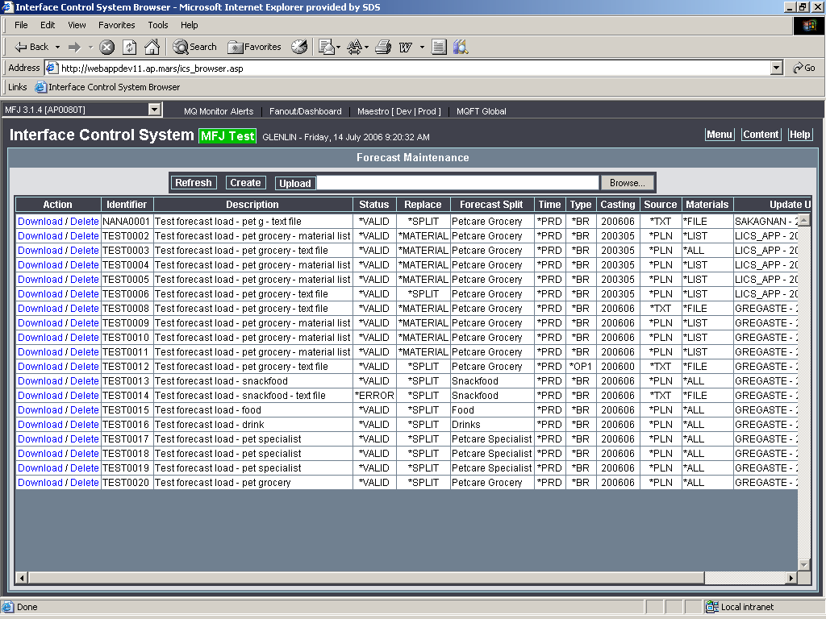

    - Forecast Maintenance - Create Load Screen

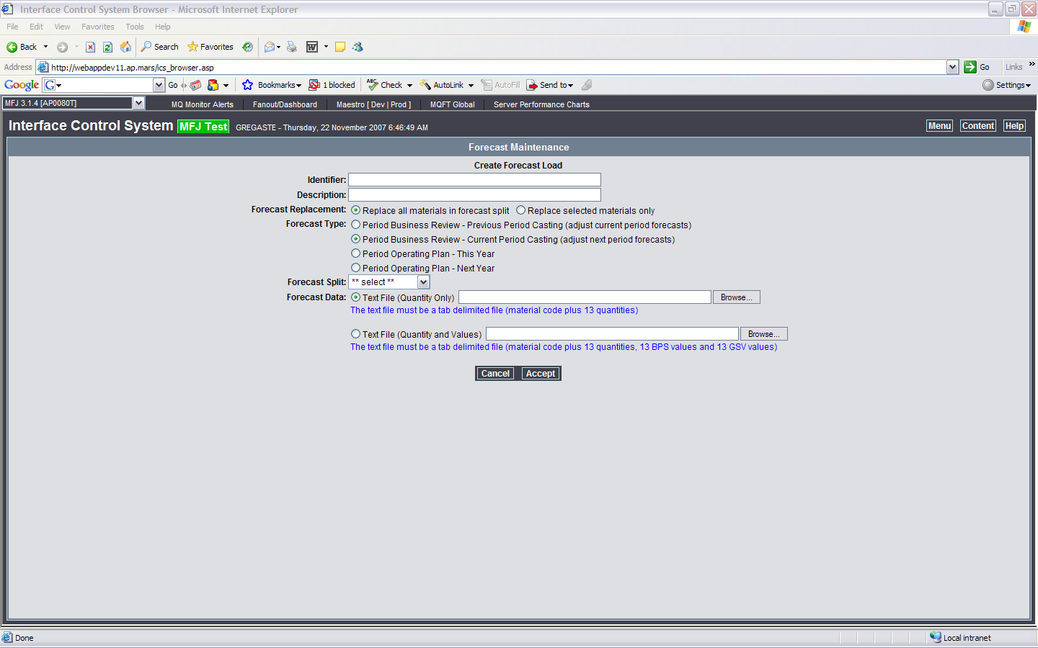

    - Forecast Maintenance - Download Load Screen
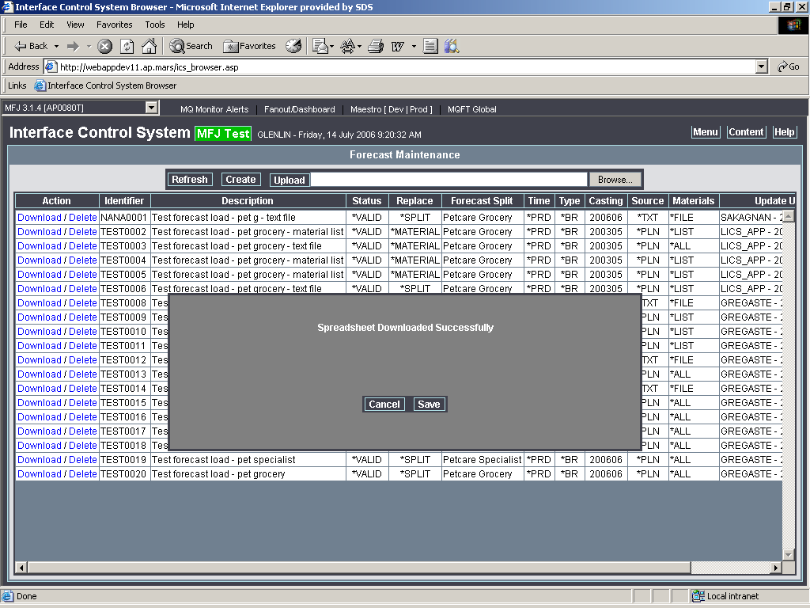

    - Forecast Loading – Selection Screen
