MARS, Incorporated
System Financial Authorization Request (SFAR)

Project Title: Product Testing
Project Number: 80011650
Functional Area: Unit Discretionary
Site CAB: N/A
CAB Number : N/A
Local Currency: AUD

1. Financial Summary and Signatures
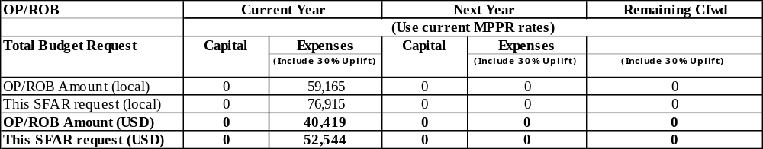

Estimated Start Date | 02/03/09
Estimated Completion Date | 26/06/09
Syndication Key | 195. UBA Only
Primary IRR | 0 %
Supporting IRR | 0 %
Contingency Included | 0 %

MARS IS Project Manager | Trevor Keon
User Project Manager(s) | Keryn Duffy
MARS IS Divisional Manager(s) | Brendan O’Kane
User Project Champion | Bill Kitchen
Regional S&F Manager / MARS IS S&F Head | Phil Patterson
MARS IS VP
Business Unit S&F head | Anthony Howard
MARS IS President
Business Unit Head
Unit President(s)
Regional S&F Staff Officer
Functional Staff
Regional President(s)
Office of the President

NOTICE OF CONFIDENTIALITY
This document and the information in it are the property of MARS INFORMATION SERVICES (MARS IS), a Division of Effem Services, Inc. They may not in any way be disclosed, copied or used by anyone except as expressly authorised by MARS IS. The document should always be kept in a secure place, and should be destroyed or returned to MARS IS when it is no longer needed.

2.1 Project Description/Objectives
The R&D team have been using an old application for managing their product testing. The application will help them configure a test for a specific group of pets/people and then create the tests, send out the test and samples, along with assist in consolidating the results. The version they are running can only work on a Windows 95 virtual machine, and only a single associate is experienced enough to use it effectively. This project will develop a new solution for the product testing application to allow for a multi-user environment and improved usability and performance. A contractor named Steve Gregan will be developing the solution in-house.
Project scope has been paired back to deliver essential functionality improvements only and has been signed off by R&D Petcare. Areas in the agreed scope are:
- Database Design and Creation
- Website Components
- Household Classification Group Maintenance
- Household Classification Type Maintenance
- Household Maintenance
- Pet Classification Group Maintenance
- Pet Classification Type Maintenance
- Pet Maintenance
- Question Group Maintenance
- Question Maintenance
- Product Test Template Maintenance
- Product Test Maintenance
- Product Test Word Template Print Extract
- S+ Extract
- Global Data Warehouse Interface
- Reporting
- Data Conversion

2.2 Alternatives
Keryn Duffy from the R&D team investigated a number of off the shelf applications to see if it could fit their needs. None of those applications where appropriate, and the cost in getting them modified to suit was too excessive. Also, there have been numerous attempts to upgrade the software without any success. The new approach utilises existing technology and will provide a solid foundation for future changes.

3.1 Costs

This SFAR Request

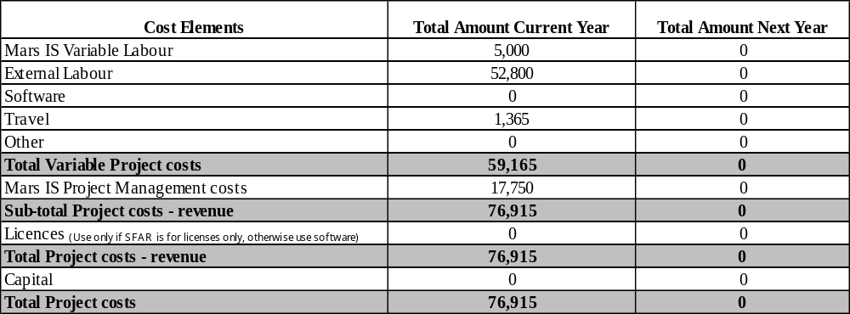

Total Project Investment

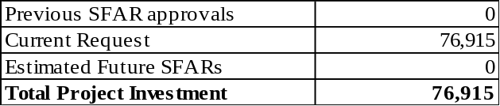

Details of Estimated Future SFARs
N/A

MARS IS Commercial associate consulted with to address any potential issues or concerns and who has signed on to the Commercial aspects of the project. Spoke to Phil Patterson and Scott Malcom.

3.2 Capital
N/A

3.3 Reconciliation to Plan/ROB
AUD $59,000 included in 2009 plan for this project against IO 80011650 (this excludes uplift).

3.4 Estimated Annual Running Costs (Support & Infrastructure)
(Only include incremental running costs as a result of this project. If there are no incremental running costs enter 'N/A')

 | Year 1 | Year 2 | Year 3 | Year 4 | Year 5
Annual Running Costs | N/A | N/A | N/A | N/A | N/A

Mars IS Support manager(s) who have been consulted with to assist in addressing any potential support requirements, legacy system retirement activities timing and funding, and who has signed on to the Global Applications Support aspects of the project. Yes, Jason Knight has been consulted regarding support from WOD site team and has approved on the basis of support and technical documentation being made available.

3.5 Retirements (systems and capital hardware)
The existing Windows 95 version of the product testing application will be retired once this project is completed and in production.

4.1 Benefit Analysis
Type | Description | Value | Owner | Specific Changes Required
C | Multi user | N/A | Keryn Duffy | - Application allows multiple users to work at a time  - Prevents locks or “dirt” data when working in a multi-user environment
C | Improved support | N/A | WOD Site Team | - Support documentation to be provided, along with technical specifications  - Multi-layer support. GSM to support ICS component, however WOD site to be primary contact for any issues, and escalate as required
C | Upgradeable | N/A | Keryn Duffy | - Future upgrades/improvements can be easily implemented

Unit S&F Associate Assigned to Measure Benefits – N/A – all benefits are C only.

4.2 Unit Resource Requirements
Business Unit Providing Resources | Unit | Current Year |  |  |  | Next Year
(If Mars IS is providing resources just enter 'N/A') |  | Q1 | Q2 | Q3 | Q4 | Q1 | Q2 | Q3 | Q4
Keryn Duffy |  | 5 | 10 | 0 | 0 | 0 | 0 | 0 | 0
Rachel Garney |  | 5 | 5 | 0 | 0 | 0 | 0 | 0 | 0

Enter Percent of full-time commitment required

4.3 Project Schedule/Phases

Activities/Phases/ Milestones | Current Year |  |  |  | Next Year
Activities/Phases/ Milestones | Q1 | Q2 | Q3 | Q4 | Q1 | Q2 | Q3 | Q4
Visioning (Project Definition) | X
Feasibility Study | X
Development (includes design) |  | X
Commissioning |  | X
(Lead) Unit/Site 1 – Implement & Nurture |  |  | X
Other Units implementation
Post Implementation Review |  |  | X
Rolling Benefits Statement |  |  |  | X

4.4 Project Organisation Chart

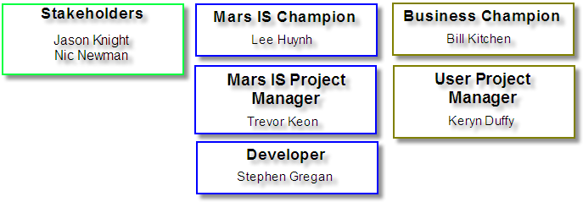

4.5 Technical Description / Project Architecture

Technical Description:
See proposal by Steve Gregan. (Product_Testing_Propsal.doc)

Project Architecture:
See proposal by Steve Gregan. (Product_Testing_Propsal.doc)

A Project Architecture review has been conducted with the Architecture Expert Center Yes / No (circle one) if No please explain in detail why it is not applicable.

Application Pattern:
AEC said N/A

Technology Components (ie Bricks):
AEC said N/A

Note: The security consulting engagement is currently pending approval. This has process is currently underway with the security team.

