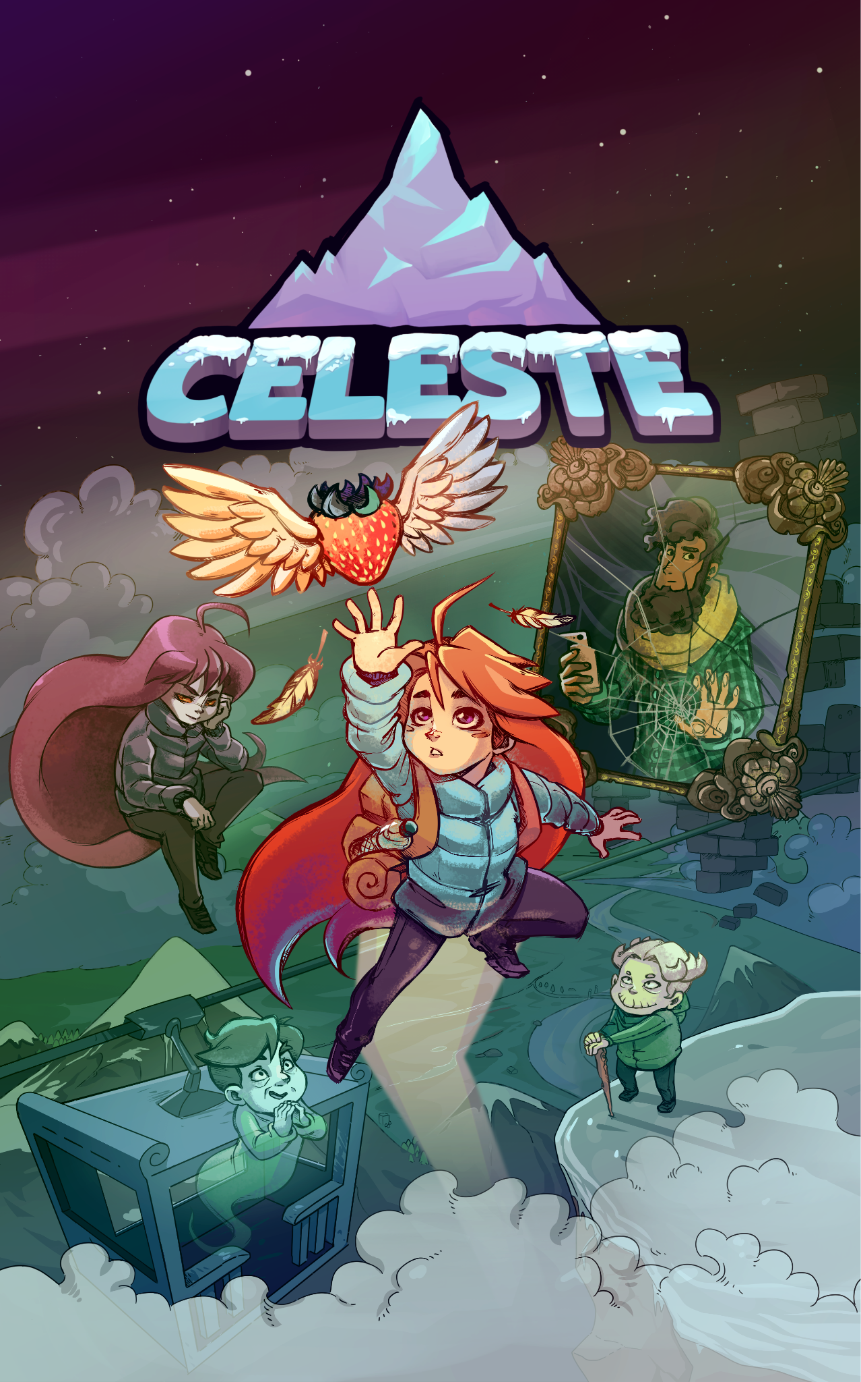
Table of content
- Introduction……………………………………........................3
- Game overview…………………………………......................4
- Loop Description and analysis…………………………………5
3.1. Game’s loop…………………………………………………………5
3.1.1. Game’s loop description…………………………………..5-6
3.1.2. Game’s loop analysis………………………………………..6-7
3.2. Game’s mechanic…………………………………………………7
3.2.1. Character’s mechanic………………………………..7-13
3.2.2. Environment’s mechanic………………………………14
3.2.3. Hidden’s mechanic…………………………………15-17
3.2.4. Asist mode………………………………………………17-19
3.3.Formal element ……………………………………………19-23
3.4.Dramatic element ………………………………………..23-36
- Other insight…………………………………………….............37
- Conclusion……………………………………………………………40
- Reference…………………………………………………………….42

- Introduction
Celeste is one of the games I've played a lot and recently completed. It features incredibly challenging gameplay that required me to fail thousands of times before completing it. After finishing the game, I realized the profound message that the developer of the game intended: never give up and accept yourself. This inspired me to choose Celeste for my research, not only to spread the message the game wanted to convey but also to explore the deeper layers of meaning embedded in the game.

In this article, I will focus on analyzing the game’s loop and other factors directly or indirectly related to it. Because the main focus of the game is the mechanics, most of this research will analyze how the game’s mechanics affect the game loop. The game’s plot is quite lengthy, it will be challenging to detail everything that happens. Therefore, it would be helpful to have some understanding of Celeste’s story and gameplay to understand what I discuss fully. Additionally, I will include my own perspective on the game.

This article draws from various sources, including books, articles, YouTube videos, and other references.

2.Game overview
Celeste is a single-player platformer parkour game where players play a young girl named Madeline on her journey to conquer the mountain named Celeste. Contrary to its colorful, cartoonish appearance, Celeste offers incredibly challenging gameplay that demands skill and patience from the player.

The game provides a consistent gameplay experience throughout, with a total of seven main chapters and two additional chapters that extend the story. Additionally, chapters one through eight include two extra modes called B-Side and C-Side, which are considered a more challenging mode of the chapter.

In each chapter, Madeline must overcome various obstacles in different levels, or "rooms," with varying difficulty to complete the chapter.

Throughout her journey up the mountain, Madeline learns valuable lessons, accepting herself and recognizing her worth. It becomes clear that Madeline's climb up the mountain symbolizes her overcoming personal struggles and striving towards a better version of herself.
3.Loop description and analysis
3.1. Game’s Loop
3.1.1. Game’s loop description
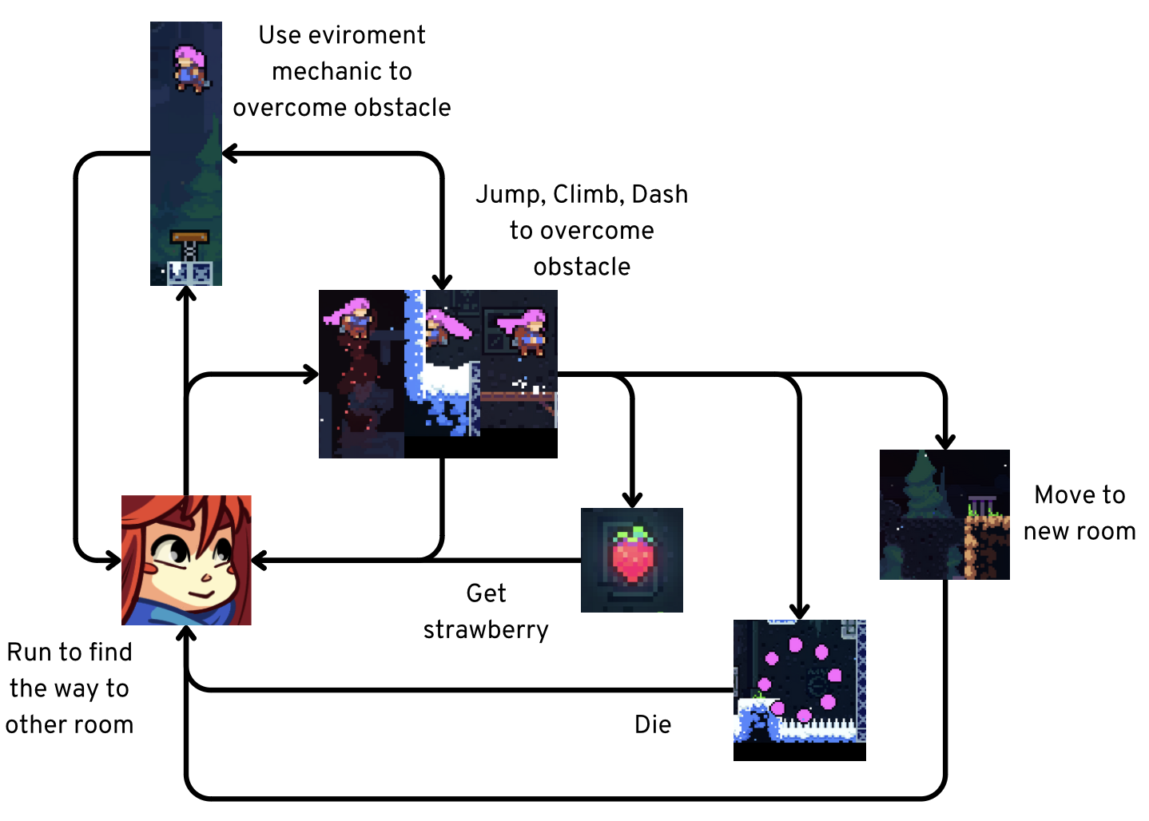
Celeste presents players with a core gameplay loop that is brilliantly designed to convey the developer's message.
Figure 1: Produced by the author, Figure 1 illustrates their own
game loop of Celeste created in Canva in with In game asset 2024.
As illustrated in Figure 1, The diagram shows the main gameplay loop of Celeste, focusing on the actions players will perform within a level design.

Here, we see that when starting a level design, players will engage in actions such as running, jumping, dashing, collecting strawberries, and interacting with the environment. If they make a mistake, they may die and need to try again. Each level thus requires players to execute one or more specific sequences of actions to successfully overcome the challenges.

3.1.2. Game’s Loop Analysis
The Game Loop diagram is synthesized from various action sequences within a level of the game, but they all based on a core loop that serves as the foundation for developing and
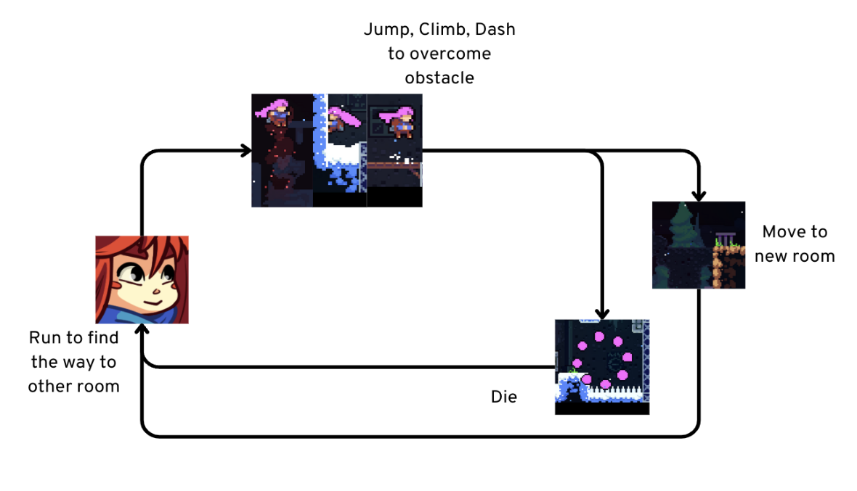
expanding into other loops.
Figure 2: Produced by the author, Figure 2 illustrates their own
core game loop of Celeste created in Canva with In game asset in 2024.
As illustrated in Figure 2, The core game loop of Celeste, as determined by the developers from the beginning, is based on running and jumping to overcome obstacles without dying. Other loops, such as collecting strawberries or interacting with environmental mechanics, are added to provide varied experiences across different levels of design.

Next, I will identify and analyze elements such as the Game’s mechanic, formal elements, dramatic elements, and other additional factors that enhance the player's experience with the game loop.

3.2. Game’s mechanic
3.2.1. Character's mechanic
In Celeste, the main character, Madeline, has four primary control mechanics provided by the game: Running, Jumping, Climbing, and Dashing. Let's analyze these four mechanics and how they support the game's core loop.

3.2.1.1. Run and time in running
Running is a common mechanic in many games, both 2D and 3D. Depending on the genre, developers can adjust the running mechanics to fit their game’s needs.

Dahl and Kraus (2015:42) assert that ' An important aspect of game feel is controlling virtual objects and how responsive these controls are.'.

When designing a running mechanic, developers need to carefully consider three key factors:
- Acceleration: The rate at which the character speeds up from a standstill.
- Deceleration: The rate at which the character slows down when the player stops running.
- Top Speed: The maximum speed the character can reach while running.

Even small changes in any of these factors can have a significant impact on the player’s experience and gameplay. For example, adjusting the acceleration might make the character feel more responsive, while changing the top speed could alter how challenging or easy it is to navigate through levels. Balancing these elements is crucial for creating a satisfying and engaging running mechanic in the game.

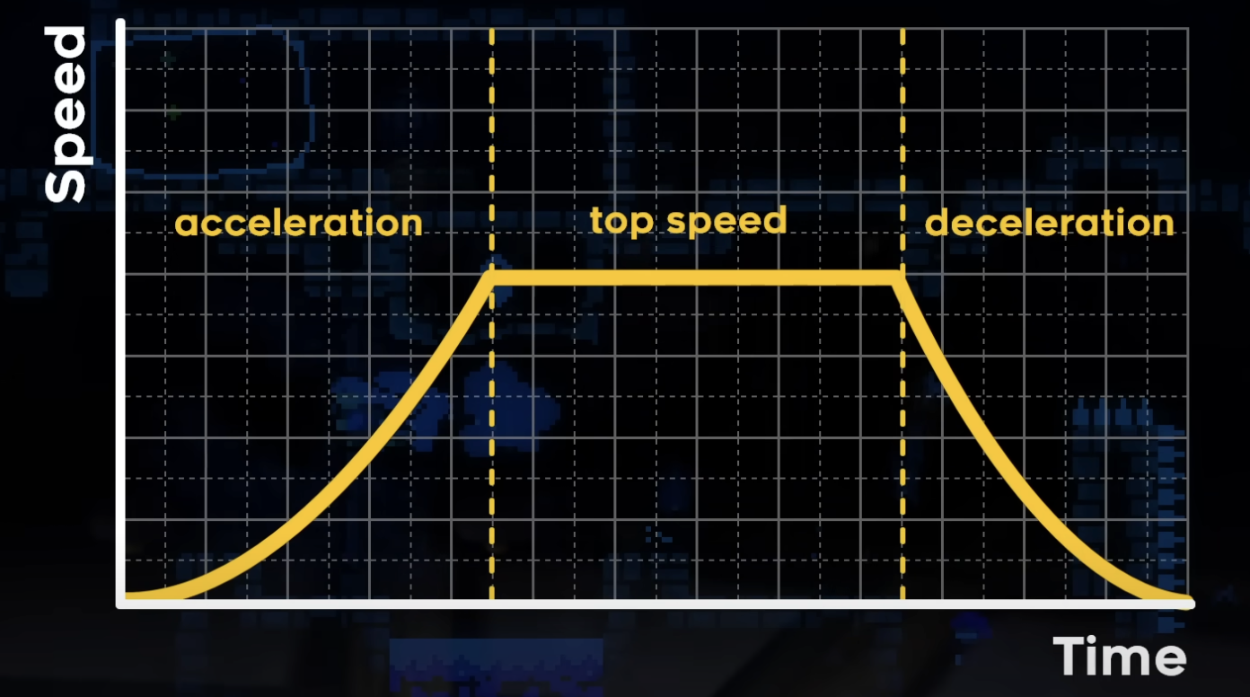
Figure 3: Example diagram
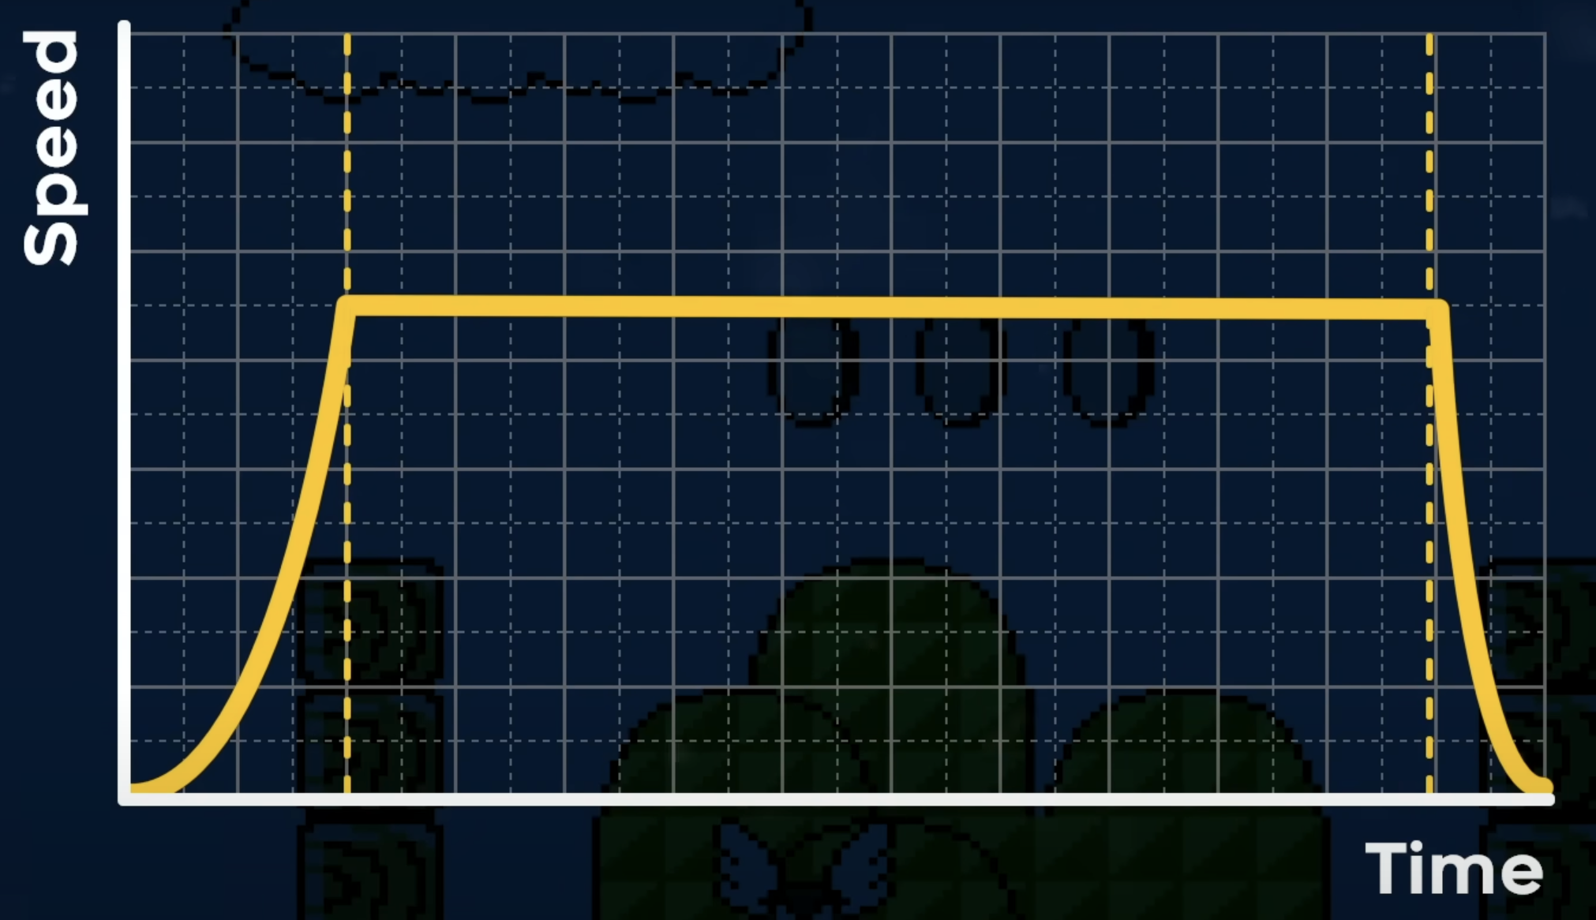
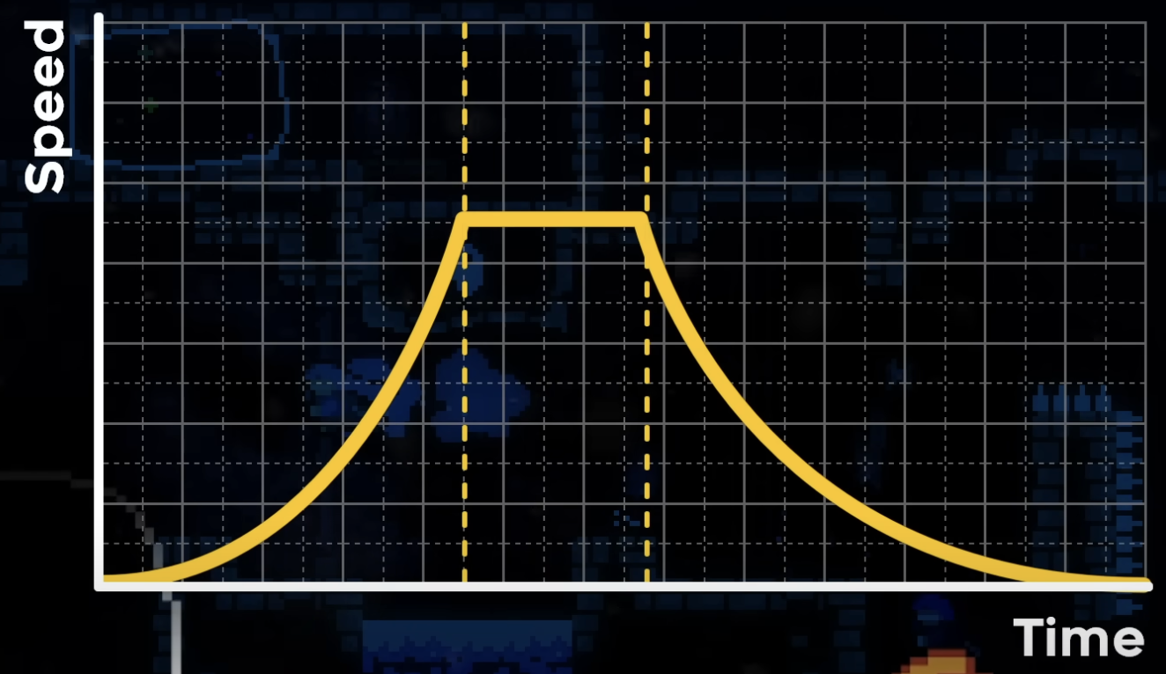
In the video “Why Does Celeste Feel So Good to Play?” by Game Maker’s Toolkit, there is a comparison is made between the running mechanics of Super Mario Bros 3 and Celeste. This comparison highlights how variations in acceleration, deceleration, and top speed can significantly impact gameplay and player experience.

Figure 4 and 5: Super Mario Bros 3 is on the left and Celeste is on the right.

Here’s a comparision chart about the differences of three factor based on the comparison chart above:
Factor | Super Mario Bros 3 | Celeste
Acceleration | Mario accelerates gradually to reach top speed. | Madeline accelerates quickly
Deceleration | Mario decelerates gradually when the run button is released. | Madeline’s decelerates is faster
Top Speed | Mario’s top speed is moderate | Madeline’s top speed is higher

I will explain how it affects on Gameplay Experience of the player from each factor:
Acceleration:
- Super Mario Bros 3: The acceleration creates a smoother line so that there are more controlled movement experiences, which can feel less abrupt.
- Celeste: The quick acceleration contributes to a more dynamic and responsive gameplay experience, allowing players to make rapid movements.
Deceleration:
- Super Mario Bros 3: The gradual deceleration can make stopping or changing direction feel less immediate, leading to a more unpredictable platforming experience.
- Celeste: The quick deceleration creates a sharper contrast between movement and stopping, giving the player permission to turn around immediately.
Top Speed:
- Super Mario Bros 3: The moderate top speed balances the gameplay, ensuring that levels are challenging but not overwhelmingly fast.
- Celeste: The higher top speed allows for quicker movement and can lead to a more interesting experience, but also demands control to navigate complex environments.

Therefore, when running in Super Mario Bros 3, players might feel that the character is moving on ice, which can make control feel more challenging. On the other hand, in Celeste, Madeline’s movement is more exact, reducing mistakes while maintaining a natural motion.

This precision in Celeste allows for a satisfying gameplay experience, balancing responsiveness with natural movement. This effectively makes players feel like they are controlling a character who is genuinely climbing a mountain, with a high degree of agility.

3.2.1.1. Jump
Jumping is an essential mechanic in games, especially in Celeste, where players must scale a mountain. While jumping in Celeste might seem like jumping in other games at first glance,

However, when having a closer examination reveals notable differences in jumping when comparing the landing times of Celeste with games like Super Mario Bros and Super Meat Boy, we can see the differences.

Figure 6:

We can notice that Celeste features an almost instantaneous landing time. Madeline’s landing is highly responsive, providing immediate contact with the ground upon descent. This allows players to do quick and precise movements. Overall, the developer has set a reasonable setting for the jumping mechanics to balance bouncy and reality for Celeste's character.

3.2.1.2. Climb and dash
In a mountain-climbing game like Celeste, climbing is an obvious and essential mechanic. However, the Dash mechanic in Celeste significantly enhances the climbing experience, making it faster and smoother. So I want to analyze and compare the Dash and Climb mechanic:
Climbing:
- Description: Climbing allows Madeline to climb on vertical surfaces and hold onto walls for an amount of time.
- Affect on gameplay: It’s important to overcome obstacles and provide a safe zone to plan for the next movements.
Dashing:
- Description: Dashing provides Madeline with a burst of speed in any direction, allowing her to reach distant platforms, it can be used both horizontally and vertically.
- Affect on gameplay: The Dash mechanic contributes to a smoother gameplay experience, making the climbing and overall movement feel more satisfying. It helps in maintaining momentum and allows players to make exact adjustments and navigate through tight spaces.
In conclusion, This combination of climbing and dashing creates a dynamic and engaging gameplay experience, essential for a game that demands 2D platforming challenges.

3.2.2. Environment mechanic (Puzzle)
The environment mechanics in Celeste are indeed highly varied in both appearance and function. According to the Celeste fandom wiki, the game includes over 70 different types of interactive objects that can be worked with the four-core mechanics (running, jumping, climbing, and dashing). The interaction between these mechanics and the diverse environmental elements leads to a highly varied and engaging gameplay experience.
Iwill highlight the environment mechanic that I love the most:
Wind
- Description: Wind in Celeste can either boost or slow down Madeline's movement, depending on its direction.
- Affect on gameplay: In level design, players must timing the action according to the wind's influence to jump further or move faster. So, players need to be cautious of the wind to avoid potentially failing the level.

Overall, Celeste’s developer combines core mechanics and a rich variety of environment mechanics to create a game that is both simple in control and complex in design. This approach enhances the replayability and depth of the game, offering players an engaging experience in gameplay

3.2.3. Hidden mechanic
3.2.3.1. Air Friction
Air friction in games refers to the resistance encountered by a character while moving through the air. In Celeste, air friction is designed carefully to enhance the gameplay experience.
- Description: When Madeline is airborne and the player stops holding the directional input, she will quickly fall vertically. This design also allows players to control Madeline’s descent. If a player jumps too far or needs to quickly adjust their direction, the drop can help them take control and make the adjustment.
- Affect on gameplay: The swift descent helps players correct mistakes if they overjump and need to reposition. This responsiveness is important for navigating complex platforming challenges and also helps players time the progress in difficult-level design.
Overall, air friction in Celeste enhances players’ experience and lets them quickly correct their mistakes and overcome challenging levels.

3.2.4.2. Coyote time and forgiven mechanic
In Celeste, there is an interesting hidden mechanic that is related to the game Coyote Time. We can understand it according to the blog Coyote Time: What Games Can Teach Us About Forgiveness in Learning by Eva Grouling Snider: “Named after the Wile E. Coyote cartoon, coyote time is a brief period after running off a platform where the game will still register the player presses the jump button. This means that players don’t have to be perfect to complete a jump – there’s a small amount of wiggle room.”
Thanks to this hidden mechanic, players can jump after a small amount of time falling down the ground. This mechanic helps players so much in controlling and gameplay, players do not feel annoyed just because of small mistakes in the game.

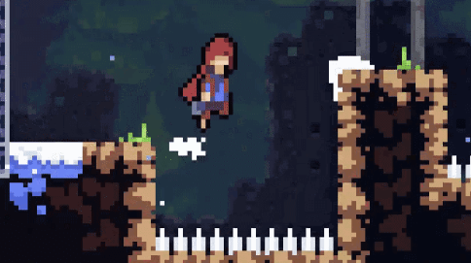
Figure 7: image in game
In addition, Celeste provides players with several other "cheating mechanics” designed to enhance the gameplay experience. These can be found on the personal website of one of the game's co-creators, Maddy Thorson. Maddy has listed a total of nine hidden mechanics beyond Coyote Time. For example, one of these is the Jump Corner Correction, which helps players avoid getting stuck when jumping into wall corners.

In summary, providing players with hidden mechanics like these helps to naturally enhance their experience. These features significantly support the game loop, which involves players repeatedly engaging in the core gameplay mechanics throughout their playthrough. By supportive elements, the game ensures a smoother and more enjoyable experience, making the challenging gameplay more accessible and less frustrating.

3.2.4. Asist mode (helping mode)
The asist mode is the masterpiece in the game that contain a high number of difficulty level designs, it helps player to decrease the game’s difficulty that let players can play the game at their level. In Celeste, it more than a masterpiece to me, it help me to enjoy the game easier. I will explain why asist mode in Celeste is even better than other helping mode in other game:
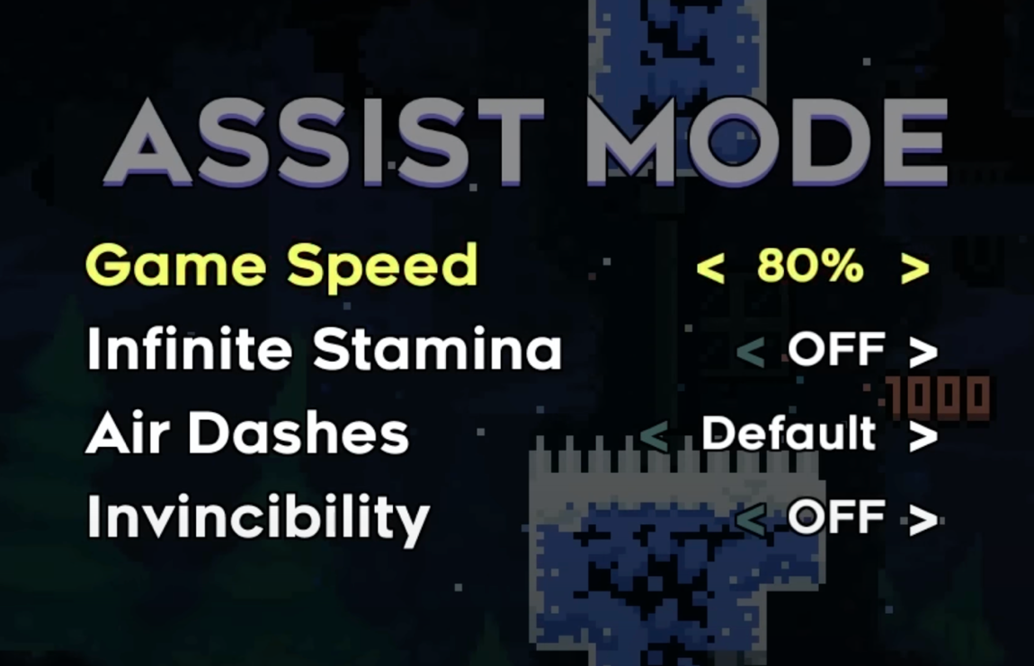
- Adjustable: the asist mode in Celeste can let player to adjust whatever element they want in the game. For instance, if you feel the game speed is too fast to play, you can definitely slow down the speed. You can be invisible or have unlimited dash in the game, it up to your choice.
Figure 8: Image in game

- Full content: In some game, the content of the game can be reduce if you choose the easy mode. It is unfair to players because they can not enjoy all the content of the game. In Ceslete, if you choose asist mode or not, there is no effect on the content and story of the game
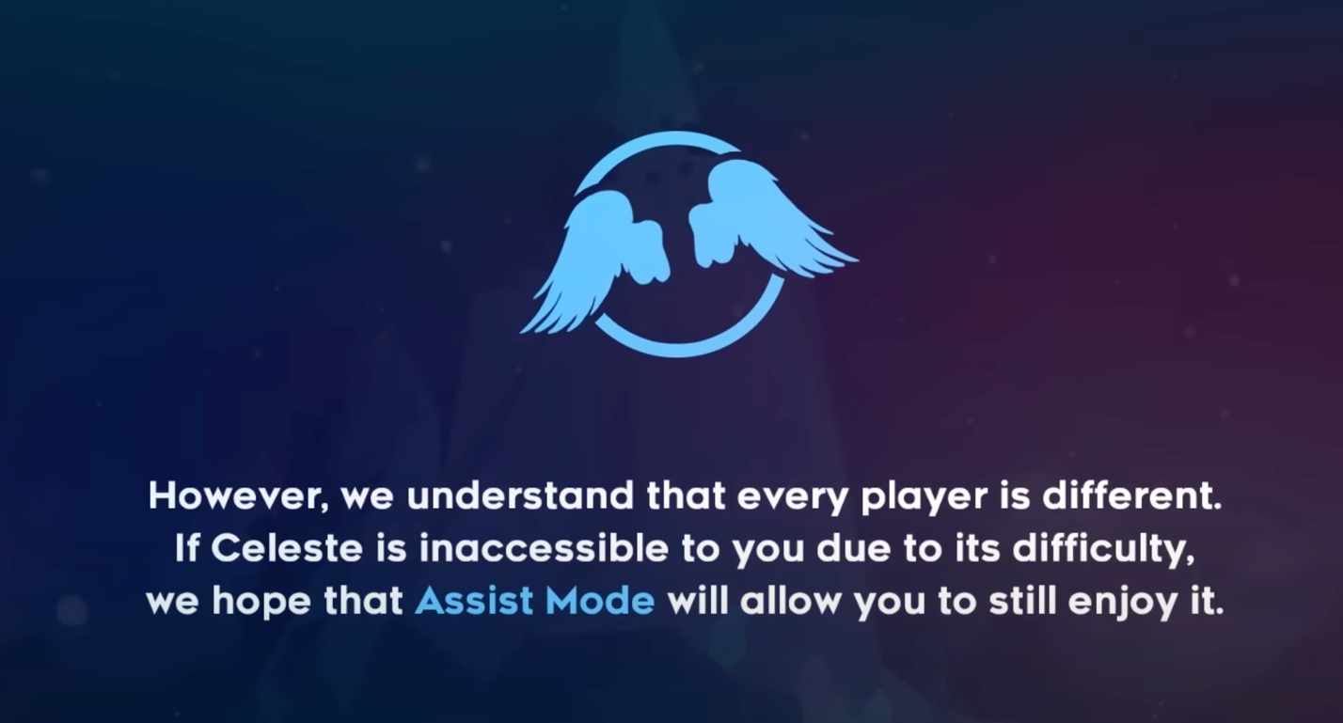
- Instructure: Before players turn on asist mode in Celeste, there is announcement to make player understand more about asist mode and the purpuse of the game.
Figure 9: Image in game

3.3. Formal element
In game design, formal elements are essential in shaping the overall game loop. According to Game Design Workshop: A Playcentric Approach to Creating Innovative Games by Tracy Fullerton, the eight formal elements include players, objectives, procedures, rules, resources, conflict, boundaries, and outcomes. In Celeste, these elements are connected to support and enhance the gameplay. I'll focus on some formal elements that connect directly to the game loop such as players, objectives, and how they influence the game loop.

3.3.1. Player and target audience.
When first seeing Celeste’s art style, I think it might seem aimed at a young audience. However, when I actually try the game, the difficulty level design is totally aimed at hardcore players. However, thanks to Assist Mode it allows even casual players to enjoy the game. So, Celeste attracts a diverse range of players from young to old.
Celeste is a single-player game, but I wonder if it could have been designed as a multiplayer game. Here’s an analysis of why Celeste should remain a single-player experience from my perspective:
We might ask why the game developers didn't include a co-op mode to make Celeste become a multiplayer game. To answer this question, we need to understand what Celeste truly represents:
- Personal Journey: Celeste is about Madeline's journey to conquer the mountain named Celeste, which can also be understood as her journey to overcome her mountain inside. Therefore, help from others is unnecessary. This point will be analyzed in the game's objectives.
- Difficulty: The game's difficulty also makes cooperative play challenging and ineffective.
- Alone Path: The single-player experience implies that the path to conquering the mountain, or more deeply, the mountainside, is alone. It means that you cannot rely on anyone else to complete it.

3.3.2. Objective
From the beginning of the game, players are introduced to the objective: Madeline’s quest to conquer the mountain. This is clearly shown through the cutscene where Madeline converses with the elderly woman. This straightforward approach and without a lengthy introduction, this is a good way to start a game. It allows players to focus more on gameplay rather than spending time trying to understand the game's narrative.
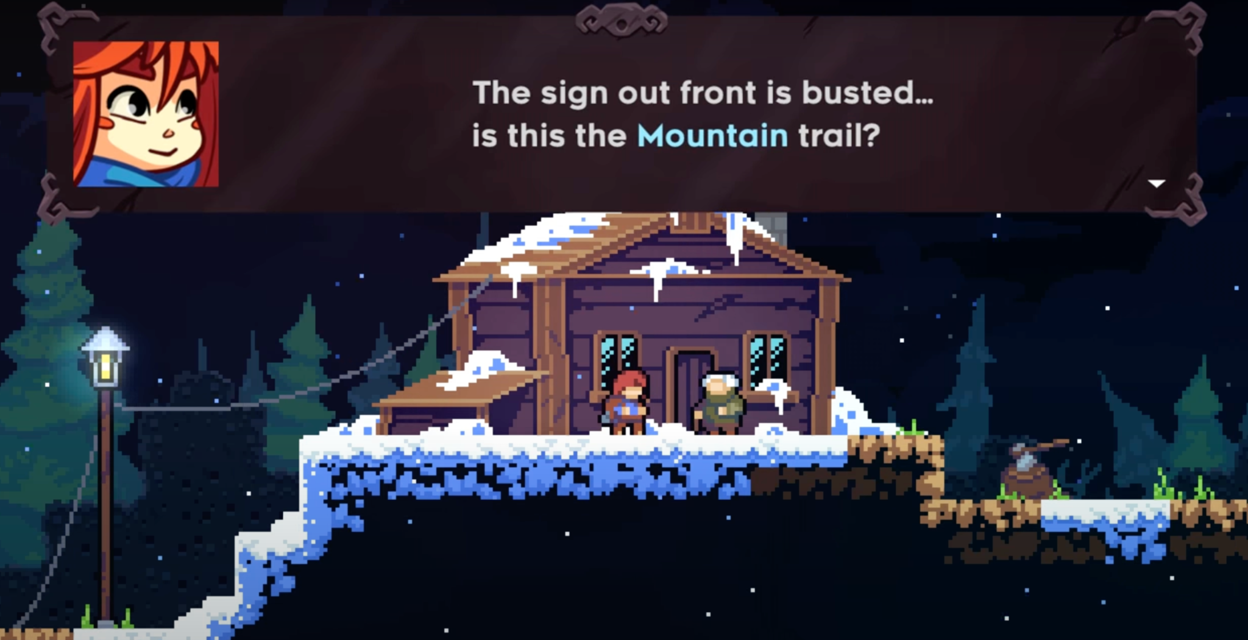
Figure 10: Image in game
It is also evident that this is not an easy objective for Madeline or for the players.
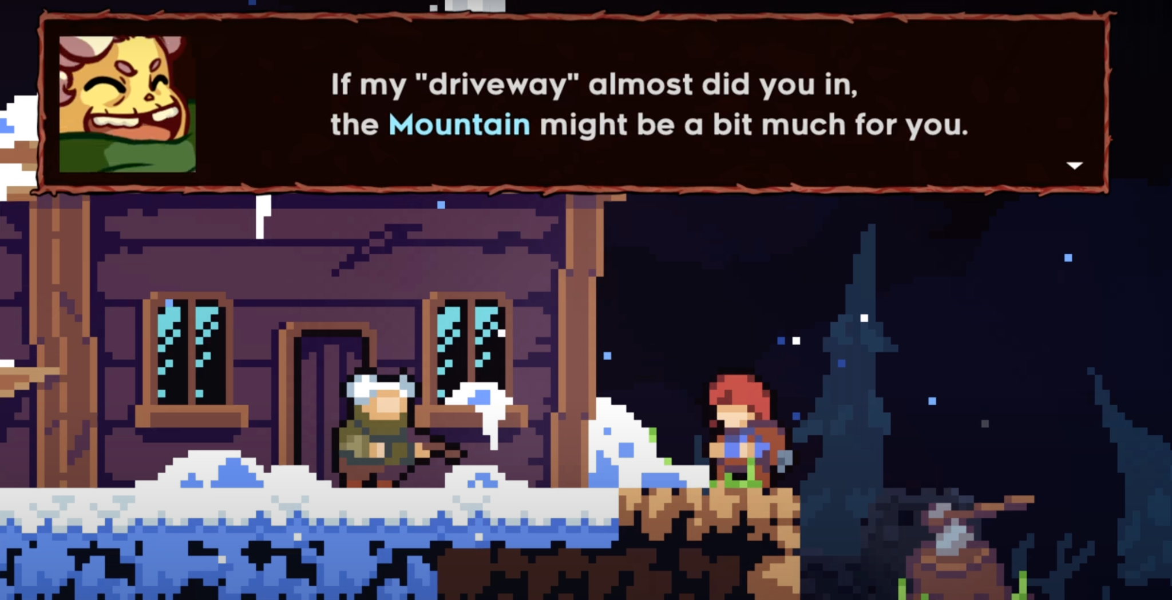
Figure 11: Image in game

As previously mentioned, Celeste features a highly challenging gameplay where players must overcome obstacles with precision. Therefore, an objective that sounds as difficult as conquering a mountain reflects the similarity between Madeline's journey and the players. The difficulty in climbing the mountain mirrors the real challenges players face, creating a strong sense of connection and empathy between Madeline's struggles and players.
However, after completing the game, I realized there is a hidden objective that both the player and Madeline must overcome the mountain inside us.
- In the game, the journey to conquer the mountain is also a journey of self-overcoming for Madeline. This is evident in the storyline, where Madeline faces Badeline - her negative side, which is introduced in the later chapters of the game. This confrontation is not just a physical challenge but also an inner battle, where Madeline must learn to accept the parts of herself.
- In real life, it's the journey for players to continually overcome failures in the game time and time to reach the final goal. The persistence required to beat the challenging levels in Celeste mirrors the player’s growth and makes the player's experience deeply meaningful and rewarding.
This will be analyzed more in the Dramatic Element of this research.

3.4. Dramatic element
According to "Game Design Workshop: A Playcentric Approach to Creating Innovative Games" by Tracy Fullerton, there are a total of seven dramatic elements in a game: challenge, premise, character, story, world-building, and the dramatic arc. It must be said that Celeste did very well in building and balancing these dramatic elements. While some elements might not be clearly connected, however, this does not significantly affect the message the game aims to convey to the player. In this section, I will focus on three elements that enhance the player's experience during the game: challenge, character, and the dramatic arc.

3.4.1. Challenge
Hefkaluk et al. (2023:6) assert that 'Failure was motivational when players noted a purpose in overcoming obstacles, generating tension as this purpose diminished (subtheme 1). Players strived to resolve this tension with stubborn persistence, eventually producing an invigorating sense of success (subtheme 2)'.

Challenge in Celeste is one of the game's core elements. Difficult-level designs give players a sense of achievement and satisfaction when they succeed. On Madeline's journey to conquer the mountain, she faces a ton of challenges such as spikes, cliffs, and various mountain creatures. Explaining the game's difficulty is challenging if you haven't played it yourself, but you can imagine that the game requires precise movements to avoid collisions with objects. If you touch any of these objects, you have to start the level again. This makes the gameplay extremely challenging for new players, but also incredibly engaging and rewarding.

To analyze Celeste's challenges, there are many aspects to cover. Therefore, I want to focus on the elements that significantly enhance the gameplay experience and keep players playing continually through tough challenges: the flow of the challenge and the feedback of the challenge.

3.4.1.1. Flow of challenge
In Celeste, the challenge of each level follow closely to the principles of balance, as illustrated in the diagram below:
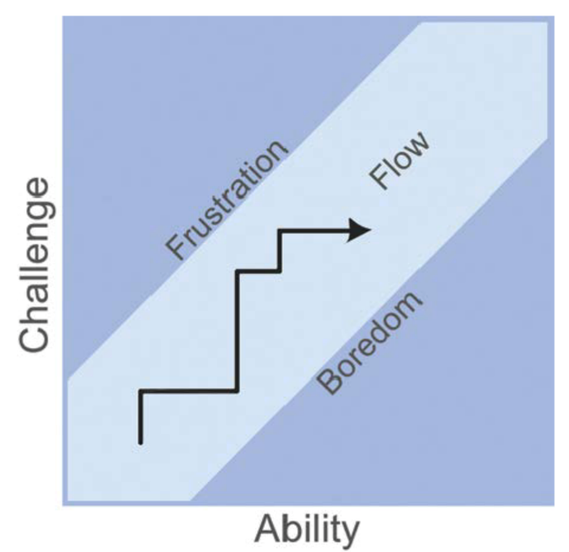
Figure 12: A diagram of Flow of challenge In Game Design Workshop : A Playcentric Approach to Creating Innovative Games book
This diagram represents the balance between the difficulty of the challenges and the player's skills, creating a state of "flow" where the game remains engaging without becoming too frustrating or too easy.
After a period of simple tutorials at the beginning, the game's difficulty increases rapidly but still remains within the player's control. Honestly, I almost gave up when trying a few levels of the game. Each level in Celeste requires players to play repeatedly and die many times to master it. However, it creates a compelling desire for players to keep trying. I wonder if the developers could have made a level design easier, but why did they make it so difficult for newcomers right from the start?
The game is designed to push players to their limits, requiring them to master precise movements and timings. This repeated practice fosters a sense of accomplishment and mastery when players finally overcome difficult sections. The balance between challenge and skill development is key to maintaining player interest and satisfaction.
A significant aspect of Celeste's challenge design is the use of "dead space" or areas where players can pause and plan their next move. These sections provide a breather, allowing players to strategize their approach to upcoming obstacles. This design element ensures that players can focus entirely on the challenges ahead without feeling rushed or overwhelmed.
The lack of guidance in Celeste's environment mechanics allows for a high degree of player autonomy. This freedom to experiment and find unique solutions makes the gameplay experience more interesting. Players can try different strategies and refine their techniques without feeling restricted by rigid instructions. This autonomy is crucial for maintaining player engagement and enjoyment, as it aligns with the core reason many people play games: the freedom to make choices and explore possibilities.

3.4.1.1. Feedback of challenge
What makes the challenge in Celeste unique and allows players to try again and again is the game's mechanic that lets them retry easily and quickly.

Celeste gives a quick respawn mechanic, which is crucial in maintaining the game's challenging. When players fail, they are immediately respawned at the last checkpoint without any significant delay. This immediate reset reduces frustration and keeps players engaged, allowing them to quickly learn from their mistakes and try new strategies. The lack of long loading times or penalties for failure encourages players to experiment and refine their skills, making each attempt feel like a natural progression rather than a setback.

3.4.2. Character
In analyzing the characters in Celeste and their roles in enhancing gameplay and storytelling, several key aspects stand out. Here’s a breakdown of the background and role of each significant character and how they contribute to the overall experience:

3.4.2.1. Madeline
Madeline is the character you control throughout the game. She is described as a young Canadian woman with long orange hair and brown eyes. Madeline is portrayed as brave, determined, and somewhat stubborn, with a desire to conquer Mount Celeste.
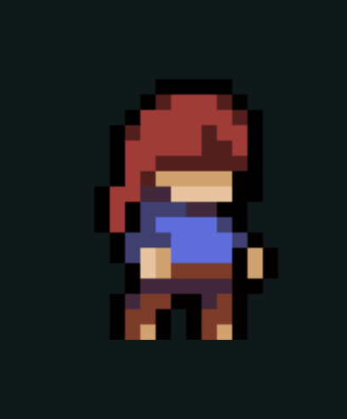
Figure 13, 14: Artwork and In game

The background and reasons behind Madeline's decision to climb the mountain are not shown detailed in the game. We only know that she wants to challenge herself and find personal motivation.

Badeline, introduced as an evil alter ego or a darker aspect of Madeline, constantly disrupts Madeline’s journey. Badeline plays a crucial role in helping Madeline realize her self-worth, which will be demonstrated later in this research.

Figure 15, 16: Artwork and In game
In the game, Madeline is portrayed with mental health conditions.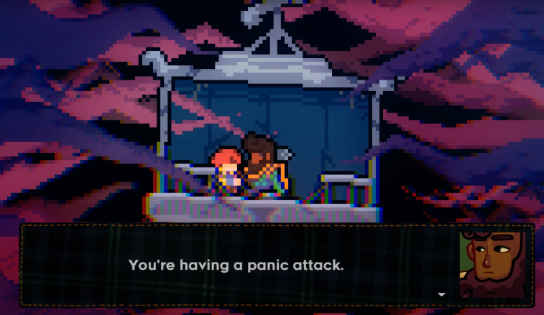
Figure 17: Maddy Makes Games Inc., Extremely OK Games, Ltd. (2018) Celeste [2D illustration], accessed 31 July 2024.

3.4.2.2. Theo
Theo is an another character who is also on a journey to conquer Celeste mountain, similar to Madeline. He is Brazilian-American, with dark brown skin and curly hair. Theo is characterized by his cheerful and sociable nature, his love for photography, and his passion for exploration.

Figure 18, 19: Artwork and In game
In the game, you will encounter Theo during your journey up the mountain. Theo is a supportive person and a brotherly figure to Madeline, encouraging her to focus on positive aspects. He serves as a brother in Madeline’s self-improvement journey, helping her overcome her personal challenges.
Figure 20: Maddy Makes Games Inc., Extremely OK Games, Ltd. (2018) Celeste [2D illustration], accessed 31 July 2024.
3.4.2.3. Granny
Granny is a character that players also interact with in the game. She is depicted as an elderly woman with white hair and a quirky personality that often irritates the player. Granny has no direct familial relationship with the main character but
look like Madeline’s grammar

Figure 21, 22: Artwork and In game
Granny plays a significant role in the psychological development of Madeline, just like Theo. She helps Madeline gradually accept her own flaws and self-doubt. Through her interactions with Madeline, Granny contributes to the character's journey of self-acceptance and personal growth.
Figure 23: Maddy Makes Games Inc., Extremely OK Games, Ltd. (2018) Celeste [2D illustration], accessed 31 July 2024.
Granny, in Celeste, plays not only as a guide but also as a person who stands by Madeline during her most challenging moments. Her advice, while sometimes harsh, is deeply meaningful with Madeline. It mirrors the kind of tough but loving guidance that make her role in the game both significant and empathetic.
3.4.2.4. Oshiro
Oshiro is a Japanese ghost trapped in his own hotel and serves as a boss character in Celeste.

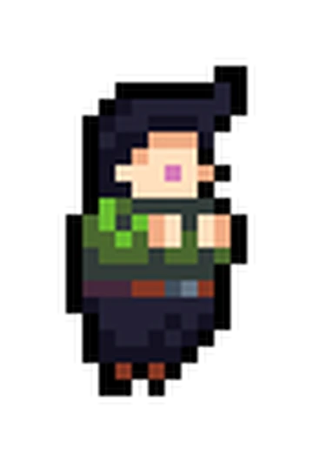
Figure 24, 25, 26: Artwork and In game
Oshiro represents those who cannot escape their past, being stuck in that bygone era. His character embodies the struggle of moving on and the difficulty of letting go of what once was.

We realize that sometimes Oshiro also represents some of us. We might have lived in the past, constantly think about the good things that once passed through our lives, while overlooking the new and wonderful opportunities that lie ahead.

3.4.2.5. Side Character
In addition, there are other supporting characters such as Madeline's mother, Madeline's ex-boyfriend, and Theo's father. However, these characters do not play a major role in the game but serve more as side character in Madeline's journey of self-improvement or appear in less significant conversations.

In summary, character stories play a crucial role in engaging players. Keeping players requires more than just unique game mechanics or beautifull visual; it also involves the characters's narratives. Players become more immersed in the game world when they connect characters.

3.4.3. Dramatic arc
The storyline in Celeste is constructed quite simply, but this does not mean its development is bad. I will attempt to summarize the plot in the simplest way possible while pointing out the story align with the diagram below and how they affect the game loop.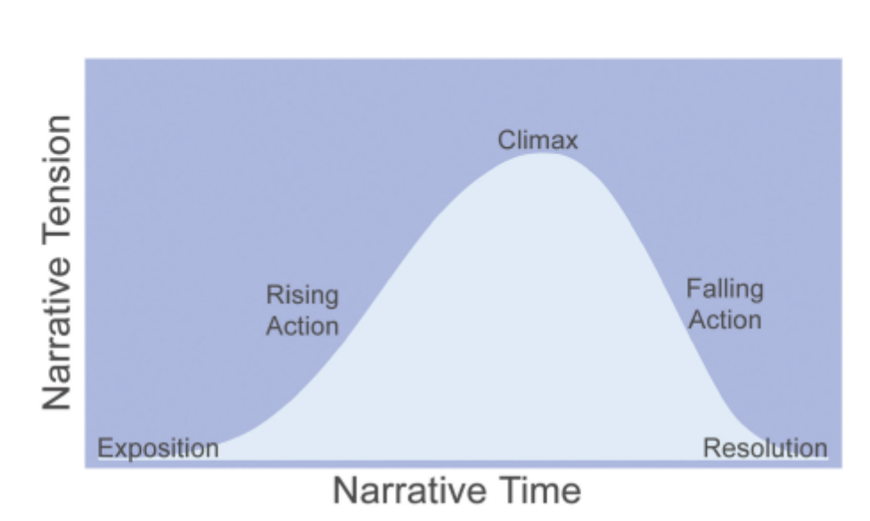
Figure 26: Chart of narrative

3.4.3.1. Exposition
In Celeste, Madeline is on the journey to climb the mountain, as well as to conquer the mental mountain within herself. This is the initial setting of the storyline that helps players understand what they need to do in the game.

3.4.3.2. Rising Action
During the climb, the issue arises when Badeline (Madeline's darker self, who emerges from the mirror world) begins to interfere and disrupt Madeline's journey.

What we can observe as the Rising Action in the chart is the moment when Madeline realizes that Badeline is the dark side of herself. Despite this, Madeline chooses to ignore it and continues her journey to conquer the mountain.

3.4.3.3. Climax
After hearing Theo’s advice, Madeline realizes that letting go of her dark side is essential for her to continue her journey up the mountain. This means that Madeline will sever a part of her inner self.

Madeline decides to tell Badeline that they should part ways. However, this has the opposite effect: Badeline becomes angry and pushes Madeline back down to the base of the mountain.

3.4.3.4. Falling Action
Being pushed back to the base of the mountain and having to start over makes Madeline feel discouraged and prompts her to reflect on her journey.

3.4.3.5. Resolution
Madeline receives advice from Granny, who tells her that her darker self, Badeline, is a part of who she is. Even though it may be negative or harmful, it cannot be simply discarded—it must be accepted and integrated.

Understanding this, Madeline apologizes to Badeline. Although Badeline resists, through many trials and challenges, they come to accept and reconcile with each other. This reconciliation unlocks a new ability for Madeline, allowing her to dash once more in her journey to conquer Mount Celeste.

In the end, Madeline and Badeline conquer the mountain together, and Madeline also succeeds in overcoming the inner challenges she faced within herself.

The story of a game can set a compelling reason for players to continue progressing through the game. Establishing a coherent and engaging narrative arc can motivate players to keep playing. An incoherent or unsatisfactory story can lead to a lack of motivation, causing players to lose interest and become frustrated with the game.

4.Other information
4.1. Map of the game
Based on my observations, the map design in Celeste always directs players upward or sideways. This level design approach helps players feel a sense of immersion, as they are playing a mountain-climbing game where the goal is to finish the mountain. Additionally, designing levels that emphasize upward movement allows the game to use game’s mechanics and environment’s mechanic.
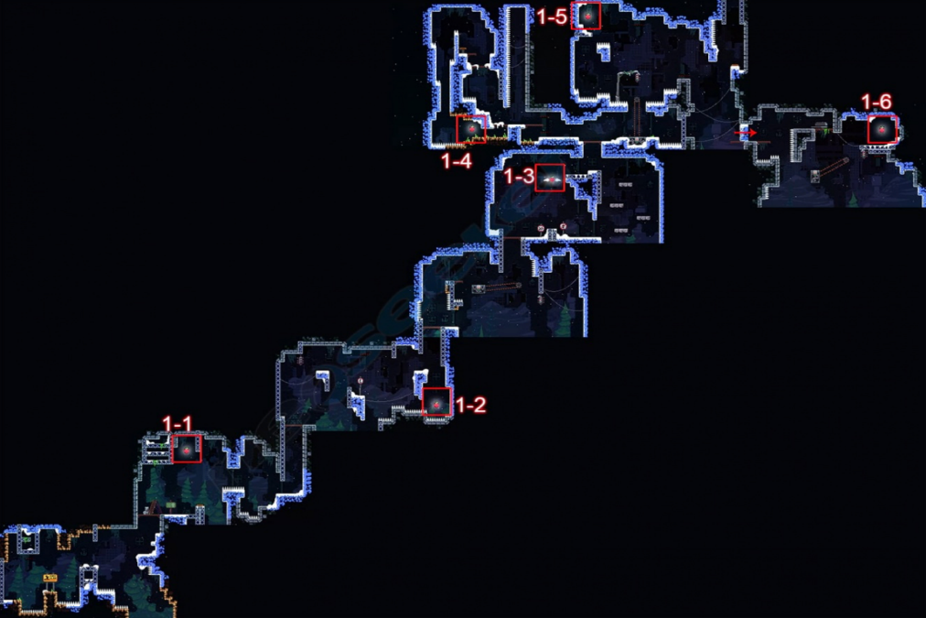
Figure 27 : Map of Celeste's chapter 1

4.2. Reason for Madeline’s panic attack
We can understand another indirect reason for Madeline's panic attacks: Madeline is canonically trans, a fact confirmed by Maddy Thorson on their personal website. This helps us observe the panic attacks and social anxiety is the things that Madeline or other Trans peopel faces it every day.

However, this is not the author's intention to describe Madeline's panic attack but only what the author experienced. We can understand the author's words in the article. “Is Madeline Canonically Trans?” on Maddy Thorson's personal website. "When I wrote Celeste I sincerely still believed that I was cisgender, but I was nevertheless waist-deep in gender feelings

(among other anxieties)”.
Figure 27: Image In blog
4.3. The real-life treatment
In Celeste, Theo (a character in the game) teaches Madeline a technique to counter her panic attacks and reduce her stress: Figure 28: Feather mechanic In Celeste

After researching on the internet, I realized that this technique is similar to controlled breathing techniques, which genuinely help people in extreme stress situations. This detail also show that the developer actually try to put some real-life technics to game.

5.Conclusion
In summary, through this article, we can see the significant contributions of game mechanics, formal elements, and dramatic elements to the core game loop. Particularly, the game's mechanics play a crucial role; providing players with simple control schemes combined with creative level design can deliver an outstanding experience for players.

I have discovered many fascinating aspects through studying Celeste. As someone aspiring to become a game developer, I have learned a great deal about how game mechanics and level design can combine to create an amazing experience. Additionally, I understand how a game with a seemingly childish appearance can convey a meaningful message to players. Furthermore, I have gained insight into what individuals with panic attacks endure daily.

In this article, I would also like to expand on various other aspects if I have enough time, such as:
- Art of Story: How the game's narrative provides an immersive experience for the players.
- Music and Sound: Music and sound are undoubtedly crucial for Celeste fans, but addressing them superficially in this article would undermine their importance, so I prefer to delve into them in a future discussion.
- Game Design Process: Finally, I want to explore the development process of the game, including the playtesting and feedback the design team utilized to create a polished game.
explore further, including:
- Symbolic Details of Characters: The symbolic meanings behind the characters.
- Related Games and Prototypes: Other game parts related to Celeste and its prototypes.
- Speedrunning Techniques: Investigating the techniques used by speedrunners to optimize their runs. Speedrunning in Celeste is a distinctive feature within the game's community.

6.Reference
- Eva Grouling Snider (2023) Coyote Time: What Games Can Teach Us About Forgiveness in Learning, The Teaching Innovation Blog, accessed 31 July 2024. https://blogs.bsu.edu/teaching-innovation/2023/11/15/coyote-time-games-teach-forgiveness-learning/#:~:text=Named%20after%20the%20Wile%20E,small%20amount%20of%20wiggle%20room.

- Fandom (n.d) Badeline [2D illustration], Fandom website, accessed 31 July 2024. https://celestegame.fandom.com/wiki/Badeline.

- Fandom (n.d) Mr.Oshiro [2D illustration], Fandom website, accessed 31 July 2024. https://celestegame.fandom.com/wiki/Mr._Oshiro.

- Fandom (n.d) Old Woman [2D illustration], Fandom website, accessed 31 July 2024. https://celestegame.fandom.com/wiki/Old_Woman.

- Fandom (n.d) Theo [2D illustration], Fandom website, accessed 31 July 2024. https://celestegame.fandom.com/wiki/Theo.

- Game Maker’s Toolkit (2019) Why Does Celeste Feel So Good to Play?, YouTube website, accessed 31 July 2024. https://www.youtube.com/watch?v=yorTG9at90g&t=859s.

- Gustav Dahl and Martin Kraus (2015) ‘Measuring How Game Feel Is Influenced by the Player Avatar’s Acceleration and Deceleration’, DOI: http://dx.doi.org/10.1145/2818187.2818275.

- Maddy Makes Games Inc., Extremely OK Games, Ltd (2018) Celeste [game], Maddy Makes Games Inc.

- Maddy Thorson (n.d) Celeste & Forgiveness, Maddy Makes Games, accessed 31 July 2024. https://maddymakesgames.com/articles/celeste_and_forgiveness/index.html.

- Natalia Hefkaluk, Conor Linehan and Anna Trace (2023) ‘Fail, fail again, fail better: How players who enjoy challenging games persist after failure in “Celeste”’, doi: https://doi.org/10.1016/j.ijhcs.2023.103199.

- neoseeker (2021) Chapter 1 - Forsaken City, neoseeker, accessed 31 July 2024. https://www.neoseeker.com/celeste/walkthrough/Level_1_-_Forsaken_City.

- Tracy Fullerton (2019) Game Design Workshop: A Playcentric Approach to Creating Innovative Games (Fourth edition), Taylor & Francis, CRC Press.

- Wikipedia (2024) Madeline (Celeste) [2D illustration], Wikipedia website, accessed 31 July 2024. https://en.wikipedia.org/wiki/Madeline_%28Celeste%29.

