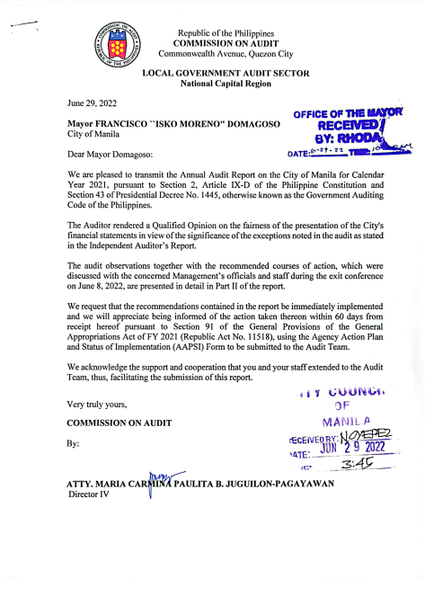

Copy furnished:

The Secretary, Sangguniang Panlungsod, Manila City
The Bureau of Local Government Finance
The Secretary, Department of the Interior and Local Government
National Library (soft copy)
University of the Philippines (soft copy)
COA Commission Central Library (soft copy)

