<http://rritw.com/a/caozuoxitong/Linux/20130313/322581.html>

**Overview and basic concepts**

[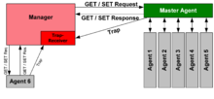](http://en.wikipedia.org/wiki/File:SNMP_communication_principles_diagram.PNG)

Essentially, SNMP agents expose management data on the managed systems as variables. The protocol also permits active management tasks, such as modifying and applying a new configuration through remote modification of these variables. The variables accessible via SNMP are organized in hierarchies. These hierarchies, and other metadata (such as type and description of the variable), are described by [Management Information Bases](http://en.wikipedia.org/wiki/Management_Information_Base)(MIBs).A **management information base** (**MIB**) is a database used for managing the entities in a communications network. The database is hierarchical (tree-structured) and each entry is addressed through an [object identifier (OID)](http://en.wikipedia.org/wiki/Object_identifier) .

An SNMP-managed network consists of three key components: (1) Managed device. (2) Agent - software which runs on managed devices. (3) Network management system (NMS) — software which runs on the manager.

A *managed device* is a network node that implements an SNMP interface that allows unidirectional (read-only) or bidirectional (read and write) access to node-specific information. Managed devices exchange node-specific information with the NMSs. Sometimes called network elements, the managed devices can be any type of device, including, but not limited to, [routers](http://en.wikipedia.org/wiki/Router_(computing)), [access servers](http://en.wikipedia.org/wiki/Network_access_server), [switches](http://en.wikipedia.org/wiki/Network_switch), [bridges](http://en.wikipedia.org/wiki/Network_bridge), [hubs](http://en.wikipedia.org/wiki/Network_hub), [IP telephones](http://en.wikipedia.org/wiki/IP_phone), [IP video cameras](http://en.wikipedia.org/wiki/IP_camera), computer [hosts](http://en.wikipedia.org/wiki/Host_(network)), and [printers](http://en.wikipedia.org/wiki/Computer_printer). An *agent* is a network-management software module that resides on a managed device. SNMP agent’s key functions: 1. Collects management information about its local environment. 2. Stores and retrieves management information as defined in the MIB. 3. Signals an event to the manager. 4. Acts as a proxy for some non–SNMP manageable network node. A [*network management system*](http://en.wikipedia.org/wiki/Network_management_system) (NMS) executes applications that monitor and control managed devices. NMSs provide the bulk of the processing and memory resources required for network management. One or more NMSs may exist on any managed network.

**Management information base (MIB)**

SNMP itself does not define which information (which variables) a managed system should offer. SNMP uses an extensible design, where the available information is defined by [management information bases](http://en.wikipedia.org/wiki/Management_information_base) (MIBs). MIBs describe the structure of the management data of a device subsystem; they use a [hierarchical namespace](http://en.wikipedia.org/wiki/Hierarchical_name_space) containing [object identifiers](http://en.wikipedia.org/wiki/Object_identifier) (OID). Each OID identifies a variable that can be read or set via SNMP.

**Protocol details**

SNMP operates in the [Application Layer](http://en.wikipedia.org/wiki/Application_Layer) of the [Internet Protocol Suite](http://en.wikipedia.org/wiki/Internet_Protocol_Suite) ([Layer 7](http://en.wikipedia.org/wiki/Layer_7) of the [OSI model](http://en.wikipedia.org/wiki/OSI_model)). The SNMP agent receives requests on UDP port 161. The manager may send requests from any available source port to port 161 in the agent. The agent response will be sent back to the source port on the manager. The manager receives notifications ([*Traps*](http://en.wikipedia.org/wiki/Simple_Network_Management_Protocol#Trap) and *[InformRequests](http://en.wikipedia.org/wiki/Simple_Network_Management_Protocol" \l "InformRequest)*) on port 162.

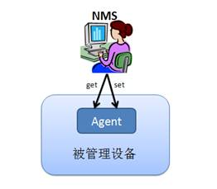

簡單網络管理協議(Simple Network Management Protocol)是應用層協議，是TCP/IP協議族的一部分。它使網络設備間能交換管理信息。讓網络管理員管理網络的性能，發現和解决網络問題及進行網络的擴充。SNMP是管理設備的協議：監控(get)和配置(set)。如果NMS(網管系統)要查詢被管理設備的狀態，要通過SNMP的get操作獲得設備的狀態信息；如果NMS要修改或者配置被管理設備的参數，則通過SNMP的set操作完成。

**什麼是MIB**?

MIB是描述被管理設備上参數的數據結構。用SNMP協議管理設備，通過網络對被管理設備上的参數進行get和set操作。参數很多，假如僅線性罗列它們，操作不便。被管理的設備相當复雜，有很多可被管理的参數，要進行歸類分級。管理信息庫(MIB)是一個具分層特性的信息的集合，通過SNMP存取它。MIB的成員是一些被管理的對象(Managed Object)，以對象標示符(Object Identifiers)區分它們。被管理的對象由一個或多個對象實例(Object Instances)組成，本質上這些對象實例就是變量。MIB的層次結構中，一個對象標示符唯一標識被管理對象。MIB的層次結構可被描述成無根名的樹，樹的級別被不同的組織劃分。如下圖所示：  
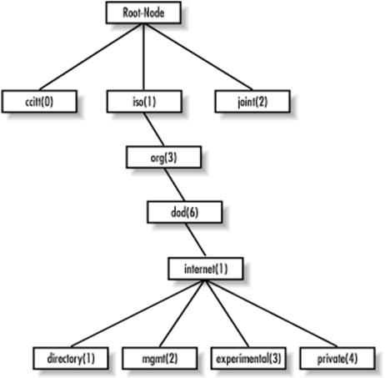

很多被SNMP管理的對象是由標准組織定義好的。如系統磁盤的信息，用OID ”1.3.6.1.4.1.2021.9”表示。這串數字是定義好的，大家要遵循。如果開發的設備有管理需求沒有任何RFC定義過，也可編寫自己的MIB文件來定義私有的MIB對象。

什麼是SNMP Trap

前面介紹的get/set操作都是從NMS發送到被管理設備的。但有時從被管理設備主動發送信息到NMS是必要的。

SNMP Trap是SNMP的一部分，當被監控段出現特定事件，可能是性能問題，甚至是網络設備接口宕掉等，代理端會给管理站發告警事件。假如在特定事件出現的時刻，不是由Agent主動通知NMS，那麼NMS須不斷地對Agent輪詢。這是浪費計算資源的方法，如用中斷通知CPU數據的到達，不讓CPU進行輪詢。Trap通知是更加合理的選擇，SNMP Trap是被管理設備主動發送消息给NMS的機制。