Ardupilot 编译环境配置：

Tools/scripts/install-prereqs-ubuntu.sh -y

. ~/.profile

+ pip2 -q install --user -U future lxml pymavlink MAVProxy pexpect pygame intelhex

pip2 install --user -U future lxml pymavlink MAVProxy pexpect pygame intelhex --proxy='socks5://127.0.0.1:1080'

运行：pip2 install --user -U future lxml pymavlink MAVProxy pexpect pygame intelhex
Collecting future
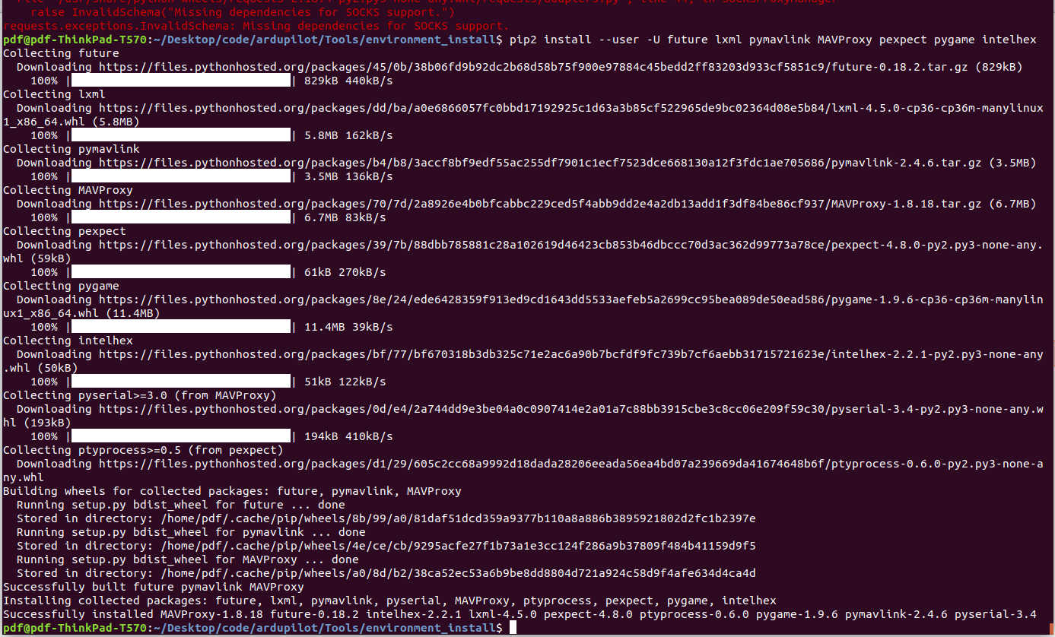

安装：gcc-arm-none-eabi

sudo apt-get install gcc-arm-none-eabi

./waf
list_boards
./waf configure --board fmuv3
./waf

搞定！！！！ 2020－－－2－－－25
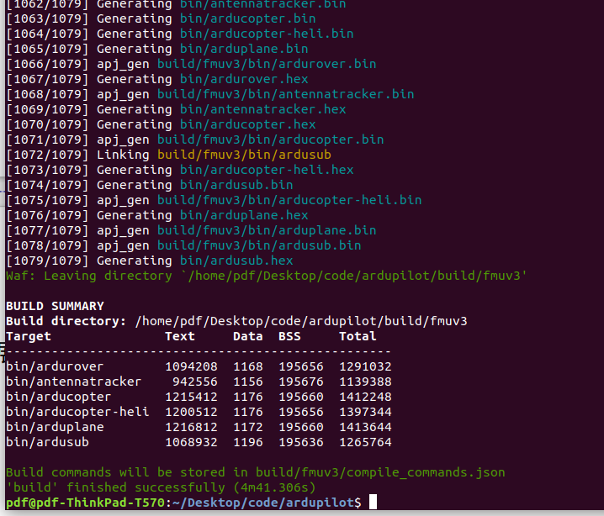

dpkg: error: dpkg status database is locked by another process 解决方法

$ sudo rm /var/lib/dpkg/lock
$ sudo dpkg --configure -a
$ sudo rm /var/lib/apt/lists/lock

.deb文件安装；
sudo dpkg -i 安装包名称.deb

SITL

https://blog.csdn.net/breederbai/article/details/98877906

SITL:
进入：ardupilot/Tools/autotest

sim_vehicle.py -V ArduCopter

sim_vehicle.py --console --map

更新MAVProxy和pymavlink

pip2 install MAVProxy

pip install --upgrade pymavlink MAVProxy --user
Error:
sudo -H pip2 install --upgrade pymavlink future lxml

Open a new command prompt and run the appropriate shell file for your vehicle in /ardupilot/Tools/autotest/: fg_plane_view.sh (Plane) and fg_quad_view.sh (Copter).

成功：
/ardupilot/Tools/autotest/目录下运行以下语句将启动SITL，并打开FlightGear.
fg_plane_view.sh (Plane)
fg_quad_view.sh (Copter).

展开ardupilo 的深层次研究与应用。

ardupilot SITL仿真

https://www.bilibili.com/video/av80625259/MissionPlanner

