IPsecTrace — EXECUTIVE WHITE PAPER
A Protocol-Aware Multi-View Framework for Encrypted IPsec Traffic Forensics and Behavior Attribution
1. Abstract
Internet Protocol Security (IPsec) encapsulates, authenticates, and encrypts enterprise network communications, rendering traditional Deep Packet Inspection (DPI) obsolete without intrusive payload decryption appliances. This paper introduces IPsecTrace, a protocol-aware multi-view IPsec traffic analysis framework that combines deterministic protocol forensics with encrypted-side statistical and temporal representation learning, self-supervised sequence representation, experimental novelty detection, and evidence-grounded reporting without requiring payload decryption. Evaluated across 1,829 native IPsec flow windows from 294 capture runs under a strict 5-fold GroupKFold protocol with zero PCAP leakage, our winning Hybrid Tabular + Sequence model achieves 80.25% ± 13.77% accuracy and 81.89% ± 9.15% Macro-F1 (+13.35% over canonical tabular baselines). We demonstrate deterministic cryptographic compliance verification, sequence-based traffic behavior attribution, and robust out-of-distribution (OOD) detection (AUROC = 0.9962), establishing a non-intrusive paradigm for zero-trust IPsec security monitoring.
2. High-Level Architecture
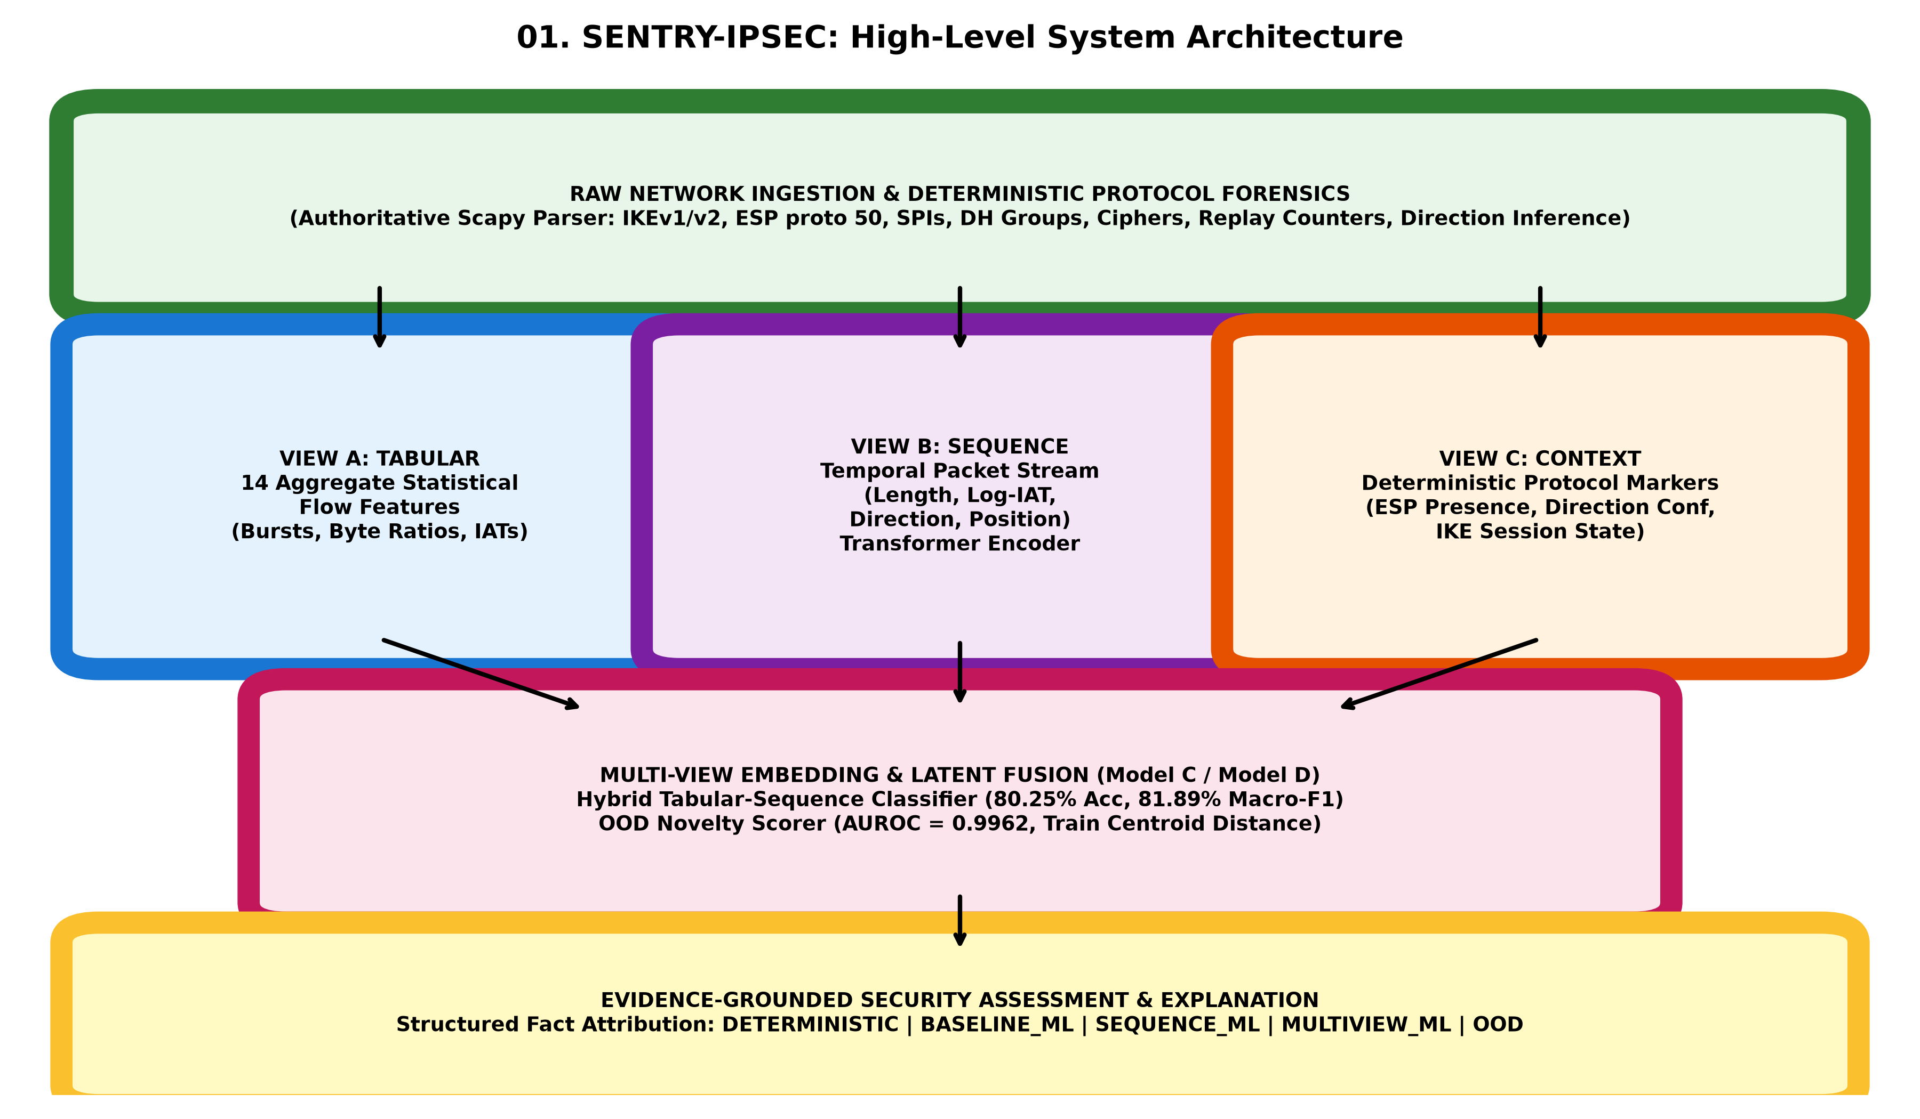
Figure 1: High-Level IPsecTrace Multi-View Architecture.
3. Key Experimental Results
Model ID & Description | Accuracy (Mean ± Std) | Macro-F1 (Mean ± Std) | Weighted-F1 (Mean ± Std)
A: Canonical Tabular XGBoost | 66.91% ± 18.66% | 73.91% ± 4.84% | 68.22% ± 18.65%
B1: Sequence Transformer | 69.96% ± 26.40% | 77.66% ± 14.59% | 68.29% ± 30.87%
B2: Protocol-Aware Sequence | 67.23% ± 22.06% | 70.95% ± 10.62% | 64.75% ± 26.99%
B3: SSL Pretrained Sequence | 72.25% ± 25.73% | 76.18% ± 13.33% | 68.51% ± 30.06%
C: Hybrid Tabular + Sequence (Best) | 80.25% ± 13.77% | 81.89% ± 9.15% | 81.56% ± 12.48%
D: Multi-View IPsec (Negative Finding) | 61.33% ± 25.07% | 70.28% ± 9.54% | 58.13% ± 30.02%

