IPsecTrace — SYSTEM ARCHITECTURE & TECHNICAL DESIGN
Comprehensive Pipeline Engineering, Dual-Branch Representation, and Technology Stack
1. System Overview
The IPsecTrace platform is an enterprise-grade, non-intrusive traffic inspection and protocol compliance engine.
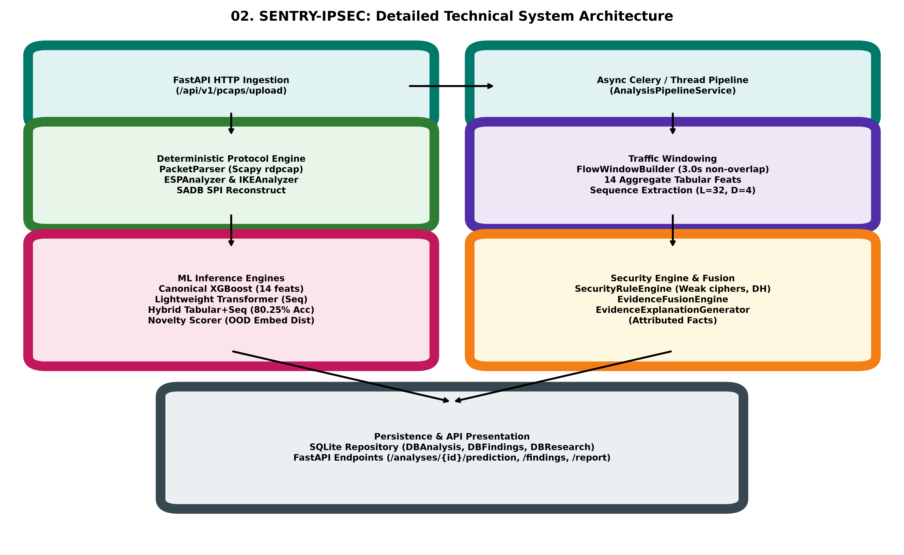
Figure 2: Detailed IPsecTrace Architectural Pipeline.
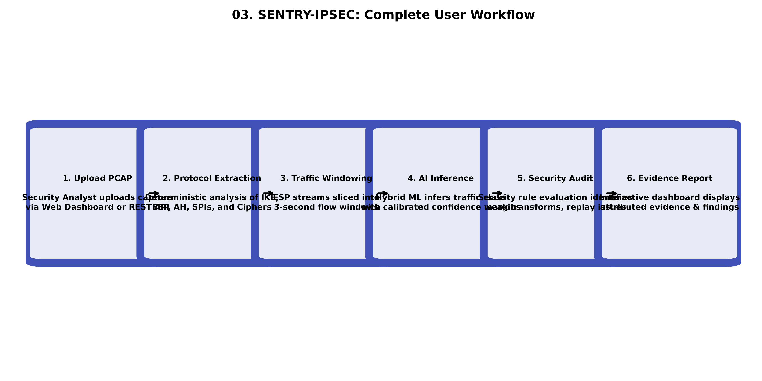
Figure 3: End-to-End User Interaction and Execution Workflow.

