IPsecTrace — DATASET & EXPERIMENTAL METHODOLOGY
Dataset Construction, Physical Group Partitioning, and Zero-Leakage Protocol Rigor
1. Dataset Overview
Primary native IPsec benchmark dataset DS1_NATIVE_IPSEC_ENHANCED consists of 1,829 flow windows across 294 PCAPs and 157 physical experiment groups.
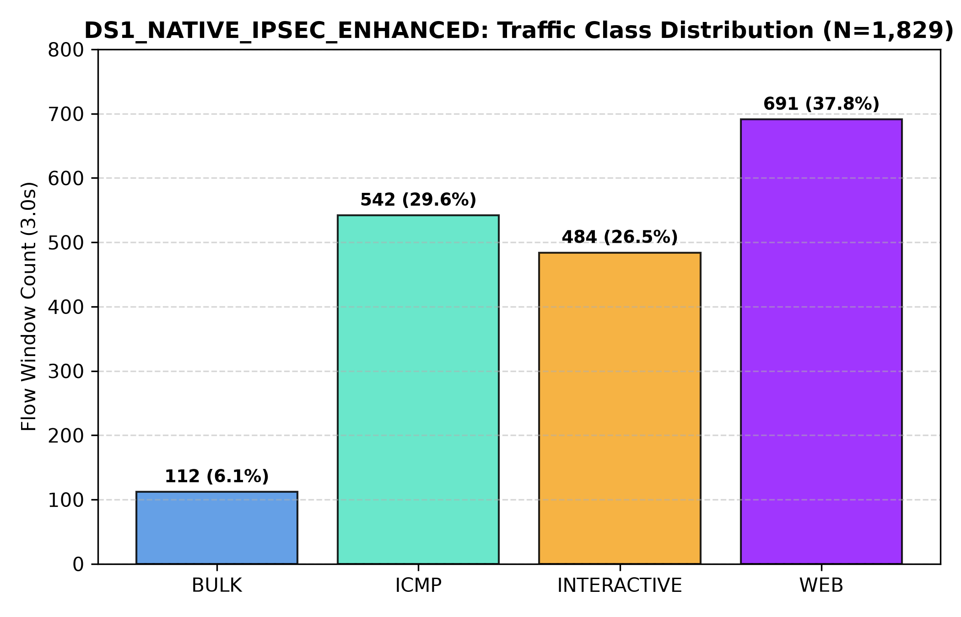
Figure 4: Traffic Class Sample Distribution across Native IPsec Dataset.

