IPsecTrace — MACHINE LEARNING EXPERIMENTS & RESULTS
Authoritative 6-Model Benchmark, Multi-View Fusion Gains, Ablations, and Negative Findings
1. Benchmark Overview
Systematic evaluation of six model configurations on the leak-free native IPsec benchmark.
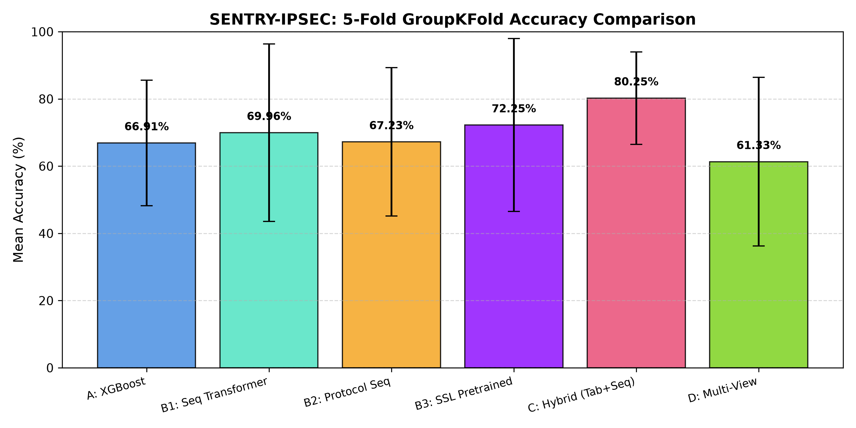
Figure 5: Model Accuracy Comparison across 5-Fold Evaluation.
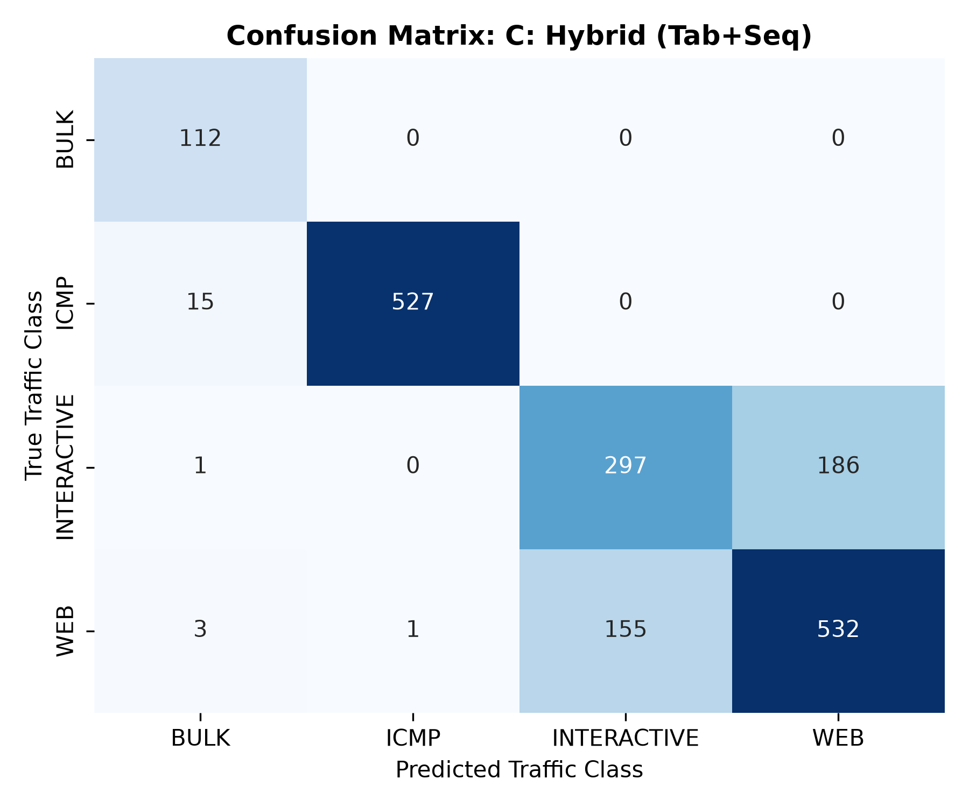
Figure 6: Confusion Matrix for Winning Hybrid Model C.

