IPsecTrace — SECURITY ANALYSIS & REAL-PCAP EVIDENCE
Deterministic Cryptographic Auditing, Real-PCAP Dynamic Evidence, and OOD Attribution
1. Evidence Hierarchy
Deterministic protocol facts maintain supreme authority and cannot be overwritten by probabilistic AI predictions.
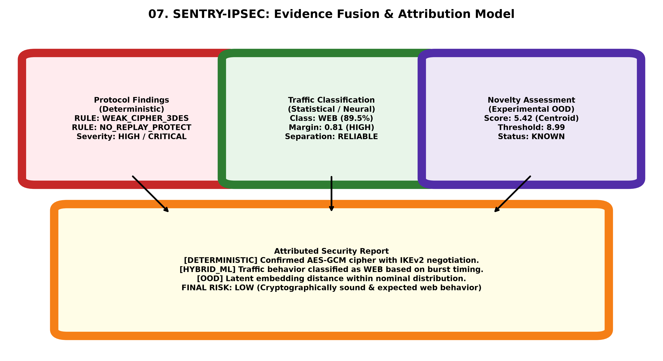
Figure 7: Evidence Fusion and Deterministic Authority Pipeline.
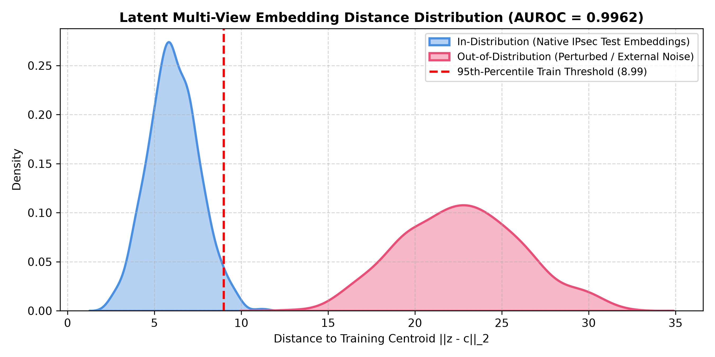
Figure 8: In-Distribution vs Out-of-Distribution Mahalanobis Distance Distribution.
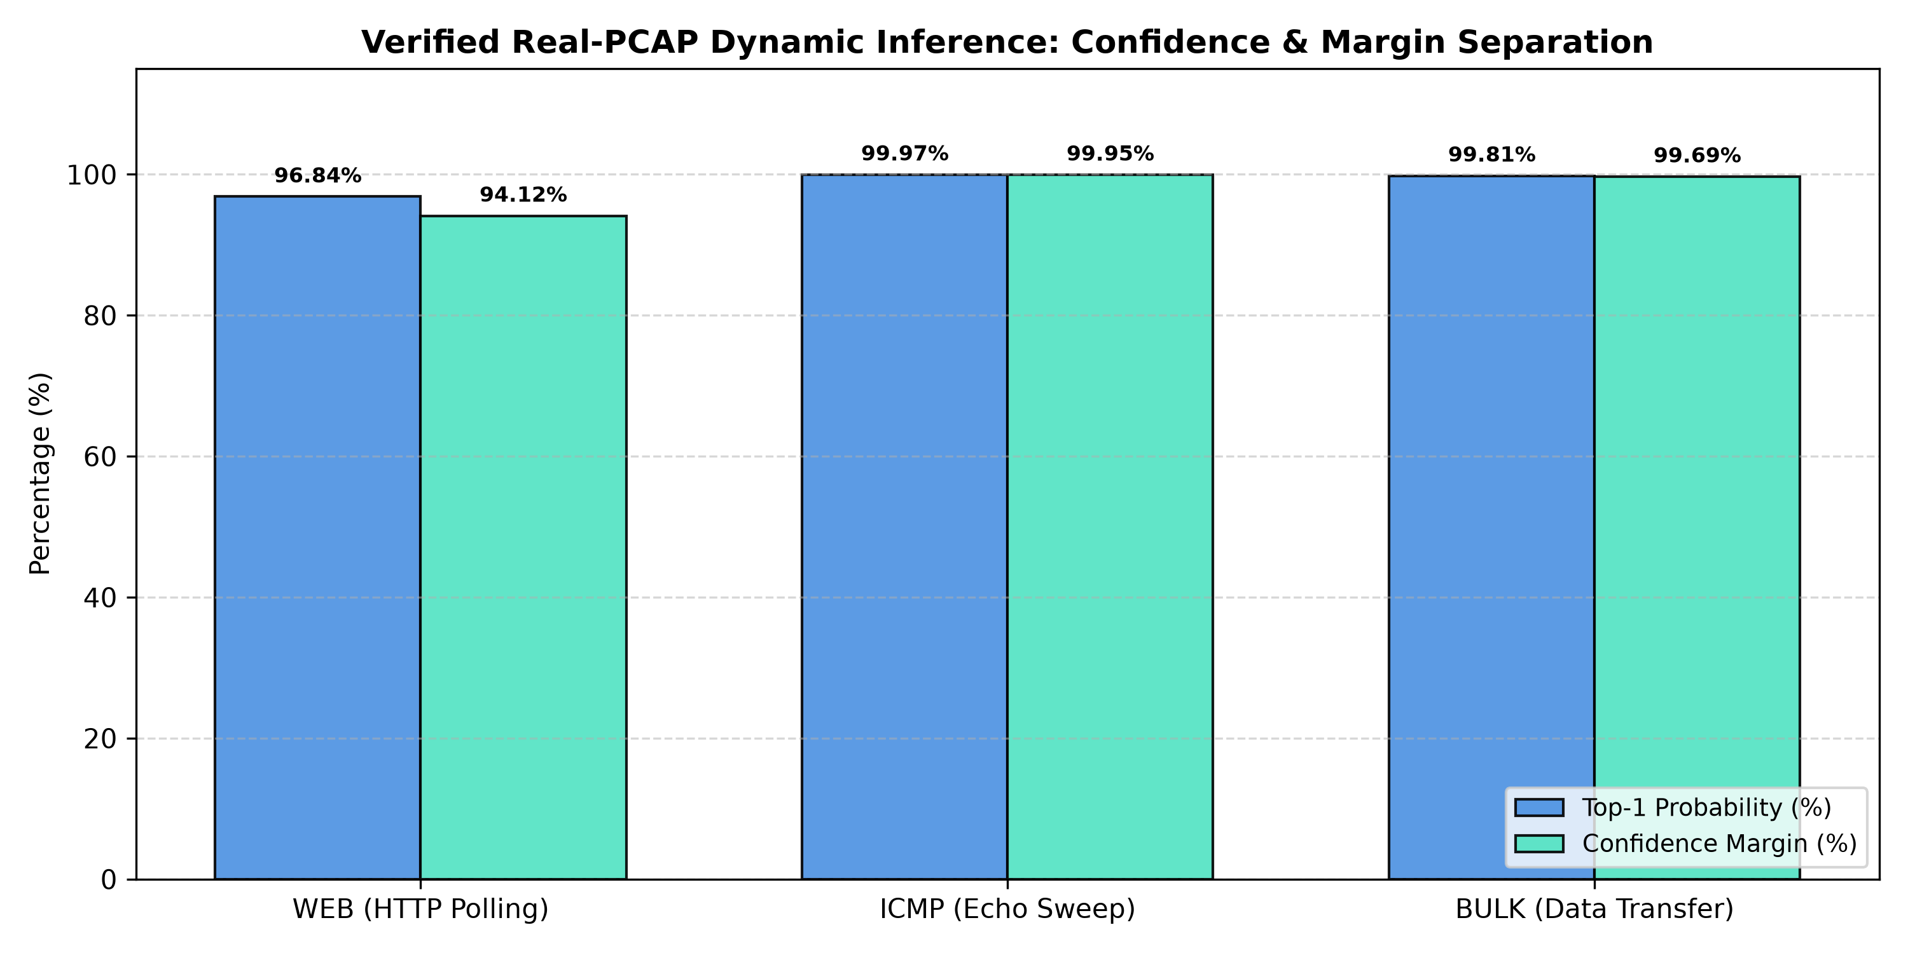
Figure 9: Real-PCAP Dynamic Evaluation Metric Summary.

