Department of Artificial Intelligence and Machine Learning

Experiment No.: 8
To implement Interval Tree

Aim
To implement an Interval Tree for efficiently storing intervals and performing overlap queries, and to analyze its use in solving interval-based searching problems.

Learning Objectives
After completing this experiment, students will be able to:

- Understand the structure and working principle of an Interval Tree.
- Represent intervals efficiently using an augmented Binary Search Tree.
- Construct an Interval Tree by inserting a set of intervals.
- Understand the significance of the max value stored at each node.

Theory
An Interval Tree is an augmented Binary Search Tree used to store intervals and ef-ficiently determine whether a given interval overlaps with any interval already stored in the tree. An interval is represented as:

I = [low, high]

where low represents the starting point and high represents the ending point of the interval.Each node of an Interval Tree stores:
  - An interval [low, high]
  - The maximum upper endpoint (max) among all intervals in the subtree rooted at that node
  - A pointer to the left child, a pointer to the right child
The tree is constructed based on the low value of each interval, similar to a Binary Search Tree.For every node,

max = max(high, left.max, right.max)

The max value allows the search algorithm to eliminate subtrees that cannot contain an overlapping interval.

Algorithm

Algorithm 1: Insert an Interval
- Create a new node containing the given interval.
- If the tree is empty, make the new node the root.
- Compare the lower endpoint of the new interval with the lower endpoint of the current node.
- If the new lower endpoint is smaller, recursively insert the interval into the left subtree.
- Otherwise, recursively insert it into the right subtree.
- Update the max value of the current node.
- Return the root of the modified tree.

Algorithm 2: Search for an Overlapping Interval
- Start searching from the root node.
- Check whether the interval stored at the current node overlaps with the query interval.
- If an overlap is found, return the interval.
- Otherwise, check the left subtree.
- If the left child exists and its max value is greater than or equal to the lower endpoint of the query interval, continue searching in the left subtree.
- Otherwise, search the right subtree.
- If no matching interval is found, report that no overlapping interval exists.

Code:

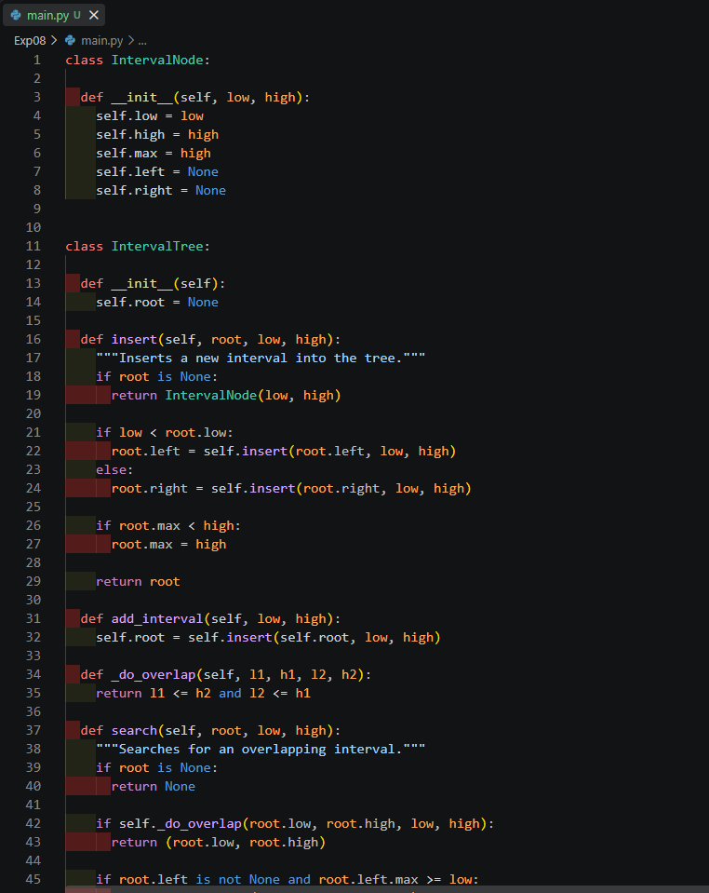

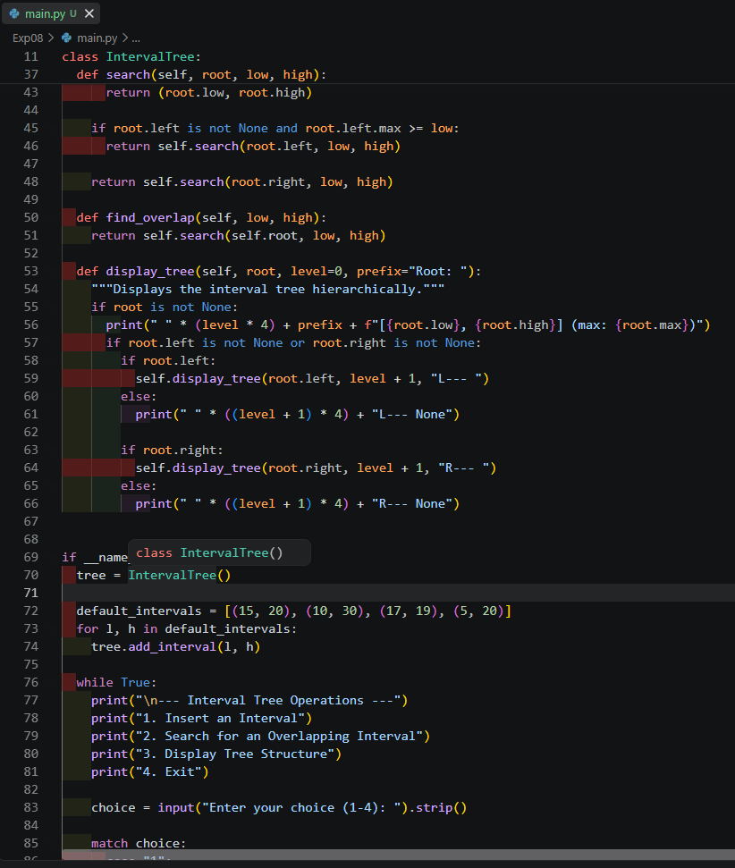

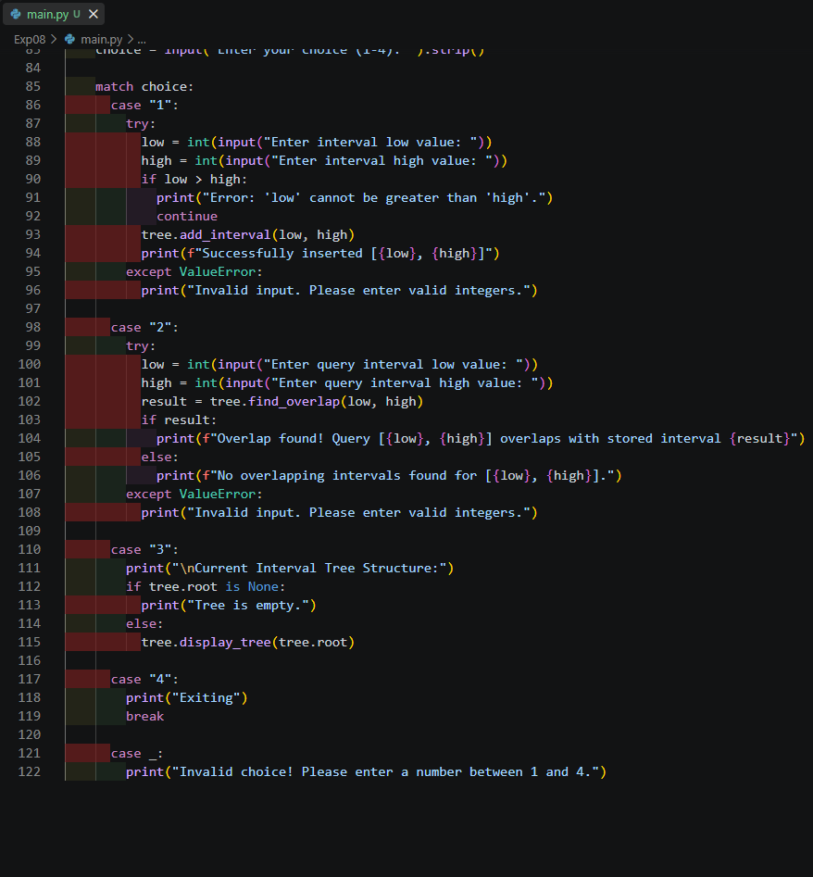

Output:

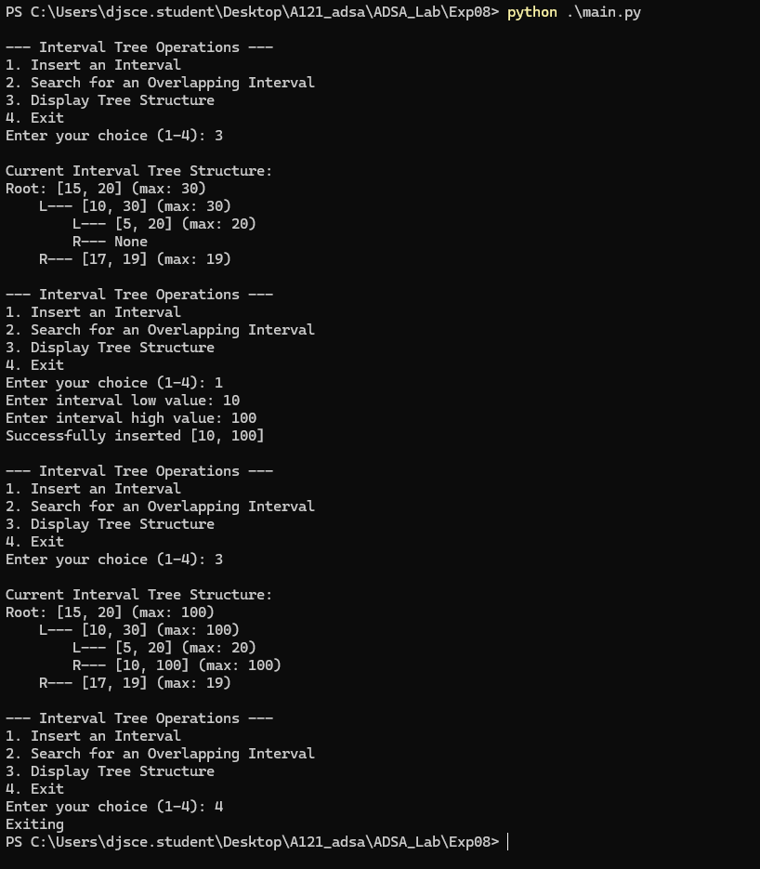

Problem Statement
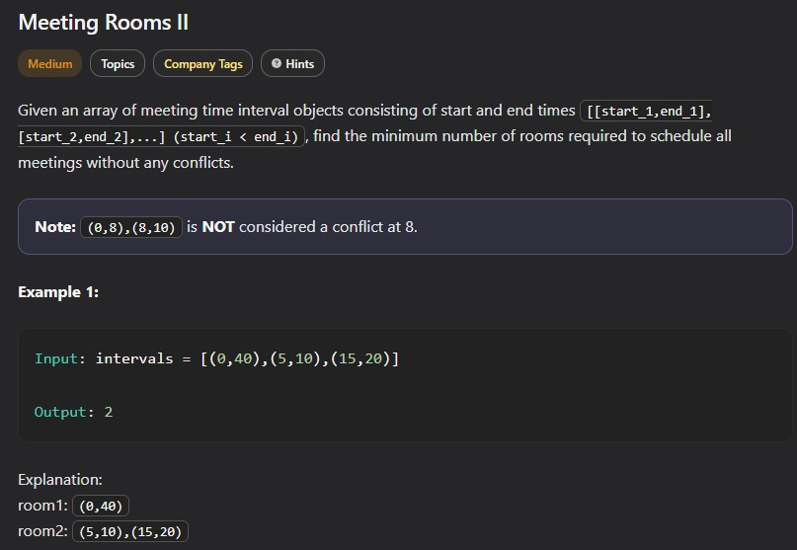

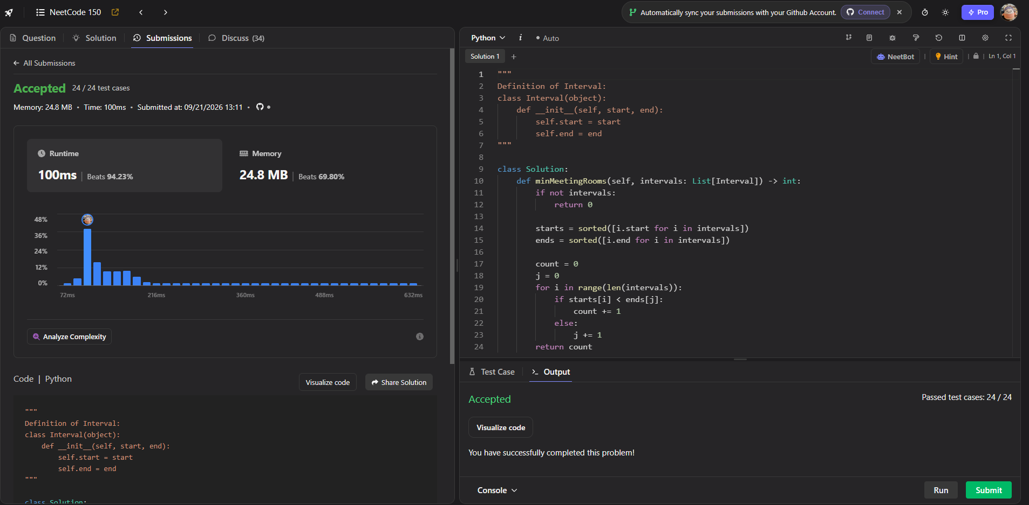
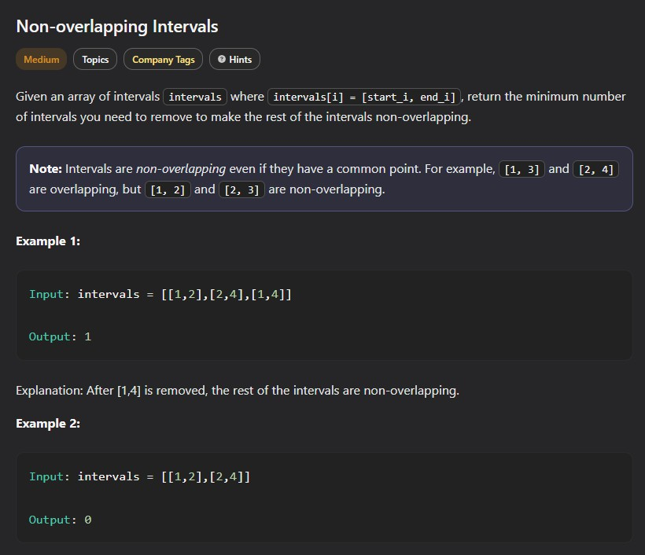

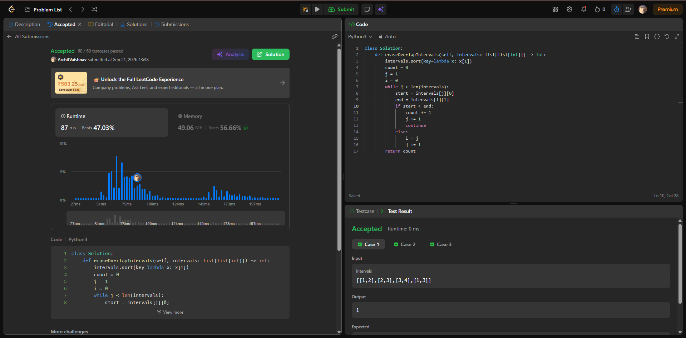

Conclusion
The Interval Tree was successfully implemented for storing and searching intervals.

Post-Lab Questions
- What is an Interval Tree? How is it different from a conventional Binary Search Tree?
- Why is the max value maintained at every node of an Interval Tree?
- Write the mathematical condition for determining whether two intervals overlap.
- Consider the intervals

[5, 8], [10, 15], [12, 18], [20, 25], [30, 35].

Which intervals overlap with the query interval [13, 21]?
- What happens to the performance of an Interval Tree if the tree becomes highly skewed?
- What is the average time complexity of searching for an overlapping interval in a balanced Interval Tree?
- How can AVL Trees or Red-Black Trees improve the performance of an Interval Tree?
- Modify the program so that it returns all overlapping intervals instead of re-turning only the first overlapping interval.
- Modify the program to count the total number of intervals overlapping with a given query interval.
- Give three real-world applications where Interval Trees can be used effectively.

