Department of Artificial Intelligence and Machine Learning
Experiment No.: 7
To implement KD Tree

Aim
To implement a K-D Tree for storing multidimensional points and perform insertion and nearest-neighbor search efficiently.

Objective
- To understand the structure and working of a K-D Tree.
- To represent multidimensional data using a binary tree structure.
- To implement insertion of points in a K-D Tree.
- To understand the applications of K-D Trees in multidimensional searching problems.

Theory
A K-D Tree (K-Dimensional Tree) is a binary tree used to organize points in a K-dimensional space. Each node of the tree contains a point having K coordinates. A non-leaf node divides the space into two regions. The points belonging to one region are stored in the left subtree, while the points belonging to the other region are stored in the right subtree.The dimension used for comparison changes according to the depth of the node. If the dimensions are numbered as
0,1,2,...,K − 1,
then the dimension used at depth D is
A = D mod K
where:
- D represents the depth of the current node, K represents the number of dimensions,
- A represents the dimension used for comparison.
For example, in a two-dimensional K-D Tree (K = 2), the comparison alternates between the x and y coordinates.
Depth | D mod K | Coordinate Used
0 | 0 | x
1 | 1 | y
2 | 0 | x
3 | 1 | y
4 | 0 | x
If the current node uses dimension A, a new point having a smaller coordinate in dimension A is inserted into the left subtree. Otherwise, it is inserted into the right subtree.

Construction of a 2-D Tree
Consider the following points:
(3,6), (17,15), (13,15), (6,12), (9,1), (2,7), (10,19)
These points are inserted one after another into the K-D Tree.
- Insert (3,6) Since the tree is initially empty, (3,6) becomes the root. The root is compared using the x-coordinate.
- Insert (17,15) At the root, compare the x-coordinates:
17 > 3
Therefore, (17,15) is inserted into the right subtree of (3,6).The next level uses the y-coordinate.
- Insert (13,15) First compare x with (3,6):
13 > 3
Therefore, move right to (17,15). At this level, compare the y-coordinates:
15 = 15
Equal values are directed to the right subtree. Hence, (13,15) becomes the right child of (17,15).
- Insert (6,12) At (3,6):
6 > 3
Move right. At (17,15), compare the y-coordinates:
12 < 15
Therefore, (6,12) becomes the left child of (17,15).
- Insert (9,1) The point is compared successively using the appropriate dimensions and is inserted as the right child of (6,12).
- Insert (2,7) At the root:
2 < 3
Therefore, (2,7) is inserted as the left child of (3,6).
- Insert (10,19) After comparisons at the appropriate levels, (10,19) is inserted as the left child of (13,15).
The resulting K-D Tree is:
(3,6)
/ \
(2,7) (17,15)
/ \
(6,12) (13,15)
\ /
(9,1) (10,19)

Space Partitioning
A K-D Tree can also be understood as a method for recursively partitioning multidimensional space. For the above two-dimensional example: • (3,6) divides the complete space using
x = 3
- (2,7) further divides the region to the left of x = 3 using
  - = 7
- (17,15) divides the region to the right of x = 3 using
  - = 15
- (6,12) further divides its corresponding region using
x = 6
- (13,15) partitions its region using
x = 13
- The next level again uses the y-coordinate for partitioning.

Algorithm for Insertion
- If the tree is empty, create a new node containing the point.
- Determine the current comparison dimension:
cd = depth mod K
- Compare the coordinate of the new point with the coordinate of the current node in dimension cd. 4. If
point[cd] < root.point[cd],
recursively insert the point into the left subtree.
- Otherwise, recursively insert the point into the right subtree.
- Increase the depth by one during every recursive call.
- Return the root of the modified tree.

Algorithm for Search
- Start searching from the root node.
- If the root is NULL, the required point is not present.
- If all coordinates of the current node are equal to the coordinates of the search point, return True.
- Determine the current dimension:
cd = depth mod K
- Compare the search point and current node using dimension cd. 6. If
point[cd] < root.point[cd],
continue searching in the left subtree.
- Otherwise, continue searching in the right subtree.
- Repeat until the point is found or a NULL node is reached.

Program Code
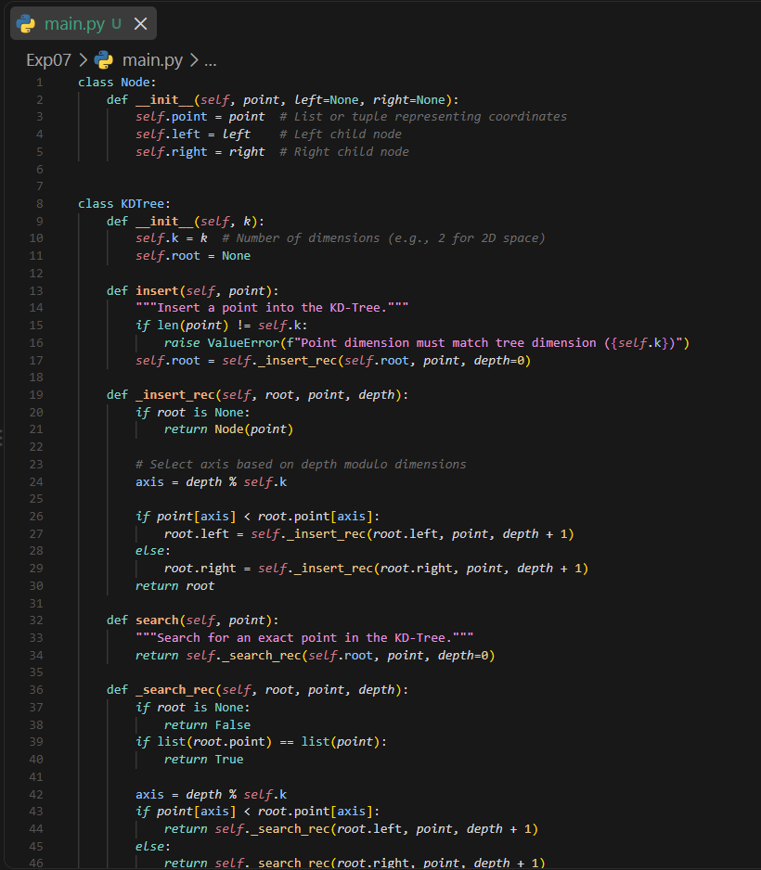
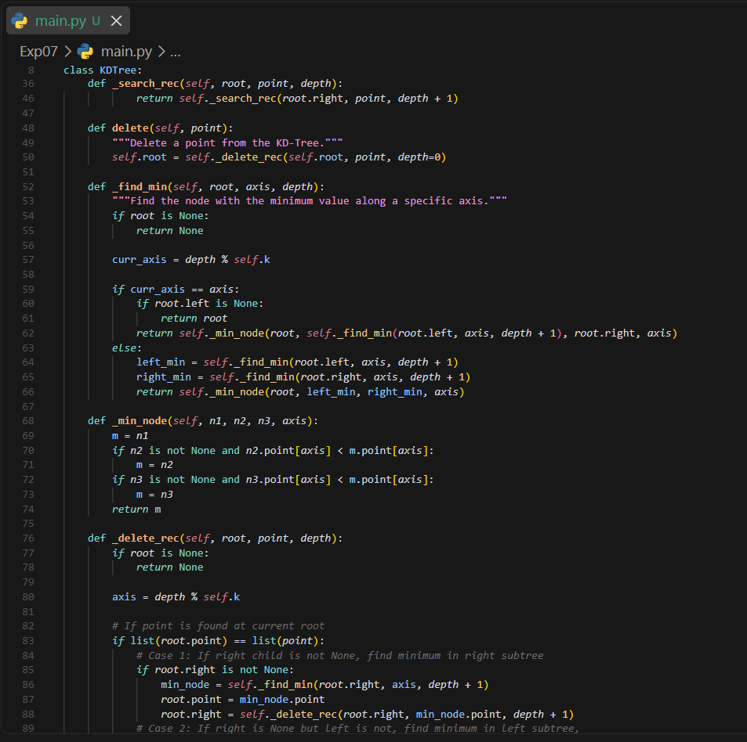

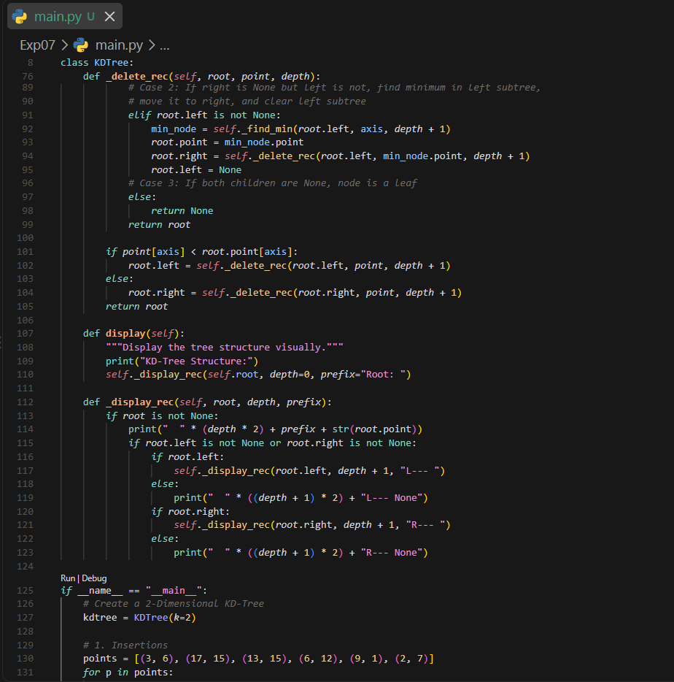
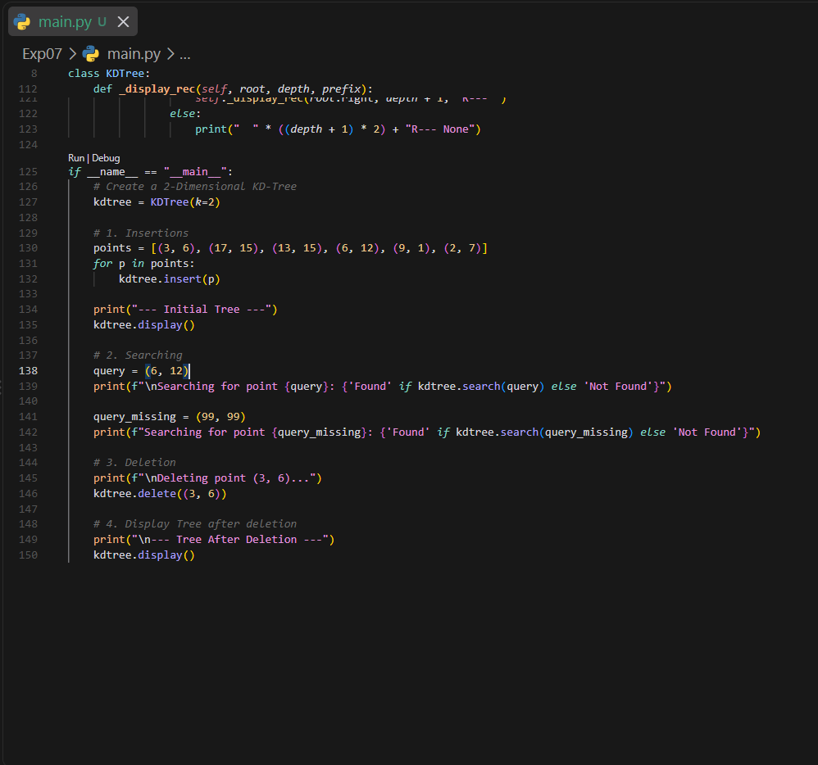

Output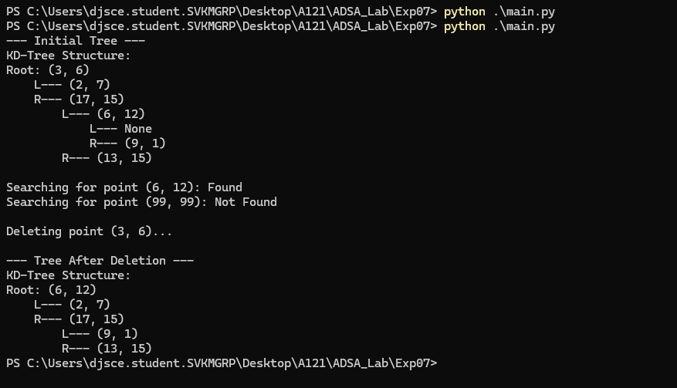

Applications of K-D Tree
K-D Trees are useful for organizing and searching multidimensional data. Some common applications include:
- Multidimensional searching
- Range searching
- Nearest-neighbor searching
- Spatial data organization
- Computer graphics
- Data mining
- Scientific computing

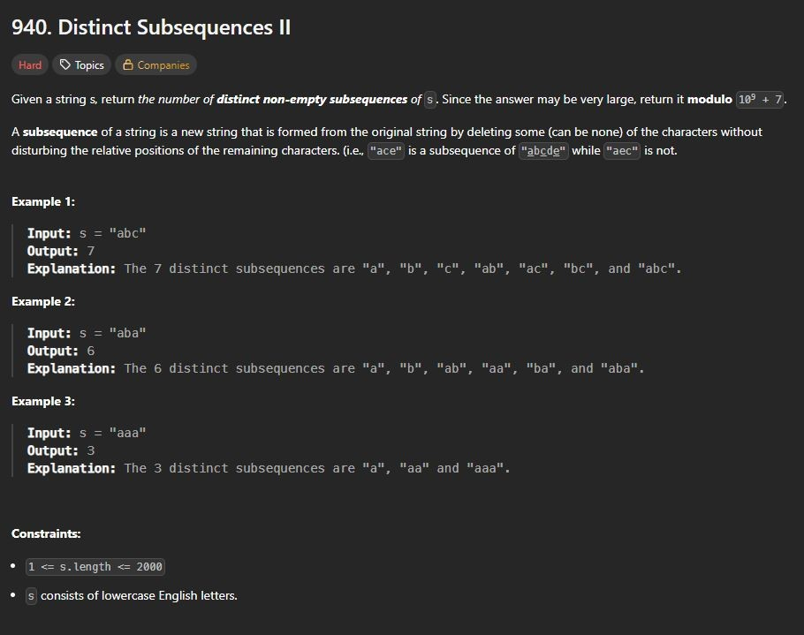
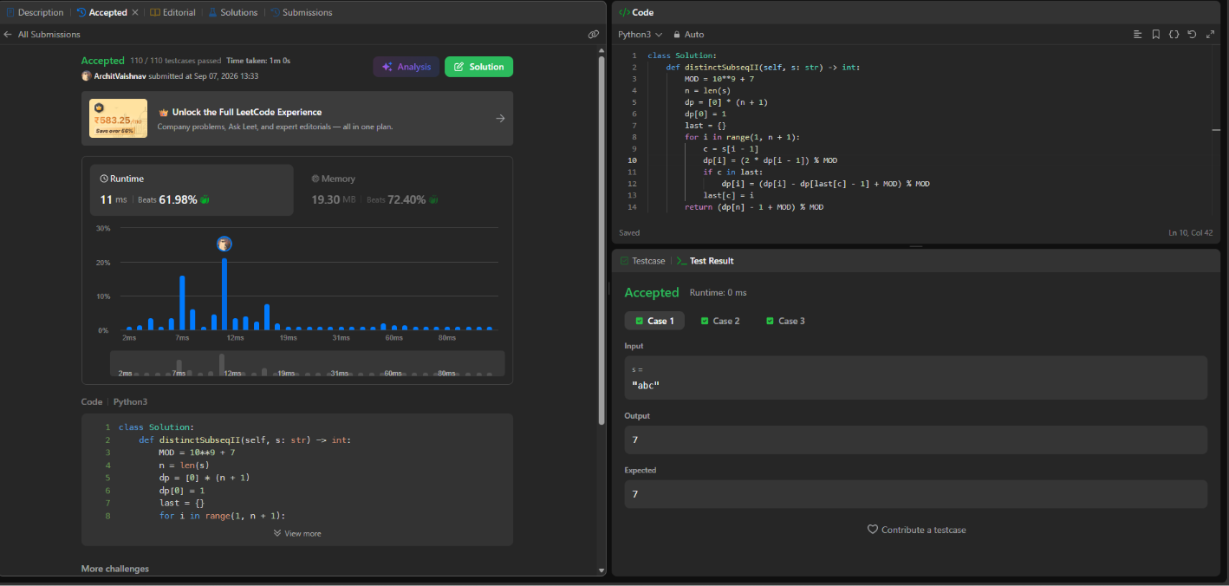

Viva Questions
- What is a K-Dimensional Tree?
- Why is a K-D Tree called a multidimensional data structure?
- How is a K-D Tree different from a normal Binary Search Tree?
- How is the comparison dimension determined at a particular depth?
- Which coordinate is compared at the root of a 2-D Tree?
- Which coordinate is compared at depth 1 of a 2-D Tree?
- How is a new point inserted into a K-D Tree?
- What happens when two points have equal values in the current comparison dimension?
- What is space partitioning in a K-D Tree?
- What is the worst-case search complexity of an unbalanced K-D Tree?
- Mention two applications of K-D Trees.

