Department of Artificial Intelligence and Machine Learning
Experiment No.: 9
To implement B+ Tree
Name: Mohd Sohail Siddique.
Roll no: A119. Div: A2. Batch: A2-2.
Sap Id: 60017240079. Date: 01st October 2026.

Aim
To implement a B+ Tree and perform insertion and search operations while maintaining a balanced tree structure.

Learning Objectives
After completing this experiment, the student will be able to:
- Understand the structure and properties of a B+ Tree.
- Understand the difference between B-Tree and B+ Tree.
- Implement insertion and search operations in a B+ Tree.
- Understand node splitting during insertion.

Theory
A B+ Tree is a balanced multiway search tree commonly used in database indexing and file systems. It is an extension of the B-Tree in which actual records or data pointers are stored only at the leaf nodes.Internal nodes contain only search keys and child pointers. The leaf nodes contain all the actual keys and are usually connected using linked-list pointers. This allows efficient sequential and range access.

Properties of a B+ Tree
For a B+ Tree of order m:
- Every internal node can have at most m children.
- An internal node with k children contains k− 1 keys and stores copies of keys for searching.
- All leaf nodes occur at the same level and linked sequentially.
- Actual records or data pointers are stored only in leaf nodes and tree always remains height-balanced.
The internal node contains separator keys, whereas all actual keys are available at the leaf level.

Algorithm

Algorithm: Search
- Start from the root node.
- Compare the search key with the keys in the current node.
- If the current node is an internal node, select the appropriate child pointer.
- Continue until a leaf node is reached.
- Search for the required key in the leaf node.
- If the key exists, return success; otherwise return failure.

Algorithm: Insertion
- Start from the root node.
- Traverse the tree until the appropriate leaf node is reached.
- Insert the key into the leaf node in sorted order.
- If the node does not overflow, stop.
- If the leaf node overflows, split it into two leaf nodes.
- Copy the first key of the new right leaf to the parent node.
- If the parent node overflows, split the internal node.
- Promote the appropriate separator key to its parent.
- Continue splitting upward if required.
- If the root splits, create a new root.

Code: 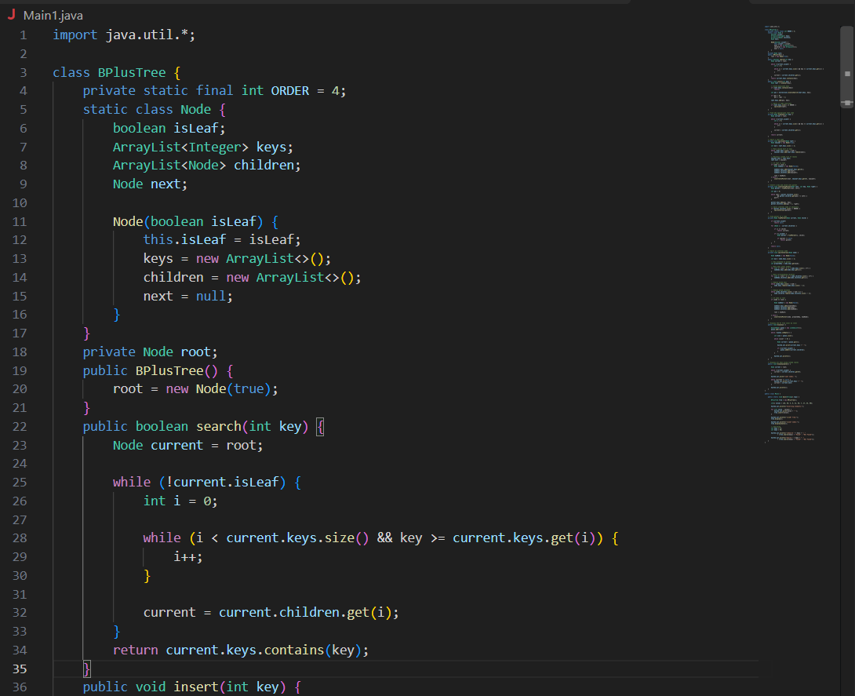

Output:
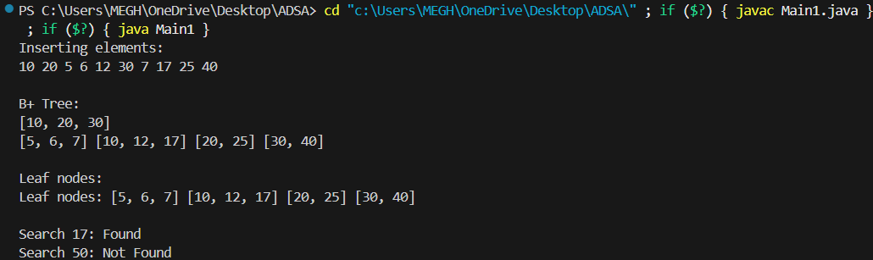

Problem statement
https://neetcode.io/problems/lowest-common-ancestor-in-binary-search-tre e/question?list=neetcode150

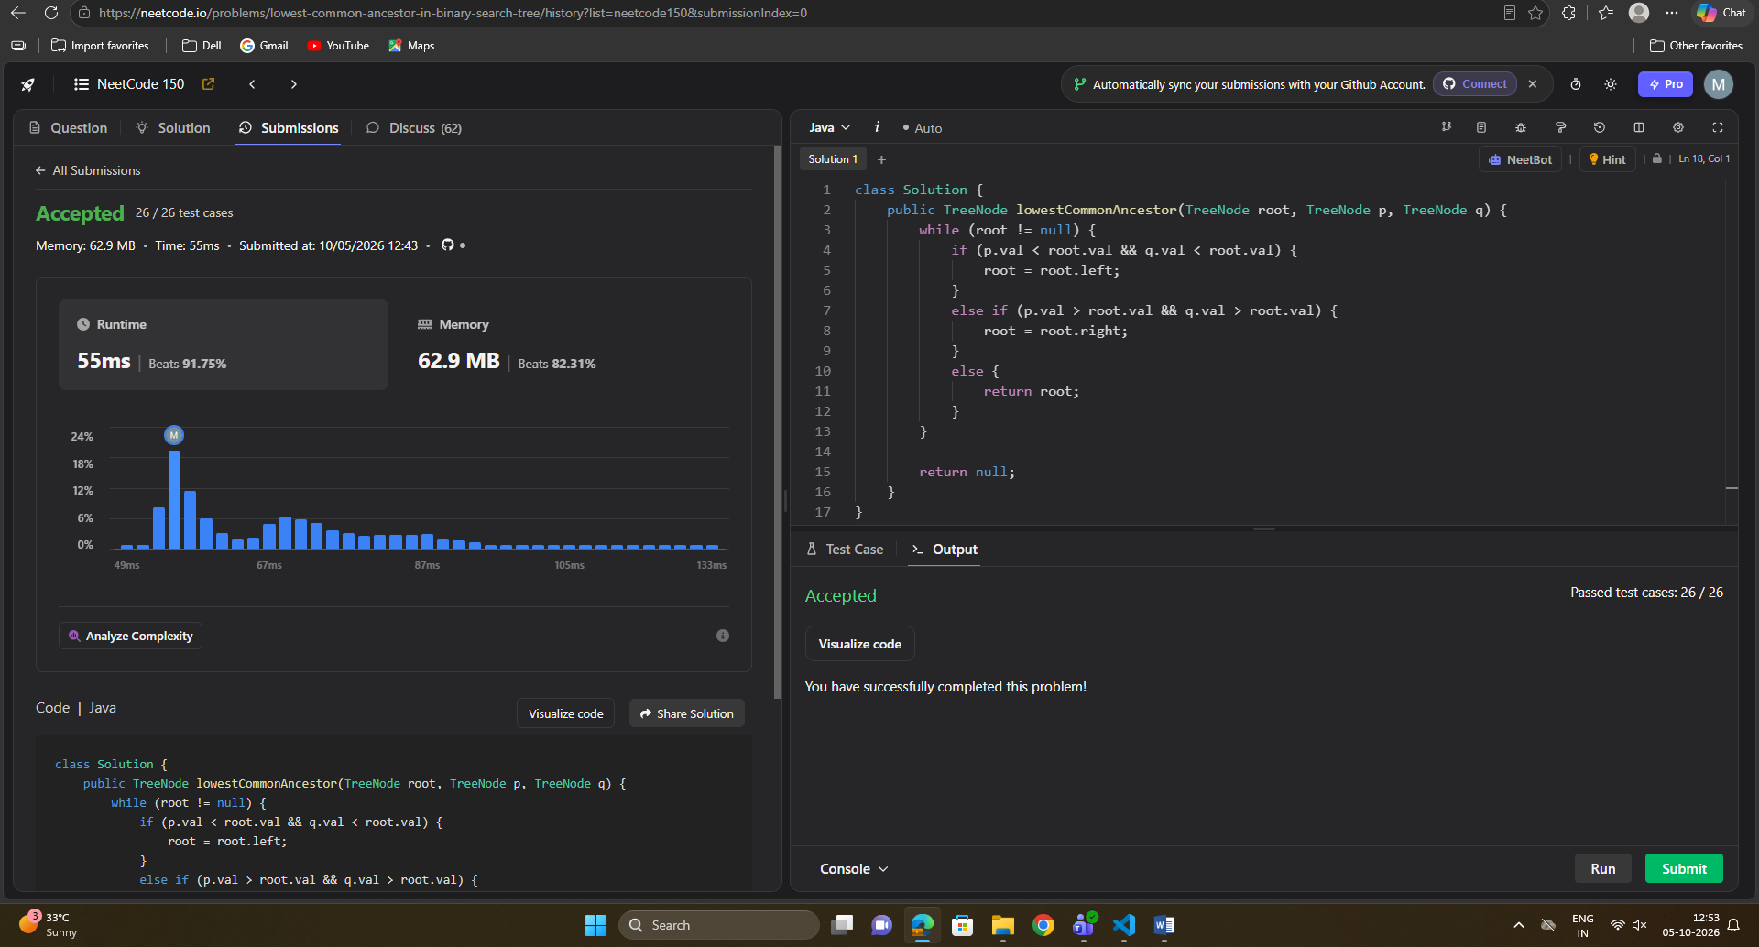

Conclusion
Thus, a B+ Tree was implemented successfully using Python. Insertion and search operations were performed while maintaining the balanced structure of the tree.

Post-Lab Questions
- What is a B+ Tree?
- What is the difference between a B-Tree and a B+ Tree?
- Why are all records stored in the leaf nodes of a B+ Tree?
- Why are leaf nodes linked in a B+ Tree?
- What happens when a leaf node overflows during insertion?
- What happens when the root node overflows?
- What is the time complexity of searching in a B+ Tree?
- Why are B+ Trees preferred for database indexing?
- How does a B+ Tree support efficient range queries?
- Explain the role of separator keys in internal nodes.

