Department of Artificial Intelligence and Machine Learning
Experiment No.: 10
To implement Ford Fulkerson Algorithm
Name: Mohd Sohail Siddique.
Roll no: A119. Div: A2. Batch: A2-2.
Sap Id: 60017240079. Date: 01st October 2026.

Aim
To implement the Ford–Fulkerson Algorithm to find the maximum flow from a source vertex to a sink vertex in a flow network.

Learning Objectives
After completing this experiment, students will be able to:
- Understand the concept of a flow network and maximum flow.
- Identify source, sink, capacity, flow, and residual capacity.
- Understand the concept of an augmenting path.
- Construct and update a residual graph.
- Implement the Ford–Fulkerson algorithm.

Theory
The Maximum Flow Problem deals with finding the maximum amount of flow that can be sent from a designated source vertex to a designated sink vertex in a directed graph.A flow network is represented as

G = (V,E)
where V represents the set of vertices and E represents the set of directed edges.Each edge (u,v) has a non-negative capacity
c(u,v) ≥ 0
which specifies the maximum amount of flow that can pass through that edge.For every edge, the flow must satisfy the capacity constraint:
0 ≤ f(u,v) ≤ c(u,v)
For every intermediate vertex other than the source s and sink t, the incoming flow must be equal to the outgoing flow.
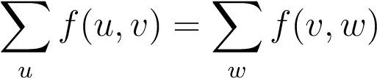
This property is called flow conservation.

Residual Graph
The Ford–Fulkerson algorithm maintains a residual graph. The residual capacity of an edge represents the additional amount of flow that can be sent through that edge.For an edge (u,v),
c_{f}(u,v) = c(u,v) − f(u,v)
A reverse edge is also maintained so that previously assigned flow can be reduced if a better augmenting path is found later.

Augmenting Path
An augmenting path is a path from source s to sink t in the residual graph such that every edge on the path has positive residual capacity.If an augmenting path P is found, the maximum additional flow that can be sent through that path is
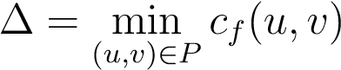
where ∆ is called the bottleneck capacity of the path.The residual capacities are then updated and the process is repeated until no augmenting path exists.

Ford–Fulkerson Algorithm
- Initialize the flow on every edge to zero.
- Construct the residual graph.
- Search for an augmenting path from source s to sink t.
- If an augmenting path exists:
  - Find the minimum residual capacity along the path.
  - Add this value to the total flow.
  - Reduce the residual capacity of all forward edges.
  - Increase the residual capacity of corresponding reverse edges.
- Repeat until no augmenting path from source to sink exists.
- Return the total flow as the maximum flow.

Pseudocode
FORD-FULKERSON(G, s, t) max_flow = 0 while an augmenting path P exists from s to t:
path_flow = infinity for every edge (u,v) in P:
path_flow = min(path_flow, residual[u][v])
for every edge (u,v) in P: residual[u][v] -= path_flow residual[v][u] += path_flow
max_flow += path_flow
return max_flow
1 2 3 4
5 6 7 8 9
10 11
12

Code
from collections import deque
def ford_fulkerson(capacity, s, t):
n = len(capacity)
residual = [row[:] for row in capacity]
max_flow = 0
while True:
parent = [-1] * n
parent[s] = s
q = deque([s])
while q and parent[t] == -1:
u = q.popleft()
for v in range(n):
if parent[v] == -1 and residual[u][v] > 0:
parent[v] = u
q.append(v)
if parent[t] == -1:
break
flow = float('inf')
v = t
while v != s:
u = parent[v]
flow = min(flow, residual[u][v])
v = u
v = t
while v != s:
u = parent[v]
residual[u][v] -= flow
residual[v][u] += flow
v = u
max_flow += flow
return max_flow
# Example
capacity = [
[0, 16, 13, 0, 0, 0],
[0, 0, 10, 12, 0, 0],
[0, 4, 0, 0, 14, 0],
[0, 0, 9, 0, 0, 20],
[0, 0, 0, 7, 0, 4],
[0, 0, 0, 0, 0, 0]
]
print("Maximum Flow:", ford_fulkerson(capacity, 0, 5))

Output
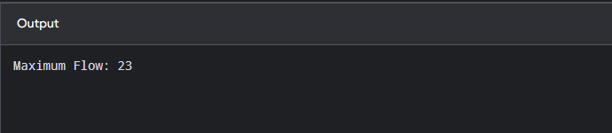

Conclusion
The Ford–Fulkerson algorithm was successfully implemented to determine the maximum possible flow from a source vertex to a sink vertex in a flow network.

Problem Statement
https://leetcode.com/problems/valid-parenthesis-string/description/?envType=daily-question&envId= 10-04
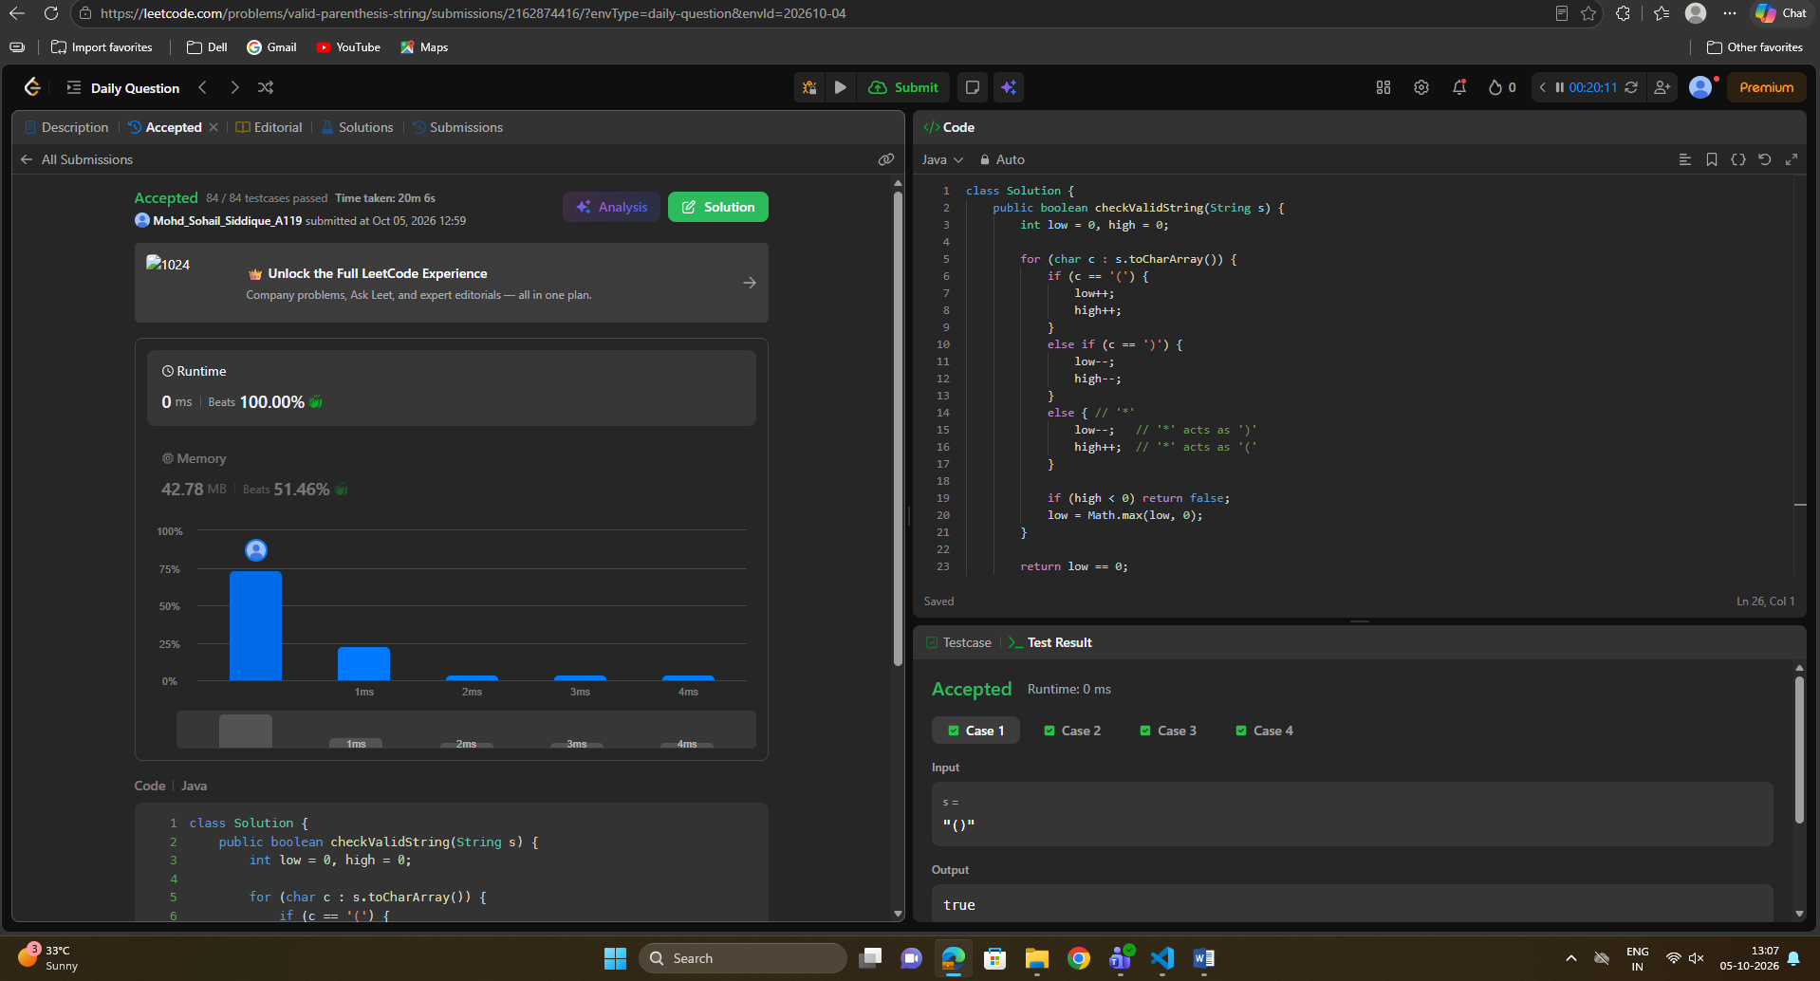

Post-Lab Questions
- What is a flow network?
- What is meant by the maximum flow of a network?
- What is an augmenting path?
- What is residual capacity?
- Why are reverse edges required in a residual graph?
- What is the bottleneck capacity of an augmenting path?
- When does the Ford–Fulkerson algorithm terminate?
- What is the difference between Ford–Fulkerson and Edmonds–Karp algorithms?
- What is the time complexity of the Ford–Fulkerson algorithm?
- State the Max-Flow Min-Cut Theorem.

