Documentation: Assignment 2

(Number guessing game)

**CODE:**

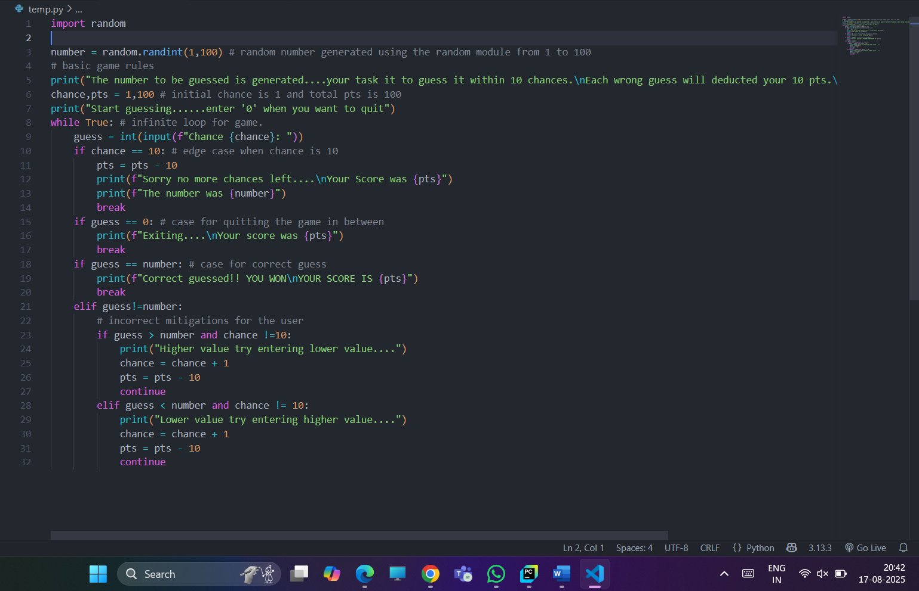

**OUTPUT:**

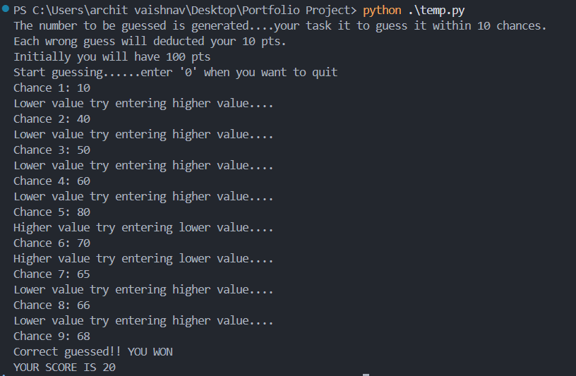

**EXPLANATION:**

1. This program is a simple **guessing game** where the computer generates a random number between 1 and 100, and the player has **10 chances** to guess it correctly. The player starts with **100 points**, and every wrong guess reduces the score by **10 points**.
2. Importing **random** module to generate a random number. ***import random***
3. Initializing the ***chance , pts = 1,100*** for chances for user and his score
4. For each wrong guess there will be a deduction of **10 points**
5. Then a while loop is implemented which runs infinitely, and stops under these conditions:
   1. If user guessed the number correctly
   2. If there no more chances left.
6. After every wrong guess, user will get a hint:
   1. ***if guess > number:*** PRINT: “ENTER LOWER VALUE”
   2. ***elif guess < number:*** PRINT: “ENTER HIGHER VALUE”

**CONCLUSION:** In this way, we have created a number guessing game in Python using concepts of **loops, if-else statements** and we have seen use of Python keywords like **continue** and **break.**

**Name: Archit Vaishnav**

**Rollno.: A121 Branch: AIML A2-2**