**Running static code analysis using Sonar Cloud in CI pipeline**

**Step 1:** Importing project to sonar cloud: login to sonarcloud.io 🡪 import GitHub organization 🡪 select a repository in which you want to run sonar cloud static code analysis 🡪 sonar cloud will import the repository 🡪 copy paste the project key and organization key from the landing page 🡪 these values has to be updated in sonar-project.properties in project root directory.

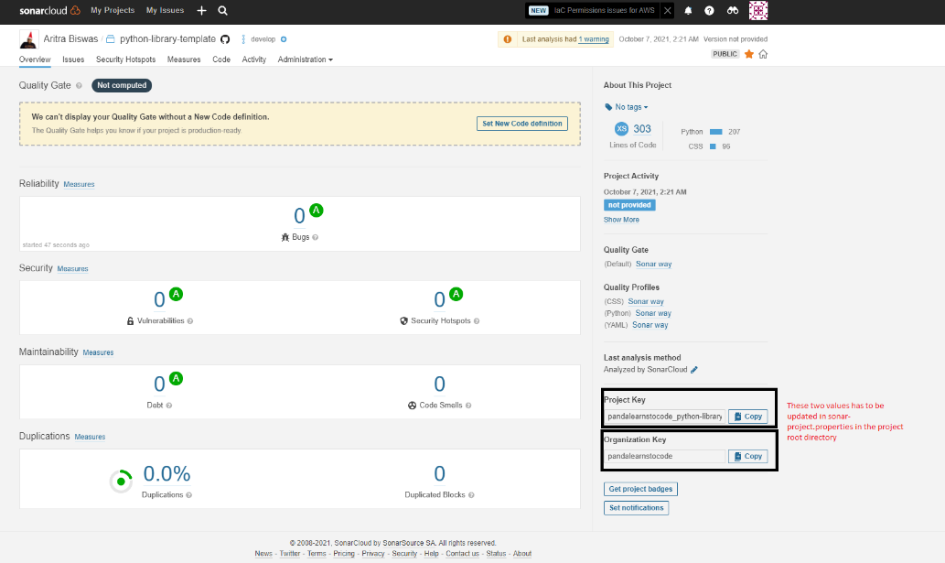

**Step 2:** Get SONAR_TOKEN from sonarcloud.io. Log into SonarCloud 🡪 Click on your profile 🡪 'My Account' 🡪 'Security' 🡪 Generate your access token for SonarCloud here 🡪 Go to your repository settings in GitHub 🡪 'Secrets' 🡪 add a new secret with name SONAR_TOKEN and use the generated SonarCloud access token as value.

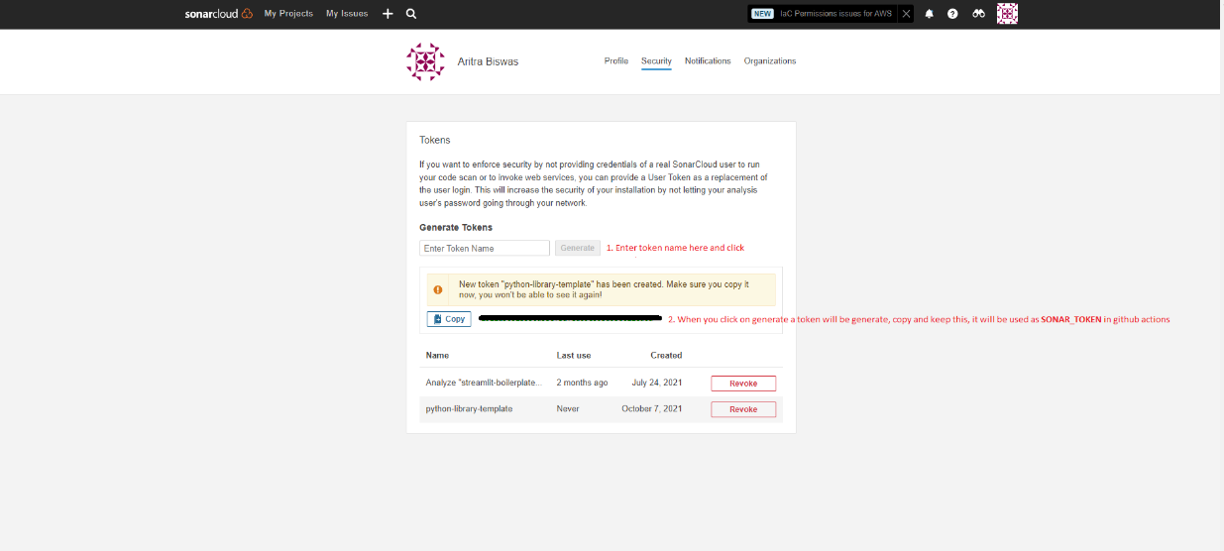

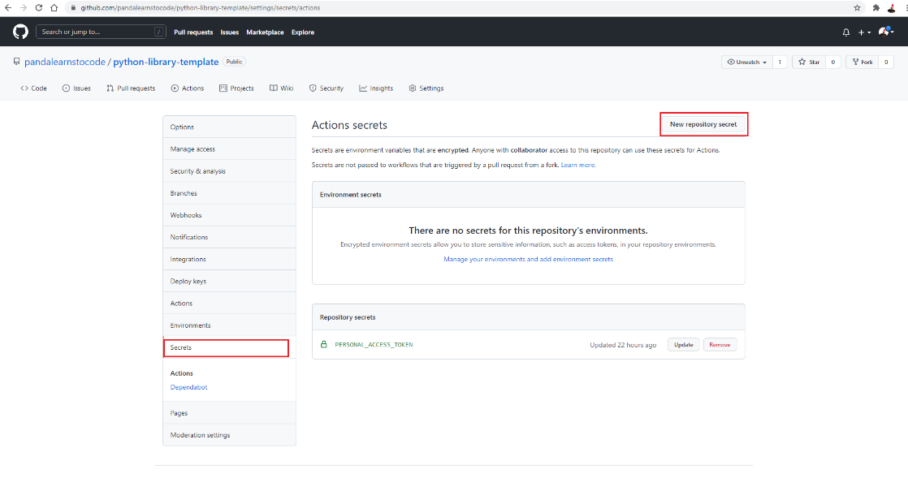

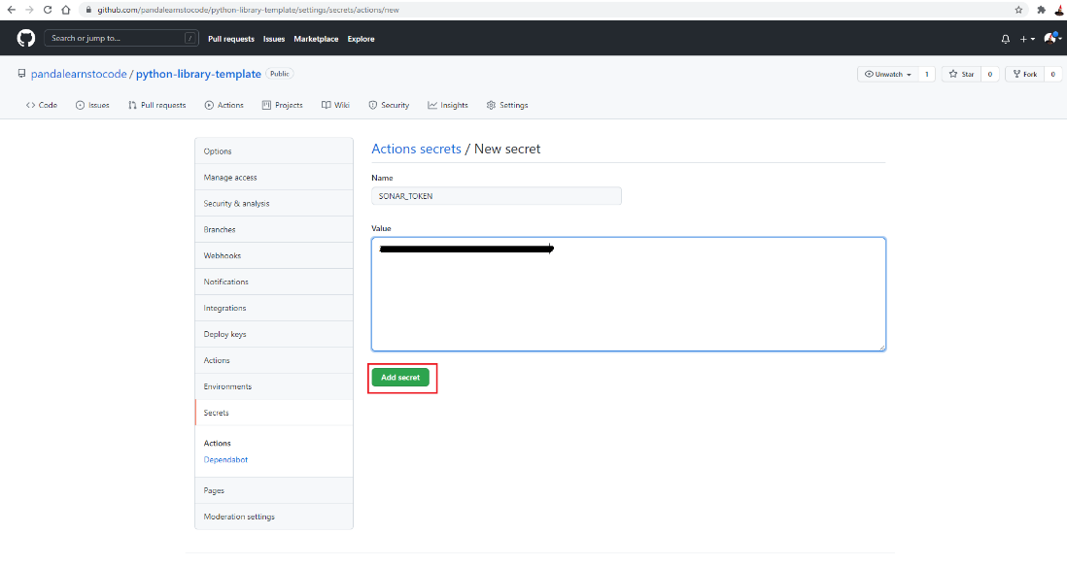

**Step 4:** Add pytest, flake8 and pylint related command in action 🡪 add SonarCloud action in GitHub action 🡪 From sonar cloud project 🡪 administrative 🡪 switch off automatic integration with github repository 🡪 trigger CI pipeline 🡪 Validate all the required things are getting reflected in sonar cloud dashboard or not.

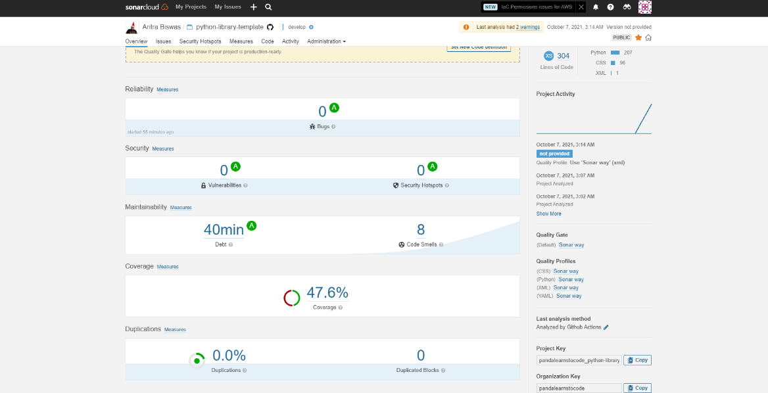

**TODO:**

* Quality gate
* PR decorator
* Adding status badge
* Notification if the merge fails
* Enabling things based on PR, not by push

**Reference:**

1. <https://dev.to/remast/go-for-sonarcloud-with-github-actions-3pmn>
2. <https://github.com/pandalearnstocode/python-library-template/blob/develop/.github/workflows/python-app.yml>
3. <https://github.com/pandalearnstocode/python-library-template/blob/develop/sonar-project.properties>
4. https://sonarcloud.io/dashboard?id=pandalearnstocode_python-library-template