**Create project wiki or library documentation or test coverage report static HTML website using Azure**

**Step 1:** Create a storage account with follow settings and keep rest to default.

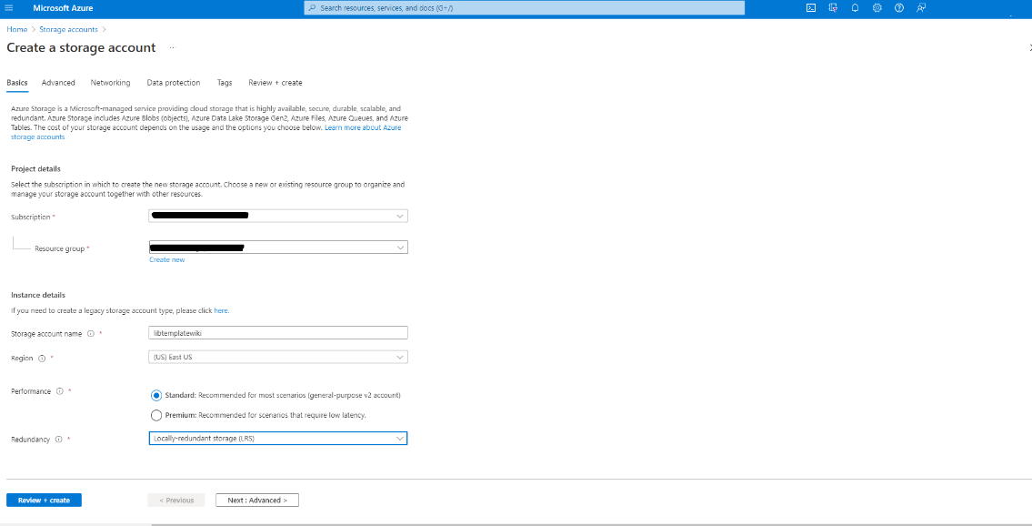

**Step 2:** Go to create storage account 🡪 Blob storage 🡪 Static website from left menu 🡪 enable 🡪 set landing page name 🡪 set error page name 🡪 save settings of the static web app.

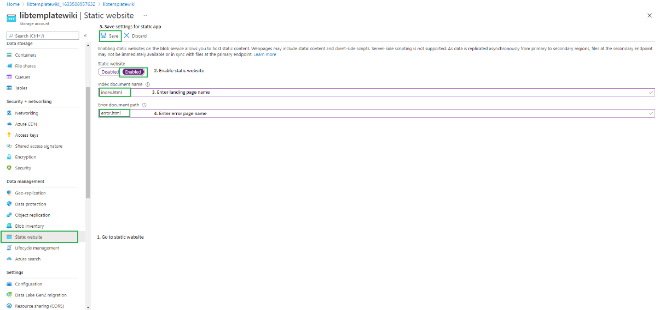

**Step 3:** After saving this will generate the static web app URL in the same page.

**URL:** https://libtemplatewiki.z13.web.core.windows.net/

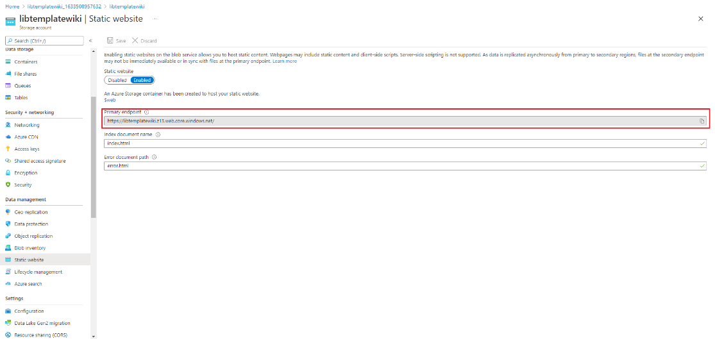

**Step 4:** Go to container 🡪 New $log and $web folder will be created in the container.

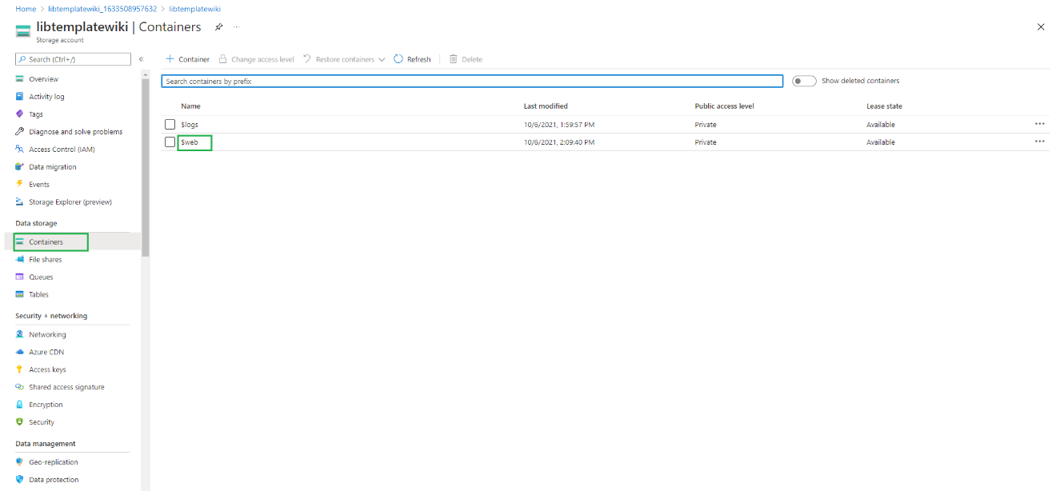

**Step 5:** Select and upload index.html and error.html in the $web folder in the container.

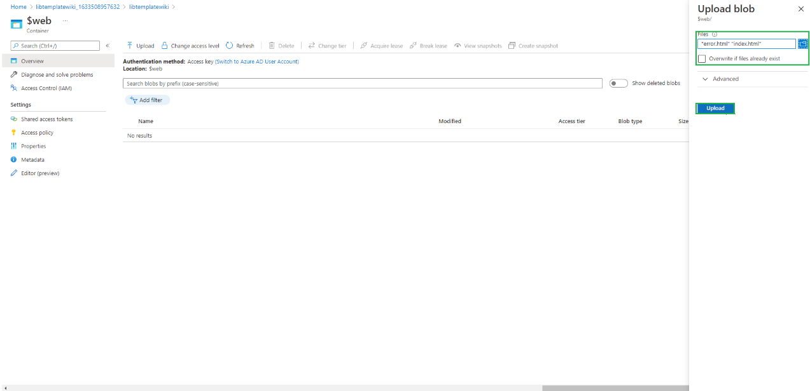

**Step 6:** Validate the website is reflecting the right content

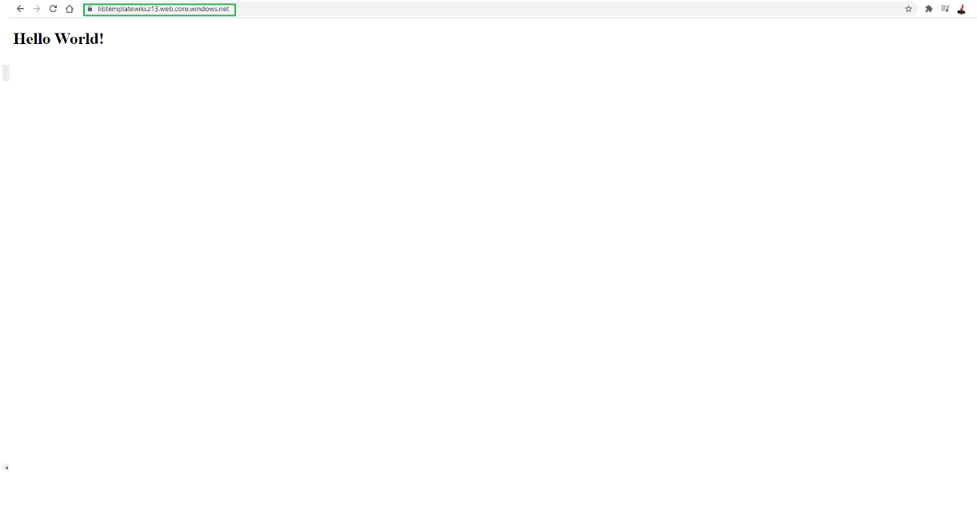

**Step 7:** Publish static HTML site from GitHub action to azure static web site

**Workflow:**

pull latest code 🡪 login to azure using azure cli 🡪 setup python version 3.8 🡪 install documentation related dependencies 🡪 generate wiki, library documentation and other HTML sites 🡪 publish project wiki to GitHub pages 🡪 publish docs, wiki and others to azure static web site 🡪 Purge CDN endpoint 🡪 Logout using Azure CLI.

**Notes:**

**Some of the required environment variables.**

* PERSONAL_ACCESS_TOKEN 🡪 generate and save in repository secret.
* AZURE_CREDENTIALS 🡪 Generate SP and store in repository secret.
* STORAGE_ACCOUNT_NAME_WIKI, STORAGE_ACCOUNT_NAME_DOCS, STORAGE_ACCOUNT_NAME_OTHERS 🡪 generate and store in repository secret.

**Reference:**

1. <https://docs.microsoft.com/en-us/azure/storage/blobs/storage-blob-static-website-host>
2. https://docs.microsoft.com/en-us/azure/storage/blobs/storage-blobs-static-site-github-actions
3. <https://www.youtube.com/watch?v=ttmEOLKk3Cw>
4. https://github.com/pandalearnstocode/python-library-template/blob/develop/.github/workflows/documentation-builder.yaml