Container scanning using snyk

**Step 1:** Login to snyk.io 🡪 Login using GitHub account or SSO 🡪 Import a repository you want to scan.

**Step 2:** Go to <https://app.snyk.io/account> 🡪 Generate API token 🡪 Copy the value and keep it 🡪 Go to GitHub repository secret 🡪 Create a new env variable 🡪 Name of the variable will be SNYK_TOKEN and copy paste the value generated in the link above 🡪 save.

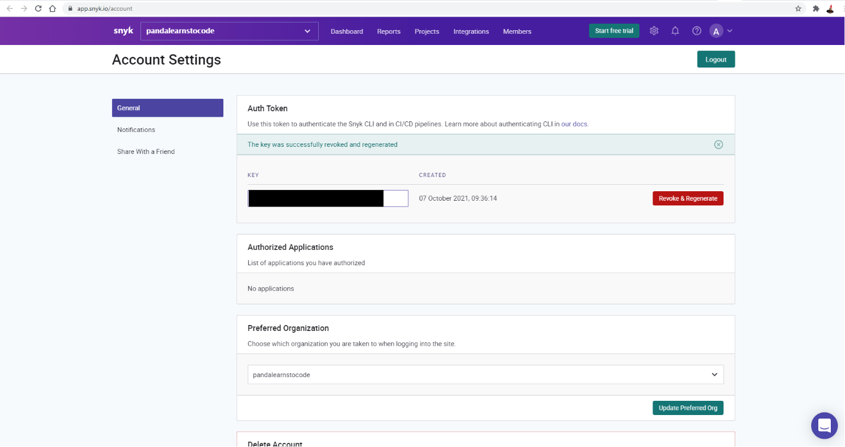

**Step 3:** Add the synk related section in GitHub action.

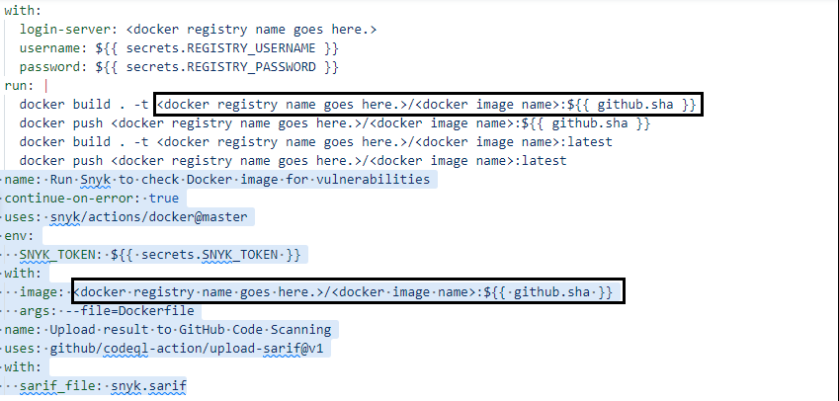

**Reference:**

1. snyk.io
2. <https://github.com/snyk/actions/tree/master/docker>
3. <https://github.com/pandalearnstocode/python-library-template/blob/develop/others/ci/ado_lib_publish/ado_lib_publisher.yaml>
4. https://github.com/snyk/actions#getting-your-snyk-token