**1. Environment IDE:**

eclipse(create maven project)+tomcat+mysql+jersey

**2. import downloaded web project folder**

1. On Eclipse Click File->Import , then Select General->Existing Projects into Wrokspace.
2. Select the folder which have your Project ,Click on Finish
3. From Window->Preferences Menu, select Server->Runtime environments
4. Add your Tomcat server instance(need to download from web)
5. From Window->Show view menu, select 'Servers'
6. On Servers Tab right click, select Add Server
7. Add Tomcat,Tomcat instance show up in 'Servers' Tab
8. Right click on 'Tomcat server' and select 'Add/Remove'
9. Add your Project to Tomcat
10. Right click on 'Tomcat server' again and click on 'Clean' then 'Publish'
11. Select Tomcat and click on Run button

**3. mysql database table(can be improved )**

user_table:(only username and password)

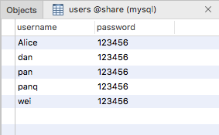

userprofile_table(until now, username and interest_category, can add more information like description)

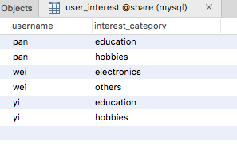

post_table(also can add more information as you want)

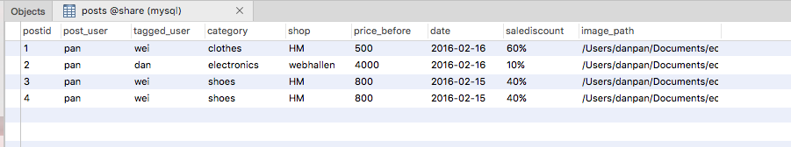

following friendship table

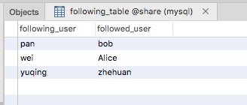

4. **restful api web service**

**------use “Postman” as restful client to test(can be downloaded from web)**

**----in web.shares.resources file, different resource java file represent different URI resource**

1. LoginResource.java(login authentication) 2) SignupResource.java(user signup)

POST <http://localhost:8080/shares/webapi/login> POST <http://localhost:8080/shares/webapi/signup>

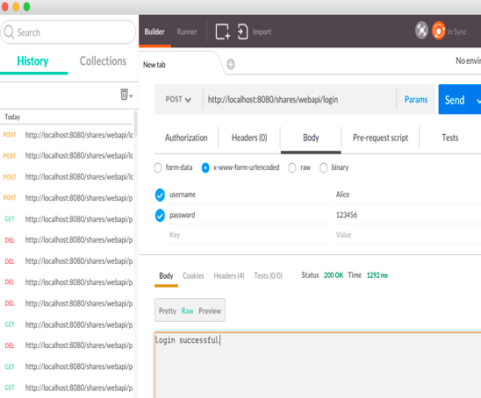 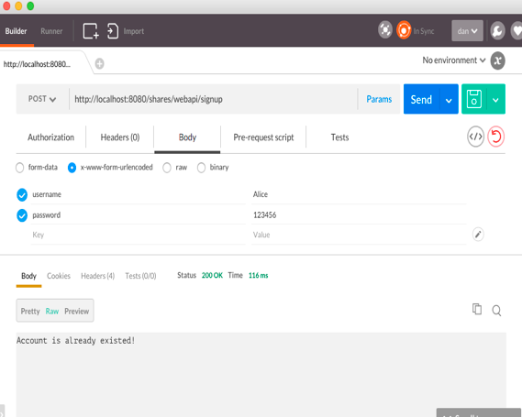

1. UserProfileResource.java(user information)

GET <http://localhost:8080/shares/webapi/pan> POST http://localhost:8080/shares/webapi/pan

----- get User “pan” information(e.g. interest category) ----add User “pan” information

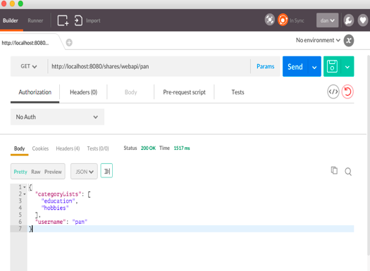 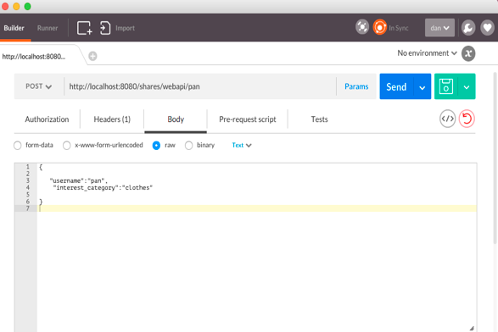

GET <http://localhost:8080/shares/webapi/pan/friends> POST <http://localhost:8080/shares/webapi/pan/friends>

-----get User “pan ” friend list -----add User “pan ” friend

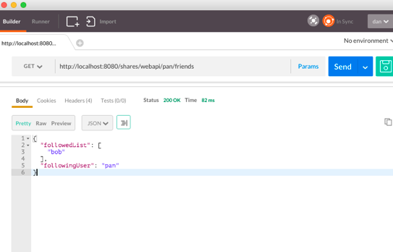 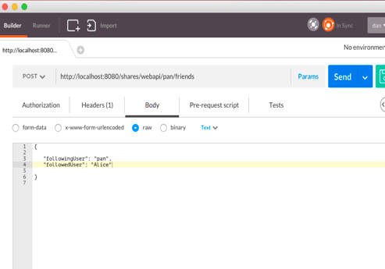

DELETE <http://localhost:8080/shares/webapi/pan/friends>

----delete User “pan” some friend

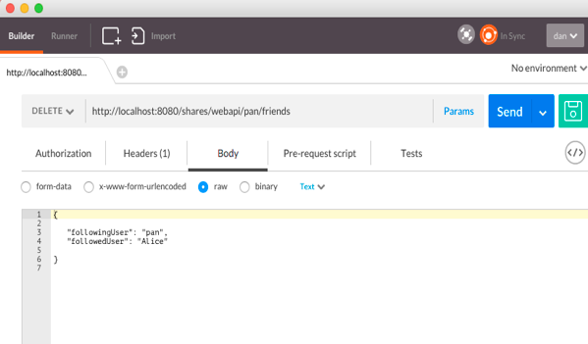

4) PostInfoResource.java(post information)

GET <http://localhost:8080/shares/webapi/posts> GET http://localhost:8080/shares/webapi/posts?category=electronics

----get all posts ----get all posts by specific category

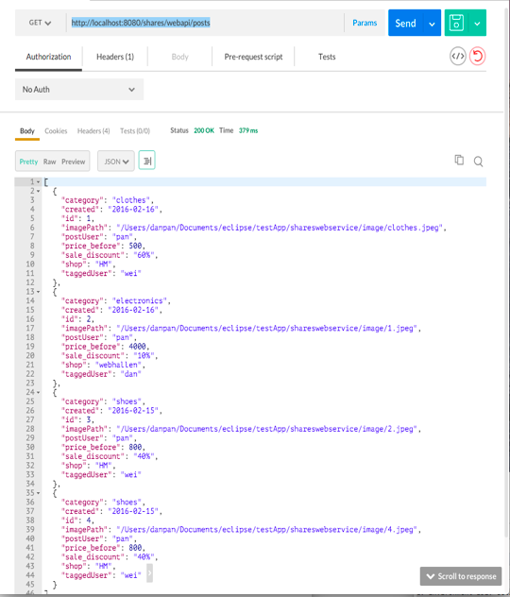 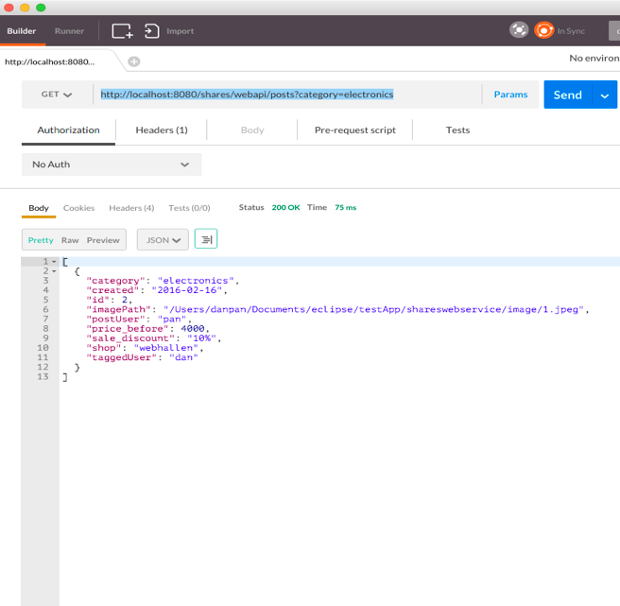

POST <http://localhost:8080/shares/webapi/posts> PUT <http://localhost:8080/shares/webapi/posts>

----add new post ----update some post with another tagged_user

