LegalLens: Product Requirements (BRD / PRD / FRD)
Oct 5, 2026 · @Shashank Panda
LegalLens is a private AI assistant for one lawyer. It answers questions about their documents, summarizes them and drafts replies, citing every source, with all AI on the lawyer's own computer. Each requirement has a Test and cites its source ID in IDEAS.md, where the detail lives.

1. Overview and scope
Problem. Lawyers spend hours reading documents and writing routine replies. General AI tools invent citations, which has led to sanctions (Mata v. Avianca, 2023). They also send client data to outside services.
Non-negotiables
- Documents only: answers come from uploads, or say not found (DEC-06).
- Local only: all AI runs on the lawyer's computer, with no outside AI or training (DEC-08).
- The lawyer decides: LegalLens never sends, files or submits anything (DEC-07).
- Clients stay separate: one matter per client case, and nothing crosses (DEC-09).
In the MVP: one solo US lawyer with many matters; Ask, Summarize, and Draft for letters and memos; .docx export (DEC-02, DEC-10). Later: court filings, more summary types and PDF (V1.x); teams and multi-agent (Future). Never: legal research, good-law checks or public users (SUG-02).
Success measures, checked on the test set before every release (SUG-04, SUG-05): at least 95% of citations exist and support their sentence. Invented authority, cross-matter leaks and exports with metadata are all 0. Every point in an incoming letter is answered or flagged. Value is measured as time saved and draft text kept.

2. Ask
As a lawyer, I ask a question in plain English and get an answer drawn only from the matter's documents, with each sentence linked to its page. Target: first words within 5 s, full answer within 30 s (DEC-14).
- FR-ASK-01 Answer only from the current matter's documents, labeled From your documents, Not found or partial. Test: unanswerable questions return Not found (DEC-06, DEC-37).
- FR-ASK-02 Let the lawyer pick the scope, This document or All documents in this matter, and show it on every answer. Follow-up questions keep the chat's context (DEC-31, DEC-35).
- FR-ASK-03 Give every statement a pinpoint cite: page and paragraph, section, or page:line. Test: clicking a cite opens the passage, highlighted (DEC-36).
- FR-ASK-04 If a question needs law that hasn't been uploaded, say so and suggest uploading it. Uploaded authority carries a "good law not checked" note (DEC-38, DEC-39).

3. Summarize
As a lawyer, I upload a letter, complaint or court opinion and get a structured, cited summary, plus a report of what was read. Target: a 50-page document within 5 min (DEC-14).
- FR-SUM-01 Provide three templates. Letter or demand: who wants what, by when, and each claim; it also feeds Draft. Complaint: parties, claims, relief. Court opinion: facts, issue, holding, reasoning. Test: every field is cited or marked Not found (DEC-40).
- FR-SUM-02 Offer three presets: One paragraph, Detailed digest and Plain English for the client (DEC-41).
- FR-SUM-03 Process the whole document and report coverage, e.g. "212 of 214 pages processed; pages 37 and 88 unreadable", with OCR confidence (DEC-42).

4. Draft, review and export
As a lawyer, I upload the letter I must answer and explain in a chat what to say. I get a draft that answers every point and invents no law, and I review, sign and send it myself. Letters come first; memos follow in Slice 5 (DEC-10). Target: a letter draft within 3 min (DEC-14).
- FR-DRF-01 Show the draft in an editor beside the chat. The lawyer can refine it by chat or regenerate one section alone (DEC-43, DEC-44).
- FR-DRF-02 Base every factual or legal statement on an uploaded passage, the lawyer's timestamped instruction, or the matter profile (DEC-21).
- FR-DRF-03 List each claim in the incoming letter and show whether the draft answers it. Test: if 5 claims are made and 4 answered, the fifth is flagged (DEC-47).
- FR-DRF-04 Never add authority from the model's own knowledge. Write [CITE NEEDED] or a placeholder instead, and mark untraceable cites [UNVERIFIED]. Test: 0 model-introduced authorities (DEC-48).
- FR-DRF-05 Structure memos as Question → Brief Answer → Facts → Discussion (IRAC/CREAC) → Conclusion. Take law only from uploads, and show [RULE NEEDED] where there is none (DEC-45).
- FR-DRF-06 Write to counsel when the other party is represented (Model Rule 4.2), and show a Rule 4.3 reminder when not. FRE 408 wording is opt-in (DEC-46).
- FR-DRF-07 Allow export only after every authority is acknowledged, no placeholders remain, and the lawyer signs off Reviewed and adopted. The sign-off is logged (DEC-49, DEC-51).
- FR-DRF-08 Build the .docx fresh from the approved text, with no internal cites, comments or properties. Test: an automated check runs on every export (DEC-50).

5. Cross-cutting requirements
In plain terms: how client files stay separate and safe, and how quality is proven.
- FR-MAT-01 Put every item in exactly one matter. The matter profile holds client, side, opposing counsel, court and the AI-consent record, and a licensing-state setting drives the ethics reminders (DEC-09, DEC-29, DEC-30, DEC-60).
- FR-MAT-02 Let the lawyer close a matter (read-only), export it, or delete it after a typed confirmation. Test: deletion clears text, index and caches at once, and backups within 35 days (DEC-13, DEC-58).
- FR-DOC-01 Ingest text PDF, DOCX, clean scans and email (.eml/.msg), up to 300 pages or 50 MB each and 200 per matter, keeping clause numbers and exhibits (DEC-14, DEC-67).
- FR-DOC-02 Treat every upload as untrusted: allowlist, local malware scan, origin tag, and hidden text neutralized. Test: injection traps never change behavior (DEC-59).
Non-functional
- NFR-01 Isolation: the backend applies the matter filter to every search and cache lookup. Leak tests run on every build, with 0 allowed (DEC-53).
- NFR-02 Data location: no document content leaves the computer, as proven by a test (DEC-56).
- NFR-03 Security: MFA, a session timeout, encryption in transit and at rest (backups and logs too), and an incident plan (DEC-54, DEC-57, DEC-62).
- NFR-04 Recovery: encrypted off-machine backups under the lawyer's keys, with a restore tested before real data goes in (DEC-61).
- NFR-05 Audit: an append-only trail of inputs, outputs, passages and model versions. Answers can be replayed (DEC-68, DEC-69).
- NFR-06 Quality gate: a 30–50 question test set runs on every prompt, model or retrieval change, and any drop blocks release (DEC-63, DEC-64).
- NFR-07 Other: a swappable model, named on every output; WCAG 2.1 AA; feedback buttons feed the test set (DEC-18, DEC-52, SUG-07).

6. Architecture
LegalLens is a local web app. A React front end and a FastAPI back end drive a RAG pipeline that calls a locally run model (DEC-16, DEC-18).
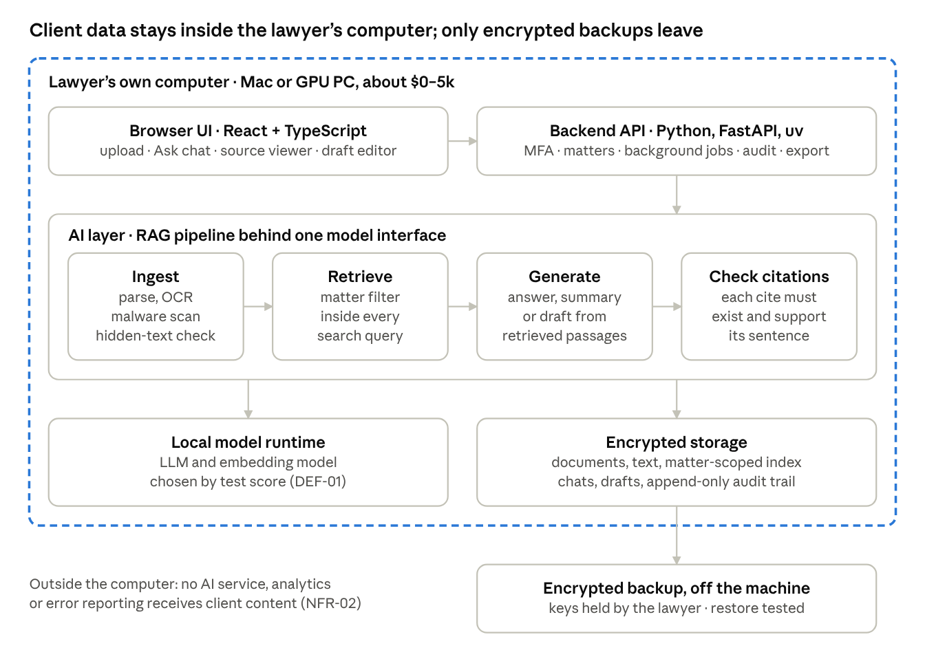
deployment and AI pipeline · one computer, four AI steps
Each AI step has its own input and output, so a multi-agent version can reorganize the steps later (SUG-01). The Technical Architecture doc chooses the model, vector store, RAG variant and minimum hardware, by test score (DEF-01, DEF-02).

7. Delivery, risks and open items
The MVP is built in six thin slices, and each one can be demonstrated end to end (DEC-72, DEC-73).
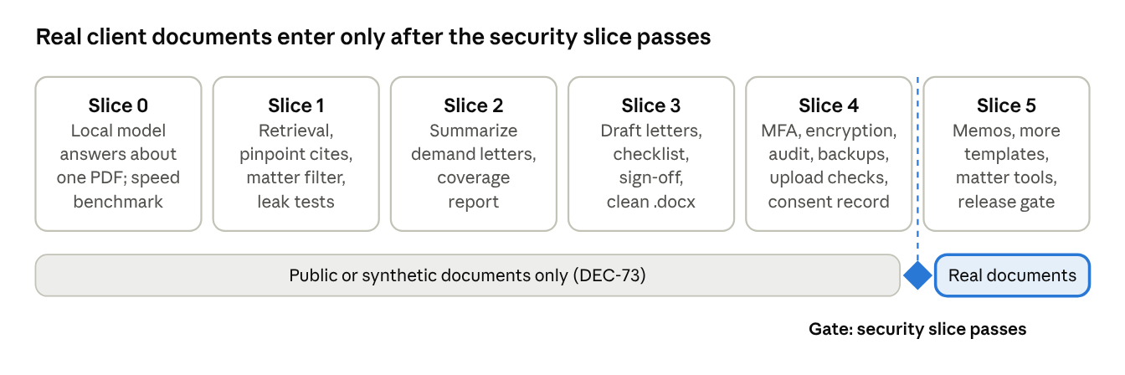
build roadmap · six slices, one gate
Done when Slices 0–5 are complete, every Test passes, NFR-01 and NFR-02 pass on every build, the test set meets the §1 targets, and a restore has been tested.
Top risks and what guards against them: invented citations (FR-DRF-04, FR-DRF-07), cross-matter leaks (NFR-01), metadata in exports (FR-DRF-08), hidden instructions in the other side's letter (FR-DOC-02), and a weak or slow local model (DEF-01). The full register is RISK-01 to RISK-20 in IDEAS.md.
Assumptions. The first user practices general civil litigation (DEC-19). The targets hold on a computer costing about $5k, as checked in Slice 0 (DEC-14). A self-hostable model with a suitable license exists (RISK-16).
Open items
- ☐ Find a practicing lawyer to review the test set. It stays provisional until then (OPEN-01).
- ☐ Confirm the first real user's practice area and licensing state (OPEN-02).
- ☐ Decide whether Bluebook formatting comes in V1.x (OPEN-03).

