**Project A: Quad-dumbbell and spinning screw**

**Xiao Pan, NetID: xpu1036**

Users’ Guide:

1. Basic shape:
   1. I have to 3D object, quad-dumbbell and spinning screw.
   2. Both objects could rotate and move. The quad-dumbbell could react to the mouse-dragging and mouse-clicking, and the screw will react to keyboard input.
2. Button interaction:
   1. 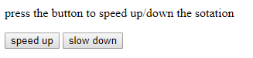Users could press “speed up” or “slow down” to control the speed of rotation for both objects.
   2. 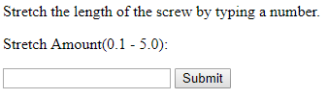Users could input a length for the second and third part of the screw, and after press the “submit”, the screw will continually stretch to that length.
3. Mouse interaction:
   1. Users could click mouse on canvas, the quad-dumbbell will change its color.
   2. Users could drag mouse on canvas, the quad-dumbbell will change its position with user’s mouse moving.
4. Keyboard interaction:
   1. Users could user “a”, “w”, “s” and “d” the fours keys to move the spinning screw, corresponding directions are left, up, down and right.

Result:

1. Basic shapes:

Before any operation, the two objects are like below:

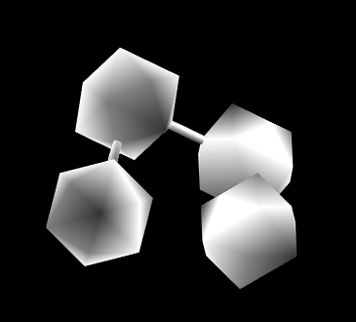 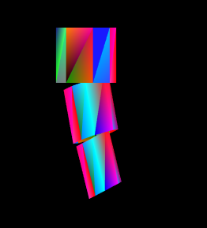

1. Length change and color change:
   1. After inputting a new number of length for the screw:

 🡪 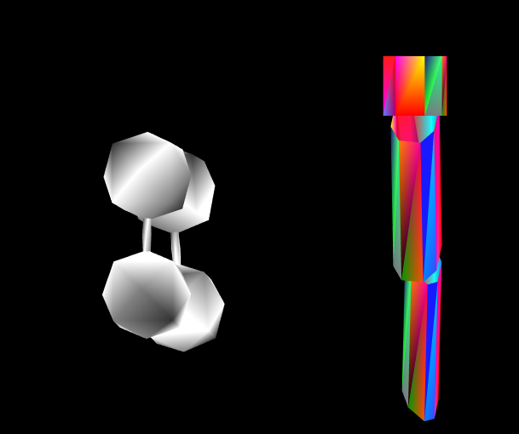

* 1. After clicking on the canvas:

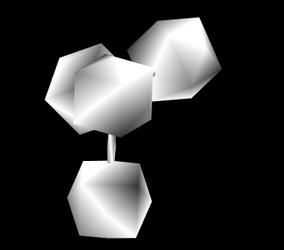 🡪 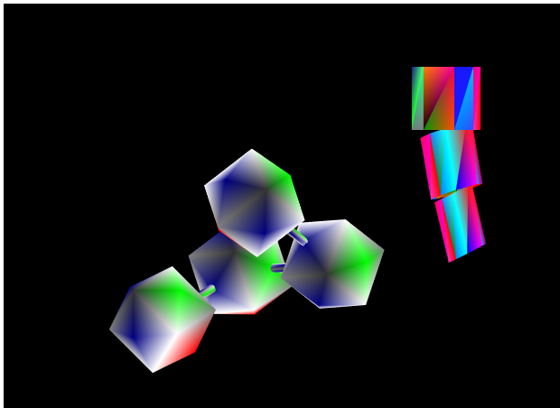

Scene graph：

