**Project B: quad-dumbbell and windmills with diffuse shading**

**Xiao Pan, NetID: xpu1036**

Users’ Guide:

1. goal:

One 3-jointed, 4-segment shape with diffuse shading: quad-dumbbell from my projectA. 4 other shapes: a windmill, a cylinder, a torus and a single dumbbell on the same ground.

1. User instructions:
   1. Users could press “w, a, s, d” to control the direction of the camera

w: up, a: left, s: down, d: right

* 1. Users could press arrow keys to move forward, backward, left and right.
  2. Users could input the 6 frustum parameters individually, in website:

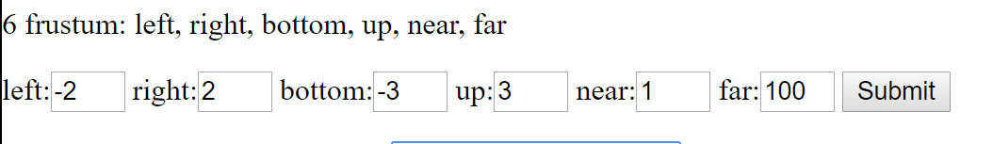

* 1. Users could click on the button “ViewFromEndSegment” to change the perspective view to follow the end segment of the quad-dumbbell:

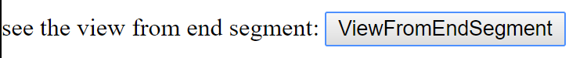

1. Result:
   1. Basic result: two side by side viewports:

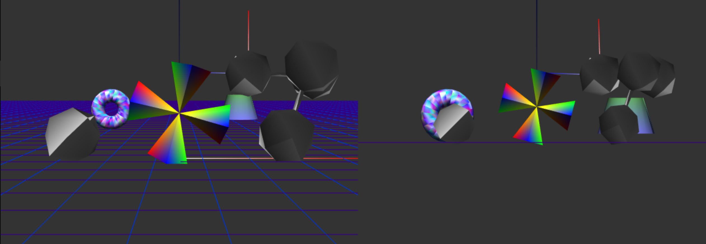

Left side is the perspective view, right side is the Orthographic view.

* 1. Different camera positions:

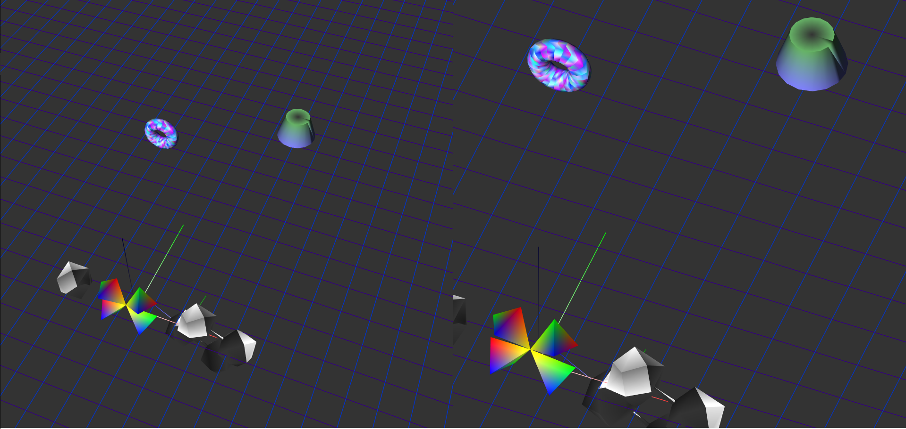

* 1. After change some frustum with below arguments:

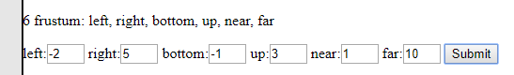

The Orthographic view will change like that:

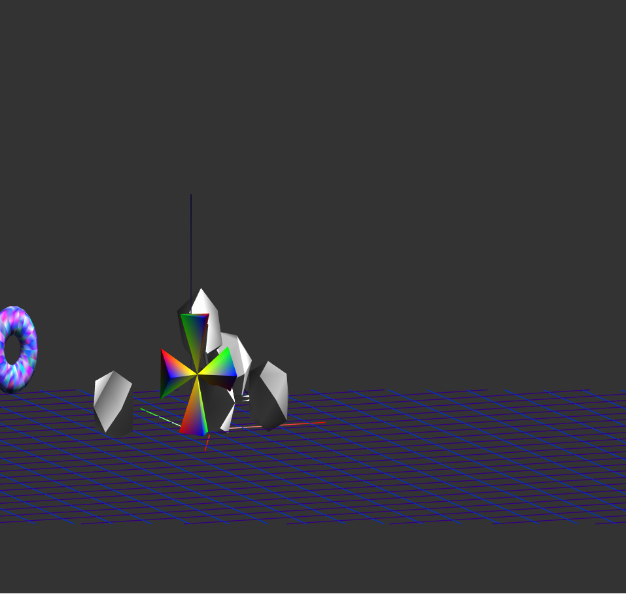

* 1. After clicking on the “ViewFromEndSegment” button:

The perspective view will follow the end of the segment of the quad-dumbbell, and from some angle, you can only see the ground.

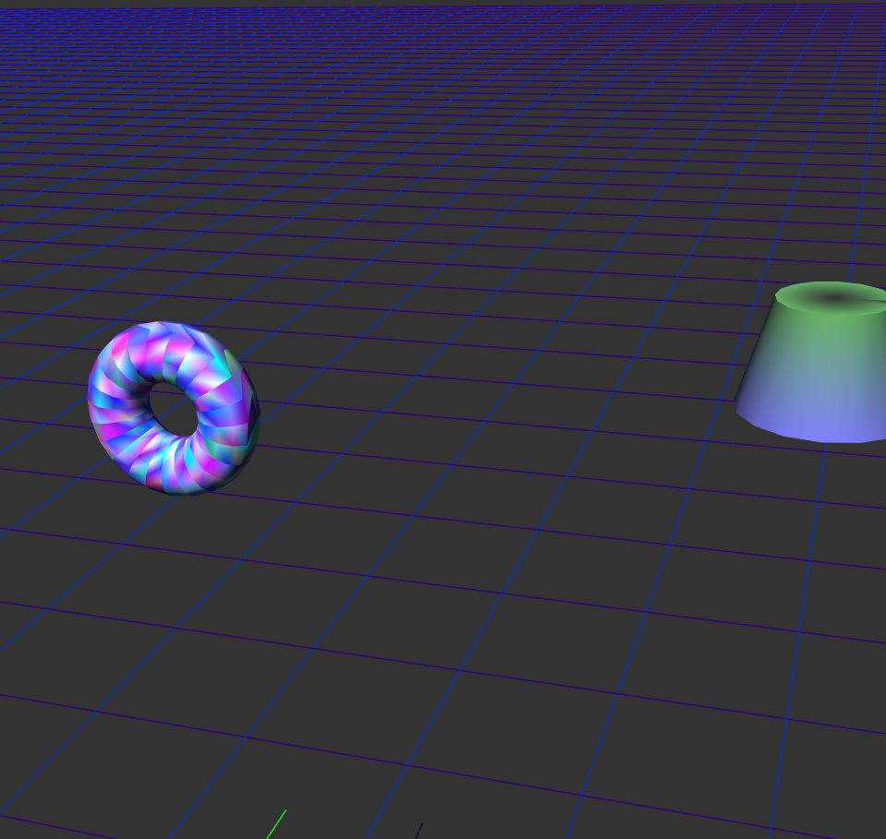

Scene graph：

