**Project B: dumbbells and** **windmills with different shading and lighting**

**Xiao Pan, NetID: xpu1036**

Users’ Guide:

1. goal:

Implement 3 solid, jointed and flexing shapes and one large slowly-spinning sphere, and they are in different materials. We could see all the shapes are on the ground grid and from a movable camera. Users could also change lighting mode between Phong lighting and Blinn-Phong lighting, change shading between phong shading and gouraud shading.

1. User instructions:
   1. Users could press “w, a, s, d” to control the direction of the camera

w: up, a: left, s: down, d: right.

* 1. Users could press arrow keys to move forward, backward, left and right.
  2. Users could press “I, j, k, l” to control the position of the lamp.

i: y+, j: x-, k: y-, l: x+.

* 1. Users could press space key to turn on/off the lamp, press enter to turn on/off the headlight.
  2. Users could change lighting mode between Phong lighting and Blinn-Phong lighting, change shading between phong shading and gouraud shading:



* 1. Users could input the 9 parameters individually of the lamp light source, in website:



1. Result:
   1. Basic result: sphere on the center, quad-dumbbells and double-dumbbells beside the sphere, windmills behind it.

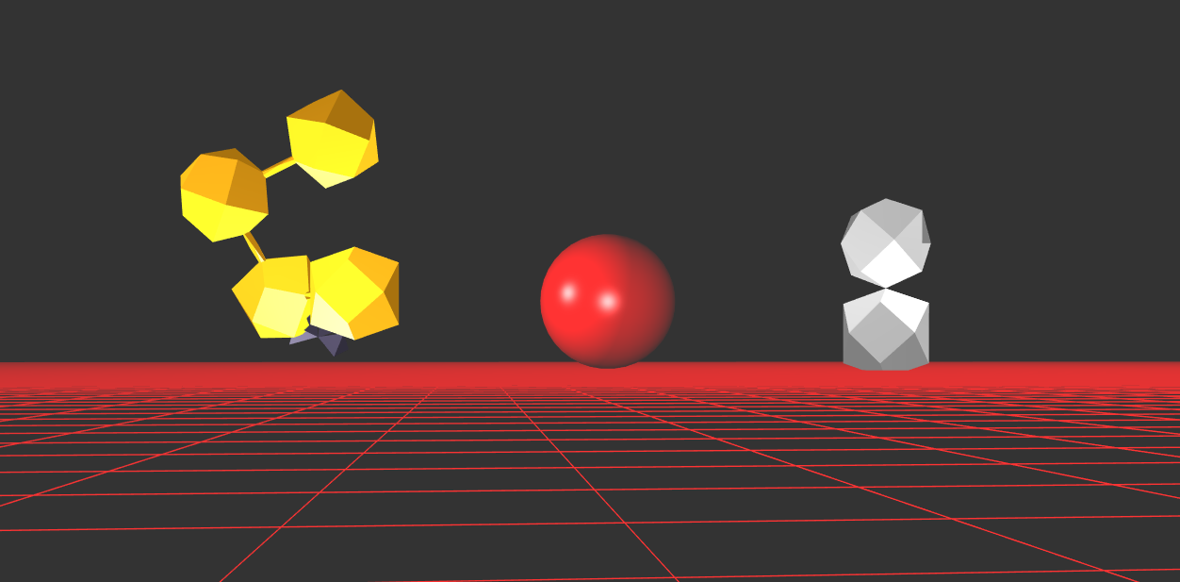

* 1. Different camera positions and different material:

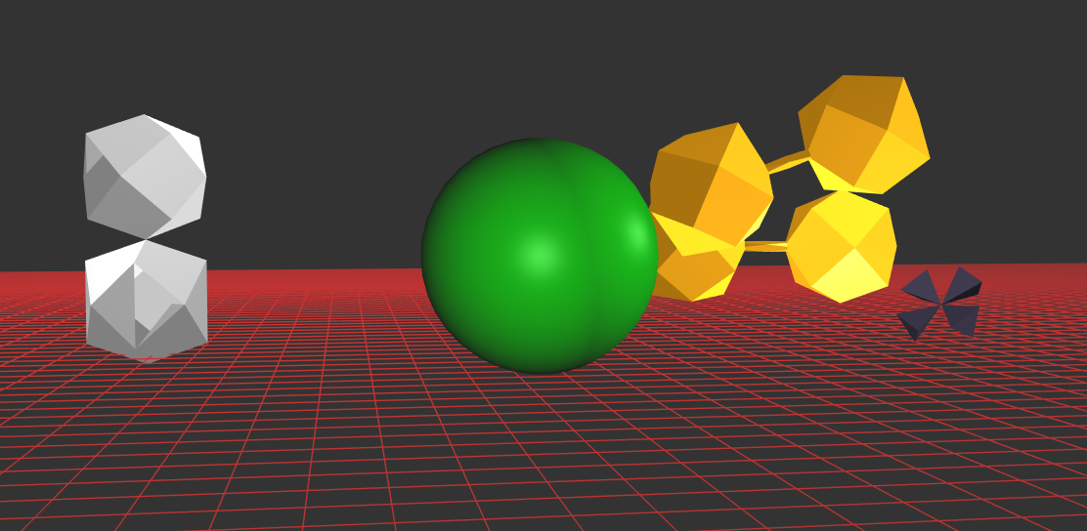

* 1. Change the lighting mode and shading mode:

Blinn-Phong lighting & Gouraud shading:

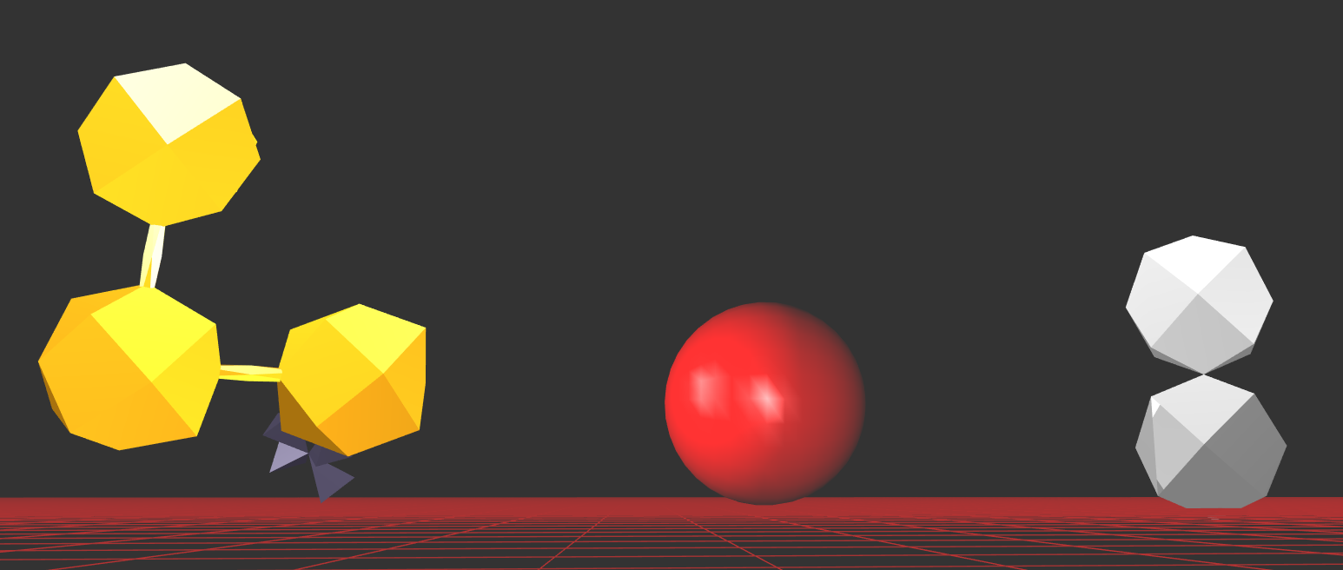

Phong lighting & Phong shading:

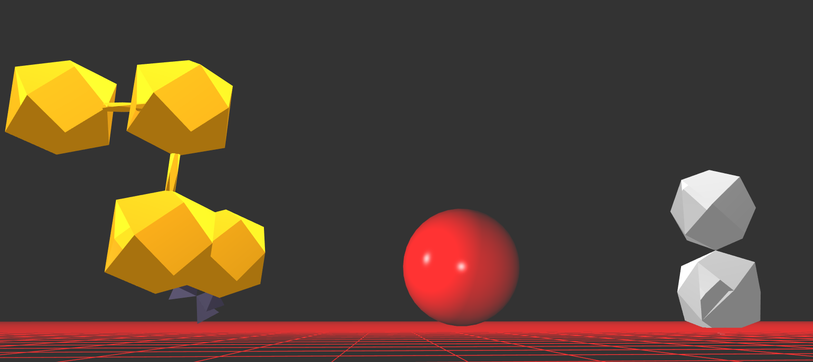

Blinn-Phong lighting & Phong shading:

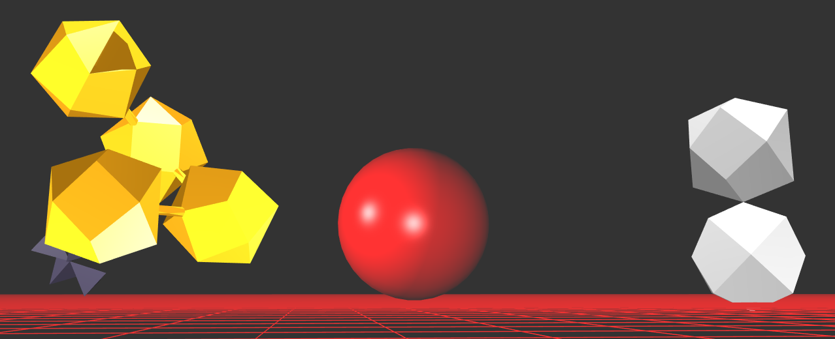

* 1. Turn off the lamp:

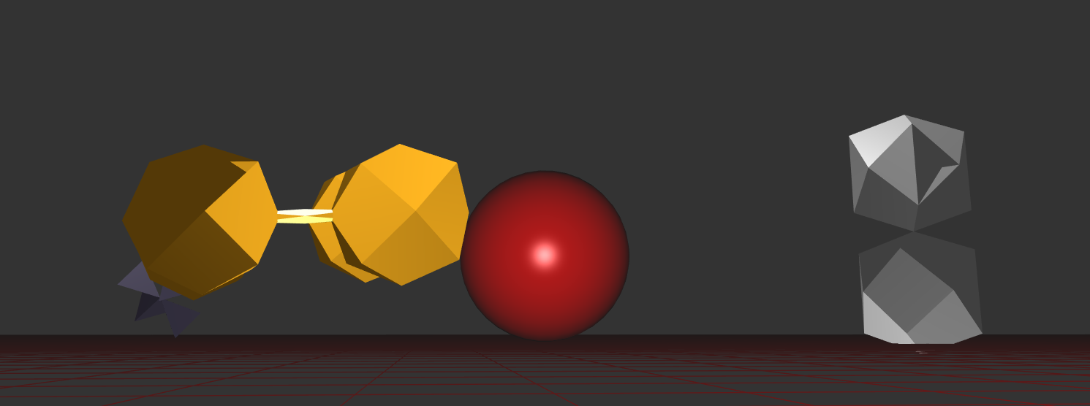

Turn off the headlight:

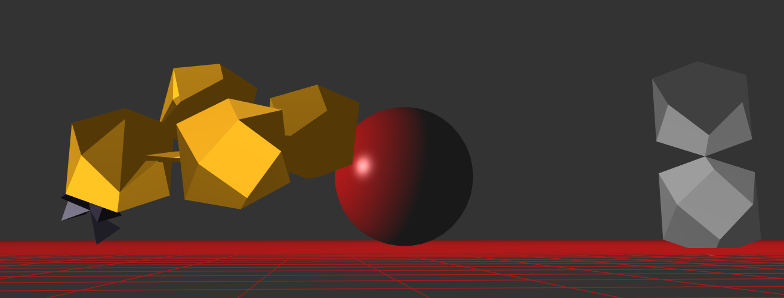

Scene graph：

