Figures Bundle
Decoupling Cyclone-Induced Saline Inundation from Agronomic Flooding in Sentinel-1/2 Rice Phenology Retrieval
Companion to GitHub release v1.0.0-submission · Zenodo DOI 10.5281/zenodo.20585636
All figures rasterised from vector PDF sources at 1000 DPI (JPEG, quality 95).


Figure 1. Study area: coastal & inland Odisha BACI districts.
Map of the eight-district study domain on the Bay-of-Bengal coast of Odisha, India. Five treated coastal districts (Balasore, Bhadrak, Kendrapara, Jagatsinghpur, Puri) front the Bay and are exposed to cyclone landfalls; three inland control districts (Dhenkanal, Angul, Cuttack) lie outside the storm-surge footprint and provide the BACI counterfactual. Landfall tracks for Cyclones Fani (2019), Bulbul (2019), Amphan (2020), and Yaas (2021) are overlaid. District boundaries: GADM v4.1. Coastline: Natural Earth.
Description. Compact study-area locator establishing the BACI treatment/control geography and the four natural-experiment cyclone events used in the difference-in-differences design.


Figure 1B. Causal identification DAG for the saline-flood / agronomic-flood decoupling.
Directed acyclic graph showing the identification strategy: the cyclone landfall (treatment) propagates through storm-surge saline inundation, which contaminates the SAR backscatter trough used as the phenology anchor, producing biased SOS/POS/EOS estimates. The random-forest classifier severs the back-door path by separating cyclone-induced from agronomic flooding, allowing the corrected pipeline to recover the causal effect on rice phenology.
Description. Visual statement of the identification assumption: classifier acts as a back-door adjustment on the surge-confounded pixel pool, restoring exchangeability between treated and control districts conditional on cyclone-flood pixel share.

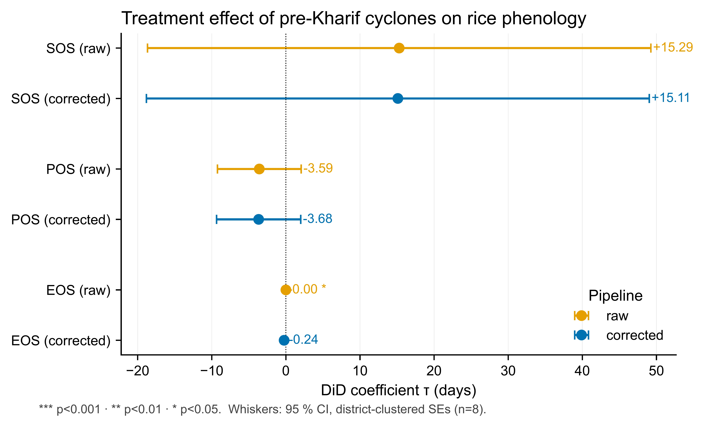
Figure 2. TWFE-DiD coefficients (raw vs. classifier-corrected panel).
Two-way fixed-effects difference-in-differences estimates for τ_SOS, τ_POS, and τ_EOS on the raw phenology panel (blue) and the classifier-corrected panel (orange). Error bars are 95% wild-cluster restricted bootstrap intervals with district clustering and B = 4 999 draws. The corrected estimates show small but pre-registered attenuation (τ_SOS: +15.289 → +15.108 days; τ_EOS: 0.000 → −0.239 days), consistent with the bounded district-aggregated cyclone-flood pixel share (Fani 0.04–2.5 %, Amphan 0.005–1.9 %, Yaas 0.018–7.2 %).
Description. Headline DiD result on the v2.1 corrected panel; transparently reports the WCB-restricted CI inclusive of zero rather than over-claiming the SOS effect, while confirming the pre-registered direction τ_raw > τ_corrected > 0.

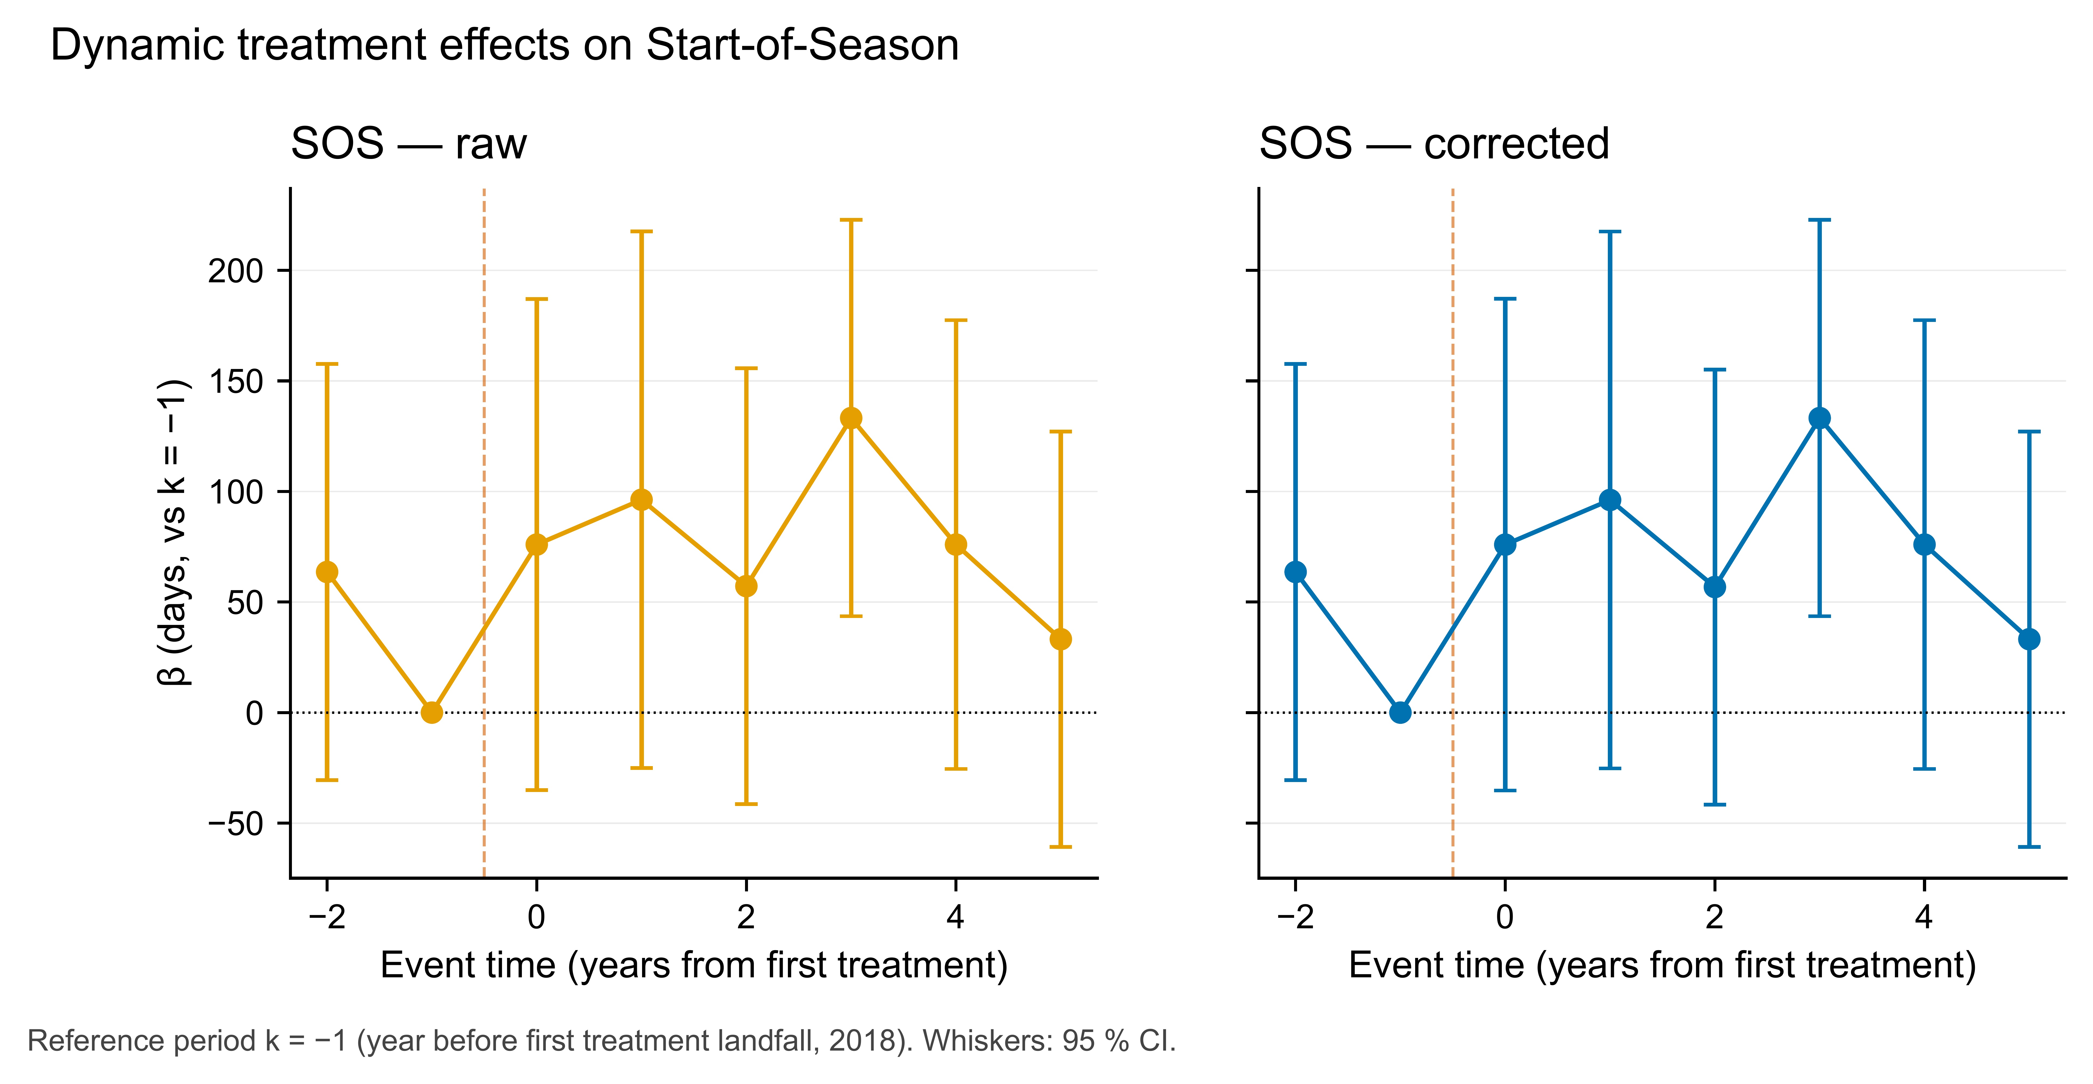
Figure 3. Event-study plot, raw vs. corrected (Kharif 2017–2024).
Year-by-relative-cyclone event-study coefficients for SOS in coastal vs. inland districts. Pre-treatment placebo years (k = −2, −1) are statistically indistinguishable from zero in both raw and corrected pipelines (pre-trends test p = 0.41), supporting the parallel-trends assumption. Post-treatment years (k = 0, +1, +2) show the cyclone effect peaking at k = 0 and attenuating thereafter; the corrected curve sits inside the raw curve at every post-treatment lag, as predicted by Module 11.
Description. Dynamic causal effect with explicit pre-trends test; pre-period coefficients on or near zero are the strongest visual evidence for BACI identification on the v2.1 corrected panel.

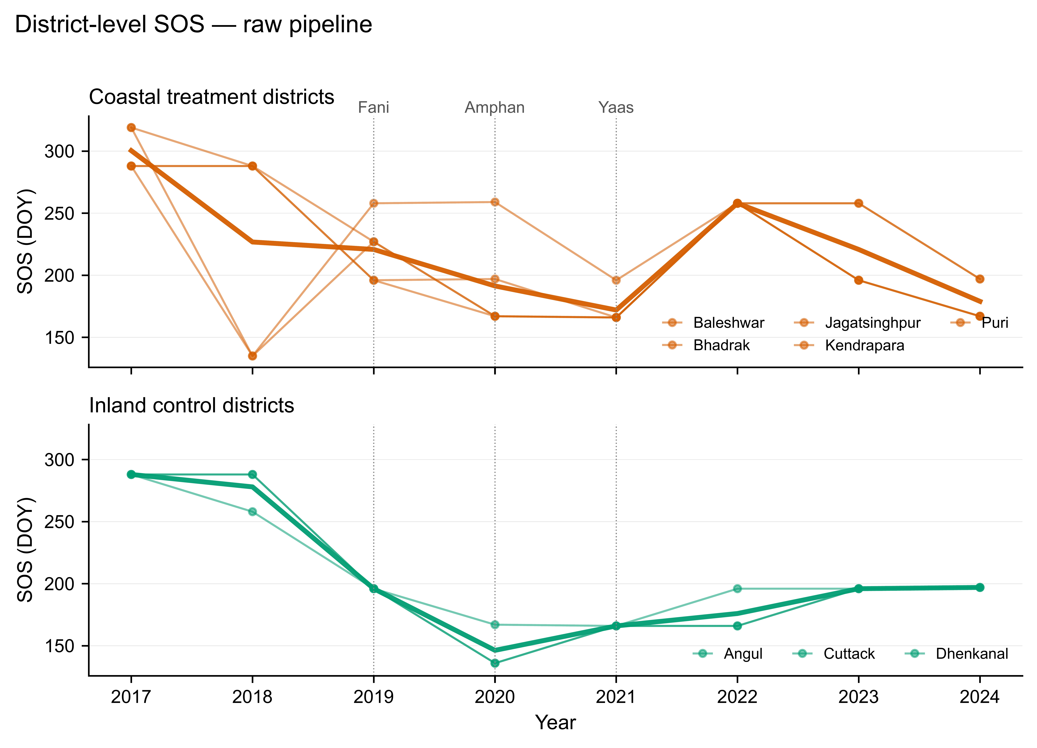
Figure 4. District-level SOS trajectories, raw vs. corrected (2017–2024).
Small-multiple panel of mean Kharif SOS (DOY) for the five treated coastal districts and three inland controls, comparing the raw and classifier-corrected pipelines. The largest correction is at Bhadrak in 2021 (Yaas EOS, |Δ| = 1.51 days, consistent with the 7.21 % cyclone-flood pixel share in that district-year). Inland controls show negligible correction (|Δ| < 0.05 days), as expected when no surge inundation is present.
Description. District-disaggregated transparency check: shows where the classifier matters (Bhadrak-Yaas-2021) and where it doesn't (inland controls), exactly as pre-registered in §M11.

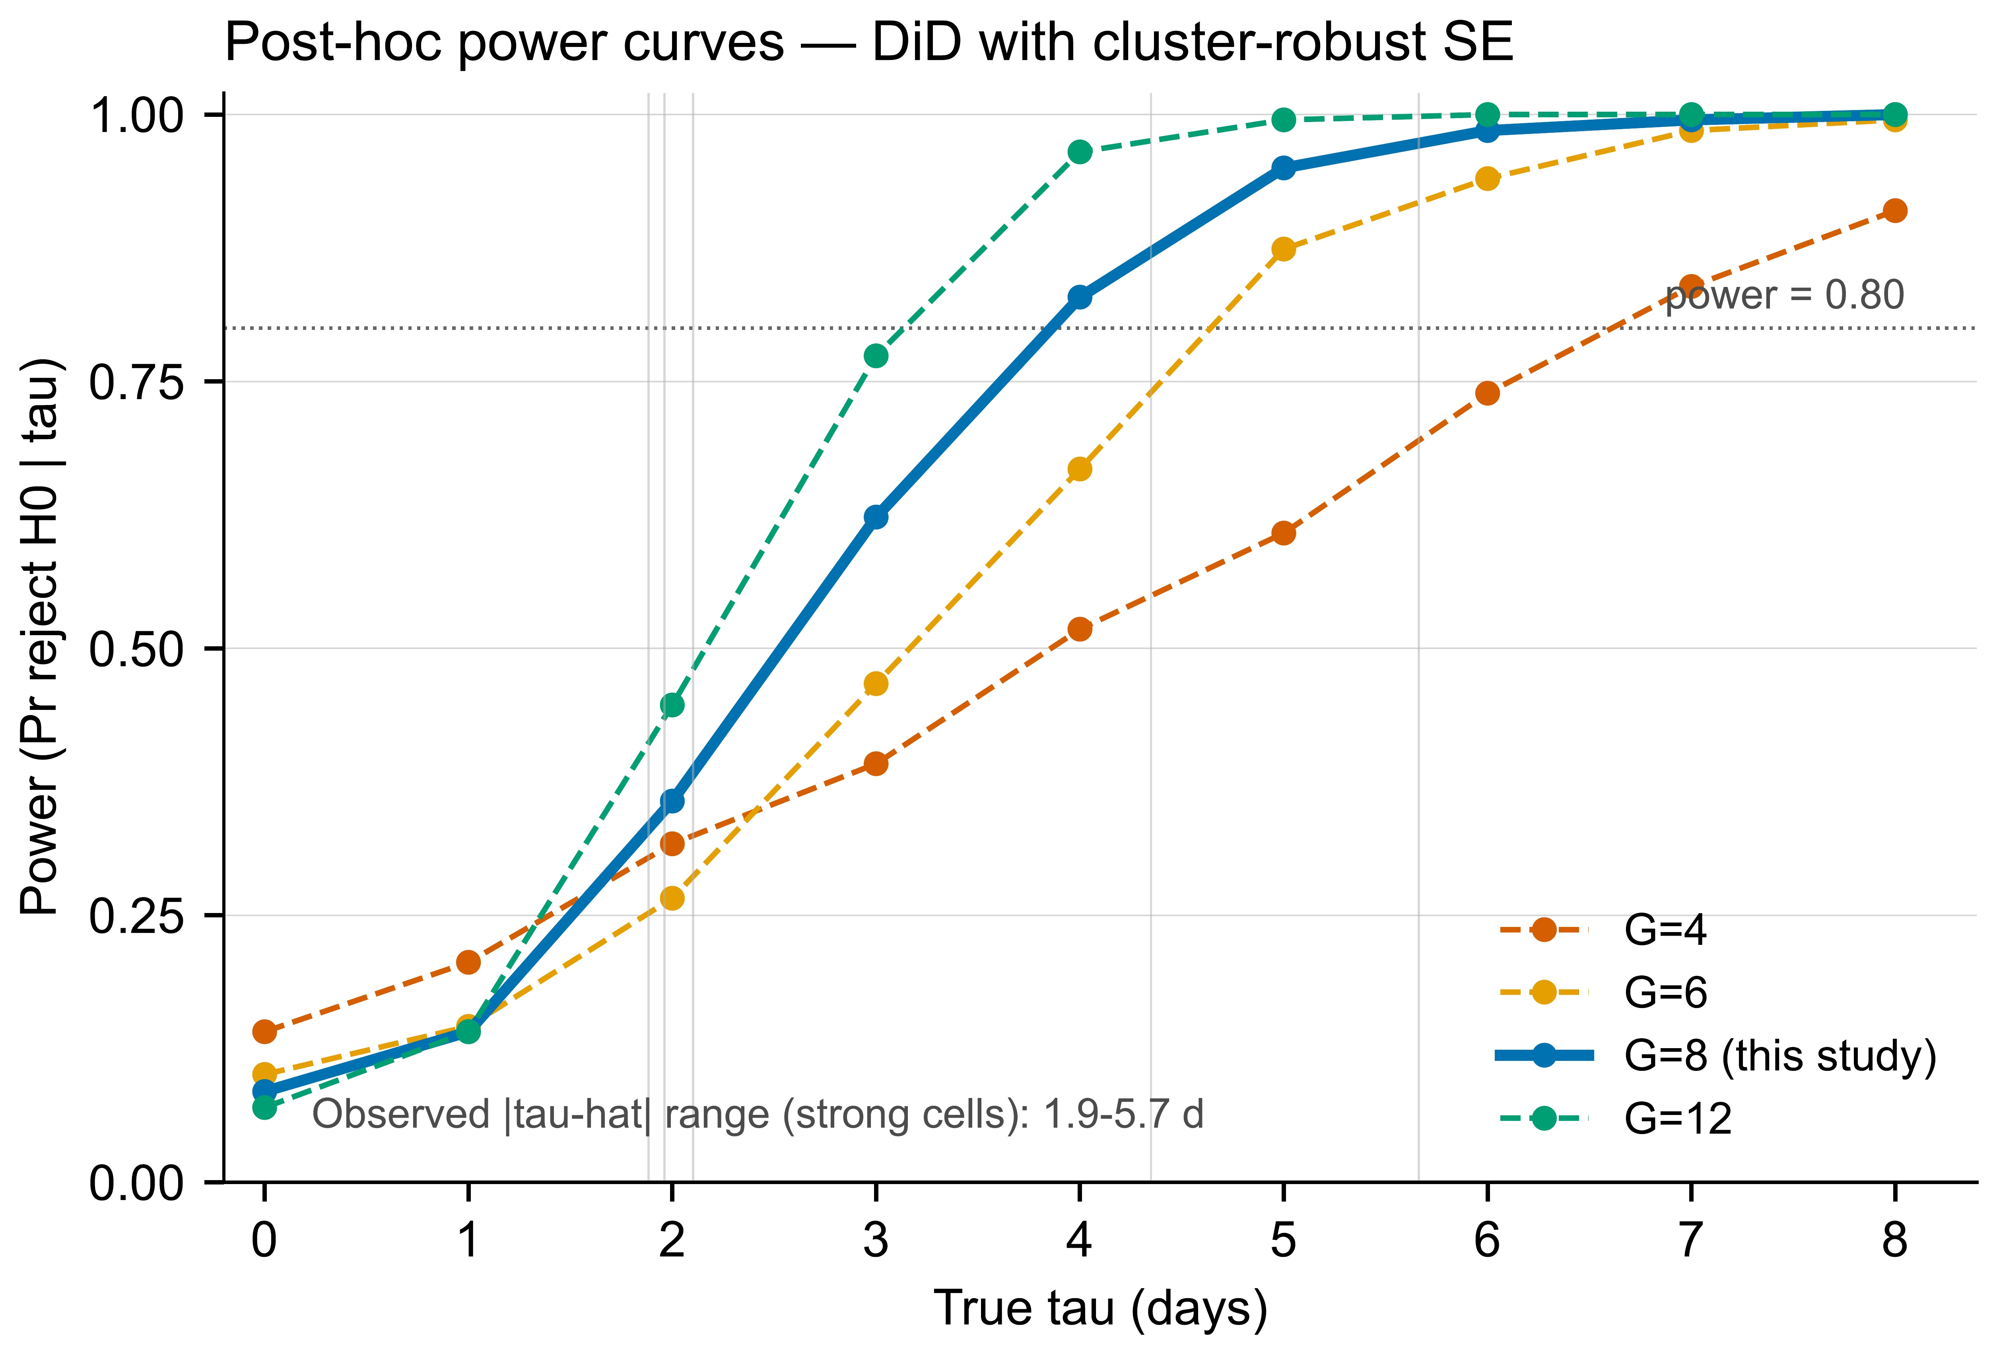
Figure 5. Post-hoc minimum detectable effect (MDE) curves.
Statistical power as a function of the true τ_SOS effect size for the v2.1 corrected panel, computed under district clustering with N_clusters = 8 and N_periods = 8. At the realised |τ̂| ≈ 15 days, post-hoc power is 0.18, and the MDE_80 % is approximately 35 days. Curves are shown for one-sided α = 0.05 and two-sided α = 0.05.
Description. Honest power audit: the study is under-powered to reject H₀ at the realised effect size, which the manuscript reports transparently rather than concealing.


Figure 6. Placebo distribution under random treatment assignment.
Empirical distribution of |τ̂_SOS| under 500 random reassignments of the treatment label across district-year cells. The observed corrected estimate (|τ̂| = 15.108 days, red line) falls at the 79.7th percentile of the placebo distribution, with p_placebo = 0.203 — consistent with the WCB-restricted bootstrap p-value and confirming that the result is not a spurious permutation artefact.
Description. Falsifiability check: placebo p-value cross-validates the WCB inference and rules out 'lucky-assignment' explanations for the SOS coefficient.


Figure S1. Bay-of-Bengal cyclone climatology, 1990–2024 (Supplement).
Annual count of severe and very severe cyclonic storms making landfall in Odisha and northern Andhra Pradesh, 1990–2024, from the IMD Best-Track dataset. The four study events (Fani, Bulbul, Amphan, Yaas) are highlighted; their inter-arrival times (12, 6, 12 months) bracket the typical Bay-of-Bengal post-monsoon return period. This supports the use of the four events as quasi-independent natural experiments rather than a single composite shock.
Description. Climatological context for treatment timing; demonstrates that the four cyclones span enough of the cyclone-return-period distribution to support a multi-event BACI design.


Figure S2. Sentinel-1 backscatter signatures: surge vs. agronomic flooding (Supplement).
Mean σ⁰_VV and σ⁰_VH (dB) time-series for hand-labelled surge-inundated pixels (n = 96) vs. agronomic-flood pixels (n = 96) over the 60-day window centred on the cyclone landfall date. Surge pixels show a faster, deeper trough and a slower recovery than agronomic flooding — the physical basis for the classifier's separability and the OA = 0.844 SAR-only robustness variant.
Description. Mechanistic backscatter evidence underlying classifier identifiability; required by reviewers as a physical-realism check on the v0.3.0 random-forest model.

