PANDATEC
How to Send New Product Information
For staff who do not use coding
This guide uses normal Windows folders and Excel. Staff do not need to write code. They put one Excel file and the product photos into one new product folder, fill in three columns, and double-click one checker file.
Important: Do not edit convert_products.py or any other technical file. Staff only use the Excel template, the images folder, and convert_products.bat.

1. What the company needs
- PANDATEC_Employee_Product_Input_Template.xlsx — the Excel file staff complete.
- One new product folder containing products.xlsx and an images folder.
- convert_products.bat — the file staff double-click to check the new product folder.
- If Windows says a setup component is missing, send a screenshot to the person who prepared the tool.
File or folder | Purpose
products.xlsx | The only spreadsheet staff edit: SKU, Category, and Product Description.
images\SKU.jpg | The main image; the filename must exactly match the SKU.
images\SKU-01.jpg to SKU-03.jpg | Optional additional product images.
PANDATEC_Product_Upload_Ready.xlsx | The converter’s full upload workbook for review/import.

2. Make one new product folder
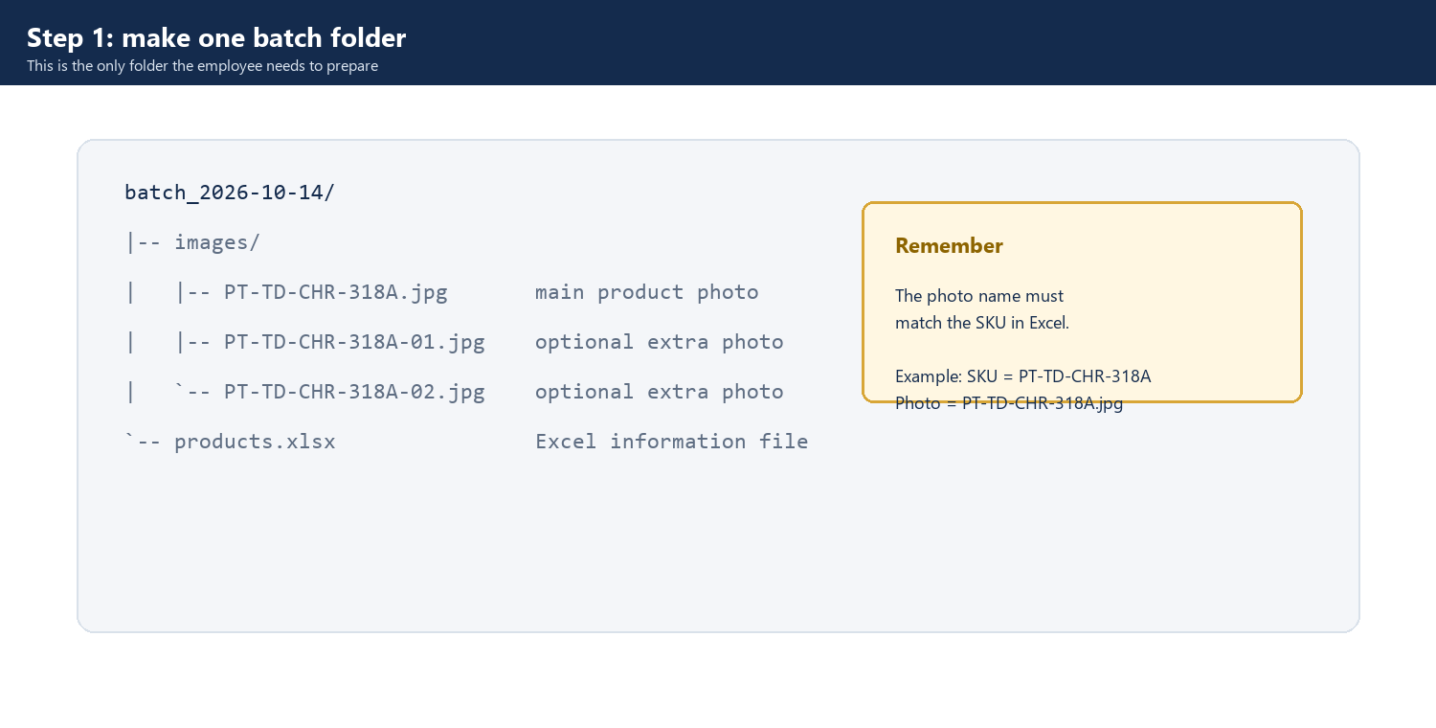
Figure 1. Required batch folder structure and image names.
Folder rule: Make one new folder for each group of products. Keep the Excel file and all photos together inside it.

3. Complete only the three Excel columns
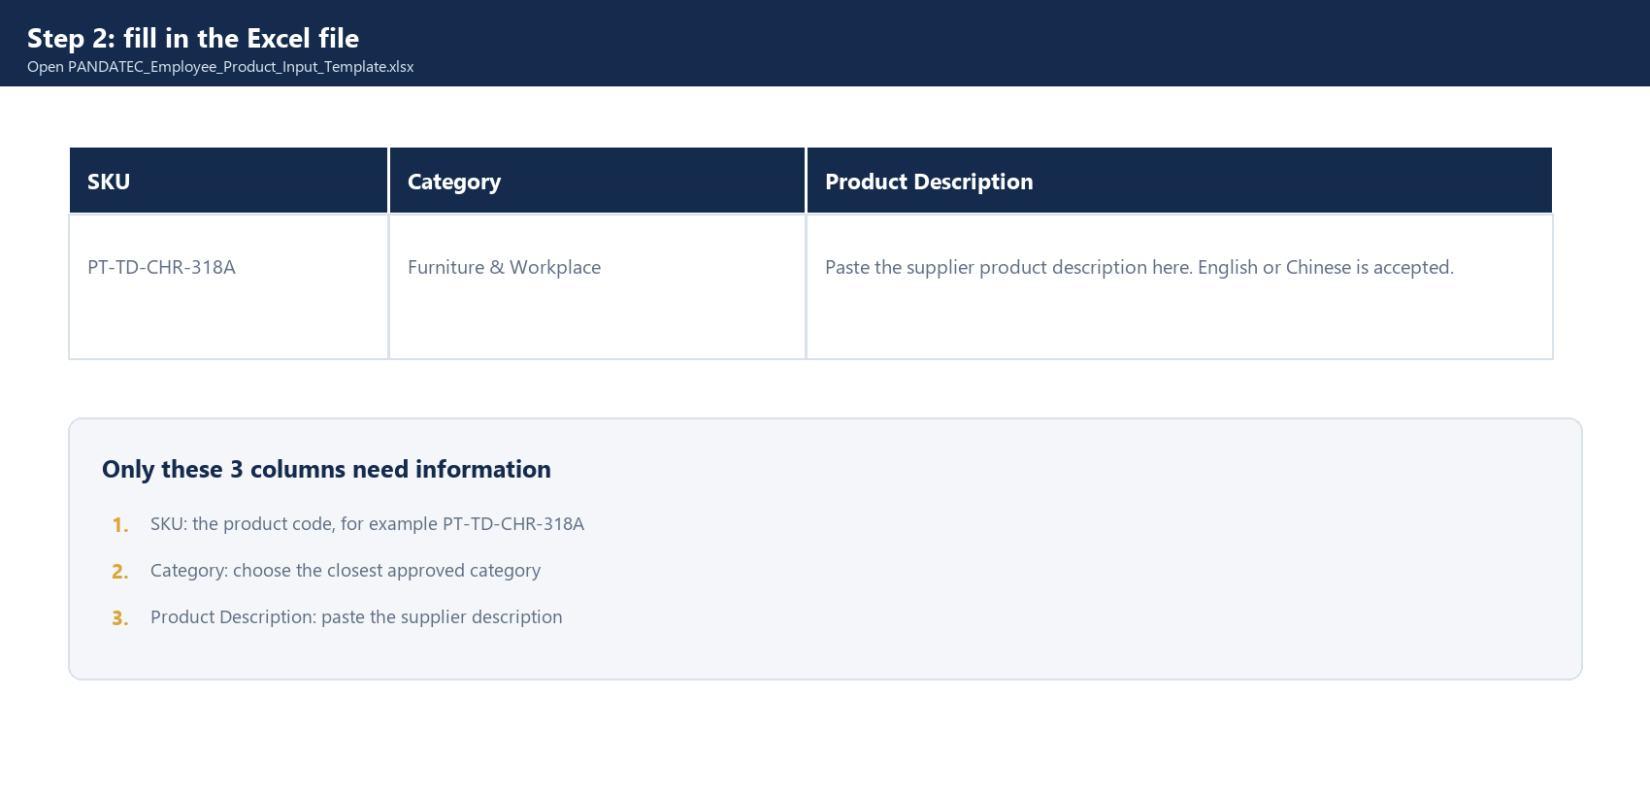
Figure 2. The staff template: only three columns need to be completed.
- SKU — use uppercase letters, numbers, and hyphens only. Do not use spaces. Each SKU must be unique.
- Category — select an approved category from the dropdown. Do not type a new category unless it has been approved.
- Product Description — paste the supplier’s wording. English or Chinese is acceptable. Do not invent technical facts and do not add SEO text here.
Photo rule: The product code in Excel must match the main photo filename. Example: product code PT-TD-CHR-318A uses photo PT-TD-CHR-318A.jpg.

4. Name the images correctly
- Main image: SKU.jpg — for example, PT-TD-CHR-318A.jpg.
- Additional images: SKU-01.jpg, SKU-02.jpg, and SKU-03.jpg.
- Do not use spaces, different SKU spelling, or filenames such as final.jpg or chair-new.jpg.
- If a product has no main image, the converter will report it. Fix the filename or add the missing image before continuing.

5. Run the checker — no coding required
- Close the Excel file.
- Open the product-upload-tool folder.
- Double-click convert_products.bat.
- Open your new product folder in File Explorer. Click the address bar at the top, copy the folder address, paste it into the black window, and press Enter.
- Wait until the checker finishes.
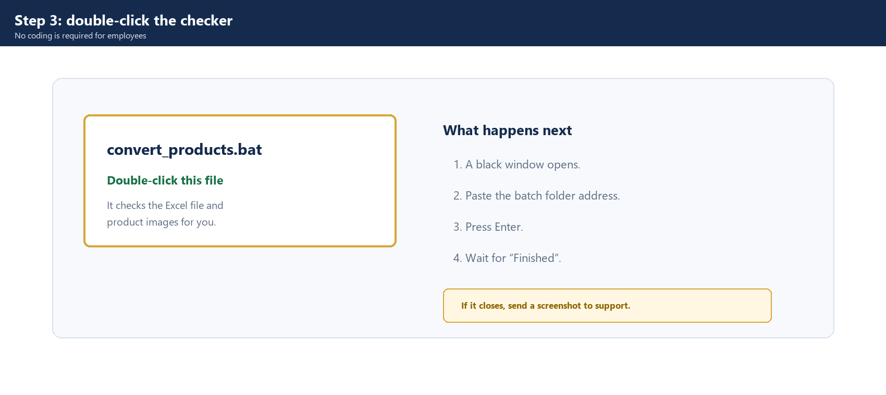
Figure 3. Double-click convert_products.bat. Employees do not need to type code.
One-time setup: If Windows says Python is missing, send that message to the person who prepared the tool. Employees should not edit the files.

6. Check the result and fix problems
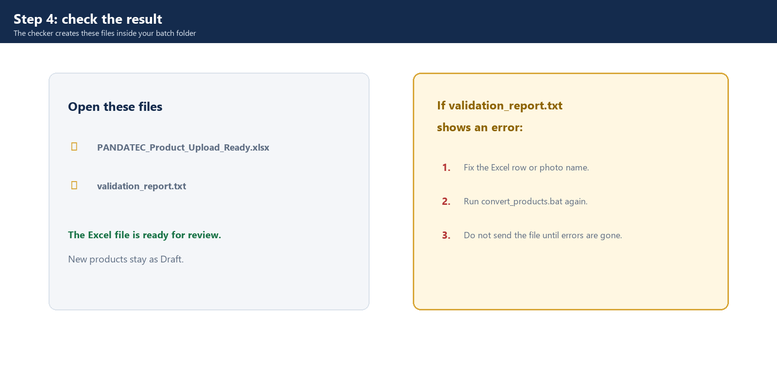
Figure 4. Example validation errors. Correct the source files and run the converter again.
- Duplicate SKU — give each product a unique SKU.
- Missing primary image — add the image or rename it to exactly SKU.jpg.
- Invalid category — select a category from the approved dropdown.
- Filename mismatch — correct the image filename, then rerun the converter.
Clean folder: Do not send the finished Excel file while validation_report.txt still lists errors. Correct the product information or photo filename and run convert_products.bat again.

7. Review the generated workbook
- Open PANDATEC_Product_Upload_Ready.xlsx.
- Check the product names, descriptions, categories, photos, and SKUs.
- Check that the description does not claim certifications, stock availability, dimensions, or materials that the supplier did not provide.
- Keep new products in Draft/review status until the responsible person approves them.

8. Send the clean files for publishing
Staff send: the new product folder, the finished PANDATEC_Product_Upload_Ready.xlsx file, and validation_report.txt showing no errors.
Website owner does the final step: the responsible person imports or publishes the products in the company website system. Staff should not change the website or edit technical files.

9. Final checklist
- Every product has a unique SKU.
- Every SKU with a product image has an exact SKU.jpg main image.
- Optional additional images use SKU-01.jpg to SKU-03.jpg.
- Category values are approved dropdown values.
- Descriptions are supplier-provided and contain no invented claims.
- The validation report has no errors.
- The generated workbook was reviewed before import or publication.
- Products remain Draft until the responsible person approves them.

Quick handover summary
Staff provide: one images folder + one three-column Excel file. The converter checks the batch and creates: one full upload workbook. The responsible person then: reviews, imports, and approves the products before publication.

