**Week-4**

**HandsOn-1: Create a Spring Web Project using Maven**

1. Go to <https://start.spring.io/>
2. Change Group as “com.cognizant”
3. Change Artifact Id as “spring-learn”
4. Select Spring Boot DevTools and Spring Web

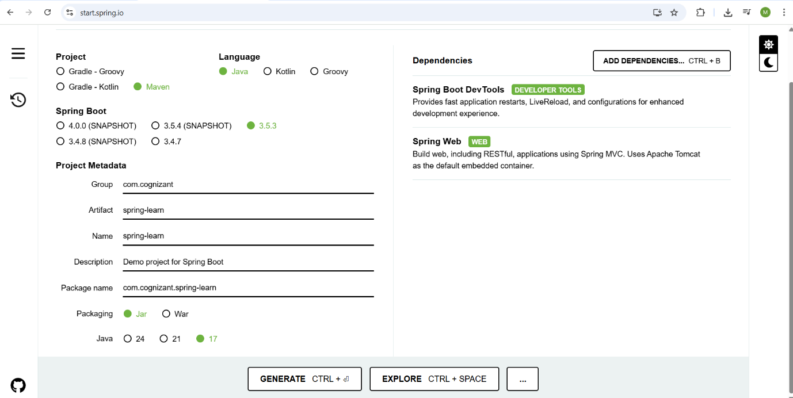

1. Create and download the project as zip
2. Extract the zip in root folder to Eclipse Workspace
3. Build the project using ‘mvn clean package -Dhttp.proxyHost=proxy.cognizant.com -Dhttp.proxyPort=6050 -Dhttps.proxyHost=proxy.cognizant.com -Dhttps.proxyPort=6050 -Dhttp.proxyUser=123456’ command in command line

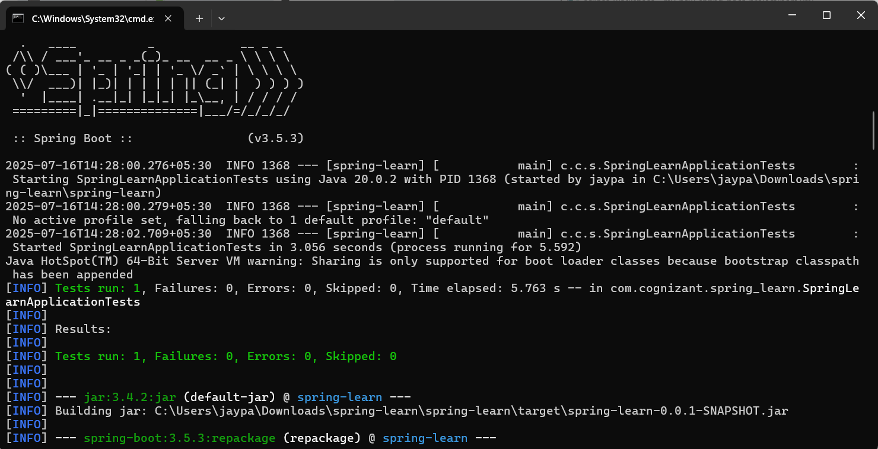

1. Import the project in Eclipse "File > Import > Maven > Existing Maven Projects > Click Browse and select extracted folder > Finish"
2. Include logs to verify if main() method of SpringLearnApplication.

package com.cognizant.spring_learn;

import org.springframework.boot.SpringApplication;

import org.springframework.boot.autoconfigure.SpringBootApplication;

@SpringBootApplication

public class SpringLearnApplication {

public static void main(String[] args) {

SpringApplication.run(SpringLearnApplication.class, args);

System.out.println("Spring Learn Application Started...");

}

}

1. Run the SpringLearnApplication class.

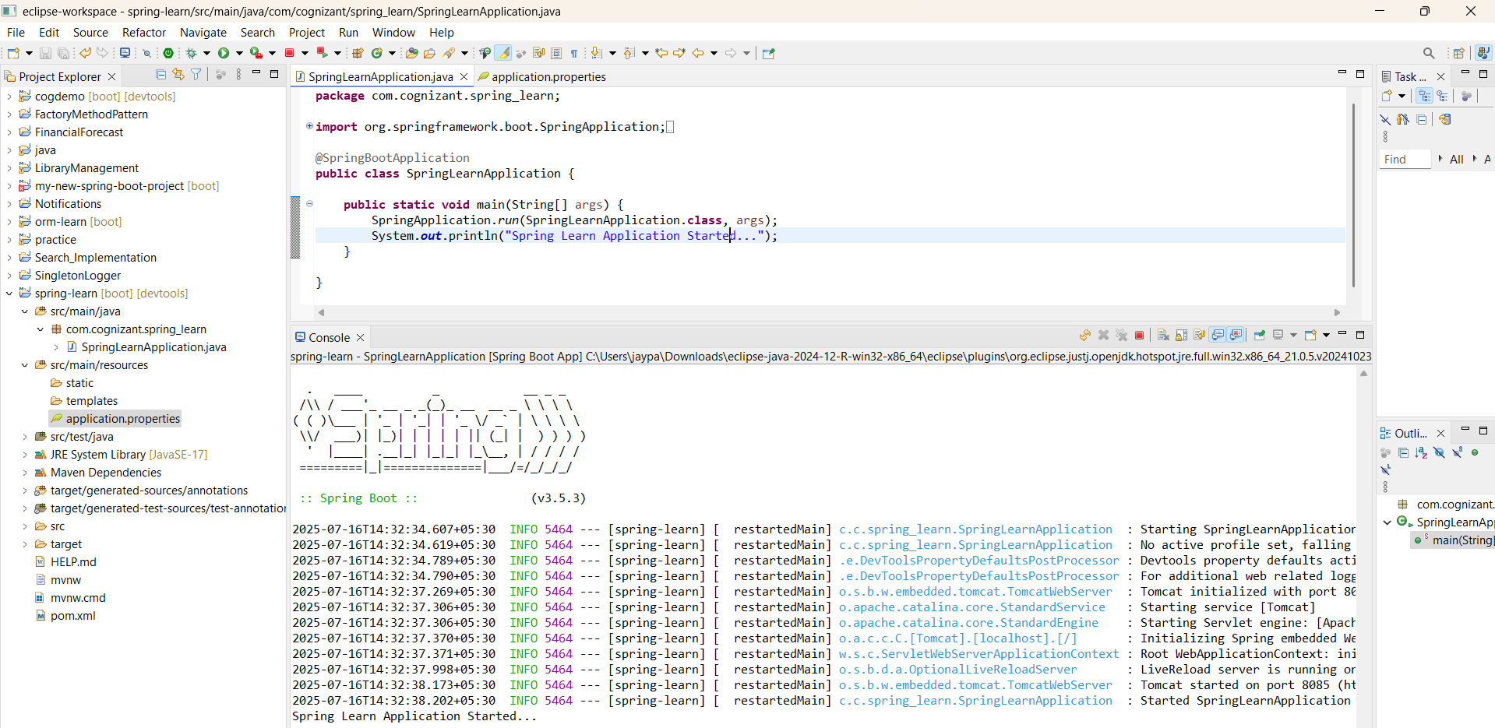

**HandsOn-2 : Spring Core – Load Country from Spring Configuration XML**

1. **/spring-learn/src/main/java/com/cognizant/spring_learn/Country.java**

package com.cognizant.spring_learn;

import org.slf4j.Logger;

import org.slf4j.LoggerFactory;

public class Country {

private static final Logger LOGGER = LoggerFactory.getLogger(Country.class);

private String code;

private String name;

public Country() {

LOGGER.debug("Inside Country Constructor.");

}

public String getCode() {

LOGGER.debug("Getting code: {}", code);

return code;

}

public void setCode(String code) {

LOGGER.debug("Setting code: {}", code);

this.code = code;

}

public String getName() {

LOGGER.debug("Getting name: {}", name);

return name;

}

public void setName(String name) {

LOGGER.debug("Setting name: {}", name);

this.name = name;

}

@Override

public String toString() {

return "Country [code=" + code + ", name=" + name + "]";

}

}

1. **/spring-learn/src/main/resources/country.xml**

<?xml version="1.0" encoding="UTF-8"?>

<beans xmlns="http://www.springframework.org/schema/beans"

xmlns:xsi="http://www.w3.org/2001/XMLSchema-instance"

xsi:schemaLocation="http://www.springframework.org/schema/beans

http://www.springframework.org/schema/beans/spring-beans.xsd">

<bean id="country" class="com.cognizant.spring_learn.Country">

<property name="code" value="IN"/>

<property name="name" value="India"/>

</bean>

</beans>

1. **/spring-learn/src/main/resources/application.properties**

spring.application.name=spring-learn

server.port=8085

1. **/spring-learn/src/main/java/com/cognizant/spring_learn/SpringLearnApplication.java**

package com.cognizant.spring_learn;

import org.slf4j.Logger;

import org.slf4j.LoggerFactory;

import org.springframework.context.ApplicationContext;

import org.springframework.context.support.ClassPathXmlApplicationContext;

public class SpringLearnApplication {

private static final Logger *LOGGER* = LoggerFactory.*getLogger*(SpringLearnApplication.class);

public static void main(String[] args) {

*displayCountry*();

}

public static void displayCountry() {

System.*out*.println("Loading context...");

ApplicationContext context = new ClassPathXmlApplicationContext("country.xml");

System.*out*.println("Getting bean...");

Country country = (Country) context.getBean("country", Country.class);

*LOGGER*.debug("Country : {}", country.toString());

System.*out*.println("Country loaded: " + country);

}

}

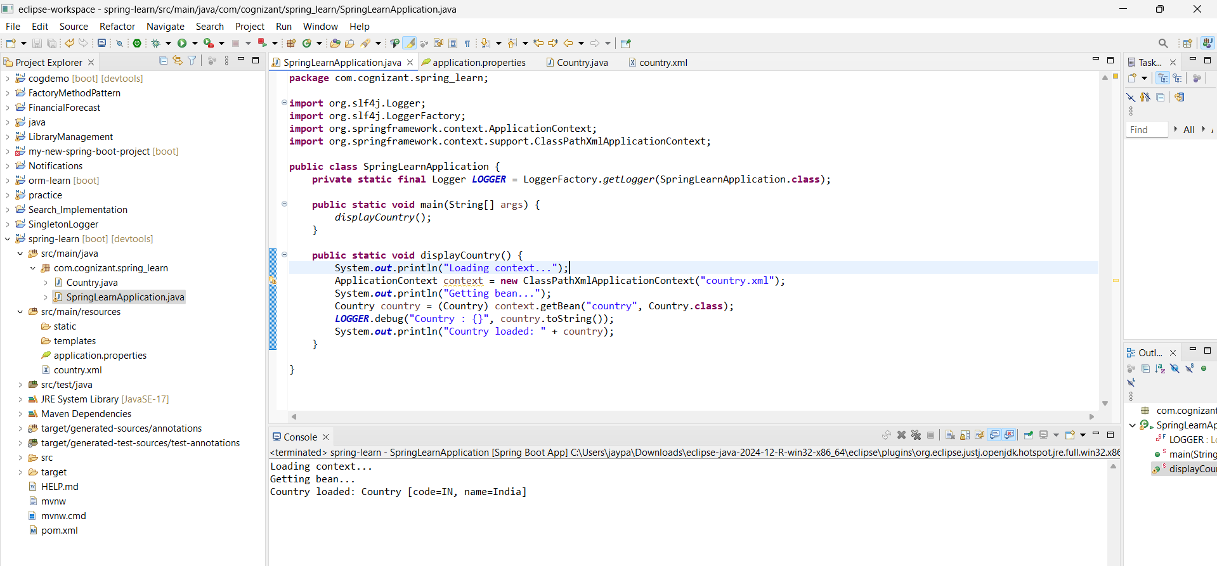

**HandsOn-3 : Hello World RESTful Web Service**

* 1. **/spring-learn/src/main/java/com/cognizant/spring_learn/controller/HelloController.java**

package com.cognizant.spring_learn.controller;

import org.slf4j.Logger;

import org.slf4j.LoggerFactory;

import org.springframework.web.bind.annotation.GetMapping;

import org.springframework.web.bind.annotation.RestController;

@RestController

public class HelloController {

private static final Logger *LOGGER* = LoggerFactory.*getLogger*(HelloController.class);

@GetMapping("/hello")

public String sayHello() {

*LOGGER*.info("START - sayHello()");

String message = "Hello World!!";

*LOGGER*.info("END - sayHello()");

return message;

}

}

* 1. **/spring-learn/src/main/resources/application.properties**

spring.application.name=spring-learn

server.port=8085

* 1. **/spring-learn/src/main/java/com/cognizant/spring_learn/SpringLearnApplication.java**

package com.cognizant.spring_learn;

import org.springframework.boot.SpringApplication;

import org.springframework.boot.autoconfigure.SpringBootApplication;

@SpringBootApplication

public class SpringLearnApplication {

public static void main(String[] args) {

SpringApplication.run(SpringLearnApplication.class, args);

}

}

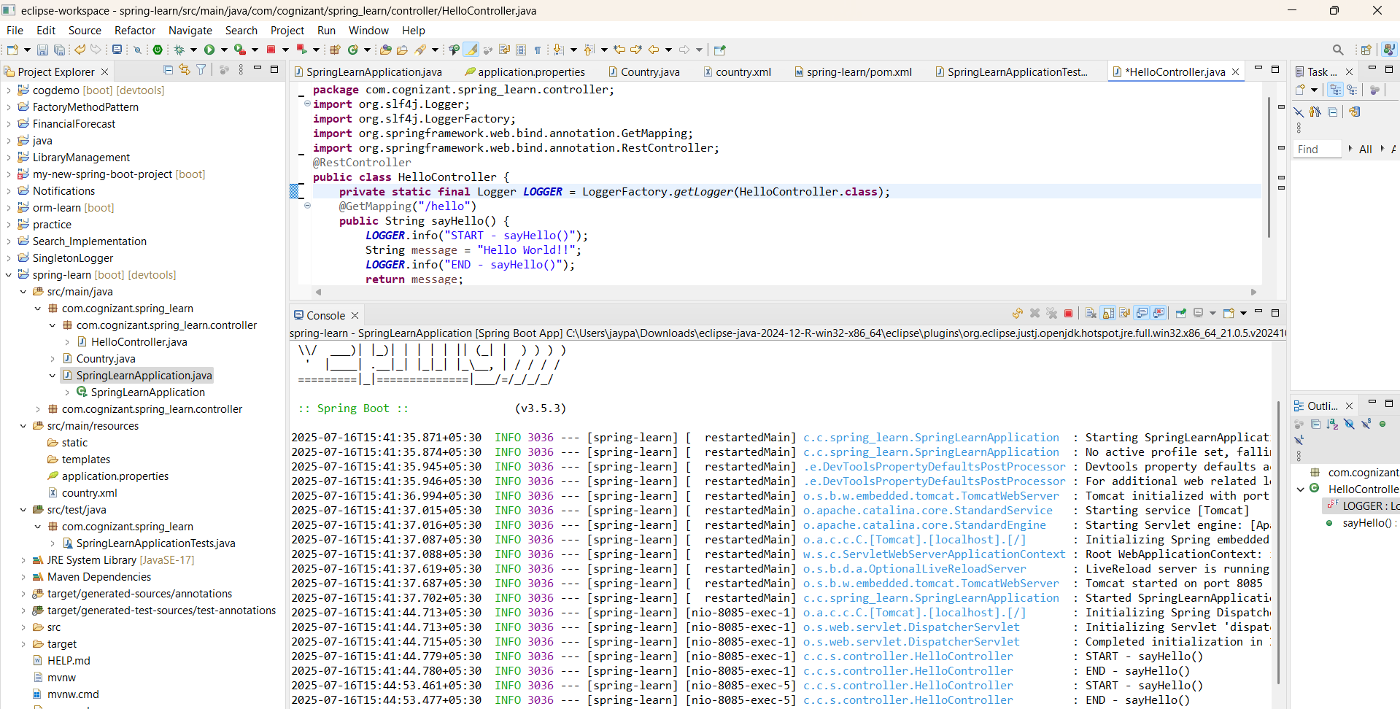m

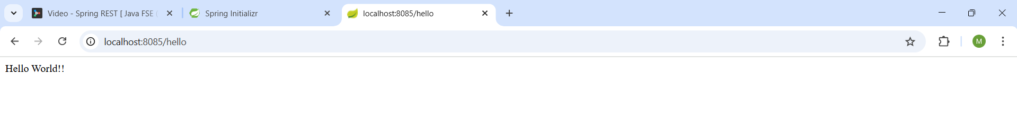

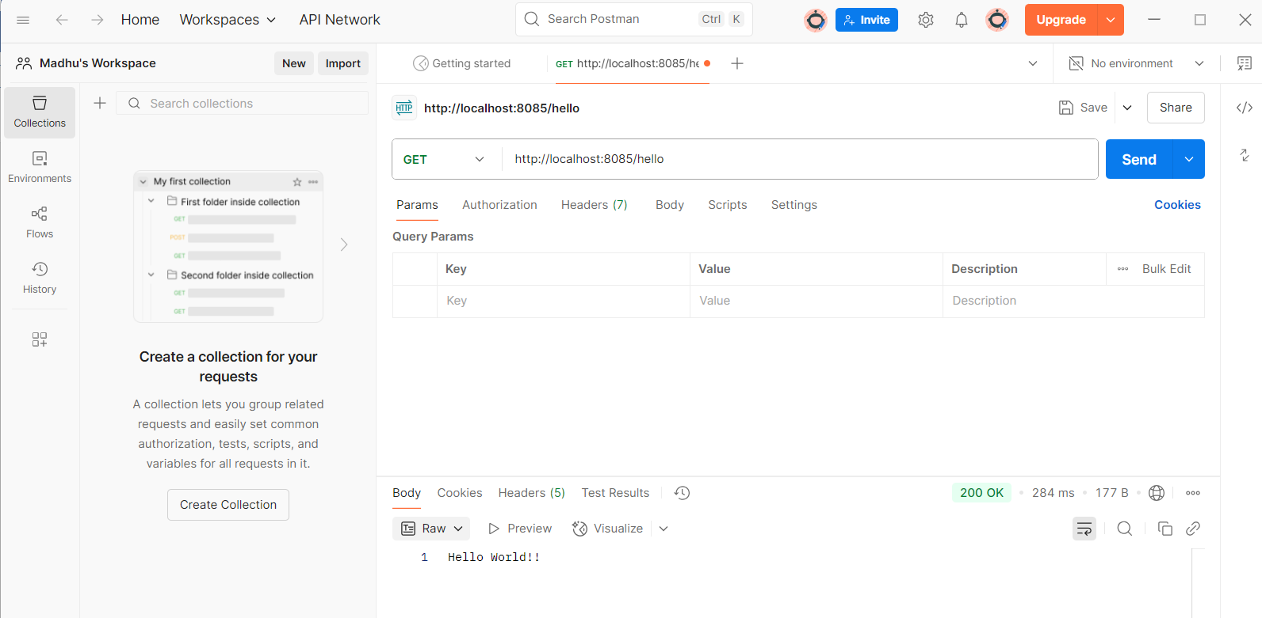

**HandsOn-4 : Country Web Service**

* + 1. **/spring-learn/src/main/java/com/cognizant/spring_learn/controller/CountryController.java**

**package** com.cognizant.spring_learn.controller;

**import** com.cognizant.spring_learn.Country;

**import** org.springframework.context.ApplicationContext;

**import** org.springframework.context.support.ClassPathXmlApplicationContext;

**import** org.springframework.web.bind.annotation.RequestMapping;

**import** org.springframework.web.bind.annotation.RestController;

@RestController

**public** **class** CountryController {

@RequestMapping("/country")

**public** Country getCountryIndia() {

ApplicationContext context = **new** ClassPathXmlApplicationContext("country.xml");

Country country = context.getBean("country", Country.**class**);

**return** country;

}

}

* + 1. **/spring-learn/src/main/resources/country.xml**

<beans xmlns="http://www.springframework.org/schema/beans"

xmlns:xsi="http://www.w3.org/2001/XMLSchema-instance"

xsi:schemaLocation="http://www.springframework.org/schema/beans

http://www.springframework.org/schema/beans/spring-beans.xsd">

<bean id="country" class="com.cognizant.spring_learn.Country">

<property name="code" value="IN"/>

<property name="name" value="India"/>

</bean>

</beans>

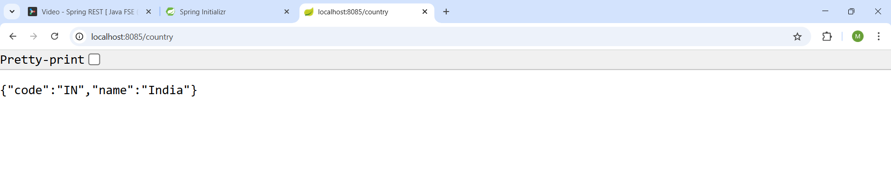

**HandsOn-5 : REST - Get country based on country code**

1. **/spring-learn/src/main/java/com/cognizant/spring_learn/service/CountryService.java**

package com.cognizant.spring_learn.service;

import com.cognizant.spring_learn.Country;

import org.springframework.context.ApplicationContext;

import org.springframework.context.support.ClassPathXmlApplicationContext;

import org.springframework.stereotype.Service;

import java.util.List;

@Service

public class CountryService {

public Country getCountry(String code) {

ApplicationContext context = new ClassPathXmlApplicationContext("country.xml");

List<Country> countries = context.getBean("countryList", List.class);

return countries.stream()

.filter(c -> c.getCode().equalsIgnoreCase(code))

.findFirst()

.orElse(null);

}

}

1. **/spring-learn/src/main/java/com/cognizant/spring_learn/controller/CountryController.java**

package com.cognizant.spring_learn.controller;

import com.cognizant.spring_learn.Country;

import com.cognizant.spring_learn.service.CountryService;

import org.springframework.beans.factory.annotation.Autowired;

import org.springframework.web.bind.annotation.*;

@RestController

public class CountryController {

@Autowired

private CountryService countryService;

@GetMapping("/countries/{code}")

public Country getCountry(@PathVariable String code) {

return countryService.getCountry(code);

}

}

1. **/spring-learn/src/main/resources/country.xml**

<beans xmlns="http://www.springframework.org/schema/beans"

xmlns:xsi="http://www.w3.org/2001/XMLSchema-instance"

xsi:schemaLocation="http://www.springframework.org/schema/beans

http://www.springframework.org/schema/beans/spring-beans.xsd">

<bean id="country1" class="com.cognizant.spring_learn.Country">

<property name="code" value="IN"/>

<property name="name" value="India"/>

</bean>

<bean id="country2" class="com.cognizant.spring_learn.Country">

<property name="code" value="US"/>

<property name="name" value="United States"/>

</bean>

<bean id="country3" class="com.cognizant.spring_learn.Country">

<property name="code" value="DE"/>

<property name="name" value="Germany"/>

</bean>

<bean id="country4" class="com.cognizant.spring_learn.Country">

<property name="code" value="JP"/>

<property name="name" value="Japan"/>

</bean>

<!-- List of countries -->

<bean id="countryList" class="java.util.ArrayList">

<constructor-arg>

<list>

<ref bean="country1"/>

<ref bean="country2"/>

<ref bean="country3"/>

<ref bean="country4"/>

</list>

</constructor-arg>

</bean>

</beans>

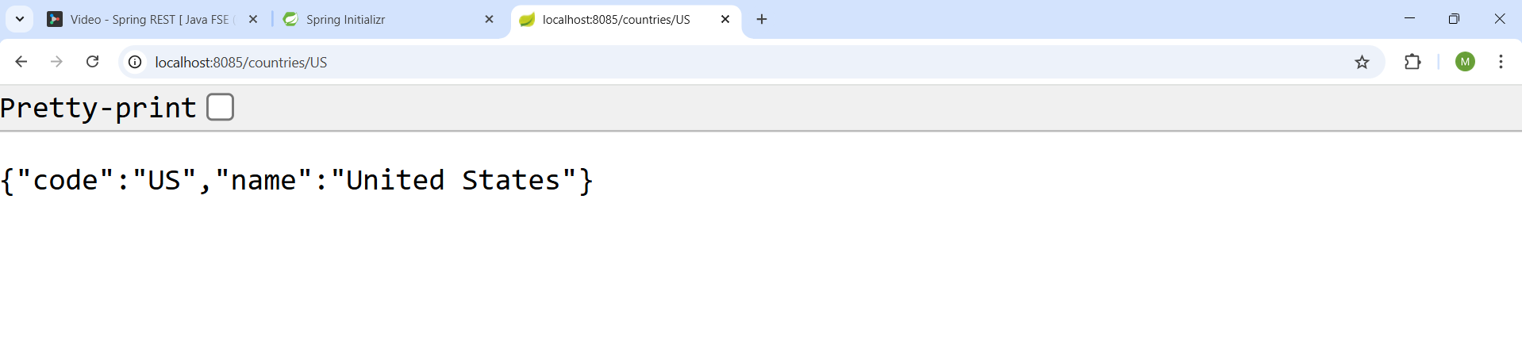

**HandsOn-6 : Create authentication service that returns JWT**

1. **/spring-learn/pom.xml**

**Add below 3 dependencies in pom file**

<dependency>

<groupId>io.jsonwebtoken</groupId>

<artifactId>jjwt-api</artifactId>

<version>0.11.5</version>

</dependency>

<!-- Runtime Dependencies -->

<dependency>

<groupId>io.jsonwebtoken</groupId>

<artifactId>jjwt-impl</artifactId>

<version>0.11.5</version>

<scope>runtime</scope>

</dependency>

<dependency>

<groupId>io.jsonwebtoken</groupId>

<artifactId>jjwt-jackson</artifactId> <!-- or jjwt-gson -->

<version>0.11.5</version>

<scope>runtime</scope>

</dependency>

1. **/spring-learn/src/main/java/com/cognizant/spring_learn/util/JwtUtil.java**

package com.cognizant.spring_learn.util;

import io.jsonwebtoken.Jwts;

import io.jsonwebtoken.SignatureAlgorithm;

import io.jsonwebtoken.security.Keys;

import org.springframework.stereotype.Component;

import java.security.Key;

import java.util.Date;

@Component

public class JwtUtil {

private final Key key = Keys.secretKeyFor(SignatureAlgorithm.HS256);

public String generateToken(String username) {

return Jwts.builder()

.setSubject(username)

.setIssuedAt(new Date(System.currentTimeMillis()))

.setExpiration(new Date(System.currentTimeMillis() + 1000 * 60 * 10))

.signWith(key)

.compact();

}

}

1. **/spring-learn/src/main/java/com/cognizant/spring_learn/controller/AuthenticationController.java**

package com.cognizant.spring_learn.controller;

import com.cognizant.spring_learn.util.JwtUtil;

import org.springframework.beans.factory.annotation.Autowired;

import org.springframework.http.HttpHeaders;

import org.springframework.web.bind.annotation.*;

import java.util.Base64;

import java.util.HashMap;

import java.util.Map;

@RestController

public class AuthenticationController {

@Autowired

private JwtUtil jwtUtil;

@GetMapping("/authenticate")

public Map<String, String> authenticate(@RequestHeader(HttpHeaders.*AUTHORIZATION*) String authHeader) {

// Basic dXNlcjpwd2Q=

if (authHeader != null && authHeader.startsWith("Basic ")) {

String base64Credentials = authHeader.substring("Basic ".length());

byte[] decoded = Base64.*getDecoder*().decode(base64Credentials);

String[] credentials = new String(decoded).split(":", 2);

String username = credentials[0];

String password = credentials[1];

// Dummy check: user/pwd

if ("user".equals(username) && "pwd".equals(password)) {

String token = jwtUtil.generateToken(username);

Map<String, String> response = new HashMap<>();

response.put("token", token);

return response;

}

}

throw new RuntimeException("Invalid credentials");

}

}

1. **/spring-learn/src/main/resources/application.properties**

spring.application.name=spring-learn

server.port=8090

