**CS210- Lab 12:**

**Study of multi- Cycle Processor/Pipelined MIPS processor**

**Task 1: Study the given pipeline implementation of the processor, and identity error in the design (if any) . Convert the following C code to MIPS assembly, test the code in MIPS pipelined version(Given) .**

**for(i = 0; i < 100; i++)**

**A[i] = i;**

**Mips code for our circuit in which data starts at 0**

.data

array : .word 0

.text

addiu $s0,$s0,100

addiu $s7,$s7,1

loop:

beq $s7,$s0,exit

sw $s7,0($s1)

addiu $s1,$s1,4

addiu $s7,$s7,1

beq $0,$0,loop

exit:

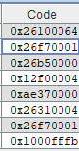

**The Mips Code**

**The .dat file contains**

v2.0 raw

26100064

26f70001

26b50000

12f00004

ae370000

26310004

26f70001

1000fffb

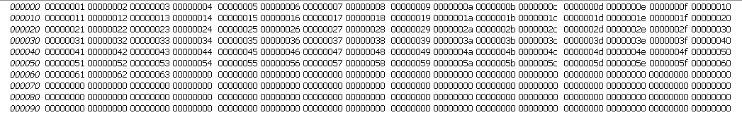**Our data in Circuit**

**Task 2:** ***Write ASCII values of your name full name to the memory using appropriate instruction, and write program to find the sum of those values using the given pipeline MIPS design. Computer the number of cycles required and compare with number of cycles that you got in previous(Multi-cycle implementation).* Enter the relevant information in the r*ecord* for demonstration*.***

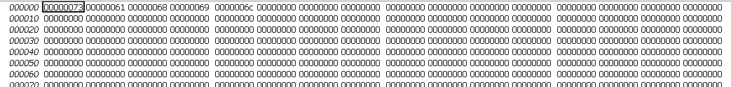

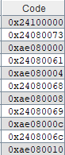

FULL CODE

.data

.text

addiu $s0,$0,0

#s

addiu $t0, $0, 0x73

sw $t0, 0($s0)

#a

addiu $t0, $0, 0x61

sw $t0, 4($s0)

#h

addiu $t0, $0, 0x68

sw $t0, 8($s0)

#i

addiu $t0, $0, 0x69

sw $t0, 12($s0)

#l

addiu $t0, $0, 0x6c

sw $t0, 16($s0)

addiu $t0, $t0, 5

add $s3, $0,$0

add $s1, $0, $0

loop: beq $s3,$t0, done

lw $t1, 0($s0)

add $s1, $s1, $t1

addiu $s0, $s0 , 4

addiu $s3, $s3 , 1

beq $0, $0 , loop

done:

v2.0 raw

24100000

­­24080073

ae080000

24080061

ae080004

24080068

ae080008

24080069

ae08000c

2408006c

ae080010

25080008

00009820

00008820

12680005

8e090000

02298820

26100004

26730001

1000fffa

FOR writing the name

Now CPI FOR pipelined is generally slightly higher than 1 (due to delay)

For ideal pipelined, it is 1 .

Multicycle cpi

Beq, j is 3 cycles and lw is 5 cycles and others are 4 cycles

No of cycles without in loop is 56 and in loop is 23

So 23*5 +1 in loop and 56 = 172 cycles

And no of instructions is 45

3.822 is cpi

**Task 3: Add one new instruction to the given architecture and test using new test program.**

***The Function code for average of 2 numbers is implemented***

***Suppose a and b are given in register..***

***c=(a+b)/2 ( average of 2 numbers)***

***Function = 111000***

***And opcode = 000000***

***As this is implemented as a R type register***

***Example code 01095038***

***This stores in t1 and t2 and save avg in t3***

***Example***

**Submission (modified file and test files) :**

<https://u.pcloud.com/#page=puplink&code=YHwkZXumzadobsxQuqiGEkouWoft2M4LX>

Due: 12.30 PM, 28th March 2023.