SHOPSTREAM · INTERVIEW COMPANION
3. Microservices Architecture
Boundaries, data ownership, messaging, sagas, resilience and migration in ShopStream
Item | Value
Version | v0.1 (living). Evidence: design Designed; messaging and hot-stock spikes pending
Last updated | 2026-10-25
Owner | Hrushikesh Pande
Companion to | Project_Documentation (ADM documents), docs/adr, spikes/
Purpose | Explain why and how ShopStream is split into services, which patterns are used and why, what they cost, and what has been proven.

Evidence key (used on every claim about what exists)
Tag | Meaning | How to say it in an interview
Designed | Reasoned and written down. Not yet built or measured. | "This is the design and the numbers behind it. I haven't load-tested it yet."
Proven in spike | Run under load or failure in a throwaway spike. Results recorded. | "I tested this in a spike and here is what broke and what I changed."
Built | In the main codebase with automated tests. | "This is implemented and covered by tests."
Planned | On the roadmap with a work package. | "This is the next stage."

Cheat sheet (read this first)
Frame it as a decision, not a belief: "I scored three options against six objectives. Services won, narrowly under sensitivity analysis, and I wrote down what would reverse the decision."

The system on one page
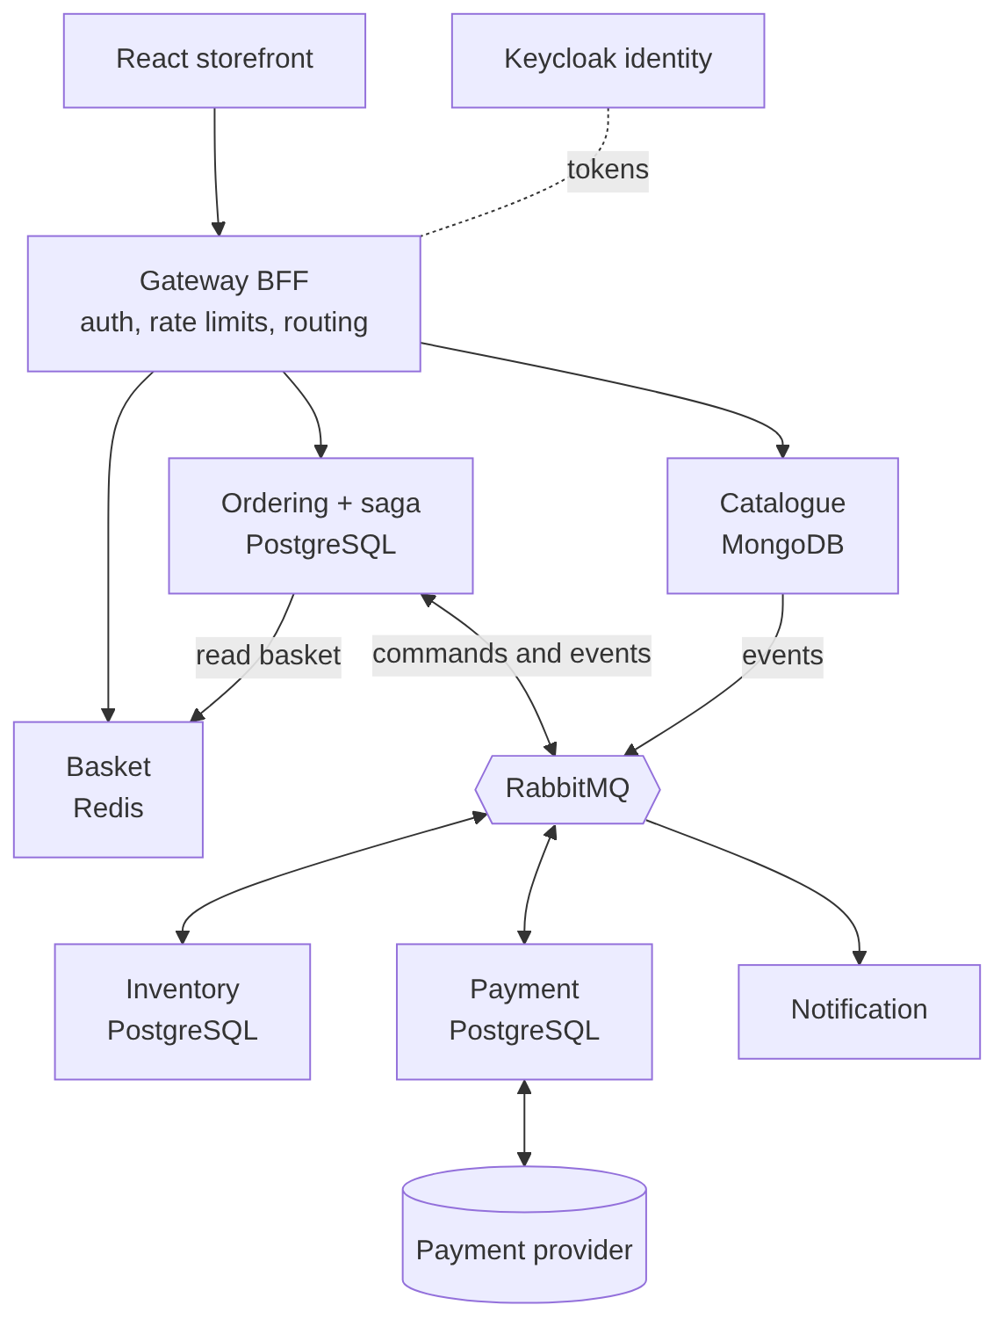
Component view (C2). Gateway acts as a backend-for-frontend (ADR-008). Each service owns its data.
Service | Owns | Store | Tier
Catalogue | Products, categories, offers, prices | MongoDB | 2
Basket | Customer baskets with expiry | Redis-compatible | 2
Ordering | Orders, saga state, checkout keys, local price list | PostgreSQL | 1
Inventory | Stock levels, reservations | PostgreSQL | 1
Payment | Payments, refunds, reconciliation | PostgreSQL | 1
Notification | Messages and delivery attempts | Simple store | 3
Gateway and Identity | Edge, limits, tokens | Redis, Keycloak with PostgreSQL | 1

Seven patterns to name
Pattern | One-line purpose | Evidence
Capability-aligned boundaries | Services change at the rate of the business (PR-01) | Designed
Database per service | No shared tables, no hidden coupling (PR-03) | Designed
Saga with orchestration | Consistency across services without a distributed transaction | Designed
Outbox and inbox | Publish atomically with the state change; ignore duplicates | Designed
Idempotency keys | Retries and duplicates cannot double-charge or double-order (PR-07) | Designed
Strangler migration | Replace the monolith capability by capability at the gateway | Designed
Gateway protection | Authenticate, rate limit and admit at the edge | Proven in spike

1. Why services here (and when not to)
Evidence: Designed
Principle PR-02 says complexity must earn its place and that a modular monolith is the default alternative. C3 therefore compared three options against the six objectives.
Option | Description
A Improved monolith | One deployable with cache, job queue, more instances, read replicas, automated deployment
B Modular monolith plus extracted hot services | Strict internal modules; Inventory and Payment extracted; broker for the order flow
C Capability-aligned services | Catalogue, Basket, Ordering, Inventory, Payment, Notification behind a gateway

Scenario | A | B | C
Base weights | 3.05 | 3.45 | 3.85
Independent delivery 10, simplicity 25 | 3.45 | 3.45 | 3.55
Integrity 35, simplicity 15, delivery 10 | 3.35 | 3.55 | 3.65

How to read it. C leads everywhere, but in the sensitivity cases the margin is small and B is credible and cheaper. The result depends mainly on how much weight independent delivery by four teams carries. With one or two teams, B wins.

Guardrails recorded with the decision (ADR-004)
- Start with six domain services. Do not split further without evidence.
- Merge trigger: if two services change together in more than half of their releases over a quarter, or share a transaction need, merge them.
- Fallback: if platform maturity is not reached by the first production release, deploy Ordering, Basket and Notification as one deployable with identical contracts.
- Every service names an owning team and a capability.
Context disclosure to say aloud. ShopStream is a learning project. That goal was not scored, and the table shows C leads without it. Also, one person builds what four teams would own (H1 section 5), so a modular monolith would be cheaper to run. I accepted that as the learning cost and kept the fallback.

2. Boundaries and data ownership
Evidence: Designed
Boundaries follow business capabilities (PR-01), not technical layers. Each capability has exactly one owning application in the C2 matrix, which is the traceability check. Data follows PR-03: every entity has one owner, and others hold only an identifier or an explicitly named replica built from events.
Service | Responsible for | Explicitly does not
Catalogue | Products, categories, offers, prices; publishes product and offer events | Hold stock quantities
Basket | A customer's intended items; expires | Decide prices
Ordering | Idempotent checkout, order state, saga, order timeline | Reserve stock or touch payments directly
Inventory | Stock, reservations, expiry, per-customer limits, commit and release | Know about payment or notifications
Payment | Charges, refunds, unknown-outcome resolution, reconciliation | Store card data (tokens only)
Notification | Customer messages about order outcomes | Decide order state
Gateway | Authenticate, rate limit, route, simple aggregation | Contain business rules

How to find boundaries (the method, not the answer)
- List capabilities from the business (B1), not from tables or screens.
- Ask which data must be strongly consistent together; keep that data in one service.
- Ask which things change together; keep them together. This is the basis of the merge trigger.
- Check team ownership: if no team can own it, it is not a service yet.
- Prefer fewer, larger services at first. Splitting is easier than merging live systems.

Replicas and reporting
- Named replicas only: Ordering's local price list (from Catalogue events) and Payment's order reference. Both eventual with bounded lag and periodic resync.
- No cross-service joins or foreign keys. Cross-domain reporting uses a separate read model fed from events (out of the first release). The daily reconciliation report is produced by Payment from its own records.
- Identifiers are generated by services, not database sequences, are time-sortable where paging needs it, and all times are UTC. This keeps merging and multi-region replication possible.

3. Communication: synchronous and asynchronous
Evidence: Designed
Need | Style | Why
Queries (browse, read an order) | Synchronous through the gateway | Caller needs the answer now; failure tolerable with cache
State changes across services | Asynchronous commands and events via RabbitMQ | Limits temporal coupling; absorbs bursts (PR-08)
Order placement response | Synchronous acknowledgement, then async processing | Honest "received" state without waiting for payment
External payment provider | Synchronous with timeouts, plus status query | Provider is external; outcome may be unknown

Commands and events
A command asks one service to do something (ReserveStock, TakePayment, CommitStock, ReleaseStock, RefundPayment). An event states a fact that already happened (StockReserved, PaymentSucceeded, OrderConfirmed). Every message carries a message id, correlation id, order id where relevant, UTC time and schema version, and holds identifiers rather than personal data.

Orchestration versus choreography
Aspect | Orchestration (chosen for checkout) | Choreography
Where order state lives | One place (Ordering) | Reconstructed from events
Compensations | Explicit steps | Scattered across services
Coupling | Ordering knows the steps | Services know each other's events
Risk | Ordering becomes complex | Hard to follow and debug

Simple one-directional flows (catalogue to price list, outcome to notification) stay event-based choreography.

Messaging library decision (OD-1)
RabbitMQ with quorum queues is decided (ADR-007). The library that implements outbox, inbox, retries and the saga was the open question. MassTransit v9 is commercial; v8 is open source with a reported patch window ending in 2026. Sponsor decision: no paid licence, start with v8, keep our own messaging port so application code never references a vendor library, and search for a free alternative if v8 hurts. Spike SP-1 tests v8 on .NET 10 against defined pass criteria. Status: not yet run.

4. The checkout saga
Evidence: Designed
A saga replaces one distributed transaction with a sequence of local transactions, each with a compensation if a later step fails. Ordering orchestrates it. The state model is below.
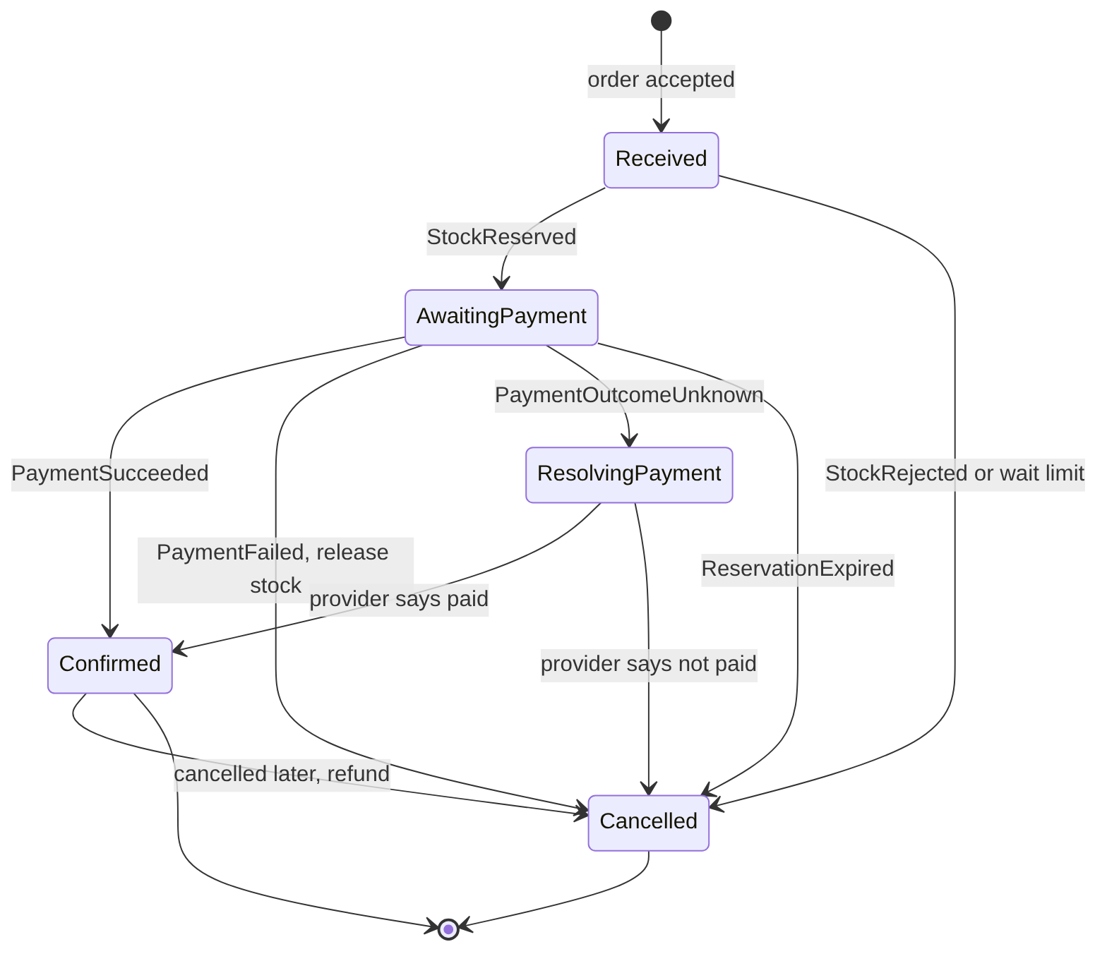
Step | Trigger | Action | Compensation if a later step fails
1 | Place order accepted | Store order, saga state and outbox row in one local transaction | None needed; nothing external done
2 | State Received | Send ReserveStock | ReleaseStock
3 | StockReserved | Send TakePayment | RefundPayment if paid, ReleaseStock
4 | PaymentSucceeded | Send CommitStock, mark Confirmed, publish OrderConfirmed | RefundPayment, ReleaseStock if commit fails permanently
5 | Any failure | Mark Cancelled with reason, publish OrderCancelled | Already applied

Time limits (assumed): stock wait 2 minutes; payment attempt bounded by the 10-minute reservation (BR-01); unknown payment outcome resolved within 10 minutes, then an operator alert. Customer-visible states are simplified: Received, Confirmed, Cancelled.

Races the design already handles
Race | Rule
Reservation expires while payment is in flight | Request payment only if enough time remains; extend the reservation by a bounded amount while a payment is open; if payment succeeds after expiry, try to re-reserve, otherwise refund and cancel with a clear reason
Customer cancels while payment is in flight | Accept the cancellation as a request; Ordering decides after the payment outcome is known
Duplicate PaymentSucceeded delivered | Ignored by the inbox rule
Order confirmed but notification fails | Notification retries independently; no effect on state
Price changes after order received | No effect: price is snapshotted (BR-06)

5. Reliability patterns: outbox, inbox, idempotency
Evidence: Designed
Networks fail and brokers deliver at least once. These three patterns turn "might happen twice or not at all" into "happens once in effect".

The dual-write problem and the outbox
If a service saves an order and then publishes an event, a crash between the two loses the event. If it publishes first, the event can announce something that never committed. The outbox writes the event into a table in the same local transaction as the state change. A relay then publishes it, retrying until acknowledged. Alert if outbox age exceeds 1 minute.

Inbox and consumer idempotency
Consumers record processed message ids and skip repeats, so redelivery is harmless. After 5 attempts with exponential backoff and jitter, a message goes to a dead-letter queue with an alert and a replay tool.

Idempotency across the checkout
Where | Rule
Place order | Checkout key is unique per customer. A repeat returns the existing order and starts no second saga
Commands to Inventory and Payment | Carry the order id; handling the same command twice equals once
Payment provider calls | Idempotency reference derived from order id and attempt, so a retry cannot charge twice
Event consumers | Remember processed message ids
Refunds | One refund per order and reason

Unknown payment outcome
If a charge times out, the outcome is unknown. The saga enters ResolvingPayment and asks the provider for the status. It never retries blindly with a new reference. Operators are alerted after 10 minutes.
Sentence to memorise: "Exactly-once delivery does not exist; at-least-once delivery plus idempotent handling gives exactly-once effect."

Failure behaviour per component
Failing component | Customer effect | Required behaviour
Notification | None on the order | Queue and send later
Catalogue | Browse degrades | Serve cached content; checkout uses Ordering's local price list
Basket | Cannot start checkout | Reject checkout before payment with "try again"
Inventory slow or down | Orders wait in Received | Cancel without charge if not reserved within 2 minutes
Payment provider slow or down | Payment delayed | Circuit breaker, bounded retries, unknown-outcome path
Broker | New sagas cannot progress | Orders recorded atomically with the outbox, relayed on return
Identity | Sign-in fails | Existing tokens stay valid until expiry

6. Data stores and consistency
Evidence: Designed
Boundary | Model | Mechanism
Inside one service | Strong | Local transaction
Order, stock and payment together | Eventual, guided by a saga | Orchestration with compensations
Publish an event with a state change | Atomic together | Outbox in the same transaction
Consume an event | At least once, safe to repeat | Inbox of processed ids
Replicas | Eventual, bounded lag | Events plus periodic resync

Polyglot persistence: the honest version (ADR-006)
Option | Engines | Assessment
1 Three engines (chosen) | PostgreSQL, MongoDB, Redis | Fits every access pattern; three skills to run; keeps the existing Catalogue spike; high learning value
2 Two engines | PostgreSQL with JSON for Catalogue, Redis | Also meets needs given caching; simpler; narrowly won on business criteria alone
3 Four engines | Adds SQL Server for Ordering | Rejected: cost without objective gain, less portable

Learning value was stated as the tie-breaker. Catalogue data access sits behind a repository port, so option 2 remains an exit path.

Hot-stock contention
Stock reservation on one popular product serialises on one row. Four strategies are candidates and SP-2 will choose (see the performance document, section 2.6). Status: not yet run.

7. Edge, identity and contracts

7.1 Gateway as backend-for-frontend
Evidence: Proven in spike
The browser talks only to the YARP gateway (ADR-008). It authenticates, rate limits, routes and does simple aggregation, but holds no business rules (DD-4). The rate-limiting layer was proven in spike SP-3; token validation is not yet built (the spike used a header).

7.2 Identity and zero trust inside
Evidence: Designed
- Keycloak issues tokens through OIDC/OAuth2. Standards-based and self-hostable, so security is adopted rather than built (PR-11).
- Authenticate at the edge and validate again inside each service (PR-09), with scopes per service and least privilege for service-to-service calls. A compromised edge or internal network must not mean full compromise.
- Card data is never stored; a payment provider returns tokens. Logs hold identifiers, never personal or payment data.

7.3 Contracts and versioning
Evidence: Designed
- Contract first (PR-05): OpenAPI for synchronous APIs, versioned /v1, errors as RFC 7807 problem documents.
- Additive changes only within a version (new optional fields). A breaking change means a new version with parallel support. Consumers ignore unknown fields.
- Consumer-driven contract tests run in each service's pipeline.
- Each message and API has exactly one owning team.

8. Migrating from the monolith (strangler)
Evidence: Designed
"ShopStream Classic" (two VMs, one SQL Server, in-memory sessions) is fictional. The plan is real and rehearsed on paper.
Wave | Content | Data approach | Rollback
0 | Platform, identity, gateway | Import accounts to Keycloak; verify old hash on first sign-in then re-hash; reset email as fallback | Gateway keeps sending sign-in to Classic until verified
1 | Catalogue (read only) | One-way copy to MongoDB until cut-over, then the new service becomes the only writer | Route reads back, rerun copy
2 | Basket | No migration; baskets are short-lived | Route back
3 | Inventory, Payment, Ordering together | Drain and switch: stock copied in a freeze window; new orders use the new saga; in-flight orders finish in Classic | Hours: pause routing, return stock ownership. Days: fix forward (R-23)
4 | Notification, retire Classic | Consumers replace old code; switch off after a clean reconciliation cycle | Re-enable route until decommission

Five-stage cut-over for every wave
- Build and verify in staging.
- Shadow: the gateway copies read traffic and compares responses for 3 days without showing them.
- Canary: 1%, then 10%, then 50%, with error and latency checks at each step.
- Full cut-over: 100% routed, old route kept warm for 7 days.
- Decommission with sponsor sign-off and retained backups.
Principles: one owner of each fact at any time (no two-way sync), reversible until proven, never migrate within 48 hours of a trading peak, and a flash sale is never the first live use of the new saga.

9. Evidence status today
Claim | Status | Where the proof will be
Services beat the alternatives for these objectives | Designed | C3 scoring; revisit at merge trigger and G-7
Gateway limits hold across instances and fail safe | Proven in spike | spikes/SP3-RateLimiting/RESULTS.md
MassTransit v8 on .NET 10 delivers outbox, inbox, retry, saga | Planned | SP-1 result, appended to ADR-007
Hot-item stock never oversells at 500/s | Planned | SP-2 and test T-3, ADR-009
Duplicate submissions give one order and one charge | Planned | Test T-8 and saga tests (WP-12)
Recovery within 30 minutes with at most 1 minute data loss | Planned | Test T-7 drill
Strangler cut-over works | Designed | Paper rehearsal (WP-16) with simulated incidents

10. Interview questions and answers
Q. Why microservices? Would a monolith not do?
30-second answer: For this problem, a modular monolith was a credible option. I scored three options against six objectives and services won because of independent scaling of hot paths and delivery by four teams. Under sensitivity analysis the margin was small, and I documented the merge trigger and the fallback.
If pushed:
- With one team I would start with a modular monolith with clean boundaries and extract hot services later.
Watch out: Never say microservices are "better". Say when and why.
Q. How do you decide service boundaries?
30-second answer: By business capability and data ownership. Things that must be consistent together stay together, things that change together stay together, and each service has a team and a capability.
If pushed:
- Warning signs of wrong boundaries: chatty calls, shared tables, services that always deploy together.
Q. How do you handle transactions across services?
30-second answer: No distributed transaction. A saga runs local transactions in sequence with compensations: release stock, refund payment. Ordering orchestrates so the state and the compensations are in one place.
Q. Orchestration or choreography?
30-second answer: Orchestration for checkout because we need one visible order state and explicit compensations. Choreography for simple one-way flows such as notifications.
Q. What is the outbox pattern and why do you need it?
30-second answer: It solves the dual write: saving state and publishing an event are two systems and cannot be atomic. The event is written to a table in the same transaction as the state and published by a relay, so a crash cannot lose it.
If pushed:
- The relay can publish twice, so consumers need an inbox or idempotent handling.
Q. Can you guarantee exactly-once processing?
30-second answer: Not delivery. At-least-once delivery plus idempotent handlers gives exactly-once effect. Idempotency keys, an inbox and one-refund-per-order rules provide it.
Q. What happens if a payment call times out?
30-second answer: The outcome is unknown, so we do not charge again. The saga moves to ResolvingPayment and queries the provider using the same idempotency reference. After 10 minutes with no answer an operator is alerted.
Q. How do you query data across services?
30-second answer: Not with joins. Use API composition for simple needs, a read model fed by events for reporting, and named replicas where a service needs a copy such as the price list.
Q. Why not a shared database?
30-second answer: It couples release cycles and schemas, hides dependencies, and lets one team break another. PR-03 gives one owner per data set, and others use its API or events.
Q. How do you version APIs and events?
30-second answer: Additive changes only within a version, a new version for breaking changes with parallel support, consumers ignore unknown fields, and consumer-driven contract tests run in each pipeline.
Q. How do you prevent a cascading failure?
30-second answer: Timeouts on every remote call, retries only for idempotent work with backoff and jitter, circuit breakers, bulkheads with separate pools, and graceful degradation (cached browse, checkout rejected before payment when the basket is down).
Q. How do you test microservices?
30-second answer: Unit tests for logic, integration tests against real dependencies in containers, consumer-driven contract tests, load tests, and failure injection. In the rate-limiting spike, killing Redis under load found two defects design review had missed.
Q. How would you migrate from a monolith?
30-second answer: Strangler at the gateway, one capability at a time, shadow then canary then full cut-over. Each fact has one owner. The money path uses drain and switch, and I record that rollback after days is fix-forward.
Q. How many services is too many?
30-second answer: When changes routinely span services, when teams cannot own them, or when operations cost outweighs benefit. My guardrail is the merge trigger: two services changing together in over half their releases get merged.
Q. RabbitMQ or Kafka?
30-second answer: RabbitMQ for command and event routing with dead-lettering and enough throughput for 3,000 to 4,000 msg/s with separate queues per consumer. Kafka stays a scale-out option for the highest-volume stream if measured throughput falls short.
Q. How do you handle eventual consistency in the UI?
30-second answer: Tell the truth: the order shows Received, then Confirmed or Cancelled with a reason. Polling first, push later. A price-change confirmation prevents charging an amount the customer did not see.
Q. What would you change if the team grew, or shrank?
30-second answer: Grow: split services along team lines when changes begin to collide. Shrink: use the fallback and merge Ordering, Basket and Notification into one deployable behind identical contracts, as an incremental change recorded in an ADR.
Q. How did you handle a library going commercial?
30-second answer: I treated it as a decision with an owner. v9 needs a paid licence, v8 has a short patch window, so I started with v8 behind my own messaging port, defined spike pass criteria, and kept a free alternative and an in-house layer as fallbacks.
Watch out: Add the spike result here once SP-1 has run.

Update log and refresh checklist
This document is updated when a gate closes (rule recorded as CH-005 in H1 and added to the G1 definition of done). Use the checklist at each gate.
- Change every evidence tag whose status moved (Designed to Proven in spike to Built).
- Replace assumed numbers with measured ones and keep the old value in brackets once.
- Add the new decision, finding or incident as a story with its numbers.
- Add or refine the interview questions the new work makes likely.
- Add a line to the table below.
Date | Gate / event | What changed
2026-10-25 | Created | Sections written from C1 to C4, D2, D4, F1; gateway status from SP-3
 | Next: SP-1 | Fill messaging library decision in section 3 and the last Q&A; update evidence table
 | Next: SP-2 and WP-10 to WP-12 | Add hot-stock ADR-009 result in section 6; mark saga and idempotency rows Built when tested

